SAVE-IT

A Final Report of
SAfety VEhicles using adaptive Interface Technology (Task 15):

SAVE-IT Summary and Benefits Estimation

Prepared By
Matthew R. H. Smith
Gerald J. Witt
Debi L. Bakowski

Delphi Electronics & Safety
Phone: (765)-451-9816
Email: matt.smith@delphi.com

May 2008

Table of Contents

EXECUTIVE SUMMARY iii
1. INTRODUCTION 1
2. SAVE-IT PROGRAMMATIC OVERVIEW 2
2.1 Program Goals 2
2.2 Programmatic Structure and Funding 2
2.3 Research Strategy 4
3. SAVE-IT System Summary 8
3.1 Overview of SAVE-IT Systems 8
3.2 Data Fusion and System Integration 10
3.3 Driver Monitoring Building Block 11
3.4 Driving Task Demand Building Block 12
3.5 Adaptive Safety Warning Countermeasures 13
3.6 Distraction Mitigation Countermeasures 18
3.7 Warning Human Machine Interface 22
4. ADAPTIVE SAFETY WARNING BENEFITS SUMMARY 25
4.1 Collision-reduction potential 25
4.2 Alert Rates and Acceptance 28
5. DISTraction mitigation benefits SUMMARY 35
5.1 Collision-reduction potential 35
5.2 Acceptance 37
6. Conclusions 40
6.1 The SAVE-IT Program Findings 40
6.2 Lessons Learned 41
6.3 Future Research Needs 43
Acknowledgments 44
References 45

EXECUTIVE SUMMARY

The 100-Car study estimated that distraction may contribute to more than three quarters of all crashes¹⁵. The issue of driver distraction may become more critical in the coming years because increasingly elaborate nomadic devices (e.g., cell phones, navigation systems, wireless Internet and email devices) are being brought into vehicles that may increasingly compromise safety. In response to this need, the John A. Volpe National Transportation Systems Center (VNTSC), in support of NHTSA's Office of Vehicle Safety Research, awarded a contract to a diverse team led by Delphi Electronics & Safety that includes Ford, the University of Michigan Transportation Research Institute (UMTRI) and the University of Iowa. The goal of this program was to demonstrate a viable proof of concept that is capable of reducing distraction-related crashes and enhancing safety warning effectiveness. The contract, known as SAfety VEhicle(s) using adaptive Interface Technology (SAVE-IT), was a five-year research and development program that developed and tested two branches of countermeasures, distraction mitigation countermeasures that seek to directly reduce the amount of distraction, and adaptive warnings that seek to reduce the negative impact of distraction. This research was performed in driving simulators, on closed-course test tracks and on real roadways.

A range of distraction mitigation countermeasures were investigated in terms of collision-reduction effectiveness and driver acceptance. Real-time distraction feedback (distraction alert) and post-drive distraction feedback (trip report) were compared and it was found that providing a post-drive summary of safety-relevant events and behaviors (trip report) was effective at improving driver responses to imminent events on subsequent drives. The trip report also appeared to be viewed the most favorably by subjects, demonstrating the highest levels of satisfaction and perceived usefulness compared with the other distraction mitigation countermeasures. The trip report also has the advantage over real-time distraction feedback in that it does not have the potential to interfere with the driving task. The adaptive infotainment and availability countermeasures received lukewarm acceptance ratings but may be necessary to counteract the negative consequences of the proliferation of increasingly elaborate devices entering vehicles. A major limitation of this countermeasure is that it is unlikely to be an effective solution for nomadic devices unless some form of government mandate is in place to require the interfaces of nomadic devices to be controlled by the vehicle.

The adaptive warning countermeasures included both Adaptive Forward Collision Warning (AFCW) and Adaptive Lane Departure Warning (ALDW). Like their non-adaptive counterparts, AFCW utilizes radar to sense obstacles in front of the host vehicle and alerts the driver when there is an imminent threat of collision, and ALDW utilizes vision processing to alert the driver when the host vehicle strays across a lane boundary. The adaptive versions of these countermeasures differ from the conventional systems in that they utilize information about the driver’s head pose in order to tailor the warnings to the driver’s attention. Research in the SAVE-IT program demonstrated that tailoring alerts to the driver’s visual distraction can help alleviate the tradeoff between providing sufficient warning during distracted episodes and annoying drivers when they do not need the warnings. By avoiding this tradeoff, the collision-reduction effectiveness of forward collision warning (FCW) was increased and the acceptance of both FCW and lane departure warning (LDW) was improved by reducing the number of alerts during periods of visually-attentive driving.

The goal of this final report is to provide a concise and digestible summary of the multifaceted SAVE-IT program and to serve as an index to all of the other documents that were written in support of the SAVE-IT program.

1. INTRODUCTION

SAVE-IT is a multifaceted program that has provided a substantial body of documents, many of which are available online at www.volpe.dot.gov/hf/roadway/saveit/docs.html.
There are over fifteen tasks in this program, most of which have two research phases and a literature review phase. To summarize each task document would lead to a substantial document that would not be particularly digestible and would likely not allow the reader to understand how the component tasks fit together within the overall context of the SAVE-IT program. The primary purpose of this document is to provide a concise and digestible summary of the overall program and to provide an index to the more in-depth coverage of this work that is available in the task documents. In doing so, it is hoped that this document can provide a holistic summary of the program that illustrates how the SAVE-IT program utilized the research of the component tasks and how this research was integrated into a final system that was put to the test in driving simulators, test tracks, and on roadways. As one of the goals of this final SAVE-IT task (Task 15: Program Summary and Benefit Evaluation) is to evaluate the benefits of the SAVE-IT system technologies, this document will identify the most revealing data from this program that suggests benefits in either collision-reduction potential or driver acceptance.

This report will be organized as follows:
- SAVE-IT Programmatic Overview
Overview of the SAVE-IT program, describing the programmatic structure and what goals the SAVE-IT program was attempting to achieve.
- SAVE-IT System Summary
Summary of the implemented countermeasures and the building blocks that supported adaptation
- Adaptive Safety Warning Benefits Summary
Summary of data that evaluates the potential benefit of the adaptive safety warning (forward collision warning and lane departure warning systems that adapt to the driver’s head pose) systems
- Distraction Mitigation Benefits Summary
Summary of data that evaluates the potential benefit of the distraction mitigation (countermeasures that attempt to reduce distraction) systems
- Conclusions
Summary and concluding observations and a discussion of lessons learned and future research needs

Note that in order to provide a concise method for indexing the results of the component tasks, whenever this document refers to a SAVE-IT task document, the task document will be referred to by displaying the task number in a superscript font (e.g., refer to Task 4 Distraction Mitigation⁴). Thus, references numbers 1 through 14C will be reserved for the respective SAVE-IT tasks. References thereafter (15 and up) will be in the order in which they are cited.

2. SAVE-IT PROGRAMMATIC OVERVIEW

This section will introduce the SAVE-IT program and provide some information on the programmatic structure. The subsections that follow are:
- Program Goals
- Programmatic Structure
- Research Strategy

2.1 Program Goals
The mission of the SAVE-IT program was to demonstrate viable adaptive interface technologies that provide benefit in reducing distraction related crashes and enhancing the effectiveness of collision avoidance systems. The sub-goals of this program, as identified in the initial proposal were:

- Advance the deployment of adaptive interface technology as a potential countermeasure for distraction-related crashes.
- Enhance collision warning system effectiveness by optimizing onset algorithms tailored to the driver’s level of distraction.
- Conduct human factors research to help derive distraction measures for use in algorithms for triggering interface adaptation.
- Develop and apply evaluation procedures for assessment of SAVE-IT safety benefits.
- Provide the public with documentation of the human factors research and with information describing the algorithms for controlling the driver vehicle interface to the extent needed for specifying performance and standardization requirements.
- Identify potential scalable system concepts and sensing technologies for further stages of research and development as follow on to this SAVE-IT program.

2.2 Programmatic Structure and Funding
The SAVE-IT program consisted of two phases, wherein the first phase developed the necessary components of the SAVE-IT system and the second Phase 1 integrated the results of the Phase 1 component tasks into a functioning system and then evaluated that system. Figure 1 demonstrates the structure of this program and reveals the component tasks that made up the program. Phase 1 lasted for approximately 1.5 years and consisted of the six diagnostic measures tasks^{2, 3, 5, 6, 7} , which developed the necessary sensing technologies and algorithms to support the SAVE-IT adaptive interface technologies, the two adaptive countermeasures tasks^{4, 9}, the crash scenario identification task¹, and the task of building the concept demonstration¹⁰. Phase 2 was split into two sub phases, where Phase 2A (2 years) integrated the SAVE-IT components into a functioning SAVE-IT prototype vehicle (see Figure 2) and driving simulator equivalent^{11, 13}, and where Phase 2B (1.5 years) evaluated the vehicular and driving simulator versions of the SAVE-IT systems^{14A, 14B, 14C}. Table 1 lists the SAVE-IT tasks, the institutions that performed these tasks, and the leader of each task.

The SAVE-IT Program was sponsored by the National Highway Transportation Safety Administration (NHTSA), who provided approximately $3M in funding for the project. The remainder of the funding came from Delphi, who provided approximately $2.4M, and Ford, who contributed approximately $200K of in-kind research. Neither of the commercial partners received the government funding, so that the $3M could be completely channeled into the research conducted by the university partners. The Volpe Center (a division of the Research and Innovation Technology Administration or RITA) administered the program.

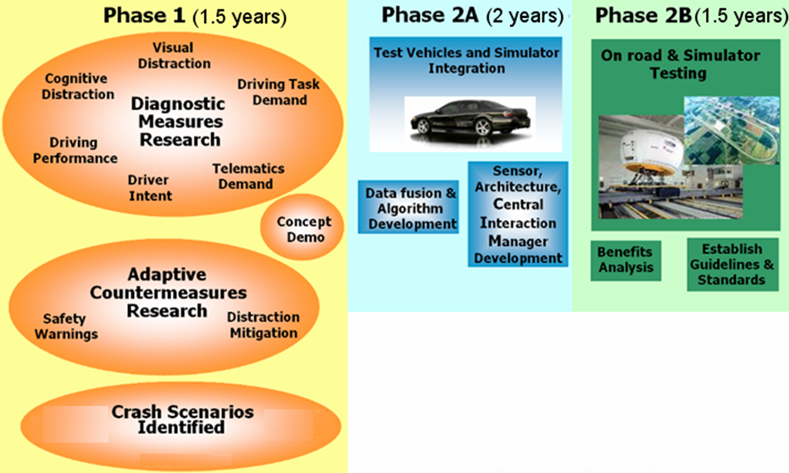
Figure 1. The Phases of the SAVE-IT research program.

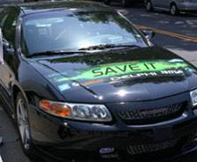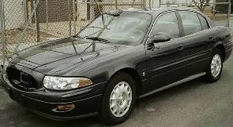
Figure 2. The SAVE-IT vehicles. The left picture displays the Phase 1 SAVE-IT concept demonstration and the right picture displays the SAVE-IT prototype vehicle that was evaluated in Phase 2B testing

Table 1. SAVE-IT Tasks, Institution, and Task Leads
# | Task | Institution | Lead
¹ | Scenario Identification | UMTRI | David Eby
² | Driving Task Demand | UMTRI | Paul Green
³ | Performance | UMTRI | Paul Green
⁴ | Distraction Mitigation | University of Iowa | John Lee
⁵ | Cognitive Distraction | University of Iowa | John Lee
⁶ | Telematics Demand | University of Iowa | John Lee
⁷ | Visual Distraction | Delphi | Harry Zhang
⁸ | Intent / Maneuver Prediction | Delphi | Matthew Smith
⁹ | Safety Warning Countermeasures | Delphi | Matthew Smith
¹⁰ | Technology Development | Delphi | Greg Scharenbroch
¹¹ | Data Fusion | Delphi | Matthew Smith
¹² | Standards and Guidelines | University of Iowa | John Lee
¹³ | System Integration | Delphi | Ray Prieto
^{14A} | Evaluation: Driving Simulator | U. of Iowa (NADS) | Timothy Brown
^{14B} | Evaluation: Driving Simulator | Ford (VIRTTEX) | Jeff Greenberg
^{14C} | Evaluation: Test track and On-road | UMTRI | David Leblanc

2.3 Research Strategy
In order to conduct this research within the constraints of the overall budget, the SAVE-IT program carefully evaluated the relative strengths and weaknesses of the three testing venues: driving simulator, test track, and field testing. In addition to satisfying an affordability constraint, a reasonable production solution must address the constraints of both collision-reduction effectiveness and acceptance. Table 2 displays the research constraints for the evaluation of collision-reduction effectiveness compared with the evaluation of acceptance.

In order to directly measure whether one system improves collision-reduction effectiveness compared to another system or whether a system compromises safety, drivers must be placed in a circumstance where there is a high risk of collision, because without any collisions, there is no room for improving in safety. This can be achieved by either exposing vehicles to several million miles of on-road driving*, which is not usually practical, or through constraining scenarios in order to increase the likelihood of real or virtual crashes. Driving simulators provide researchers with a means of efficiently placing drivers at a high risk of virtual collision, without any real risk to the driver. Because of the high level of efficiency in producing these collision scenarios, one-exposure experimental (between-subject) designs become practical, which avoids the issue of a highly-imminent event contaminating driver’s future responses. When a driver is placed in a surprise circumstance where there is a high risk of collision, the event likely changes the driver’s behavior to subsequent events. For this reason, an evaluation of collision-reduction effectiveness is ideally conducted on a between-subjects basis, where each driver experiences only one surprise-collision event. Although the between-subjects methodology requires a large number of subjects, the design may potentially be streamlined to require only a short amount of time per participant. Expanding on the driving simulator work that Delphi conducted in the ACAS FOT program¹⁷, the SAVE-IT program⁹ further refined the between-subjects testing methodology to provide an efficient and sensitive protocol for measuring the effectiveness of different collision warnings. In this context, this between-subjects methodology was used to measure the differences between various human machine interfaces and different methods of adapting warnings.

Table 2. The Research Constraints for Collision-reduction effectiveness vs. Acceptance.
Research Constraints | Collision-reduction effectiveness | Acceptance
Central Question | Which system compromises safety the least or provides the greatest safety benefit? | Which system is least annoying, most acceptable, most preferred, or provides the greatest perception of benefit?
Exposure Requirements | Expose drivers to real or simulated threatening scenarios where there is an apparent danger of collision | Expose drivers to a representative experience that balances favorable and unfavorable aspects of the system
Control Requirements | Control driver expectations | Facilitate adequate driver comprehension of the system
Participant Requirements | Between-subjects design | Span representative demographics
Dependent Measures | Objective Performance  (Reaction times, time to collision, collision rates and velocities) | Subjective Measures  (Annoyance, perceived effectiveness, buy likelihood, preference)
Number of Participants vs. Amount of Time per Participant | More participants | More time per participant
Ideal Research Facility | Driving Simulator | On-road

Drivers who are exposed to an imminent event likely only receive a limited and biased exposure of the system in the driving simulator. Therefore they are unlikely to be able to provide representative subjective feedback. Because the evaluations designed to measure collision-reduction effectiveness were relatively ineffective for measuring acceptance, the acceptance of the systems was examined in another venue, on-road field testing. Acceptance often varies greatly across individuals and across demographics, such as age or gender. For this reason, the subject pool must span a wider range of participants than the collision-reduction effectiveness, where demographic effects are less likely. Furthermore, in acceptance testing, the driver and system should be exposed to a representative experience that balances both favorable and unfavorable aspects of the system. Ideal for acceptance testing, field-testing is also a valuable tool for exposing the system to a wide range of circumstances that may test important aspects of the system-environment performance that have not been considered. Although field testing was used almost exclusively in the ACAS FOT (Advanced Collision Avoidance Systems Field Operational Test) program, the testing provided relatively little information about collision-reduction effectiveness. The mileage of ACAS FOT was insufficient to expect any collisions. Field testing on the scale of the ACAS FOT program, which included over one hundred thousand miles¹⁸, although relatively uninformative about collision-reduction effectiveness, has provided a large amount of useful information about acceptance and how forward collision warning operates on real roadways.

In human-subject testing, the test track represents a compromise in many respects between driving simulator research and on-road testing. The environment is more realistic than the driving simulator and the fidelity of the simulation cannot be called into question to the same extent as in driving simulator research. Because of the level of control, the research can also more efficiently examine the question of collision-reduction effectiveness. In some circumstances, methods can be developed on the test track where the driver believes that they are at risk when there is actually little or no risk to the driver. One of the difficulties with human-subject research on the test track is that drivers are often at a heightened level of arousal and readiness, because they may not feel at ease in the test-track environment. The need to communicate with traffic control and other vehicles in combination with the responsibility of driving a real vehicle in a novel environment can sometimes be overwhelming for participants, preventing them from relaxing or adopting realistic driving behaviors. For example, it may be quite difficult to distract drivers at a high level. Exposing drivers to test conditions over long periods of time may help to reduce this limitation.

The SAVE-IT program identified a research strategy that is summarized in Figure 3. In order to evaluate acceptance, a high level of realism is required and the events do not need to be highly controlled, and so on-road field testing was the primary venue for evaluating effectiveness. At the other extreme, in the evaluation of collision-reduction effectiveness, the control of the events is more important than the realism, and thus a driving simulator was selected as the primary venue for effectiveness testing. As a compromise between realism and control, the test-track was used to bridge the gap between on-road and driving simulator evaluations. Because the SAVE-IT exposures were relatively brief^{11, 14C} and each driver received relatively few alerts, the test track was used to educate drivers about the tradeoff between collision-reduction effectiveness and nuisance, prior to drivers later experiencing the systems on real roadways^{14C}.

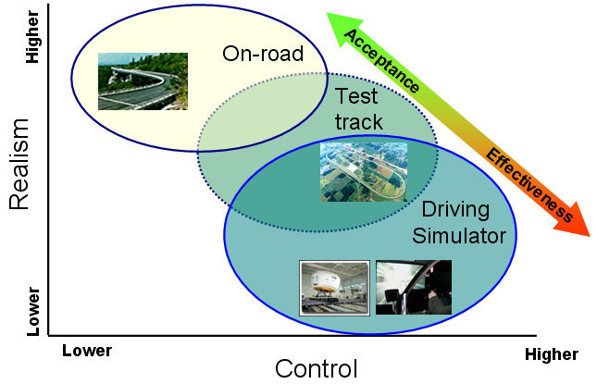
Figure 3. How driving simulator, test track, on-road venues fit into the realism by level of control space and how the environments were used in the SAVE-IT program to investigate acceptance and collision-reduction effectiveness.

3. SAVE-IT System Summary

This section will provide a description of the overall SAVE-IT system and describe the components that support the adaptive interfaces. The following subsections are:
- Overview of SAVE-IT Systems
- Data Fusion and System Integration
- Driver Monitoring Building Block
- Driving Task Demand Building Block
- Adaptive Safety Warning Countermeasures
- Distraction Mitigation Countermeasures
- Warning Human Machine Interface

3.1 Overview of SAVE-IT Systems

Figure 4 displays a conceptual overview of the SAVE-IT system. The two branches of countermeasures, Adaptive Warnings^{9, 11} and Distraction Mitigation^{4, 11}, accept input from the two sources of adaptive inputs, Head Pose^{10, 13} and Driving Task Demand¹¹.

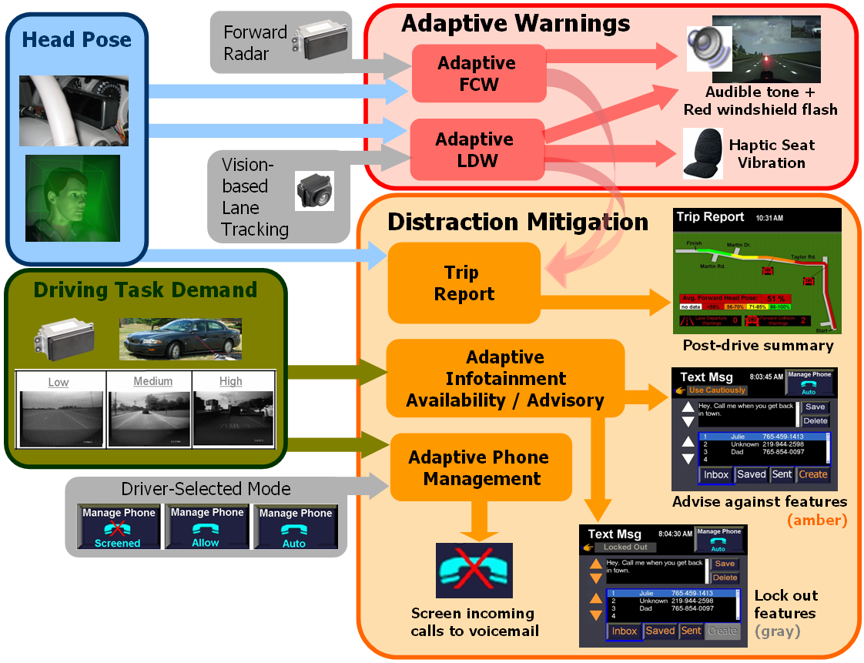
Figure 4. Summary of the SAVE-IT countermeasures as a function of adaptation inputs.
Whereas the Adaptive Warnings attempt to reduce the negative effects of driver distraction, the Distraction Mitigation countermeasures attempt to directly reduce driver distraction. The Adaptive Warnings include Adaptive Forward Collision Warning (AFCW) and Adaptive Lane Departure Warning (ALDW), which are like their non-adaptive counterparts, except that they also respond to the driver’s Head Pose. Although production AFCW and ALDW systems would also need to adapt to driver drowsiness, drowsiness was defined as beyond the scope of the SAVE-IT program and was therefore not investigated. Forward Collision Warning (FCW) and Lane Departure Warning (LDW) were selected for adaptation because an analysis of collisions suggested that distraction most impacted the events that these systems attempt to prevent¹. The Distraction Mitigation countermeasures include Trip Report, which provides post-drive feedback at the end of each trip regarding safety-relevant events and the driver’s Head Pose, Adaptive Infotainment Availability and Advisory, which either lock out or advise against infotainment features when the Driving Task Demand is too high for the given feature to be performed safely, and Adaptive Phone Management, which when placed in auto-screen mode, screens calls to voicemail when the Driving Task Demand is too high for the phone to be answered safely.

Figure 5 displays the vehicle architecture that supported the SAVE-IT systems. This information is described in more detail in other SAVE-IT reports^{10, 13}.

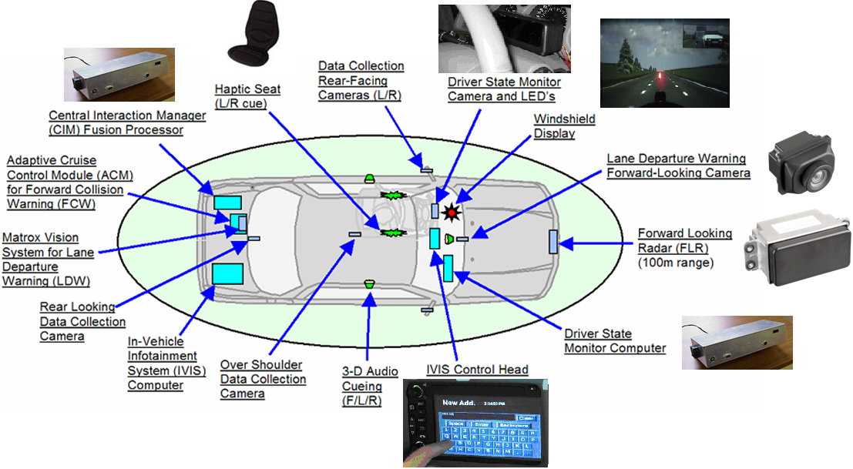

Figure 5. SAVE-IT vehicle architecture.

3.2 Data Fusion and System Integration
This implementation resulted from the observed need to maintain a relatively simple system that the driver would be able to comprehend and that could be evaluated in Phase 2B. As an extension of the driving simulator-based experiments^{4, 9}, on-road drives were conducted in Phase 2A to observe the behavior of the adaptive interfaces on real roadways and to collect a wide range of subjective measures¹¹. The drives were conducted as part of an iterative process that allowed for immediate cycles of implementation, testing, and refinement based on both subjective and objective measures. This iterative refinement process afforded a data-driven methodology to support the complex data-fusion task of integrating the components into a SAVE-IT system. As naïve drivers began to experience the systems on real roadways, it became increasingly apparent that a critical requirement was that the countermeasures needed to be understandable. Countermeasures that were more elaborate or included more hidden assumptions were not well tolerated by drivers. As the need for simplicity and clarity increasingly became the overriding principle for the SAVE-IT countermeasures, the more complex countermeasures tended to be abandoned in favor of the simpler or more transparent countermeasures. Through iterative development and testing cycles, it became increasingly clear that the most promising decision making techniques were simple rules rather than complex data fusion techniques with hidden assumptions.

Although the initial task structure included tasks that are not reflected in the Figure 4 implementation, the SAVE-IT system needed to be streamlined. Cognitive Distraction⁵ was not included, because Phase 1 research was unable to develop a set of acceptable countermeasures for cognitive distraction^{4, 9} and because cognitive distraction could not be measured using technology that is likely to be affordable in the near future. The requirements for supporting the detection of cognitive distraction were beyond the current state-of-the-art for automotive grade hardware, requiring relatively fine discriminations of the driver’s eye positions. Although the detection of cognitive distraction is possible with expensive research-grade apparatus⁵, it appears unlikely that a system that can reliably detect cognitive distraction will become available in the automotive market in the next decade. Furthermore, there were no obvious countermeasures for responding to cognitive distraction in a manner that drivers are likely to accept. So, although the task that investigated Cognitive Distraction⁵ furthered the science of this area and developed some sophisticated algorithms for detecting when a driver is cognitively distracted, it did not impact the system that is displayed in Figure 4. One of the most interesting findings about cognitive distraction was how it interacts with visual distraction, and how cognitive distraction has relatively little impact on driver reactions to unpredictable events but a much larger impact on reactions to more predictable events⁵. For example, when there were clues that the lead vehicle would need to brake, such as a vehicle cutting in, cognitive distraction had a substantial influence on the braking response. However, when no such clues were present, the influence of cognitive distraction was relatively minor.

The Intent / Maneuver Prediction task⁸ was also abandoned at the end of Phase 1, because it required a more elaborate sensing technology. This streamlining of the program also made room for greater attention on the content that was emerging in Phase 2 as the focus of SAVE-IT.

3.3 Driver Monitoring Building Block
During the course of the SAVE-IT program, Delphi developed a production-intent Driver State Monitor (DSM)^{10, 13}. This system (see Figure 6) features a single camera, and utilizes vision-processing techniques to determine whether the driver’s head pose is forward or not. Unlike research-intent driver monitoring systems that often require a non-automated training sequence, this system was completely automatic and did not require any intervention by either driver or experimenter. The DSM was also capable of measuring eye-closures for drowsiness detection, however, due to this being beyond the scope of the SAVE-IT program, these data were not utilized.

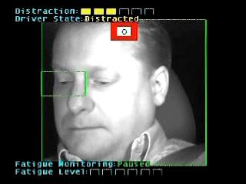
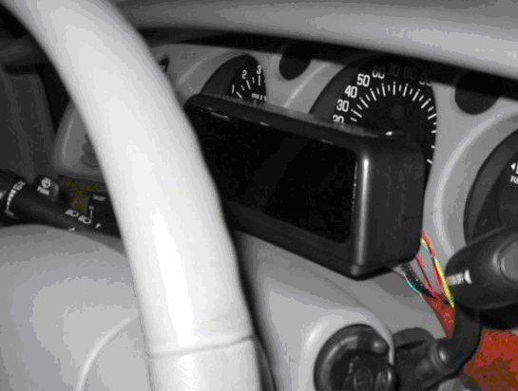
Figure 6. Delphi’s Driver State Monitor (DSM) camera and illuminators (left) and output (right).

Although many research-intent driver monitoring technologies are able to monitor eye gaze, detecting eye-gaze is a difficult task using affordable automotive-grade technology. Figure 7 demonstrates how head pose and eye-gaze measures correlate with the driver performance measures: accelerator release time (ART) and standard deviation of lane position (SDLP)⁷. Although the eye-gaze measures are able to capture slightly more of the variance than head-pose measures, head pose still provides a good estimate of driver distraction, especially for SDLP. Furthermore, it is likely that non-forward glances that cannot be detected using head pose only, are likely to be less severe than non-forward glances that produce a detectable deviation in head pose too. For either prolonged or large-eccentricity head poses, because it is more comfortable, most drivers are likely to use a combination of head and eye movements to direct their gaze to the target. Therefore, because monitoring the head pose is more feasible from a technology perspective than monitoring eye gazes, and because monitoring the head pose is likely to be able to detect the worst-case visual distractions, the SAVE-IT program utilized the head-pose-monitoring DSM system.

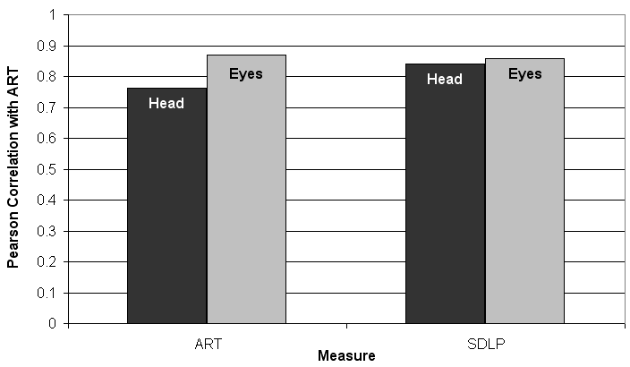
Figure 7. Correlations between head pose or eye gaze and performance measures: Accelerator Release Time (ART) and Standard Deviation of Lane Position (SDLP).

The DSM system identifies a non-forward head pose when the driver’s horizontal head pose is outside a +/- 20 deg area. The 20 deg threshold was selected based on the 100-Car Study which demonstrated an increase in risk when the driver’s glance is located between 20 and 40 deg¹⁵ and based on on-road data suggesting that over long drives, drivers sometime direct their heads a small amount (less than 20 deg) away from forward and compensate with their eyes to maintain forward attention. The instantaneous presence and duration of the non-forward head pose is fed into the adaptive warnings and recorded by the trip report in order to be displayed to the driver at the conclusion of the drive.

3.4 Driving Task Demand Building Block

The driving task demand building block measures the demand placed upon the driver by the driving environment. The amount of attention required of the driver to maintain safe operation varies greatly across driving circumstances. For example, in a circumstance of clear weather, little surrounding traffic, and wide lanes, the driving task may not demand very much attention from the driver. However, in circumstances of poor weather and heavy or chaotic traffic, the driving task may demand all of the driver’s attention. In Phase 1, attempts were made to objectively quantify the driving task demand of a given situation using crash statistics, however, as this did not appear feasible, the program used subjective quantifications of driving task demand instead. Vehicle data were generated by driving an instrumented vehicle on various roads and traffic environments¹¹. From this raw data, one hundred 8-s video segments were selected that represented different levels of traffic, road types, number of lanes and various driving maneuvers. Ten subjects (five male and five female) were recruited and after watching the segments asked:

“On a scale of 1-7 (1-low, 4-medium,7-high), rate how attentive you need to be in order to detect unexpected events and hazards, control vehicle speed and lane position, and avoid crashes and road departures.”

These subjective responses were then compared to the sensor data that was acquired from the vehicle during the rated driving segments and a driving task demand algorithm was developed¹¹. The algorithm equation included data from the radar targets (range, time headway, and angle to target), lane tracking vision processing (lane width), and from the host vehicle (yaw rate, host vehicle speed, brake pedal depression). The predicted demand levels were correlated with the median subjective demand ratings, yielding a correlation coefficient of 0.79. Moreover, for 75% of the videos the algorithm-generated demand group matched the median subjective demand ratings group. Examination of the mismatches showed that most occurred with borderline cases and that the rating cut-off values could be adjusted to generate better matches (up to 93% match).

Subjects also provided judgment on visual distraction feedback and on demand-based advisories for IVIS functions when they were asked:

“In your judgment, which of the following features should be 1 (allowed), 2 (advised not to be used), or 3 (disallowed) when driving under the condition that is portrayed by the video clip?”

These judgments were correlated with the median demand ratings. The results indicated that as ratings of driving demand increase, so do judgments of visual distraction and advisories for infotainment functions. Subjective judgments also suggested that when the driving task demand is high, drivers should be advised to refrain from using the infotainment functions. These judgments were used to calibrate the thresholds for the adaptive infotainment availability / advisory countermeasure.
Although the Driving Task Demand task² developed methods for detecting driving task demand, they were not the methods that were used in the SAVE-IT system. Due to delays in completing the Driving Task Demand task, the Data Fusion task¹¹ developed a Driving Task Demand algorithm in order to meet the deadlines of the vehicle integration activity, and so it is the Driving Task Demand algorithm that was developed in the Data Fusion task¹¹ that was implemented in the SAVE-IT system.

3.5 Adaptive Safety Warning Countermeasures

When a warning system does not take into account the driver’s state, it cannot assume that the driver is completely attentive or completely distracted all of the time. Driving simulator studies demonstrate that when a driver is distracted, single-exposure brake reaction times for unexpected lead-vehicle events often surpass 3 s^{9, 14C, 19}. Yet a forward collision warning algorithm cannot invariably assume a brake reaction time of 3 s, because it would produce alerts at a rate that would both annoy drivers and degrade their confidence that the system provides anything other than false-positives. But neither can a forward collision warning system invariably assume that the driver is attentive. Such an assumption would likely result in a system that produces few nuisance alerts; however, when a necessary warning does occur, a distracted driver may require significantly more than one second to respond to avoid the collision. Designers of non-adaptive warning systems must find some kind of tradeoff between providing distracted or impaired drivers with enough time to respond without annoying attentive drivers who do not need the warnings. Adaptive warnings attempt to find an escape from this trade off by better assessing whether the driver needs the warning or not.

The fundamental principle behind adaptive warnings is that drivers who are attentive to driving do not benefit from warnings. Data from the 100-Car Study appear to support this principle, suggesting that crashes usually result when the sudden emergence of an unexpected situation that coincides with a lapse in attention to the roadway¹⁵. In eleven of the fifteen lead-vehicle crashes, the drivers’ eyes were away from the forward scene just prior to or during the onset of the precipitating factors of the collision. Dingus et al.¹⁵ suggested that inattention converted incidents into collisions by interfering with drivers’ avoidance responses. This result indicates that inattention to the forward roadway is an important contributing factor in lead-vehicle and single-vehicle crashes, perhaps even to a greater extent than conventional crash statistics had implied (e.g., Campbell, Smith, & Najm²⁰).

Dingus et al. ¹⁹ argued that crashes are most often the result of the driver failing to adequately respond to a precipitating event due to various contributing factors. Figure 8 displays a simple model of lead-vehicle crash causation that is based on the observations of the 100 Car Study. The central idea of this model is that crashes are typically caused when contributing factors, such as inattention or weather, interfere with an avoidance response to a precipitating event. When precipitating events (such as a lead vehicle unexpectedly braking) occur in the absence of the contributing factors, they are usually resolved by the flexible and adaptive response of the driver, resulting in what may be a near-miss, but usually not a collision. However, when contributing factors, such as visual distraction are added, they act as a catalyst for a crash by interfering with the driver’s response, converting a mere incident, or near-miss, into a collision. Other examples of catalysts that can degrade driver responses might be poor roadway conditions, mechanical failure, and driver impairment due to fatigue, alcohol, or other factors.
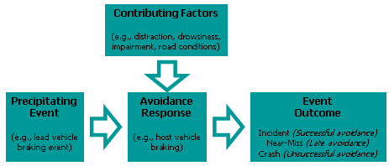
Figure 8. Simple conceptual model of how inattention is a catalyst for crashes.

This model is clearly an oversimplification and only considers the feedback of the driver in response to events rather than the ability of drivers to pro-actively drive in a manner to reduce risk. However, to the extent that this simple model approximates the reality of lead-vehicle or single-vehicle crashes, it predicts that, in the absence of a catalyst such as visual distraction, drivers are unlikely to benefit significantly from warnings. If the driver is attending to the forward roadway at the moment a precipitating event occurs, the driver usually detects the event and responds appropriately. In such a circumstance, there is usually little opportunity to improve the process. A collision warning would only present information to which an attentive driver is already aware. Even if the driver is visually-attentive but is likely to react slowly due to age or intoxication, the warning system may still be unable to hasten the process, because drivers almost always confirm the threat for themselves before applying the brake¹⁷.

The SAVE-IT program developed an initial list of adaptation strategies for the adaptive warnings (see Table 3) and selected the most promising candidates for more in-depth evaluation⁹. The four adaptation strategies were Differential Display Location, Differential Display Modalities, Differential Alert Timing, and Alert Suppression. Whereas the Differential Display Location and Differential Display Modalities adaptations modify the nature of the driver vehicle interface, the Differential Alert Timing and Alert Suppression adaptations modify the algorithms that generate alerts. The Differential Display Location adaptation positions the visual stimulus of the alert in the location of the visual distraction to which the driver is currently attending and the Differential Modalities adaptation provides a more urgent or attention-capturing stimulus when the driver is distracted. Whereas the Alert Suppression adaptation simply prevents alerts from being generated when the driver is attentive, the Differential Alert Timing adaptation modifies the likelihood that alerts will be generated by providing earlier alerts when the driver is distracted and later alerts when the driver is not.

Table 3. Negative and Positive Warning Adaptation Strategies.
Warning  Adaptation Strategy |  | Negative Adaptation | Positive  Adaptation
 |  | Attention Forward | Attention Not-forward
 |  | Goal: Improve Acceptance | Goal: Improve Collision Reduction
Non-Adaptive |  | Nominal Alert | Nominal Alert
Modify Human-Machine Interface | Differential Location | Nominal Alert | Visual alert in location of driver’s attention
Modify Human-Machine Interface | Differential Stimuli | Less intrusive or urgent stimuli | More intrusive or urgent stimuli
Modify Algorithm | Differential Timing | Later Alert (less likely) | Earlier Alert (more likely)
Modify Algorithm | Alert Suppression | No Alert | Nominal Alert

Most of the adaptations can be either negative or positive. Whereas negative adaptations diminish the warnings when the driver’s attention is on the road, positive adaptations accentuate warnings when the driver’s attention is away from the road. Specifically, adaptations in the “Attention Forward” column are negative, not in the sense that they are undesirable, but in the sense that they feature methods for suppressing or softening alerts, and the modifications under the “Attention Not-Forward” column are positive adaptations, in the sense that they include methods for accentuating or promoting the alerts. The primary goal of negative adaptation is to improve driver acceptance by reducing the potential nuisance of unnecessary and false alerts. The primary goal of positive adaptation is to improve the collision-reduction potential of the warning systems. Although the primary goals are separate for negative and positive adaptation, the dimensions of driver acceptance and safety benefit are not independent. For a system to be successful in achieving a safety benefit, the driver, to some extent, must accept the alerts. Lees and Lee demonstrated that drivers complied less with their FCW system when the system was prone to false alerts²¹. This “cry wolf” effect has been consistently shown to undermine response to warning systems (Bliss, Dunn, & Fuller²²; Bliss & Acton²³; Young, Regan, Triggs, Tomasevic, Stephan & Mitsopoulos²⁴). Furthermore, it is likely that if the system apparently fails to achieve a safety benefit, drivers may be less likely to accept the system because they do not perceive the system as being useful, thus degrading acceptance.

The adaptation strategies that were implemented for the SAVE-IT evaluation will be described separately for the forward collision warning and lane departure warning systems.

Adaptive Forward Collision Warning (AFCW).
Like traditional Forward Collision Warning (FCW) systems, AFCW utilized the Delphi forward-looking radar to assess the imminent threat of colliding with the lead vehicle. However, unlike FCW, AFCW utilized instantaneous head pose to adapt the timing of the alerts to the driver’s attentiveness to the forward scene. Table 4 displays the final system configuration for Adaptive FCW that was tested in the SAVE-IT evaluation. After investigating the different adaptation alternatives displayed in Table 3⁹, the Differential Alert Timing strategy appeared to be the most promising. This implementation was selected in order to relieve the usual tradeoff faced by FCW systems between providing distracted drivers with sufficient time to respond while not annoying drivers with unnecessary alerts during attentive periods of driving. In the non-adaptive mode, the algorithm assumed a brake reaction time of 2.5 s to the alert. In order to improve driver acceptance, when the driver’s head pose was forward the AFCW algorithm would assume a brake reaction time of 0.5 s. This late timing issued warnings very late and usually resulted in the suppression of unnecessary alerts. However, in order to provide distracted drivers with sufficient time to respond, when the driver’s head pose was not forward, AFCW would produce very early alerts. When the driver’s head pose was first directed away from the roadway, the assumed brake reaction time for the AFCW mode would begin at 1.5 s and then linearly increase towards a maximum of 3.5 s (when the driver had been looking away for at least 2 s).

Table 4. Adaptive and Non-Adaptive mode Forward Collision Warning as a Function of Driver Head Pose.

The SAVE-IT non-adaptive FCW algorithm was tuned to provide warnings earlier than most production systems. This would allow drivers to experience FCW alerts in the limited on-road testing that was planned for the evaluation phase. This means that rather than a comparison of adaptive vs. a typical production implementation, the comparison represents one between the adaptive system and a relatively sensitive FCW system that is biased more toward providing a safety benefit than avoiding annoyance.

Adaptive Lane Departure Warning (ALDW).
Like traditional Lane Departure Warning (LDW) systems, ALDW utilized the Delphi forward-looking camera and vision processing to detect lane position and alert the driver when the lane was crossed. Earlier SAVE-IT research⁹ suggested that LDW provides little benefit when the driver is visually attending to the forward roadway. For this reason, in the ALDW system, alerts were completely suppressed when the driver’s head pose was forward (the “Alert Suppression” strategy of Table 3). The logic for AFCW is displayed in Table 5. Because of the prevalence of rapid head pose movements just prior to a lane crossing resulting from mirror checks, ALDW required a distinction between brief head pose movements and extended periods of away head pose. Only when the driver’s head pose had been away for an extended period of time, were alerts presented to the driver. For an AFCW alert to be generated, the driver’s head pose needed to be away for a minimum of 2 s, and at least 1 s of the head-pose away needed to occur prior to the lane crossing. This was because if drivers looked away just as they were about to cross the lane, it could be assumed that they were aware of the lane crossing. The distinction between glances away for greater than 2 s compared with shorter driving-related glances away from the forward roadway (such as mirror checks) is supported by the results of the 100-Car Study²⁵.

Table 5. Adaptive and Non-Adaptive mode Lane Departure Warning as a Function of Driver Head Pose.

For more detailed information on how the adaptive and non-adaptive systems operated, refer to the Adaptive Safety Warning Countermeasures report⁹.

3.6 Distraction Mitigation Countermeasures

Crashes are frequently caused by drivers paying insufficient attention when an unexpected event occurs, requiring a novel (non-automatic) response. As displayed in Figure 9, attention to the driving task may be depleted from either allocation to non-driving tasks, or from impairment (drowsy or substance) leading to diminished attentional resources. Safe driving requires that attention be commensurate with the driving demand or unpredictability of the environment. Low demand situations (e.g., straight country road with no traffic at daytime) require less attention because the driver can usually predict what will happen in the next few seconds while the driver is attending elsewhere. Conversely, high demand (e.g., multi-lane winding road with erratic traffic) situations require more attention because during any time attention is diverted, there is a high probability that a novel response may be required.

A safety system that mitigates the use of infotainment must balance both attention allocated to the driving task and attention demanded by the environment. In low-driving demand scenarios, allocation of attention to non-driving tasks may not adversely impact safety. In high driving demand scenarios, the same non-driving tasks could divert much-needed attention away from the driving task. The goal of the distraction mitigation system was to maintain the level of attention allocated to the driving task above the attentional requirements demanded by the current driving environment. For example, as evident in Figure 9, “routine” driving may suffice during low or moderate driving task demand, and distracted driving may suffice during low driving task demand, but high driving task demand requires attentive driving.

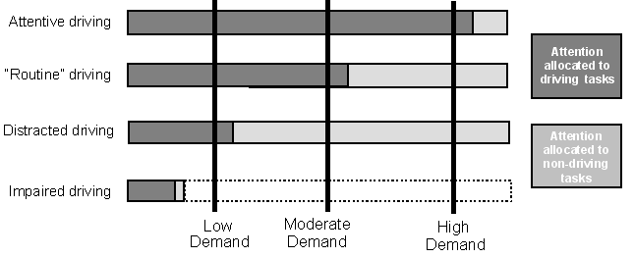
Figure 9. Attention allocation to driving as a function of driving task demand.

The three methods for mitigating distraction (Trip Report, Adaptive Infotainment Availability and Advisory, and Adaptive Phone Management) will be described separately.

Trip report.
Rather than providing real-time driver distraction alerts, a delayed feedback mechanism was implemented in the form of a trip report. This report was presented to the driver at the end of the drive as shown in Figure 10 and included the driver’s percentage of forward head-pose overlaid on the trip route and an overall average attention level for the trip. This information was color coded to make it easier to interpret. The trip report also displays the number and location of FCW and LDW alerts that occurred during the drive. Although this countermeasure would be voluntary in a production implementation, it is expected that the trip report could be implemented in a manner that might trigger the driver’s curiosity. To trigger the driver’s curiosity, the trip report might also displays the number of miles driven and the gas mileage for the trip.

SAVE-IT research suggested that post-drive feedback was more effective at improving safety than instantaneous feedback⁴. Whereas concurrent feedback alone did not result in expediting driver responses to lead vehicle braking incidents, post-drive feedback was found to significantly improve driver reaction times⁴. Post-drive feedback has an important advantage over concurrent feedback in that post-drive feedback avoids interfering with the immediate task performance. Whereas concurrent feedback focuses on immediate driving performance, post-drive feedback focuses on influencing driver behavior, by helping drivers learn what constitutes safe driving and how to diminish risk. Because there is a tendency to rapidly forget near incidents⁴, it is likely that trip report will serve to refresh the driver’s memory and help calibrate their subjective performance.

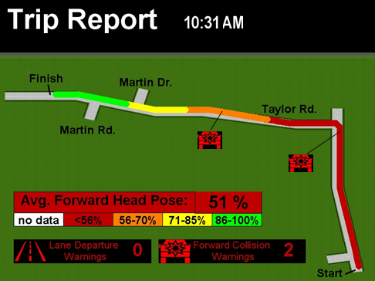
Figure 10. The trip report displayed to drivers at the conclusion their drives^{14A}, displaying the color-coded percentage of head pose forward for the trip, and the number and location of FCW and LDW alerts.

Adaptive Infotainment Availability and Advisory. As driving task demand increases, drivers are either advised or forced to shed more infotainment functions in order to concentrate on the driving task itself (see Figure 11). Table 6 lists the advisories’ logic for the infotainment functions. The advisories are signaled by coloring the text of the buttons responsible for that function in an amber color that was dimmer than the normal color used for that text (see Figure 12). In addition to the color change of the button, the “Use Cautiously” text appeared just under the page heading to help communicate to the driver the intention of the adaptation. As the driving task demand reaches greater levels, some of the more demanding infotainment features are locked-out. This interface attempted to avoid confusion by using the gray-out effect that is now common in computer graphical user interfaces, and clearly tying it to the text just below the page description.

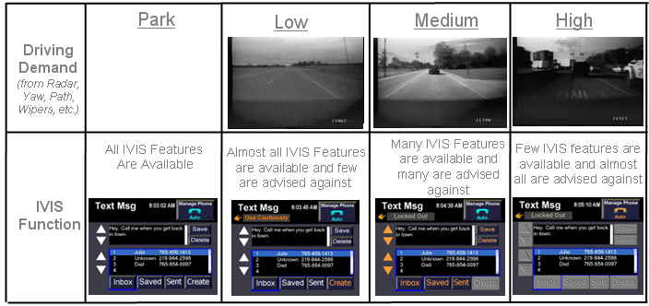
Figure 11. Task demand-based advisory and lockout for IVIS features.

Table 6. Driving task demand-based advisories and lock-outs of IVIS functions
IVIS Task | Driving Task Demand
IVIS Task | In park | Low | Medium | High
Radio Tuning | No Advisories | No Advisories | No Advisories | No Advisories
Satellite Radio | No Advisories | No Advisories | No Advisories | Advisories
CD | No Advisories | No Advisories | No Advisories | Advisories
MP3 | No Advisories | No Advisories | Advisories | Advisories
Phone Dialing | No Advisories | No Advisories | Advisories | Lock-out
Answering Phone | No Advisories | Adaptive Phone Management
Phone Conversation | No Advisories
Navigation POI | No Advisories | No Advisories | Advisories | Lock-out
Navigation Map Reading | No Advisories | No Advisories | Advisories | Lock-out
Navigation Turn-by-turn | No Advisories | No Advisories | Advisories | Advisories
Text Messaging | No Advisories | Advisories | Lock-out | Lock-out

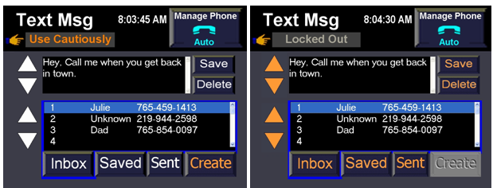
Figure 12. Advisories (amber) and lockouts (gray) for creating text messages.

Adaptive Phone Management.
Adaptive Phone Management is a special case of adaptive lock-out as it applies to the phone system. SAVE-IT research demonstrated that the perceived risk associated with phone functions increases with driving task demand¹¹. Because driver-initiated mitigation methods are more acceptable to drivers than system-initiated methods⁴, drivers were provided with three choices for phone screening: no screening, do-not-disturb and automatic screening (see Figure 13). If the driver selects automatic screening, the SAVE-IT system uses the driving task demand level to decide whether a call should be routed to the driver or to voice mail. In order to satisfy the driver’s need to answer calls that are potentially an emergency, the no-screening mode allows all calls through to the driver. The do-not-disturb option screens all incoming calls to voicemail and allows the driver to anticipate upcoming levels of driving task demand or provides the driver with peace and quiet when desired.


Figure 13. The three driver-selected modes of phone management. Only the auto mode (right) is responsive to the instantaneous assessment of driving-task demand.

In order to simplify the evaluation task, the infotainment and phone systems in SAVE-IT were simulations rather than actual functioning devices. The interface was interactive and could play MP3 files, however, the system could not be used to communicate outside the vehicle.

3.7 Warning Human Machine Interface

One of the tasks within the SAVE-IT program was to further develop the human machine interfaces of FCW and LDW systems⁹. Rather than using the traditional visual interface of an icon on the HUD, SAVE-IT developed a less expensive and more effective alternative visual display for warnings. This “exogenous display” (displayed in Figure 14) presents quick red flashes of light in the center of the driver’s forward field of view to draw the driver’s attention toward the center of the roadway. The total duration of the flashes was brief (e.g., ½ s) so that they provide little for the driver to glance at before dissipating, leaving nothing but the external scene to communicate the threat.

Figure 15 displays a conceptual diagram of some of the observations made during the ACAS FOT program¹⁷. When a distracted driver is not warned, it may take several seconds before the driver glances back and detects the collision threat. When a visual icon is displayed, the distraction may be interrupted, however, an additional step is added where the driver must look at and try to interpret the warning icon. Because drivers do not completely trust warnings¹⁷, they need to observe the actual threat with their own eyes before they brake. Although presenting an icon may expedite the transition between viewing the icon and the forward scene, the icon-viewing step is still an additional step in the process. When an icon is displayed optimally, the temporal cost of adding this stage may be justified by the interruption of distraction, however, it remains an additional stage that may require several hundred milliseconds. To avoid adding an additional step, an alternative strategy is to create a disturbance in the visual field near the focus of expansion to exogenously attract the driver’s eyes to the location where they are most likely to detect the conflict with their own perceptual system. Such a display might be referred to as an “exogenous display” because rather than convincing the driver that their eyes need to look in a given direction (endogenous control of attention), the visual field draws the drivers eyes to this location (exogenous control of attention²⁶. Ideally, such an exogenous display should be displayed briefly so that the occurrence outside, rather than the visual disturbance itself, becomes the focus of attention. In order to satisfy this requirement, the red LED was programmed to flash three times at 5 Hz, using a 50 % duty cycle.

A between-subjects comparison in the driving simulator revealed significantly faster accelerator release times for the exogenous display in comparison to a HUD icon display (see Figure 16)⁹. The simplicity and low cost of the exogenous display is likely to offer a more favorable alternative for production implementations when compared to a HUD. For this reason the exogenous display was selected as the visual display interface for both the FCW and LDW systems of the SAVE-IT program. The combinations of auditory, visual, and haptic stimuli for the FCW and LDW alerts are displayed in Table 7.


Figure 14. The exogenous display: a quick flash of light in the center of the forward roadway.
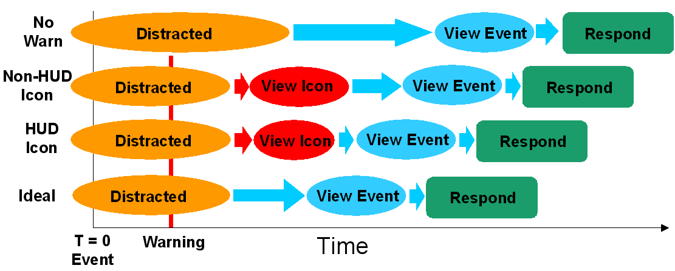

Figure 15. Conceptual diagram of a distracted driver responding to an imminent event.

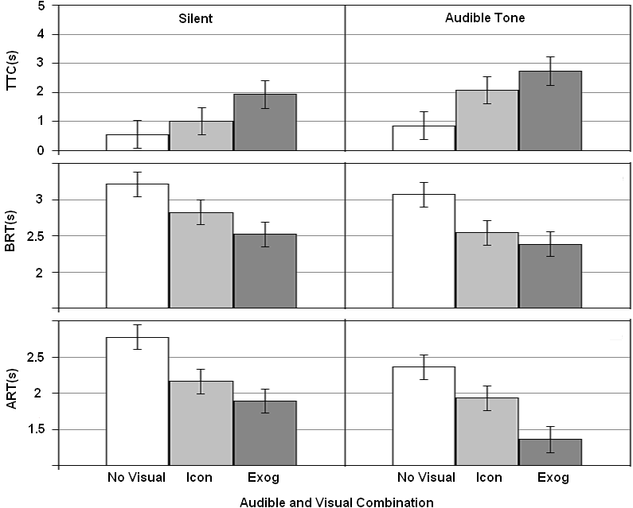
Figure 16. Accelerator Release Time (ART), Brake Reaction Time (BRT), and Time to Collision (TTC) as a function of combinations of using an audible tone and the three visual conditions: no visual display, an icon on a HUD (Icon) and the exogenous display (Exog).

Table 7. Auditory, visual, and haptic stimuli used for the FCW and LDW alerts
Warning System | Auditory cues | Visual cues | Haptic cues
Lane Departure warning | Emulation of rumble strip from speakers on relevant B-pillar | Exogenous Visual Display | Directional haptic vibration on driver seat pan
Forward Collision Warning | Short tone sequence from forward speakers | Exogenous Visual Display | None

4. ADAPTIVE SAFETY WARNING BENEFITS SUMMARY

The SAVE-IT Adaptive Warnings were evaluated in both Phases 2A and 2B. Whereas some studies focused on evaluating the potential for collision reduction, other studies focused more on the potential acceptance benefits. This section will summarize the potential benefits of the Adaptive Forward Collision Warning (AFCW) and Adaptive Lane Departure Warning (ALDW) systems that were revealed in these evaluations. This section will consist of two subsections:
- Collision-reduction Potential
- Alert Rates and Acceptance

4.1 Collision-reduction Potential

Driving Simulator Forward Collision Warning Results⁹
The fundamental principle behind adaptive warnings is that drivers who are attentive to driving do not benefit from warnings. To the extent that this true, negative adaptations (softening, delaying, or suppressing warnings) will not compromise safety. A between-subjects design factorially crossed three display alternatives (visual, visual-plus-auditory tone, and no warning) with the presence or absence of visual distraction to investigate the effect of two negative adaptation strategies on collision-reduction potential⁹ (see Table 3). Figure 17 displays the accelerator release times and crash velocities of these conditions.

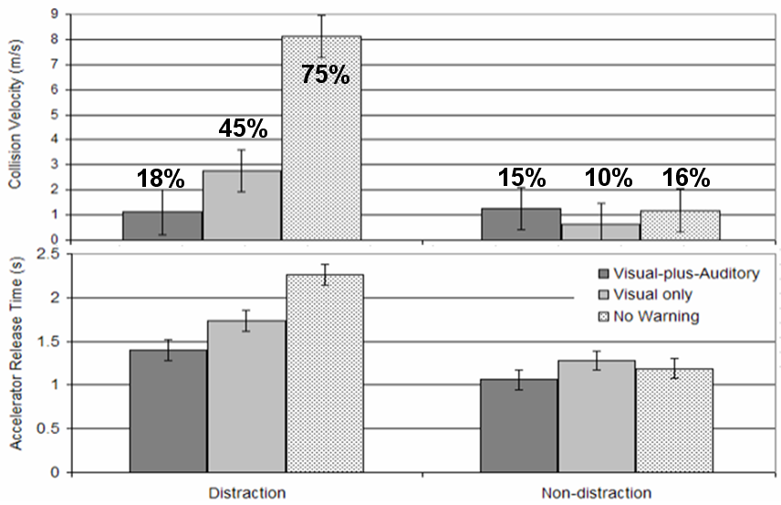
Figure 17. Accelerator Release Time (s) and Collision Velocity (m/s) as a function of warning type (Visual-plus-Auditory, Visual only, and No warning). Percentages represent crash rates.
Although the events displayed in Figure 17 were not based on real-time adaptation, two of the conditions represent the behavior of adaptive FCW systems. The non-distraction case presents two conditions that correspond to negative adaptations. Providing no warning for drivers who are not distracted represents an Alert Suppression strategy and providing a visual-only alert corresponds to the Differential Stimuli strategy. Figure 17 reveals that whereas the FCW alerts clearly benefited distracted drivers, they provided little benefit for attentive (non-distracted) drivers. This result suggests that, given attention to the forward roadway can be accurately assessed, the strategies of suppressing FCW completely (Alert Suppression) or suppressing the auditory component of the FCW stimulus (Differential Stimuli), are unlikely to compromise safety. Although it was beyond the scope of the SAVE-IT program, driver impairment (e.g., drowsiness) would also need to be monitored in a production system.

Neither of these specific adaptation strategies were used for FCW, however, the Alert Suppression strategy behaves like an extreme version of the Differential Timing strategy that was used. As the timing for non-distraction events is pushed back later and later, the conflict event is increasingly likely to be resolved prior to reaching the threshold. These data provide support for the concept of negative adaptation by demonstrating that attentive drivers do not appear to benefit from warnings, and thus these negative adaptations are unlikely to compromise the collision-reduction potential.

The Differential Timing strategy that was implemented for AFCW utilized both positive and negative adaptation. While the negative side (late alerts for attentive drivers) attempted to improve acceptance, the positive side (early alerts for distracted drivers) was designed to improve collision-reduction potential. To investigate whether earlier alerts can improve collision-reduction potential, a between-subjects experiment compared distracted drivers who received an early alert with distracted drivers who received a nominal alert⁹. Whereas the nominal alert case was designed to reflect a timing that is typical of current production FCW implementations, the early alert case provided FCW alerts 1 s earlier than the nominal case. The drivers who were alerted 1-s earlier, responded by braking 0.85 s earlier (p < 0.01), and the minimum time to collision was increased by 0.83 s (p = 0.09). An additional observation that did not reach statistical significance is that although two of the ten drivers in the nominal alert condition (FCW) crashed, there were no crashes in the early alert condition (AFCW). These results demonstrate how providing distracted drivers with earlier warnings can improve the collision-reduction potential.

Test Track Results^{14C}
The SAVE-IT program also investigated the collision-reduction potential of AFCW on a test track^{14C}. Within a series of drives, subjects were asked to enter a navigation destination into the SAVE-IT infotainment system. For each subject, the lead vehicle surrogate (see Figure 18) unexpectedly decelerated at a rate of 0.4 g during two of these destination-entry tasks. To insure that drivers were surprised by the events, only the 27 cases where the driver did not look up prior to the alert were evaluated. Figure 19 displays the statistically significant brake reaction time (BRT) result (p < 0.05), where the drivers with AFCW responded an average of 0.9 s earlier than the drivers with FCW. These test track experiments reveal that the SAVE-IT mechanisms provided inattentive drivers with additional time to respond in forward crash scenarios.

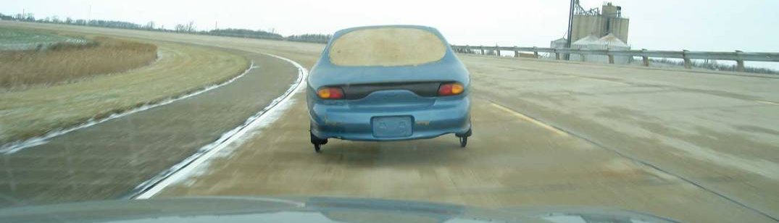
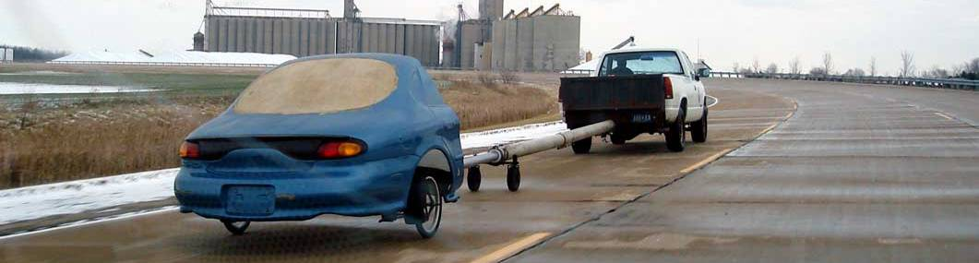
Figure 18. The surrogate target used in the Task 14C test track evaluation

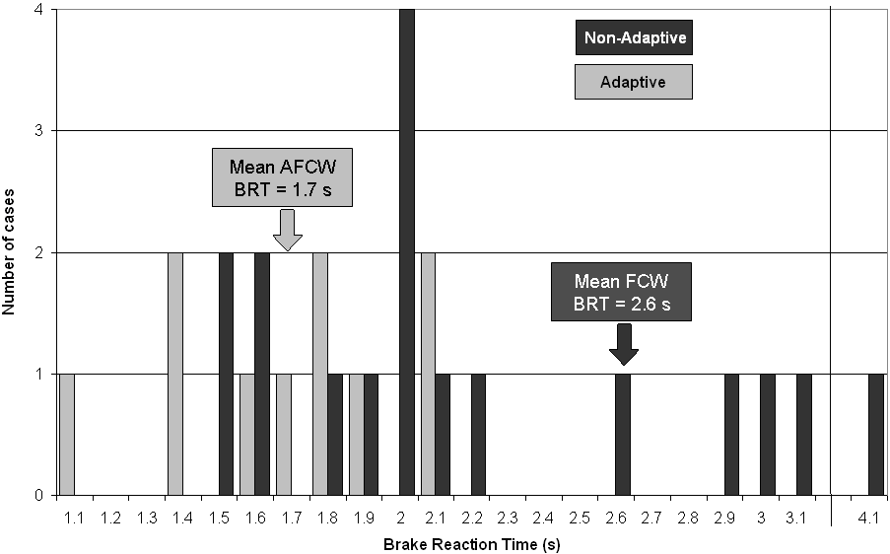

Figure 19. Test track evaluation of driver responses to the lead vehicle braking event.

4.2 Alert Rates and Acceptance
Test Track Results^{14C}
The drivers who experienced the lead vehicle braking events on the test track were exposed to the concept of adaptation for both AFCW and ALDW^{14C}. For LDW, drivers experienced scripted events that included: a non-adaptive nuisance LDW alert from a lane change, the ALDW suppression of nuisance alerts generated from lane changes, and ALDW alerts resulting from an extended non-forward head pose prior to crossing the lane marker. For FCW, in addition to experiencing two surprise braking events (one AFCW and one FCW) drivers experienced scripted events that included: non-adaptive alerts with the lead vehicle braking, non-adaptive nuisance alerts resulting from a lead vehicle changing lanes, and adaptive suppression of both lead vehicle braking and lead vehicle changing lane events. After these and other test track trials were completed, drivers were asked to rate the usefulness of the adaptive and non-adaptive systems. Figure 20 displays the Van der Laan usefulness ratings for the adaptive and non-adaptive versions of both FCW and LDW. Although the LDW trend did not reach statistical significance, the trend did reach statistical significance for FCW, where AFCW was rated as significantly more useful than FCW.

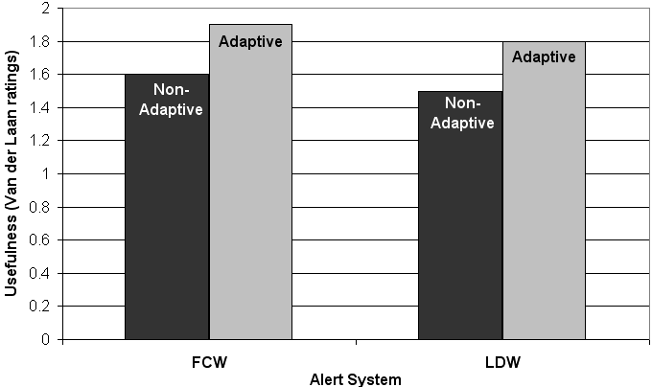

Figure 20. Usefulness Van der Laan ratings of Adaptive and Non-adaptive FCW and LDW.

Indiana On-road Results¹¹
On-road exposures were carried out both in Indiana¹¹ and in Michigan^{14C}. In Indiana, LDW and FCW exposures were conducted separately using different subjects in order to simplify the testing from the subject’s point of view. Earlier testing in SAVE-IT had revealed that the overall SAVE-IT system could be quite overwhelming for subjects during relatively brief exposures and that it helped if they could focus on just one aspect of the SAVE-IT systems. The pool of naïve participants (all Delphi employees who did not work on projects related to SAVE-IT content), included 14 drivers who experienced AFCW and FCW and 14 drivers who experienced ALDW and LDW. The FCW drives spanned approximately 120 mi per driver, and covered a route that favored conflict-rich small-city regions while avoiding long delays at intersections. The LDW drives spanned approximately 150 mi per driver, and covered a route that spanned four-lane rural highway, six-lane interstate, and four and six lane divided highway. In both cases, drivers spent half the drive in adaptive mode and half the drive in non-adaptive mode, with an order that was counterbalanced across subjects.

The drives revealed reductions in alert-frequency for the adaptive versions of both FCW and LDW. Drivers received significantly fewer alerts in the adaptive mode of both the FCW and LDW studies. The FCW and LDW warning systems demonstrated high adaptive suppression rates, approximately 70% (reducing from 7.5 to 2.2 alerts per 100 mi) and 95% (reducing from 7.8 to 0.4 alerts per 100 mi) respectively. Significantly more drivers expressed a preference for the adaptive mode in both studies (see Figure 21), and when they did so, the most common reason provided was the lower alert-rate. Ten out of the 14 FCW drivers preferred AFCW over FCW, with three drivers preferring the non-adaptive mode and one driver who was not sure. Whereas the 13 drivers who selected either AFCW or FCW as their preference all experienced fewer alerts in AFCW mode than FCW mode, the driver who did not make a choice received equal alerts during both segments of the drive. All 14 drivers in the LDW mode received more alerts in during the LDW portions that the ALDW portions, and 12 preferred ALDW and 2 preferred LDW. It appears that the difference in alert frequency between modes was the most salient aspect of both systems, and influenced several subjective ratings. The trend across both warning systems was for drivers to report that the adaptive warning system was more acceptable, had fewer nuisance alerts, and was less distracting.

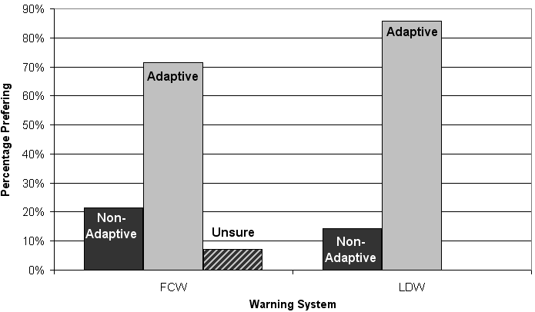
Figure 21. Preferences for Adaptive vs. Non-adaptive FCW and LDW systems.
Figures 22 and 23 plot the results of the questionnaires for FCW and LDW respectively and reveal a consistent trend of both adaptive and non-adaptive systems behaving as the driver’s expected, the adaptive versions improving the perception of whether the nuisance alert rate was acceptable, the adaptive mode improving their likelihood to recommend the system and the adaptive mode revealing no negative effect on the perception of whether the system enhanced safety.

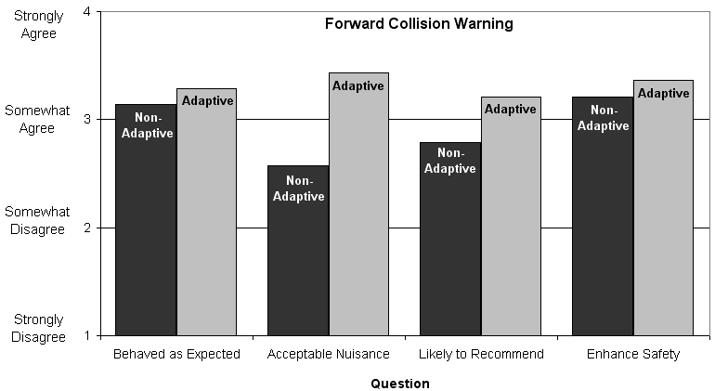
Figure 22. Subjective Adaptive vs. Non-Adaptive responses for FCW.

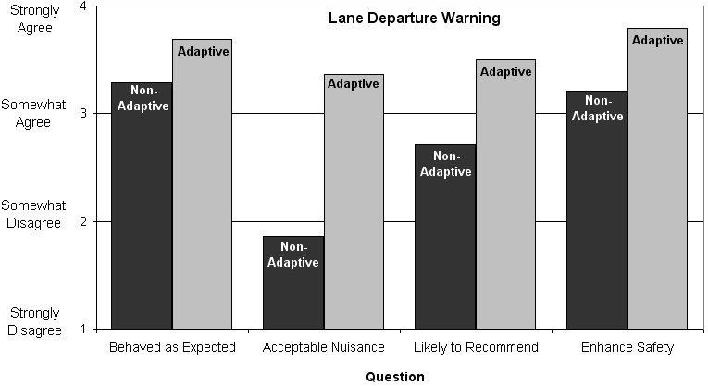
Figure 23. Subjective Adaptive vs. Non-Adaptive responses for LDW.
Michigan On-road Results ^{14C}
A subset (12 of 26) of the test-track drivers who experienced the surprise braking events, were exposed to 2000 miles of on-road driving several weeks later. These subjects drove a 84 mi route twice in the morning and in the afternoon. Approximately half of each drive was freeway and half was a mix of major and minor arterials, including urban, suburban, and rural roadways. During one drive the system was in adaptive mode and the other drive the system was in non-adaptive mode. The order was counterbalanced across subjects. Unlike the Indiana testing, drivers experienced both LDW and FCW simultaneously.

Figure 24 displays the alert rates for the adaptive and non-adaptive versions of FCW and LDW. The suppression rates are slightly smaller than the Indiana result, with ALDW suppressing at a rate of 88 % and AFCW suppressing at a rate of 60 %. Nine of the eleven drivers (one driver did not complete the second drive) received fewer alerts in during AFCW than FCW and all eleven drivers experienced the adaptive reduction for LDW.
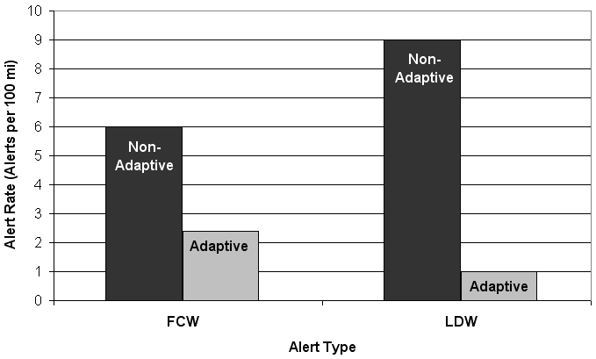
Figure 24. Suppression rates for Adaptive FCW and LDW systems in the Michigan drives.

For FCW, it was also observed that adaptive suppression tended to favor the more annoying alerts. Figure 25 displays the suppression rate for same-lane (when both vehicles stay in the same lane), multi-lane (when either host or lead vehicle changes lanes) and false alerts (when the lead vehicle is in an adjacent lane). Whereas only one third of the FCW alerts were same-lane events, two thirds of the AFCW alerts were same-lane events. This finding is important because it suggests that the AFCW alerts that are maintained are more likely to be useful to the driver and that the alerts that are suppressed were more likely to be perceived as a nuisance.

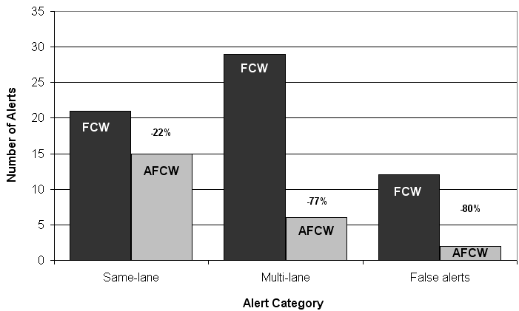
Figure 25. Suppression rates for Adaptive FCW in the Michigan drives by category.

It was also observed that had the FCW system been in non-adaptive mode during the adaptive drive, rather than 23 alerts, the driver would have received 71. Upon experimenter review, none of the 53 alerts that were suppressed by adaptation were classified as useful. Because of the earlier timing when the driver was looking away, the AFCW system introduced five alerts that would have not been presented by the FCW system, leaving 18 alerts that were common to both AFCW and FCW during the adaptive drive segments. The five alerts that were added were all events where the host approached the lead vehicle prior to a lane change, however, the subtractions far outweighed the additions and so the net effect was that alerts decreased in this category. Of the 18 common alerts, AFCW would have presented four earlier, three at the same time, and eleven later than the FCW system.

Despite many positive indications from the objective and subjective data, when drivers were asked whether they preferred the adaptive or non-adaptive system, no clear preference was observed. The majority of the drivers (6 of 11) indicated that they would like to have both adaptive and non-adaptive systems available on their vehicle and the preference for adaptive and non-adaptive systems was split evenly (2 each with 1 driver responding a preference for “other”). Whereas the Indiana drivers indicated a clear preference for the adaptive mode, these data suggested that having both systems available to the driver is desirable. There are many potential reasons for the discrepancy between the Indiana and Michigan preferences. The difference in the subject population between the Indiana and Michigan drivers may be one possible cause or perhaps the discrepancy results from the Michigan drivers experiencing the SAVE-IT systems simultaneously, potentially becoming overwhelmed. Another major difference is that the Indiana drivers were asked to select either adaptive or non-adaptive and did not have the option to select both as their preference. There were, however, other indications that suggest that a preference for the adaptive system might develop.

When asked whether they agreed that they would want the system on their next vehicle, subjects agreed significantly more for the AFCW system (near “strongly agree”: 1.27) than the FCW system (near “mildly agree”: 1.69). The breakdown of responses for both FCW and LDW is displayed in Figure 26, and reveals that the difference emerges from subjects who “strongly disagree” that they would want FCW (non-adaptive) on their next vehicle. Whereas no subjects disagreed (either “strongly” or “mildly”) that they would want AFCW, two of the twelve subjects “strongly disagreed”.

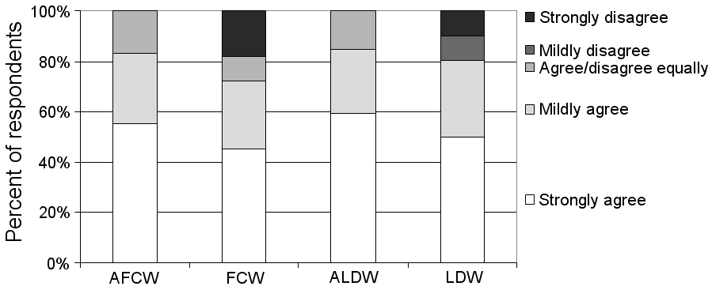
Figure 26. Agreement whether drivers want Adaptive and Non-adaptive systems on next cars.

The significant results for LDW subjective measures are displayed in Figure 27. When asked how often the system gave a warning that they felt was unnecessary, subjects perceived a significantly higher rate for LDW (above “occasionally”: 3.25) than ALDW (near “never”: 1.25). When asked whether the unnecessary alerts led to annoyance, subjects indicated a significantly higher level for LDW (above “mild”: 2.25) than ALDW (close to “none”: 1.09). After reviewing videos of the alert events that occurred during their drive, drivers agreed significantly more that alerts were useful for ALDW (near “mildly agree”: 2.16) than LDW (near “agree/disagree equally”: 3.27)

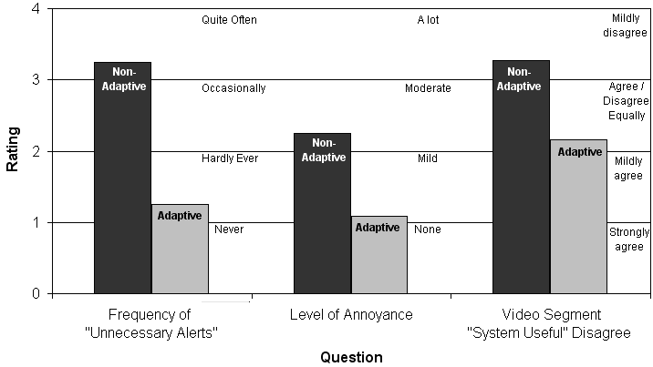
Figure 27. Subjective ratings for Adaptive and Non-adaptive LDW.

5. DISTraction mitigation benefits SUMMARY

The Distraction Mitigation benefits were evaluated in all phases of the SAVE-IT program. Although most of the studies focused on the acceptance of distraction mitigation, a smaller set of studies did evaluate the potential for collision reduction. This section will summarize the acceptance and the potential collision-reduction benefits of the Distraction Mitigation countermeasures. This section will consist of two subsections:
- Collision-reduction potential
- Acceptance

5.1 Collision-reduction potential⁴

Phase 1 driving-simulator research revealed that locking drivers out of a visually-distracting task can improve driver responses to lead vehicle braking events, revealing a statistically significant 1.87-s longer minimum time to collision when drivers were locked out of the visually-distracting task compared with when they were free to engage in the task⁴. However, the strategy of advising drivers against engaging in the visually-distracting task did not reveal any measurable benefit. The collision-reduction effectiveness of the adaptive phone management was not evaluated in the SAVE-IT program.

In Phase 1 and 2A, the SAVE-IT program examined the effectiveness of using concurrent (real-time) feedback to alert the driver of excessive levels of distraction. Although Phase 1 research demonstrated that distraction alerts could reduce the driver’s eyes-off-road glances, there was no evidence that this translated to a collision-reduction benefit. In fact, in some instances, there were slight increases in driver reaction times to lead vehicle braking events. This led to a concern that providing visual feedback regarding driver distraction might actually contribute additional visual distraction. Because the opportunity for communicating with drivers while they are engaged in the driving task is small and could potentially increase visual distraction, the SAVE-IT program also began looking at post-drive feedback (trip report). A driving simulator experiment evaluated the effectiveness of providing post-drive feedback (trip report) either alone or in combination with concurrent feedback (distraction alert). Figure 28 displays the effects of these types of feedback on the driver glance behavior. Although the combination of concurrent and post-drive feedback significantly increased the on-road glance duration on the first two trials, the effectiveness of this decreased over time. By the fourth drive, neither type of feedback appeared to significantly influence the driver’s glance behavior. Both types of feedback did, however, decrease brake reaction times (BRT) to a lead vehicle braking event after the post-drive feedback was displayed (see Figure 29). By the fourth drive, drivers in both of the post-drive feedback groups responded to the braking events significantly faster than the baseline group, whether post-drive feedback was accompanied with concurrent feedback or not. The fact that the addition of concurrent feedback provides little effect and that the significant BRT effect increases with exposure, strongly suggests that the post-drive
feedback is responsible for the measured collision-reduction potential.

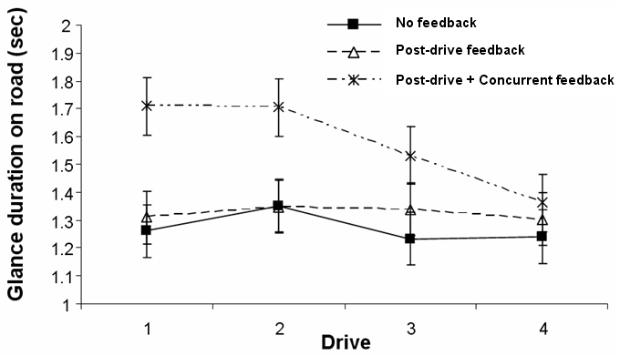
Figure 28. Glance duration on road as a function of feedback type (mean and standard error)

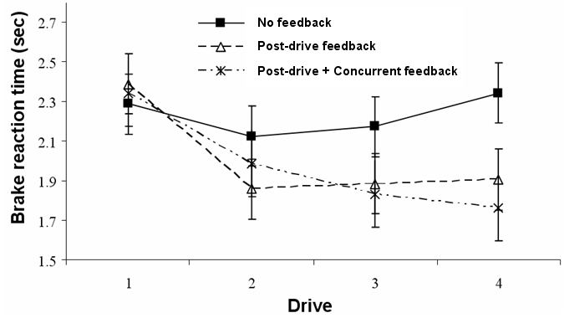
Figure 29. Brake reaction time to lead vehicle braking events (mean and standard error)

5.2 Acceptance
Driving Simulator Results⁴
Phase 2A evaluated the acceptance of the trip report and distraction alert features in one experiment and the advising and lock-out features in a separate experiment⁴. Figure 30 displays the Van der Laan scale responses from subjects for the dimensions of usefulness and satisfaction. It should be noted that these data represent only the responses of the middle age group (35 – 55) and that the responses from the older age group (65 – 75) were more favorable. This plot suggests that drivers perceived the trip report feature as being more useful than the other distraction mitigation strategies and drivers responded favorably on both dimensions of usefulness and satisfaction for the trip report feature. The distraction alert and advising adaptive features were rated as being closer to “useless” than “useful” and the lock-out feature was near the center of the scale. Although this analysis is qualitative in nature and includes comparisons across two different studies, it suggests that the trip report is a more promising strategy from a driver-acceptance standpoint.

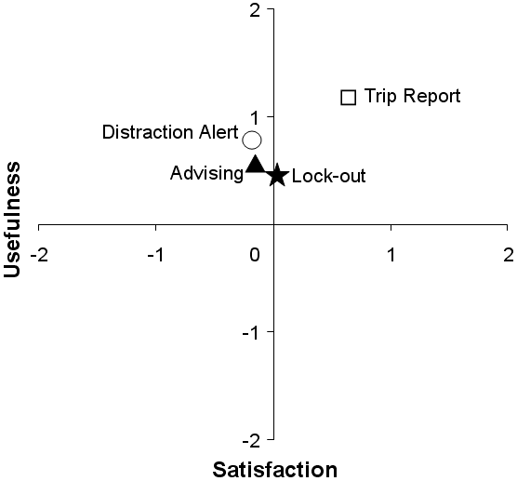

Figure 30. Usefulness and Satisfaction Van der Laan ratings for the Distraction Alert, Trip Report, Advising, and Lock-out features. The Distraction alert and Trip report values emerge from one experiment and represent the case where both features were presented to the driver (combined feedback)⁴. The Advising and Lock-out data emerged from a separate experiment and represent only the visually-oriented strategy responses from middle-aged drivers⁴.

On-road Results^{14C}
At various points of the Michigan drives, participants were asked to rate whether engaging in radio tuning, phone dialing, or destination entry tasks was safe, on a five-point scale ranging from “very safe” (1) to “very unsafe” (5). These data were collected to test the agreement between the subject’s rating of safety and the response of the adaptive infotainment feature advisory/availability system. Table 8 displays the subject ratings, the percentage of subjects who classified the task as “neither safe nor unsafe” (3), “safe” (4), or “very safe” (5), and the action taken by the adaptive system (allowed, advised against, or locked out).

Table 8. Driver perceptions of the safety of various Infotainment tasks compared with the actions taken by the distraction mitigation system.
Infotainment Task | Low Driving  Task Demand | Medium Driving  Task Demand | High Driving  Task Demand
Radio  Tuning | 1.8 (93%) | 1.9 (98%) | 2.5 (76%)
Radio  Tuning | Allowed | Allowed | Advised Against
Phone  Dialing | 2.4 (93%) | 3.1 (57%) | 3.7 (37%)
Phone  Dialing | Allowed | Advised Against | Locked Out
Destination Entry | 3.1 (65%) | 3.7 (31%) | 4.1 (18%)
Destination Entry | Advised Against | Locked Out | Locked Out
Note. The percentages in parentheses represent the number of participants who classified the task as not unsafe (between “very safe” and “neither safe nor unsafe”).

The distraction mitigation approach to advising or preventing the use of certain features was found to be quite compatible with the driver’s view of their own sense of safety with performing those tasks at the same moment. The perceptions of the drivers and the actions of the distraction mitigation system were highly correlated. When the average ratings were less than 2.5 (halfway between “somewhat safe” and “neither safe nor unsafe”) the infotainment features were allowed. When the average ratings where greater than 2.5 but less than 3.5 (halfway between “neither safe nor unsafe” and “somewhat unsafe”) the infotainment features were advised against. When the average ratings where greater than 3.5 the infotainment features were locked out. Although the linkage between the driver’s perceptions and distraction mitigation actions was strong, the distraction mitigation may have responded too cautiously compared to the perceived level of threat. For example, although 76% of participants rated radio tuning as being at least as safe as “neither safe nor unsafe”, the system advised against the task under high driving task demand. Thus, the magnitude of calibration may have been greater than most drivers prefer and the system may be more acceptable if the distraction mitigation interventions (advising against and locking out) were reserved for more threatening combinations of driving task demand and the demand of the infotainment features.

6. Conclusions

This section will conclude this final report by summarizing the major findings of the SAVE-IT program research, describing some of the lessons learned during the program, and suggesting some areas for future research to expand on what was learned. This section includes the following sections.
- SAVE-IT Program Findings
- Lessons Learned
- Future Research Needs

6.1 SAVE-IT Program Findings

The SAVE-IT program developed and investigated countermeasures that fall into two major categories: distraction mitigation countermeasures that seek to directly reduce the amount of distraction, and adaptive warnings that seek to reduce the negative impact of distraction. A range of distraction mitigation countermeasures were investigated in terms of collision-reduction effectiveness and driver acceptance. Real-time distraction feedback (distraction alert) and post-drive distraction feedback (trip report) were compared and it was found that providing a post-drive summary of safety-relevant events and behaviors (trip report) was effective at improving driver responses to imminent events on subsequent drives. The trip report also appeared to be viewed the most favorably by subjects, demonstrating the highest levels of satisfaction and perceived usefulness compared with the other distraction mitigation countermeasures. Trip report also has the advantage over real-time distraction feedback in that it does not have the potential to interfere with the driving task. The adaptive infotainment and availability countermeasures received lukewarm acceptance ratings but may be necessary to counteract the negative consequences of the proliferation of increasingly elaborate devices entering vehicles. A major limitation of this countermeasure is that it is unlikely to be an effective solution for nomadic devices unless some form of government mandate is in place requiring the interfaces of nomadic devices to be controlled by the vehicle. Of the distraction mitigation countermeasures that were tested in the SAVE-IT program, the trip report offers the greatest potential in terms of both collision-reduction effectiveness and driver acceptance.

The adaptive warning countermeasures included adaptive versions of both AFCW and ALDW. Like their non-adaptive counterparts, AFCW utilizes radar to sense obstacles in front of the host vehicle and alerts the driver when there is an imminent threat of collision, and ALDW utilizes vision processing to alert the driver when the host vehicle strays across a lane boundary. The adaptive versions of these countermeasures differ from the conventional systems in that they utilize information about the driver’s head pose in order to tailor the warnings to the driver’s visual attention. Research in the SAVE-IT program demonstrated that tailoring alerts to the driver’s visual distraction can help alleviate the tradeoff between providing sufficient warning during distracted episodes and annoying drivers when they do not need the warnings. By avoiding this tradeoff, the collision-reduction effectiveness of FCW was increased and the acceptance of both FCW and LDW was improved by reducing the number of alerts during periods of visually-attentive driving.

Due to the streamlining of the program in the second phase, the initial SAVE-IT task structure included tasks that did not directly impact the SAVE-IT systems. Cognitive Distraction⁵ was not included, because Phase 1 research was unable to develop a set of acceptable countermeasures for cognitive distraction^{4, 9} and because cognitive distraction could not be measured using technology that is likely to be affordable in the near future. However, the Cognitive Distraction task⁵ furthered the science of this area by developing some sophisticated algorithms for detecting when a driver is cognitively distracted. Research from this task also revealed some interesting interactions between visual and cognitive distractions and demonstrated that although cognitive distraction has relatively little impact on reactions to unpredictable events, the impact of cognitive distraction is much larger on reactions to more predictable events⁴.

6.2 Lessons Learned
The SAVE-IT program developed some effective protocols for investigating the potential of systems to reduce crashes. The driving simulator test protocol of the safety warnings task⁹ was efficient enough to support a completely between-subjects design, where drivers received only one imminent event, thus eliminating the risk of collecting driver responses that have been contaminated by past imminent events. An additional advantage of the between-subject approach is that comparisons can be more easily made to previously-collected conditions. Because this protocol reduced the time per subject down to less than half an hour, sixteen responses could be collected per eight-hour day. In the early stages of development, the driving simulator test protocols had a difficult time in coinciding imminent events with visual distraction and successfully surprising subjects. However, as the testing protocol matured, it became successful in surprising subjects. This protocol was refined throughout the SAVE-IT program and offers a mature testing methodology that can be used in future studies investigating the effectiveness of systems for reducing frontal collisions.

One of the major motivations for using the between-subjects methodology is that it does not require surprising drivers more than once. Prior to the evaluation phase of the program, it was assumed that it would be very difficult to surprise drivers more than once, especially on a test track where drivers often have a heightened level of arousal. However, the test track protocol developed by UMTRI was successful in surprising drivers not just once but also a second time. Although the protocol was not successful in surprising approximately half of the subjects, the success rate was higher on the second surprise event (59%) than on the first (47%). This is possibly due to the fact that drivers became increasingly comfortable with the vehicle and test track over time. The end result was that the methodology was successful in surprising 27 of 52 drivers and the methodology was sensitive to the difference in response times between adaptive and non-adaptive versions of FCW.

One of the more disappointing test methodologies of the SAVE-IT program was that used in one of the driving simulator evaluations^{14A}. In an effort to maximize resources, we exposed subjects to a wide range of systems in a relatively small space of time. Table 9 displays the table of conditions used in this evaluation, and reveals a relatively complex experimental design.

Table 9. Order of study drives and events
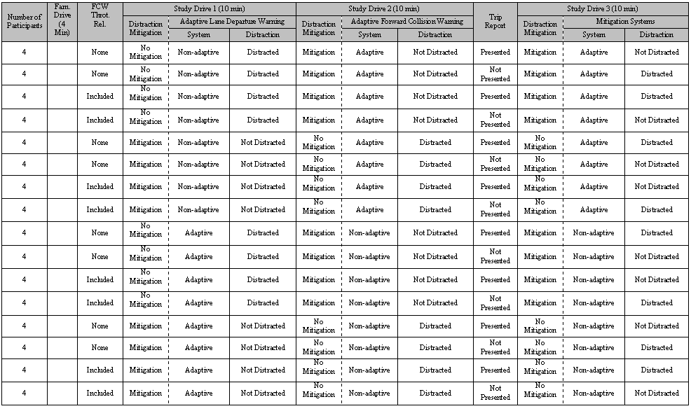

The variability present in the data appeared to be a major contributor to the lack of statistically significant results. A possible explanation for the high variability in the data was the complexity of the experimental design. Participants were presented with a great deal (alerts for lane departure, forward collision, and distraction mitigation warnings) in a short amount of time (three 10-minute drives) by a system with which they had just become familiar. The close temporal proximity of those interactions may have affected participant’s response to the system.

A similar phenomenon was observed in the early iterative stages of data fusion¹¹. Subjects, who had never experienced a collision warning system, were now experiencing more than one type of adaptive system before they could even appreciate the concept of the tradeoff between nuisance and early alerts. The responses of these subjects indicated that they were overwhelmed by these tests and led us to revise the test methodology and to separate the evaluations of AFCW, ALDW, and the distraction mitigation countermeasures for this task¹¹. The major lesson that was learned through this process was to keep the studies simple and rather than cramming as much into one large test, it appears better to use a series of simpler tests, that when combined provide the complete picture.

6.3 Future Research Needs
In order for adaptive infotainment management to have a substantial impact on driving safety, the issue of nomadic devices must be resolved. In Europe, the AIDE (Adaptive Integrated Driver-vehicle interface) Program has begun to address this issue by bringing together the manufacturers of nomadic devices in a forum, which is investigating how best to integrate nomadic devices with vehicle platforms. If the driver-vehicle interface can take control of nomadic devices, the role of adaptive infotainment management can be greatly expanded. The alternative may be that if drivers prefer not to be locked out of various infotainment functions, they may bring in nomadic devices that offer unconstrained access to the functions. This may limit the salability of such adaptive systems.

The trip report appears to offer great promise, however, in the SAVE-IT program drivers were forced to be exposed to it. In reality, the trip report is a voluntary measure that emerges at the conclusion of the drive. In many cases, the driver may lack the time required to digest the information. The challenge will be to capture the driver’s curiosity, such that they voluntarily digest the information that is provided to them at the conclusion of each trip. Some potential solutions for this might be providing fuel economy information in conjunction with the safety information, and possibly e-mailing the information to the driver so that it can be digested at a more convenient time. A combination of field operational testing and widespread questionnaires is likely to be the most effective way for answering these questions. Another potential issue with the trip report is that the notion of storing safety-relevant information on the vehicle may be met with resistance. Allowing drivers exclusive ownership of this data or enabling drivers to delete this information or to delete data on impact might be potential solutions for this problem.

The greatest benefit of trip report will be realized if it can be tied into some kind of tangible incentive for the driver. For example, there is precedent for drivers voluntarily allowing insurance companies to monitor their driving in exchange for potentially reduced insurance rates. If a clear link can be established between the information monitored by the trip report (such as safety warning events and driver head pose) and likelihood of crashing, insurance companies may be able to offer insurance premium discounts, providing a financial incentive for safer driving.

The SAVE-IT program has revealed many findings in the area of both adaptive and conventional collision warning systems, however, even when this research and the research of many other informative programs, such as the 100 Car Study, are considered, there are still many questions that remain. A key area in need of development is the validation of efficient driving simulator test protocols for measuring collision-reduction potential. SAVE-IT has provided some initial steps in the process of developing efficient driving simulator test protocols, however, more work remains in mapping the results of driving simulator test protocols to the collision-reduction effectiveness on real roadways. Furthermore, as warning systems increasingly penetrate the market, unless standards are put into place, there will be a wide range of approaches adopted by different OEMs. In order to avoid confusing the driver and potentially delaying the driver’s response, there will be a growing need for standardization of the human machine interface. More research is required, balancing the constraints of cost, collision-reduction potential, and acceptance before such a standard can be created.

Another relevant research activity is the investigation of the human factors issues that surround semi-autonomous vehicles. We are entering a period of time where semi-autonomous vehicles will be available and permitted on public roads. These systems will require that the driver perform a supervisory role and be ready to intervene when a situation develops that is beyond the automation capability. These situations may be ones that the system can recognize; however, there may be situations where the driver must intervene without a warning from the system. The need for monitoring the driver is likely to expand as a result. Research is required to identify effective adaptive mechanisms to support the interaction between driver and automation. Understanding the issues of semi-autonomous vehicles will be a crucial step in addressing the next generation of alerts. As the industry continues to deploy increasing levels of automation, the driver’s role will transform into a supervisory role that will require a different nature of alert. Thus, the interaction between collision warnings and autonomous systems will become increasingly important. Already on roadways today, FCW interacts with adaptive cruise control. For example, in the ACAS FOT program, the warning algorithm was different when adaptive cruise control was engaged. Rather than providing warning based on the constraints of the driver’s reactive capabilities, the alerts were based on the braking authority of the vehicle. As the role of automation expands in the next decades, it is this type of “driver intervention required” alert that will become increasingly important.

Acknowledgments
This research was conducted as part of the SAVE-IT program by Delphi Electronics and Safety in collaboration with the University of Michigan Transportation Research Institute (UMTRI) and the University of Iowa, sponsored by the U.S. Department of Transportation, National Highway Traffic Safety Administration (NHTSA), Office of Vehicle Safety Research, and administrated by the Volpe Center. The authors gratefully acknowledge Mike Perel and Eric Traube of NHTSA, and Mary Stearns and Tom Sheridan of Volpe for their assistance and guidance in this program.

References
1. Eby, D. W. & Kostyniuk, L. P. (2004). Safety Vehicle(s) using adaptive Interface Technology (SAVE-IT) Task 1 Final Report: Crashes and Driver Distraction: A review of Databases, crash scenarios, and distracted-driving scenarios. http://www.volpe.dot.gov/hf/roadway/saveit/docs/dec04/litrev_1.pdf
2. Eby, D. W. & Kostyniuk, L. P. (2004). Safety Vehicle(s) using adaptive Interface Technology (SAVE-IT) Task 2a Report: Using Michigan Highway Safety Information System (HSIS) Data for Estimating Driving Task Demand. http://www.volpe.dot.gov/hf/roadway/saveit/docs/dec04/finalrep_2a1.pdf
3. Zylstra, B., Tsimhoni, O., Green, P., & Mayer, K. (2004). Safety Vehicle(s) using adaptive Interface Technology (SAVE-IT) Task 3b Report: Driving Performance for Dialing, Radio Tuning, and Destination Entry while Driving Straight Roads. http://www.volpe.dot.gov/hf/roadway/saveit/docs/dec04/finalrep_3b.pdf
4. Donmez, B., Boyle, L., & Lee, J. D. (2007). Safety Vehicle(s) using adaptive Interface Technology (SAVE-IT) Task 4 Final Report: Distraction Mitigation Evaluation. http://www.volpe.dot.gov/hf/roadway/saveit/docs/phase2/distraction-mitigation-evaluation-final.doc
5. Lee, J., Reyes, M., Liang, Y., Lee, Y. (2007). Safety Vehicle(s) using adaptive Interface Technology (SAVE-IT) Task 5 Final Report: Algorithms for Cognitive Distraction. http://www.volpe.dot.gov/hf/roadway/saveit/docs/phase2/allgorithms-cognitive-distraction.doc
6. Lee, J. D., Hoffman, J. D., Bricker, D., & Sohn, H. (2007). Safety Vehicle(s) using adaptive Interface Technology (SAVE-IT) Task 6 Final Report: Telematics Demand.
7. Zhang, H., Smith, M. R. H., & Dufour, R. (2008). Safety Vehicle(s) using adaptive Interface Technology (SAVE-IT) Task 7 Phase 1 Report: Visual Distraction.
8. Smith, M. R. H. & Zhang, H. (2004a). Safety Vehicle(s) using adaptive Interface Technology (SAVE-IT) Task 8 Phase 1 Report: Intent, http://www.volpe.dot.gov/hf/roadway/saveit/docs/dec04/finalrep_8b.pdf
9. Smith, M. R. H., Bakowski, D. L., & Witt, G. J. (2008). Safety Vehicle(s) using adaptive Interface Technology (SAVE-IT) Task 9 Final Report: Safety Warning Countermeasures. http://www.volpe.dot.gov/hf/roadway/saveit/docs/dec04/finalrep_9b.pdf
10. Scharenbroch, G. K. (2005). Safety Vehicle(s) using adaptive Interface Technology (SAVE-IT) Task 10 Technology Review, http://www.volpe.dot.gov/hf/roadway/saveit/docs/dec04/finalrep_10.pdf
11. Smith, M. R. H., Bakowski, D. L., Witt, G. J., & Zhang, H. (2008). Safety Vehicle(s) using adaptive Interface Technology (SAVE-IT) Task 11 Final Report: Data Fusion. http://www.volpe.dot.gov/hf/roadway/saveit/docs/datafus_rep.doc
12. Lee, J. D., & McGehee, D. (In Preparation). Safety Vehicle(s) using adaptive Interface Technology (SAVE-IT) Task 12 Final Report: Standards and Guidelines, Design Seeds for Future Consideration
13. Prieto, R., Newman, T. J., Sovacool, R., M., Smith, M. R. (2008). Safety Vehicle(s) using adaptive Interface Technology (SAVE-IT) Task 13 Final Report: System Integration. http://www.volpe.dot.gov/hf/roadway/saveit/docs/systemint_rep.doc
14A. Brown, T., Marshall, D., Moeckli, J., & Smyser, T. (2007). Safety Vehicle(s) using adaptive Interface Technology (SAVE-IT) Task 14A Final Report: Driving Simulator Evaluation at the National Advanced Driving Simulator.
14B. In Preparation
14C. Leblanc, D., Eby, D. W., Bareket, Z., & Vivoda, J. M. (2008). Safety Vehicle(s) using adaptive Interface Technology (SAVE-IT) Task 14C Final Report: Evaluation of the SAVE-IT Vehicle Prototype.
15. Dingus, T. A., Klauer, S. G., Neale, V. L., Petersen, A., Lee, S. E., Sudweeks, J., Perez, M. A., Hankey, J., Ramsey, D., Gupta, S., Bucher, C., Doerzaph, Z. R., Jermeland, J., & Knipling, R. R. (2006). The 100-Car Naturalistic Driving Study: Phase 1I - Results of the 100-Car Field Experiment, NHTSA DTNH22-00-C-07007.
16. National Highway Transportation Safety Administration (2007).Traffic Safety Facts 2006. A Compilation of Motor Vehicle Crash Data from the Fatality Analysis Reporting System and the General Estimates System.
www-nrd.nhtsa.dot.gov/Pubs/TSF2006FE.PDF
17. Smith, M. R. H. (2002). Automotive Collision Avoidance System Field Operational Test: Warning Cue Implementation Summary Report. Washington D.C.: U.S. Department of Transportation, report no. DOT HS-809-462.
http://www-nrd.nhtsa.dot.gov/pdf/nrd-12/acas/ACAS-Interim-2002-05.pdf
18. National Highway Transportation Safety Administration (2005). Automotive Collision Avoidance System Field Operational Test: Final Program Report (No. DOT HS 809 886). Washington, DC: National Highway Traffic Safety Administration.
http://www-nrd.nhtsa.dot.gov/pdf/nrd-12/acas/809900All.pdf

19. Smith, M. R. H., Witt, G. J., Bakowski, D. L., Leblanc, D., & Lee, J. D. (In press). The adaptation of collision warnings to the driver’s visual orientation. In Regan, M.A., Lee, J.D. & Young, K.L. (Eds) (2008). Driver distraction: Theory, Effects and Mitigation. Florida, USA: CRC Press.
20. Campbell, B. N., Smith, J. D., & Najm, W. G. (2003). Examination of Crash Contributing Factors Using National Crash Databases. National Highway Transportation Safety Administration Report, Washington DC. DOT HS 809 664.
21. Lees, M. N. & Lee, J. D. (in preparation). Alarm Context Influences Trust in Collision Warning Systems and Affects How Drivers Respond to Critical and Non-Critical Events.
22. Bliss, J., Dunn, M., & Fuller, B. S. (1995). Reversals of the cry-wolf effect: An investigation of two methods to increase alarm response rates. Perceptual and Motor Skills, 80, 1231-1242.
23. Bliss, J., & Acton, S. A. (2003). Alarm mistrust in automobiles: how collision alarm reliability affects driving. Applied Ergonomics, 34, 499-509.
24. Young, K.L., Regan, M.A., Triggs, T.J., Tomasevic, N., Stephan, K. & Mitsopoulos, E. (2007). Impact on Car Driving Performance of a Following Distance Warning System: Findings from the Australian TAC SafeCar Project. Journal of Intelligent Transportation Systems (In Press).
25. Klauer, S. G., Dingus, T. A., Neale, V. L., Sudweeks, J., and Ramsey, D. J. (2006). The Impact of Driver Inattention on Near-Crash/Crash Risk: An Analysis Using the 100-Car Naturalistic Driving Study Data. Virginia Tech Transportation Institute. National Highway Traffic Safety Administration. DOT HS 810 594. Washington, DC. Retrieved from: http://www-nrd.nhtsa.dot.gov/departments/nrd-13/driver distraction/PDF/DriverInattention.pdf
26. Theeuwes, J. (1991). Exogenous and Endogenous Control of Attention - the Effect of Visual Onsets and Offsets. Perception & Psychophysics, 49(1), 83-90.

* Police-reported collisions are expected in the United States at a rate of 2.0 per million miles¹⁶.

