SAVE-IT

A Final Report of
SAfety VEhicles using adaptive Interface Technology (Phase II: Task 13):
System Integration

Prepared by:

Ray Prieto
Timothy J. Newman
Robert M. Sovacool
Matthew R. Smith

Delphi Electronics & Safety Systems
Phone: (765)-451-9366
Email: ray.prieto@delphi.com

January 2008

Table of Contents

13.0. EXECUTIVE SUMMARY 3
11.1. PROGRAM OVERVIEW 6
11.2. Introduction 7
11.3. Sub-System Descriptions 8
11.3.1. Central Interaction Manager (CIM) sub-system 8
11.3.3. Lane Departure Warning (LDW) sub-system 10
11.3.4. Driver State Monitor (DSM) sub-system 11
11.3.5. In-Vehicle Infotainment System (IVIS) sub-system 12
11.3.6. Data Collection sub-system 14
11.4. Vehicle Systems Integration 15
11.4.1. OEM Vehicle Sub-Systems Integration 15
11.4.2. Active Safety Sub-Systems Integration 17
11.4.3. Adaptive Alerts and Driving Task Demand Sub-Systems Integration 18
11.4.4. Power Moding Sub-Systems Integration 19
11.4.5. Diagnostic Sub-Systems Integration 20
11.5. Simulator Systems Integration 21
11.6. Conclusion 22

13.0. EXECUTIVE SUMMARY

The objective of Task 13 (System Integration) is to provide two system versions that implement the variety of technologies studied in this program in order to provide Distraction Mitigation and Adaptive Safety Warning countermeasures as defined in the previous tasks. The first version is a road-worthy architecture that allows in-vehicle testing of all systems by a driver while both video and data of the events are recorded for further study and evaluation. The second version is a subset of the first, developed for a driving simulator environment for similar testing, with the vehicle feedback being replaced by simulator CAN messages.

Vehicle System
The feature content of the vehicle system is shown in Figure 13.1. It consists of several sub-systems that communicate over a 500K CAN bus. These sub-systems are briefly described below.

Adaptive Cruise
Control Module (ACM)
for Forward Collision
Warning (FCW)
Over Shoulder
Data Collection
Camera
Matrox Vision System for Lane Departure Warning (LDW)
Haptic Seat
(L/R cue)
3-D Audio
Cueing
(F/L/R)
Exogenous
Display
Central Interaction Manager
(CIM) Fusion Processor
In-Vehicle
Infotainment
System (IVIS)
Computer
IVIS Control Head
Driver State Monitor
Camera and LED’s
Driver State
Monitor Computer
Forward Looking
Radar (FLR)
(100m range)
Data Collection
Rear-Facing
Cameras (L/R)
Lane Departure Warning
Forward-Looking Camera
Rear Looking
Data Collection
Camera

Figure 13.1. SAVE-IT Vehicle Distraction Mitigation and Enhanced Safety Warning Content.

Forward Collision Warning (FCW) sub-system: The combination of a 100 meter forward looking radar (FLR) in the grill of the vehicle and an adaptive cruise control module (ACM) in the trunk of the vehicle provide the basis for identifying, tracking, and prioritizing up to 20 moving and 20 stationary objects in the vehicle’s path. This information is then sent via CAN bus to the Central Interaction Manager (CIM) every 100 msec to calculate the appropriate threat assessment and control specific countermeasures. Countermeasures include an exogenous display in the dash of the vehicle that flashes to alert the driver of an object in the vehicle’s path and a center speaker in the dash to also give the driver an audible warning.

Lane Departure Warning (LDW) sub-system: The combination of a forward-looking camera behind the front windshield of the vehicle and a Delphi vision system in the trunk of the vehicle provide the basis for identifying and tracking lane markers on the road and also calculating the vehicle’s position and drift with respect to those lane markers. This information is then sent via CAN bus to the CIM every 100 msec to control the specific countermeasures. Countermeasures include a haptic seat cushion that is located on the driver’s seat with left and right motors to alert the driver that the vehicle has crossed the left or right lanes, and left and right speakers in the B-pillars to provide an audible warning.

Driver State Monitor (DSM) sub-system: The combination of a DSM computer below the glove compartment of the vehicle and an infra-red camera and LED housing facing the driver from the instrument panel of the vehicle form the basis for identifying, tracking, and monitoring the driver’s state. The DSM monitors the driver’s head pose direction to determine their degree of alertness or distraction. This information is then sent via CAN bus to the CIM every 33 msec to calculate the appropriate threat assessment and control specific countermeasures. As an adaptive system, this information can be used to suppress an alert to the driver when an attentive driver state is detected, or to alert the driver more quickly when a distracted driver state is detected. Driver head pose is also used to provide post-drive feedback in the Trip Report countermeasure.

In-Vehicle Infotainment System (IVIS) sub-system: The combination of an IVIS touch-screen control head in the center instrument panel of the vehicle and an IVIS computer in the trunk of the vehicle form the basis for providing the driver with a customizable interactive infotainment system that can limit usage based on the driving task demand level. The IVIS control head can display screens for radio, CD/MP3, navigation, phone, text messaging and audio settings. The IVIS computer also receives a CAN message from the CIM every 100 msec, updating the driver’s demand level, so the IVIS can suggest by button color that certain buttons not be used or lock them out entirely. All button presses are sent via CAN bus so they can also be recorded.

Central Interaction Manager (CIM) sub-system: The CIM is essentially the central brain of the overall system that keeps track of all inputs from sub-systems and the vehicle to make decisions as to the threat assessment at any particular time and control the appropriate countermeasures. It is also responsible for power-moding all of the sub-systems, which provides turn-key functionality.

Data Collection sub-system: During Delphi’s iterative testing for Task 11, a laptop equipped with a Vector CANcard and a video capture card forms the basis for monitoring and recording all CAN bus data and video data during a drive for subsequent study and evaluation. The vehicle is equipped with five cameras that can provide video for recording (forward looking, rear looking, left and right rear-facing and over the shoulder), and both private and public CAN busses. UMTRI is installing their own data acquisition system that will capture the video and CAN data for Task 14c.

Simulator System
The simulator system is a subset of the vehicle system, but with some of the hardware and vehicle feedback being replaced by simulator CAN messages. A block diagram containing the simulator system components and their approximate sizes is shown in Figure 13.2 below. The left box shows the components that are also a part of the vehicle system, and the right box show the signals that now have to be simulated as CAN messages from the simulator. The vehicle feedback signals that were read as Class2 messages, such as wipers, turn signals, brake, photocell, etc., now are simulated as CAN messages, and since there is no hardware for FCW or LDW in the simulator system, these signals also are simulated as CAN messages.

Figure 13.2. SAVE-IT Simulator Distraction Mitigation and Enhanced Safety Warning Content.

11.1. PROGRAM OVERVIEW

Driver distraction is a major contributing factor to automobile crashes. The National Highway Traffic Safety Administration (NHTSA) has estimated that approximately 25% of crashes are attributed to driver distraction and inattention (Wang, Knipling, & Goodman, 1996). Recent estimates from the 100-Car study suggest that distraction may contribute to more than three quarters of all crashes (Dingus, Klauer, Neale, Petersen, Lee, Sudweeks, Perez, Hankey, Ramsey, Gupta, Bucjer, Doersaph, Jermeland, & Knipling, 2006). The issue of driver distraction may become more critical in the coming years because increasingly elaborate electronic devices (e.g., cell phones, navigation systems, wireless Internet and email devices) are being brought into vehicles that may further compromise safety. In response to this situation, the John A. Volpe National Transportation Systems Center (VNTSC), in support of NHTSA's Office of Vehicle Safety Research, awarded a contract to a diverse team led by Delphi Electronics & Safety including Ford, the University of Michigan Transportation Research Institute (UMTRI) and the University of Iowa. The goal of this program was to develop, demonstrate, and evaluate the potential safety benefits of adaptive interface technologies that manage the information from in-vehicle systems based on real-time monitoring of the roadway and the state of the driver. The contract, known as SAfety VEhicle(s) using adaptive Interface Technology (SAVE-IT), is designed to mitigate distraction with effective countermeasures and enhance the effectiveness of safety warning systems.

The SAVE-IT program serves several important objectives. Perhaps the most important objective is that of demonstrating a viable proof of concept that is capable of reducing distraction-related crashes and enhancing the effectiveness of safety warning systems. Program success is dependent on integrated closed-loop principles that incorporate the state of the driver. This closed-loop vehicle system is achieved by measuring the driver’s state, assessing the situational threat, prioritizing information presentation, providing adaptive countermeasures to minimize distraction, and optimizing collision warning systems.

11.2. Introduction

The objective of Task 13 (System Integration) is to provide two system versions that implement the variety of technologies studied in this program in order to provide Distraction Mitigation and Adaptive Safety Warning countermeasures as defined in the previous tasks. The first version is a road-worthy architecture that allows in-vehicle testing of all systems by a driver while both video and data of the events are recorded for further study and evaluation. The second version is a subset of the first, developed for a driving simulator environment for similar testing, with the vehicle feedback being replaced by simulator CAN messages. This document provides a description of the vehicle from a hardware/systems perspective. For a more complete description of the human machine interfaces and the rationale behind them, please refer to the companion SAVE-IT documents that describe the other SAVE-IT tasks. The overview of the feature content of the vehicle sub-systems is shown below in figure 13.3.

3-D Audio
Cueing
(F/L/R)
Exogenous
Display
Central Interaction Manager
(CIM) Fusion Processor
Driver State Monitor
Camera and LED’s
Driver State
Monitor Computer
Forward Looking
Radar (FLR)
(100m range)
Adaptive Cruise
Control Module (ACM)
for Forward Collision
Warning (FCW)
Over Shoulder
Data Collection
Camera
Data Collection
Rear-Facing
Cameras (L/R)
Lane Departure Warning
Forward-Looking Camera
Rear Looking
Data Collection
Camera
Haptic Cueing (L/R)
IVIS Control Head

In-Vehicle
Infotainment
System (IVIS)
Computer

Vision System for Lane Departure Warning (LDW)

Figure 13.3. SAVE-IT Vehicle Distraction Mitigation and Adaptive Safety Warning Content.

11.3. Sub-System Descriptions

The SAVE-IT system consists of several sub-systems that communicate either over discrete connections, Class 2 bus, or one of two 500K CAN buses. These individual sub-systems are described in more detail below.

11.3.1. Central Interaction Manager (CIM) sub-system
The CIM is essentially the central brain of the overall SAVE-IT system. It keeps track of all inputs from sub-systems and the vehicle to make threat assessment decisions and controls the appropriate countermeasures. It is also responsible for power-moding all of the sub-systems, which provides turn key functionality.

CIM Internal Hardware
Internally, the CIM is built around a Freescale S12 processor for ease of programmability and for the number and flexibility of its input and output ports. The S12 processor simultaneously allows for two 500K CAN busses, a Class 2 bus, an RS-232 serial interface and for multiple discrete inputs and outputs. These discrete inputs and outputs are further expanded by the use of an external SPI controlled I/O port expander, discrete output buffers and input protection circuits. The S12 also runs a set of eight LEDs that provide diagnostic indicators of each major sub-system. A block diagram of the internal CIM components is shown in Figure 13.4 below.

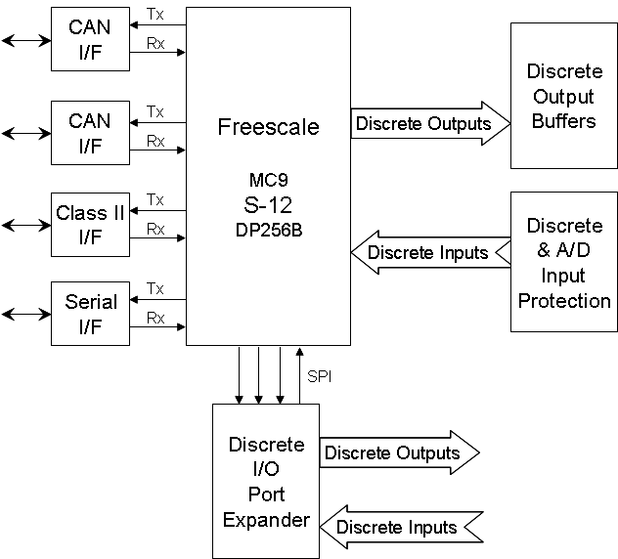

Figure 13.4. CIM Internal Hardware.
11.3.2. Forward Collision Warning (FCW) and Proximity Alert (PA) sub-system

The Forward Collision Warning (FCW) and Proximity Alert (PA) sub-system is made up of four major pieces of hardware; a forward looking radar, an adaptive cruise control module, the central interaction monitor and the audible and visible warnings to the driver. The forward looking radar and the adaptive cruise control module talk to each other via a high speed private CAN bus, which the CIM listens to in order to receive the information required to create audible and visible warnings to the driver via discrete connections.

Forward-Looking Radar (FLR)
The forward-looking radar is of a mechanically scanning type with a range of 100 meters. It is located in the grill of the vehicle and scans from -12.8 degrees to 12.7 degrees in front of the vehicle every 100 msec, looking for moving and stationary objects. The FLR then reports the closest 20 moving and closest 20 stationary objects it finds, along with their range from the vehicle and range rate, over the private CAN bus to the Central Interaction Monitor and the Adaptive Cruise Control Module for further processing. In order to provide a relatively low nuisance alert rate on roadways, the SAVE-IT project is only using the moving object information, but the FLR is also capable of identifying the stationary objects in the vehicle’s path.

Adaptive Cruise Control Module (ACM)
The adaptive cruise control module is located in the trunk of the vehicle and receives information over the private CAN bus from the FLR regarding the closest 20 moving and closest 20 stationary objects in front of the vehicle. It selects the primary in-path moving and stationary targets. It also sends the FLR and CIM information regarding the host vehicle speed, and estimates of the vehicle yaw rate and the radius of curvature of the path of the host vehicle. The speed and range rate of the objects in the vehicle’s path is also used to create a proximity alert for the driver when he is following the car ahead too closely.

Exogenous Visible Warning
The exogenous display is located in the dash of the vehicle, centerline with the driver, so that its two high-intensity LED’s will reflect on the windshield in the line of sight of the driver. It is controlled by the CIM via discrete connections. For the FCW sub-system, the exogenous display flashes a bright red LED three times to warn the driver of a possible forward collision ahead. For the PA sub-system, the exogenous display maintains a dimmer steady amber LED to warn the driver of close proximity to the lead vehicle.

Directional Audible Warnings
The directional audible warnings come from three speakers in the cabin and are controlled by the CIM via discrete connections. The center speaker is located in the center top of the dash and represents a warning in front of the vehicle. The left and right speakers are located in the B-pillars and represent warnings to the left and right of the vehicle, respectively. For the FCW sub-system, the center speaker plays a short tone four times to warn the driver of a possible forward collision ahead.

11.3.3. Lane Departure Warning (LDW) sub-system

The Lane Departure Warning (LDW) sub-system is made up of four major pieces of hardware; a forward looking camera, a Matrox vision processor, the central interaction monitor and the audible, visible, and haptic warnings to the driver. The forward looking camera feeds its NTSC video signal to the Matrox vision processor for analysis, which then communicates to the CIM via the public high speed CAN bus so it can create audible, visible and haptic warnings to the driver via discrete connections.

Forward-Looking Camera
The forward-looking camera is located behind the rear-view mirror, facing the road ahead of the host vehicle. It is a common off-the-shelf black and white bullet camera with an NTSC output that is fed to the Matrox vision processor. Its only requirement is to be able to see the horizon in addition to the host vehicle and lane boundaries ahead.

Matrox Vision Processor
The Matrox vision processor is a computer located in the trunk of the vehicle. It receives the NTSC video signal from the forward-looking camera and performs an analysis on it, frame by frame. It calculates the lane width, right and left lane offsets from the host vehicle and the lateral rate of the host vehicle, and sends this information to the CIM every 100 msec for further processing via the high speed public CAN bus. Although not used in the SAVE-IT project, the Matrox vision processor is also capable of providing other information, such as right or left lane crossing, right and left lane boundary type, road curvature, pitch and pan angle.

Exogenous Visible Warning
For the LDW sub-system, the exogenous display flashes a bright red LED three times to warn the driver of a possible left or right lane boundary crossing.

Directional Audible Warnings
For the LDW sub-system, the left speaker plays a short tone four times to warn the driver of a left lane boundary crossing and the right speaker plays a short tone four times to warn the driver of a right lane boundary crossing.

Haptic Seat Warning
The haptic seat warning was accomplished by overlaying the driver’s seat with a haptic device that allowed vibrators to be activated only on the left side, or only on the right side. The left and right vibrators are controlled by the CIM via discrete connections and represent warnings to the left and right of the vehicle, respectively. For the LDW sub-system, the left haptic warning vibrated four times to warn the driver that he had crossed over his left lane boundary. The right haptic warning vibrated four times to warn the driver that he had crossed over his right lane boundary.

11.3.4. Driver State Monitor (DSM) sub-system

The Driver State Monitor (DSM) sub-system is made up of three major pieces of hardware; an infra-red camera and LED module, a DSM computer and the central interaction monitor. The infra-red camera feeds its NTSC video signal to the DSM computer for analysis, which then communicates to the CIM via the public high speed CAN bus so it can use the analysis for adaptations of its algorithms based on the driver’s state. As an adaptive system, this information can be used to suppress an alert to the driver when they are monitored as being attentive, or to alert the driver quicker when the driver is monitored as being distracted. Sunglasses have been examined for their impact on performance and it was found that the system still worked well with sunglasses if they had at least 50% transmission in the infra-red band, and not so well if the sunglasses had less than 50% transmission in the infra-red band, although there were a few exceptions. Because the SAVE-IT program only used head-pose information, DSM did not need to find the driver’s eyes and could operate when the eyes were completely occluded. The use of head pose without utilizing information on driver eye-gaze had important implications for the SAVE-IT program. Although all major distractions either of large magnitude or for long durations could be detected using head pose alone, shorter glances with only eyes could be missed. Fortunately, drivers appeared to use eye glances without head poses for small magnitude glances or for shorter gazes. Although DSM was successful in detecting a large proportion of glances away from the forward scene, it sometimes failed to capture the brief eye-glances back to the forward roadway that often fell between the glances away. For this reason, two or three glances with small glances back in between (primarily with the eyes) would often appear to the DSM as one continuous glance. The insensitivity to brief glances back was also partially due to a short delay of less than .5 seconds in the DSM software acquiring the driver after a head pose change. Although this functionality was acceptable for the adaptive warning system because it accurately detected periods of predominant away glances, it was not sufficient for a distraction alert that attempted to warn the driver when a glance away fell beyond a given threshold. During Data Fusion (Task 11) testing, the vast majority of distraction alerts were the result of the failure to detect small and brief glances back to the forward roadway, where several glances appeared as one continuous glance for an excessive duration. For this reason, the distraction alert countermeasure was finally abandoned.

Infra-red Camera and LED Module
The infra-red camera and LED module faces the driver from the instrument panel of the vehicle. The infra-red LED’s illuminate the driver’s face and the off-the-shelf black and white bullet camera captures the video and sends the NTSC video to the DSM computer for further analysis.

DSM Computer
The DSM computer is a DSP based computer located below the glove compartment of the vehicle. It receives the NTSC video signal of the driver’s face from the infra-red camera and LED module and performs an analysis of the video to decide if the driver’s head pose is forward or not. This information is then sent via the public CAN bus to the CIM every 33 msec to adapt the safety warning countermeasures. The DSM computer also analyzes the video signal for eye closures in order to diagnose drowsiness, although this functionality was not utilized in the SAVE-IT program.

11.3.5. In-Vehicle Infotainment System (IVIS) sub-system

The In-Vehicle Infotainment System (IVIS) sub-system is made up of three components; an IVIS touch-screen control head, an IVIS computer, and the central interaction monitor. The IVIS control head interactively displays information from the IVIS computer to the driver and is a method of creating distractions for the driver to test the effectiveness of other parts of the SAVE-IT system. It also provides the driver with a customizable interactive infotainment system that can limit usage based on the driver’s demand level.

IVIS Touch-Screen Control Head
The IVIS touch-screen control head is a modified navigation radio located in the center instrument panel of the vehicle. The internal radio, CD, and navigation circuit boards have been replaced with a custom circuit board that transmits its faceplate and touch-screen button presses via a high-speed CAN connection to the IVIS computer and the CIM. It receives NTSC video information from the IVIS computer and displays it on its 5.8-inch liquid crystal display.

IVIS Computer
The IVIS computer is a pc104 Windows based PC located in the trunk of the vehicle. The IVIS computer is running a Visual Basic program that can display screens for radio, CD/MP3, navigation, phone, text messaging and audio settings among others, allowing the driver to be studied while conducting everyday tasks in the vehicle. Sample IVIS screen shots are shown in Figures 13.5 through 13.9 below. The IVIS computer also receives a CAN message from the CIM every 100 milliseconds updating the driver’s demand level, so the IVIS can suggest by button color that certain buttons not be used or lock them out entirely.

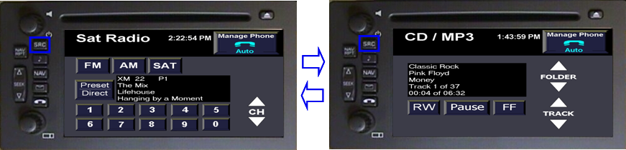
Figure 13.5. Sample IVIS Radio and CD/MP3 Pages

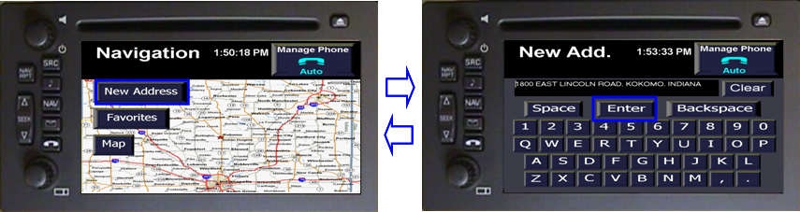
Figure 13.6. Sample IVIS Navigation and Data Entry Pages

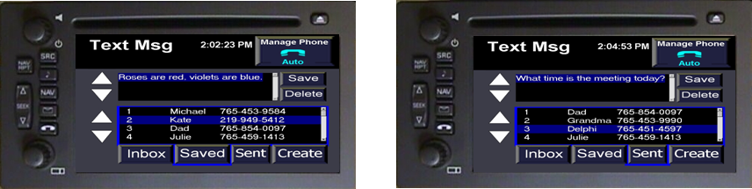
Figure 13.7. Sample IVIS Text Message Pages

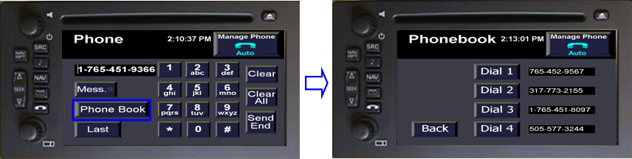Figure 13.8. Sample IVIS Phone Pages

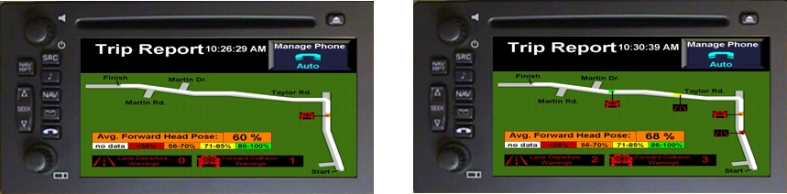Figure 13.9. Sample IVIS Trip Report Pages

11.3.6. Data Collection sub-system

The Data Collection sub-system is made up of nine major pieces of hardware; six cameras, quad video processors, a laptop and the central integration monitor. A laptop equipped with a Vector CANcard and a video capture card forms the basis for monitoring and recording all CAN bus data and video data during a drive for subsequent study and evaluation.

Data Cameras
The vehicle is equipped with six of-the-shelf black and white video cameras who’s video can be recorded for later use. There is a forward looking camera also used for the LDW sub-system, a camera pointed at the driver’s face that is also used for the DSM sub-system, a rear looking camera below the rear headliner, left and right rear-facing cameras on each side mirror and an over the shoulder camera monitoring the driver’s interactions with the vehicle controls. All of the NTSC video signals from these cameras are then fed to the quad video processors.

Quad Video Processors
The quad video processors took in the six NTSC video feeds from the data collection cameras and allowed the experimenter to locate all of the camera views into a single image that could more easily be recorded.

Data Logger Laptop
The data logger laptop is a Windows based PC with USB and PCMCIA slots. It uses Vector Canalyzer software with a Vector CanCard to record both the public and private CAN data and a video capture card to record the final quad processed video. This data can then be analyzed after the drives are complete. This data logging apparatus was utilized by Delphi for the Data Fusion on-road work, however, the Task 14 evaluations utilized their own data logging equipment.

11.3.7. Diagnostics sub-system

The diagnostic sub-system is composed of four components; the IVIS control head, IVIS computer, laptop, and the CIM. The CIM displays diagnostic activity for major sub-systems on its external LEDs and via a laptop via the RS-232 connection. It can also echo CAN messages for verification. It functioned with the IVIS computer and control head, via the public CAN bus, to test the different HMI alerts.

11.4. Vehicle Systems Integration

The overall systems integration of all of the various sub-systems in the SAVE-IT project is a complex combination of cameras, computers and warning systems. They are interconnected by CAN busses, Class 2 bus connections, discrete connections and are controlled with a flexible power-moding scheme from the CIM. An overall systems integration diagram is shown below in Figure 13.10, but its sub-sections will be described further in the following sections.

11.4.1. OEM Vehicle Sub-Systems Integration

The OEM vehicle sub-system consists of the connections needed by the CIM from the host vehicle for proper operation. Through its Class 2 bus interface, the CIM monitors the vehicle speed, RPM, brake switch and transmission gear. Because not all vehicle signals are sent over Class 2 bus, the CIM must use either its discrete input port or its analog to digital converter port to monitor the rest. Through its discrete input port, the CIM monitors the vehicle’s turn signals, windshield wiper and ignition switch. Through its analog to digital converter port, the CIM monitors the battery voltage level and the angular steering wheel position. These signals are used in the various algorithms run by the CIM for the SAVE-IT project. A diagram of the OEM vehicle sub-system is shown below in Figure 13.11.
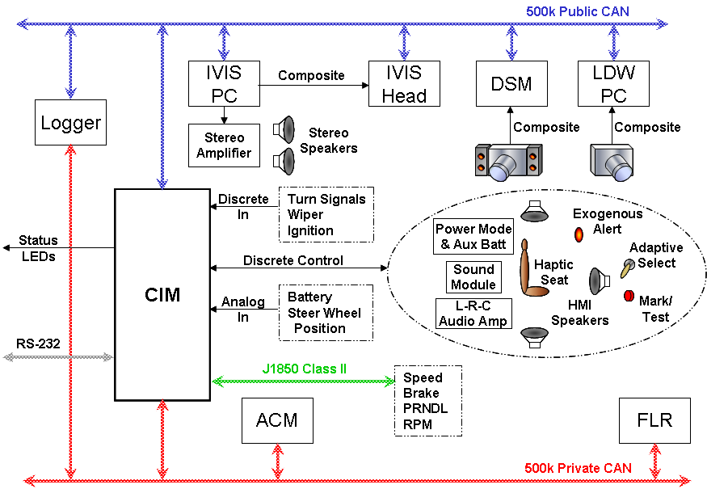

Figure 13.10. Complete Systems Integration Diagram.

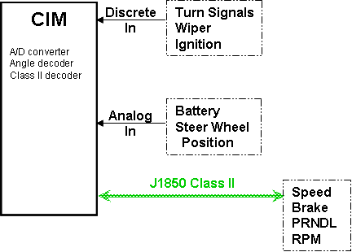
Figure 13.11. OEM Vehicle Systems Integration.

11.4.2. Active Safety Sub-Systems Integration

The active safety sub-system consists of the connections needed by the CIM from the active safety components; the DSM, FLR, ACM and audible, visible and haptic warning devices. This active safety sub-system is shown below in Figure 13.12. Because the FLR and ACM talk to each other constantly via a high speed CAN bus and because they do not like to share that bus, the CIM uses one of its high speed CAN buses in listen only mode to monitor those devices exclusively. This bus is called the Private CAN bus. Data received on this bus is used by the CIM for its FLR target buffer and the FCW and HWA threat assessment algorithms.

The rest of the SAVE-IT system that communicates over CAN uses the Public CAN bus, the other CIM high speed CAN bus. For the active safety sub-system, this includes the DSM sub-system. Data received by the CIM on this bus is used to monitor the level of driver distraction for possible adaptation of its threat assessment subroutines.

Through its discrete output port, the CIM controls the three types of warnings to the driver; the exogenous display, the haptic seat and the directional audio speakers. The exogenous display color that is used is also controlled discretely by the CIM. The haptic seat has a small interface box that gives it power, but this interface box is controlled by the CIM discretely. The directional audio speaker tones are created by a separate sound module, then amplified by an audio amp before going to the speakers. The sound module is controlled discretely by the CIM.
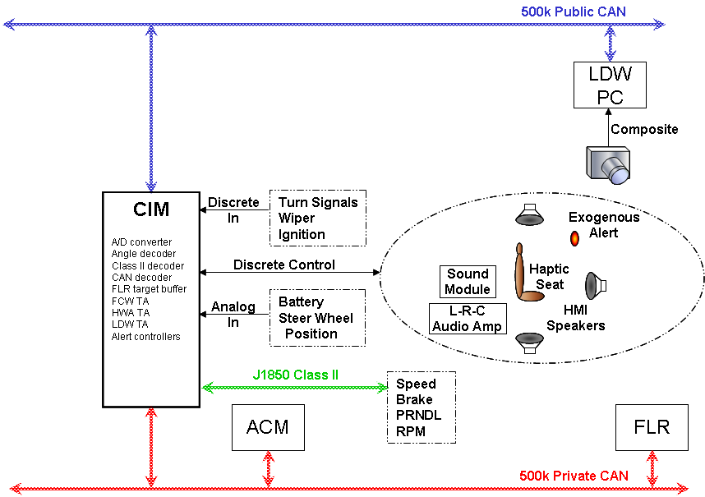
Figure 13.12. Active Safety Sub-Systems Integration.

11.4.3. Adaptive Alerts and Driving Task Demand Sub-Systems Integration

The adaptive alerts and driving task demand sub-systems consist of the connections needed by the CIM to perform its threat assessment adaptations; all of the previously mentioned systems plus the IVIS computer, the IVIS control head and an adaptive select switch. This adaptive alerts and driving task demand sub-system is shown below in Figure 13.13. Because the IVIS system simulates a modern navigation radio for the driver, its simulated audio is sent to a stereo amplifier that hooks up to the vehicle speakers. Also, since the IVIS computer audio is only left and right, the vehicle does not have any fade controls for front or back.

An adaptive select switch is added on the headliner in front of the rearview mirror so that experimenters can turn on or off the adaptive subroutines that are based on driving task demand and driver distraction. This switch is read by the CIM by its discrete input port. DSM measures driver distraction by examining whether the driver’s head is forward or not. A distraction alert feature was also originally planned but was not used for the SAVE-IT project due to the DSM sometimes not recognizing that a driver had quickly glanced forward between glances away. The DSM would consider this situation as if a driver had been looking away constantly and provide an erroneous alert.

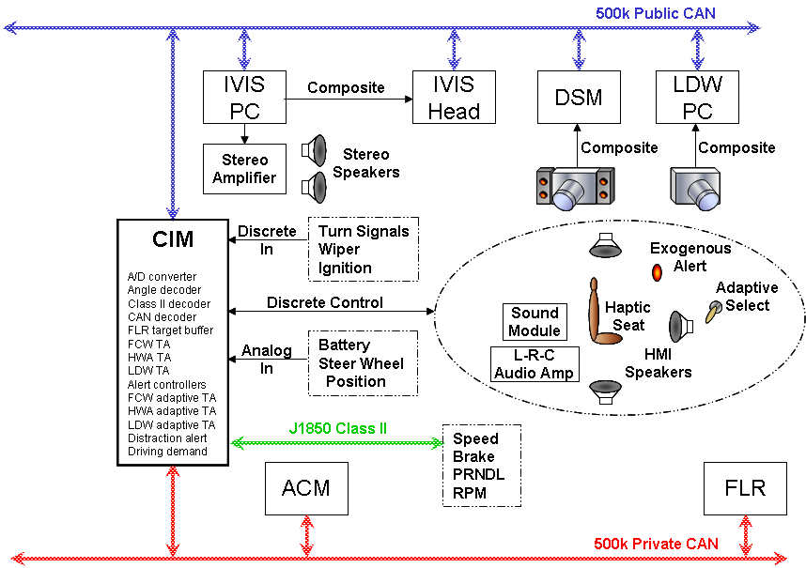

Figure 13.13. Adaptive Alerts and Driving Task Demand Sub-Systems Integration.

11.4.4. Power Moding Sub-Systems Integration

The power moding sub-systems consist of six power mode junction boxes that all sub-systems are connected to. This network of junction boxes serves as a power and public CAN distribution network that can be controlled by the CIM discrete output port. By selectively choosing which sub-systems are connected to which power junction boxes, the CIM can turn on or off different sub-systems in a particular order to give them time to boot up or shut down before the entire system is considered operational. This means that the CIM is the first sub-system to turn on and the last to turn off.

Computers on the public CAN bus also will receive a CAN message from the CIM telling them to shut down. This happens with enough time to let them shut down completely before their power is pulled by the CIM. The IVIS computer and control head are examples of hardware that shut down via the CAN shut down message.

There are four main ways to shut down the system. First, turning off the car with the ignition would be read by the CIM discrete input port and start a system shut down procedure. Secondly, the battery voltage read by the CIM analog to digital converter could fall below a pre-specified level, and the CIM would start a system shut down procedure. Thirdly, an experimenter could press the CIM button until the LED turns off and that would start a system shutdown procedure. Finally, an experimenter could also send the system shut down CAN message over the public CAN bus to shut the system down. The power moding sub-systems integration diagram is shown below in Figure 13.14.
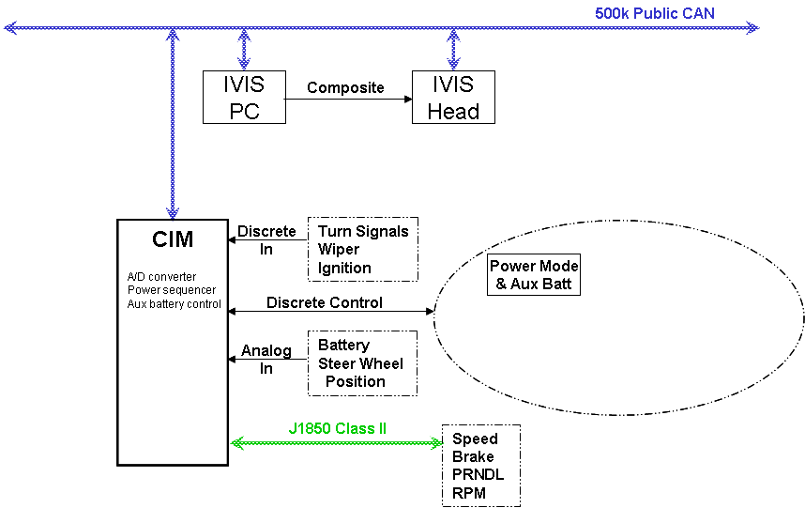
Figure 13.14. Power Moding Sub-Systems Integration.

11.4.5. Diagnostic Sub-Systems Integration

The diagnostic sub-systems are the methods used by the CIM, the IVIS and the data logger computer to diagnose problems with sub-systems, change settings, or to give the experimenter more information about the experiments.

The CIM has the capability to display diagnostic activity for each of the major sub-systems on its external LEDs. Via a laptop computer with an RS-232 connection, it can also echo CAN messages for verification using diagnostics software. Using the public and private CAN buses, the CIM constantly performs integrity checks on the data to make sure it is valid for use in its algorithms. It also works with the IVIS computer and control head, via the public CAN bus, to test the different audible, visible and haptic warnings as well as display software version information.

A mark/test button is installed on the headliner in front of the rear view mirror for use in marking special circumstances during a drive. These locations will be marked by a CAN message by the CIM so it can be reviewed later on the data logger computer. The diagnostic sub-systems integration diagram is shown below in Figure 13.15.

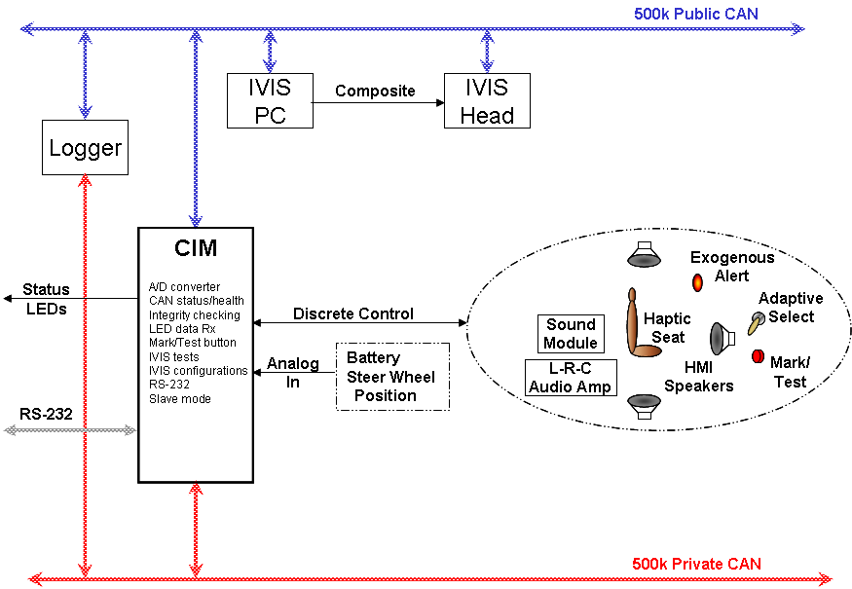

Figure 13.15. Diagnostic Sub-Systems Integration.

11.5. Simulator Systems Integration

The simulator system is a subset of the vehicle system, but with some of the hardware and vehicle feedback being replaced by simulator CAN messages. A simulator systems integration diagram is shown below in Figure 13.16 and a block diagram showing the components and their approximate sizes is shown in Figure 13.17 below. The left box shows the components that are also a part of the vehicle system, and the right box show the signals that now have to be simulated as CAN messages from the simulator. The vehicle feedback signals that were read as Class2 messages, such as wipers, turn signals, etc., now are simulated as CAN messages, and since there is no hardware for FCW or LDW in the simulator system, these signals also are simulated as CAN messages. Both public and private CAN messages must be simulated in order for the CIM to operate the system correctly. If the simulated signals are not created correctly, the CIM will send out a status CAN message showing which signals it is not receiving correctly.

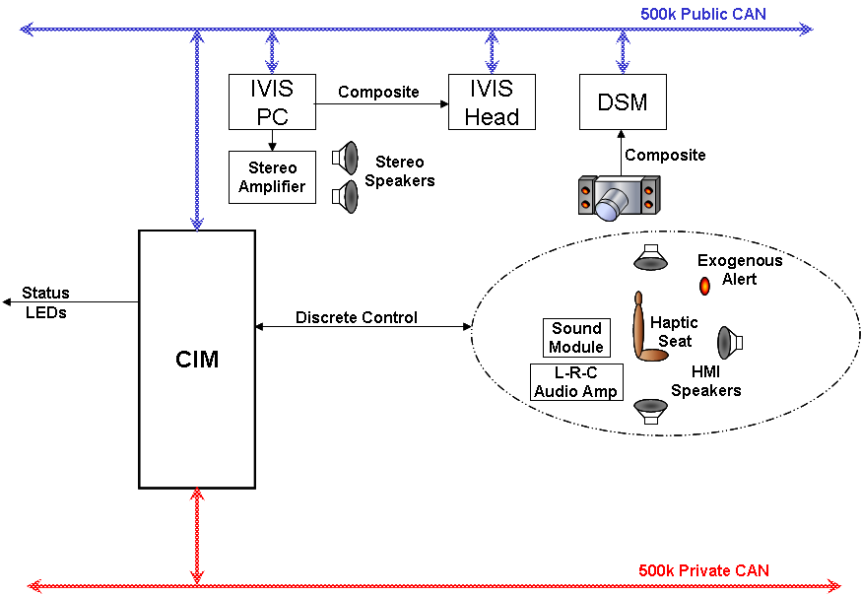

Figure 13.16. Simulator System Diagram

Figure 13.17. Simulator System Diagram and Box Sizes

11.6. Conclusion

In conclusion, for Task 13, two working types of SAVE-IT systems were provided for implementing the variety of technologies studied in this program: a vehicle system and a simulator system. The vehicle system is a road-worthy architecture that has been implemented in two vehicles that are both currently conducting drive tests. The simulator system is a subset of the vehicle system, with some vehicle and hardware signals being simulated, and has been implemented for three different simulators. With these systems now available, the threat assessment, distraction mitigation and enhanced safety warning countermeasures proposed in the previous tasks will be able to be studied in a more reliable and consistent manner.

