SAVE-IT

A Final Report of
SAfety VEhicles using adaptive Interface Technology (Phase II: Task 3C):
Driving Performance

(How Do Distracted and Normal Driving Differ:
An Analysis of the ACAS Naturalistic Driving Data)

Prepared by

Paul E. Green University of Michigan Transportation Research Institute,
+1 734 657 0578, PGreen@umich.edu
Takahiro Wada University of Kagawa, +81 87 864 2336,
wada@eng.kagawa-u.ac.jp
Jessica Oberholzer formerly University of Michigan Transportation Research Institute
Paul A. Green University of Michigan Transportation Research Institute,
+1 734 763 3795, PAGreen@umich.edu
Jason Schweitzer University of Michigan Transportation Research Institute,
+1 734 730 1396, JTSchwei@umich.edu
Hong Jun Eoh Korea Telecom Research Center, hje@kt.co.kr

August 2008

TABLE OF CONTENTS

3.0. EXECUTIVE SUMMARY 1
Background 1
Issues 1
Method 2
Results 2
Conclusions 7
3.1. PROGRAM OVERVIEW 9
3.2. INTRODUCTION 11
Research from SAVE-IT Phase 1 12
Other Key Studies 17
3.3. Method 24
Database Examined 24
How the Face Clips Were Sampled and Coded 26
3.4. RESULTS 30
1. What are the values of descriptive statistics (e.g., mean, standard deviation, etc.) for common driving performance measures (steering wheel angle, heading angle, throttle opening, and speed)? 30
2. How do road type and driver age affect those statistics? 34
3. How does distraction (as determined by head position) affect those statistics? 39
4. What distributions fit those statistics? 44
5. For all road types and driver age groups, which single throttle hold definition (sampling interval and size of change threshold (maximum minus minimum)) best distinguishes between normal and distracted driving? 51
6. As a function of road type, driver age group, driver sex, and how a throttle hold is defined, what are the odds of distracted driving? 54
7. For each specific road type and driver age group, which throttle hold definition best distinguishes between normal and distracted driving? 58
8. In addition to throttle holds, which statistics (e.g., mean, frequency above or below some extreme) for which driving-related measures (e.g., lead vehicle range, lane width, outside temperature, etc.) best distinguish between normal and distracted driving? 61
3.5. CONCLUSIONS 69
1. What are the values of descriptive statistics (e.g., mean, standard deviation, etc.) for common driving performance measures (steering wheel angle, heading angle, throttle opening and speed)? 69
2. How do road type and driver age affect those statistics? 69
3. How does distraction (as determined by head position) affect those statistics? 70
4. What distributions fit those statistics? 71
5. For all road types and driver age groups, which single throttle hold definition (sampling interval and size of change threshold (maximum minus minimum)) best distinguishes between normal and distracted driving? 71
6. As a function of road type, driver age group, driver sex, and how a throttle hold is defined, what are the odds of distracted driving? 72
7. For each specific road type and driver age group, which throttle hold definition best distinguishes between normal and distracted driving? 72
8. In addition to throttle holds, which statistics (mean, frequency above or below some extreme value, etc.) for which driving-related measures (lead vehicle range, lane width, outside temperature, etc.) best distinguish between normal and distracted driving? 73
Considerations for the Future 74
3.6. REFERENCES 75
3.7. Appendix A: Observed Frequency Data 77
3.8. Appendix B: Descriptive statistics by road superclass, age group and distraction 81
3.9. Appendix C: additional results of Standard Deviation Change Ratio analysis 83
3.10. appendix D: comparison of descriptive statistics from distribution and fitted results 85
3.11. Appendix E: Ratio of Throttle Holds (Hold/NoNhold) by Road superclass, Age group, and distraction 88
3.12. Appendix F: predictor driving variables 92

3.0. EXECUTIVE SUMMARY

Background
The first objective of Task 3c (performance) was to characterize normal and distracted driving by providing descriptive statistics (e.g., means, standard deviations) and distributions for a wide range of driving performance measures commonly reported in the literature (such as lane position, steering wheel angle, etc.) as well as statistics examined in the prior phase of the project (throttle holds).
The second objective was to determine those statistics that were most effective in distinguishing between normal and distracted driving. Thus, the larger intent is to infer from driving performance in real time when the driver appears to be distracted, and then regulate secondary tasks (by locking them out, warning the driver, etc.) based on that information.
In Phase 1, Task 3a, a summary of the literature on the statistical differences between normal and distracted driving for a wide range of measures was completed (Green, Cullinane, Zylstra, and Smith, 2004). The authors examined 9 well-known papers relating to factors that affect or are affected by driver performance (e.g., SD of steering wheel angle, headway, etc.). Very few dependent measure statistics were consistently reported across studies except for the standard deviation of lane position (8 of the 9 studies, typically 0.25 m with substantial variation). Relationships were developed between that measure and driver age, test conditions, etc. Also noteworthy was the large difference in the standard deviation of velocity between distracted and normal driving (36% on average).
In Task 3b, data was collected for dialing, radio tuning, and destination entry while driving an instrumented vehicle (Zylstra, Tsimhoni, Green, and Mayer, 2003). One of the findings was that during periods of distraction, there was evidence of throttle-holds. During normal driving, there are a large number of small corrections in throttle position that occur, sometimes several per second. When distracted, those corrections may not occur, and speed control becomes more intermittent—that is making corrections, then not making them for a few seconds, and then making them.

Issues
Given the project objectives, prior research, and project needs, the following issues were examined:
1. What are the values of descriptive statistics (e.g., mean, standard deviation, etc.) for common driving performance measures (steering wheel angle, heading angle, throttle opening, and speed)?
2. How do road type and driver age affect those statistics?
3. How does distraction (as determined by head position) affect those statistics?
4. What distributions fit those statistics?
5. For all road types and driver age groups, which single throttle-hold definition (sampling interval and size of change threshold (maximum minus minimum)) best distinguishes between normal and distracted driving?
6. As a function of road type, driver age group, driver sex, and how a throttle-hold is defined, what are the odds of distracted driving?
7. For each specific road type and driver age group, which throttle hold definition best distinguishes between normal and distracted driving?
8. In addition to throttle-holds, which statistics (mean, frequency above or below some extreme value, etc.) for which driving-related measures (lead vehicle range, lane width, outside temperature, etc.) best distinguish between normal and distracted driving?

Method
The contract plan called for re-examining the driving performance data from the ACAS field operational test (Ervin, Sayer, LeBlanc, Bogard, Mefford, Hagan, Bareket, and Winkler, 2005). That naturalistic driving study involved 96 drivers and 136,792 miles of driving. Equal numbers of men and women, in their 20s, 40s, and 60s, participated in the study. There were 9 road types driven: (0) ramp, (1) interstate, (2) freeway, (3) arterial, (4) minor arterial, (5) collector, (6) local, (7) unpaved, and (8) unknown, with many of the analyses examining 3 superclasses of roads (a) interstates and expressways, (b) major roads (arterials and minor arterials), and (c) minor roads (collectors and local roads).
Only data from the baseline condition, when the forward collision avoidance and adaptive cruise control systems were disabled, were examined. Included in the data set are forward scene and face camera views, and data from 400 engineering variables (collected in real time at 10 Hz). The forward scene was recorded at 1 Hz. Distracted driving was determined using the 4 s face video clips collected at 5 Hz, so segments examined consisted of a maximum of 20 data points, sometimes 1 or 2 less depending on system synchronization. Face video clips were recorded once every 5 minutes.
Often, exactly where the driver was looking could not be determined by looking at a face clip. However, as has been the case in prior studies, there was a high correlation between where the driver was looking and head orientation. Therefore, the rule of thumb was that the driver was considered to be distracted when 4 or more consecutive frames occurred where the driver’s head was not oriented toward the forward scene (based on manual coding of at least 2 observers of the 2,914 clips). Given a typical road scene, a glance was about 0.5 s, and some time was required to transition between the road scene and elsewhere. The 4-frame rule provided confidence that frames identified as distracted were truly such. Note that where drivers were looking and whether they were performing a secondary task before or after the 4 s face clip could not be observed.

Results
The analyses produced a large number of figures, tables, and statistics. Only a sample is provided here to give the reader an overview of the extensive results. Tables 3.1 and 3.2 show descriptive statistics for several of the driving performance measures of interest. Many of the distributions were lognormal. As shown in Table 3.3, there were differences in the means of measures related to speed between road super-classes, which makes sense (since the speed limits were different), but also statistically significant differences in the variability of steering input.
Table 3.1. Example Descriptive Statistics
Q1. Histograms and descriptive statistics of overall data for each measure

Table 3.2. Histograms as a Function of Driver Age
Q2. Histograms and descriptive statistics of measures by road type & driver age
(a) Age 21-30
(b) Age 41-50
(c) Age 61-70
(I) Limited Access Road

Table 3.3. ANOVA Results: Effects of Road Superclass and Driver Age
Q2. Do road type & driver age affect driving performance statistics?
* (p<0.05), ** (p<0.01), *** (p<0.001), - (no statistical significance)
Driving Performance Measure | Mean |  |  | SD
Driving Performance Measure | Road Superclass | Age Group | Rd x Age | Road Superclass | Age Group | Rd x Age
Steering Wheel Angle | NA | NA | NA | *** | - | -
Heading Angle | NA | NA | NA | ** | - | -
Throttle Opening | *** | *** | *** | - | - | -
Speed | *** | ** | *** | - | - | -

In terms of overall driving performance statistics, distraction had almost no effect on individual driving performance statistics (Tables 3.4 and 3.5), except for decreasing mean throttle opening by 36% and mean speed by 6%. However, more sophisticated analyses were able to identify differences due to distraction in individual cells of the data set (particular driver age-road type combinations). This led to an effort to fit the distributions of steering wheel angle, heading, and speed (all double exponential) and throttle opening (gamma) for each road type by driver age combination (Table 3.6). Again, at the overall level, there were no differences between normal and distracted driving.
Table 3.4. Effect of Distraction on Driving Performance Statistics
Q3. What are typical values for measures of driving performance?

Table 3.5. ANOVA of Distraction and Other Factors on Driving Performance
Q3. Does distraction significantly affect measures of driving performance?
* (p<0.05), ** (p<0.01), *** (p<0.001), - (no statistical significance)
Mean
Performance Measure | Road | Age | Dist | Rd x Age | Rd x Dist | Age x Dist
Steering Wheel Angle | - | - | - | *** | - | **
Heading Angle | *** | *** | ** | *** | *** | *
Throttle Opening | *** | *** | * | *** | - | -
Speed | *** | *** | - | *** | *** | -
SD
Performance Measure | Road | Age | Dist | Rd x Age | Rd x Dist | Age x Dist
Steering Wheel Angle | *** | - | * | - | - | *
Heading Angle | ** | - | - | - | - | -
Throttle Opening | - | - | - | - | - | -
Speed | - | - | ** | - | * | -

Table 3.6. Fit of Distributions to Various Road Type-Driver Age Combinations

Q4. Fit model to input and output measures of interest
Steering Wheel Throttle | Limited access road, middle age drivers  Mean Fit: Good in general
Steering Wheel Throttle | SD Fit:  Steer Error = 10-50% (fit ↓ with SD)  Heading Error=3-50% (fit ↓ with SD)  Throttle Error = 1-12%  Speed Normal Error = 1-20%  Distracted Error = 3-50%

Given the results of Phase 1, throttle-holds were given special attention. Throttle-holds are defined by 2 parameters, the time window over which it occurs and the threshold (percentage change) required. As shown in Table 3.8, differences between distracted and normal driving were most likely to occur for 1-s time windows, and the statistic was most sensitive for limited access roads for middle-age drivers, the most stable combination. What makes no sense at all is why throttle-holds were more likely for normal driving, the direct opposite of what the theory predicts. Given the 4-s limit of the data, the true intermittent nature of throttle-holds could not be explored with this data set.

Table 3.7. Throttle-Hold Parameter Estimation

Q5. Comparison of various throttle hold parameters by road type and driver age
Effect of changing parameters (Limited access road, young drivers)  Hold ratio (holds/nonholds) | Highest throttle hold frequency with smaller time window & larger threshold  Most consistent throttle holds parameters for all road x age combinations when:  Time window = 1 sec  Threshold = 4  (works best for limited access roads & for middle age drivers)

However, as with the prior analyses, the most sensitive detection of normal vs. distracted differences occurred when the statistic of interest, here throttle-holds, was tailored to the road class-driver age combination of interest, with larger thresholds being best for minor roads. Table 3.8 shows the best parameters for each case.
Table 3.8. Best Throttle Hold Parameters for Each Road Class-Driver Age Combination
Q7. Effectiveness of using throttle holds to identify distracted driving
using road type and age specific parameters
Comparison of throttle hold parameters (Major roads, older drivers)  (a) Age 21-30  (b) Age 41-50  (c) Age 61-70  (I) Limited Access Road | Best throttle hold parameters  for each road type, age combination

In the final major analysis, logistic regression identified other statistics and factors that discriminated between normal and distracted driving. For limited access roads (7.6% distraction in baseline), the 6 best predictors for distracted driving were:

- Turn signal [(0-baseline) off, (1) on]
- Age group [(0) young, (2) middle, (3) old]
- Speed from transmission –m/s [(0) .05<=x<=.95, (1) x<.05 or x>.95]
- Velocity of current in-path vehicle – Δ m/s [(0) x=0, (2) 0<x<=30, (3) x>30
- Deceleration of current in-path vehicle - percentile [(0) x>=.05, (1) x<.05]
- Lane offset confidence [(0) none, (2) low/medium, (3) high]

For major roads (4.4% distraction in baseline), the 6 best predictors for distracted driving were:

- Gender [(0) female, (1) male]
- Range to closest in-path vehicle [(0) x=0, (2) 0<x<=60, (3) x>60]
- Forward road geometry – 40m [continuous]
- Brake [(0) not active, (1) active]
- Lane offset confidence [(0) none, (2) low/medium, (3) high]
- Peak to peak vertical acceleration from ABS – g [continuous]

For minor roads (1.3% distraction in baseline), the 6 best predictors for distracted driving were:

- Lane width – m [continuous]
- Outside temperature – C [(0-baseline) .05<=x<=.95, (1) x<.05 or x>.95]
- Speed from transmission – m/s [continuous]
- Forward road geometry – 120m [continuous]
- Heading offset from lane center – m [(0) .05<=x<=.95, (1) x<.05 or x>.95]
- Deceleration of current in-path vehicle [continuous]

Conclusions
This report contains a wealth of statistics and figures that describe normal and distracted driving as a function of the type of road driven and driver age and sex. Data provided includes the mean and standard deviation, as well as the distribution type, for each combination, all of which should be extremely useful for modeling of driver performance.
Particularly striking was the lack of significant differences due to distraction when driver performance statistics such as the overall mean speed were examined (though the standard deviation of speed was significantly different).
In part, this is because the effects of distraction are complex, and differences become more apparent when particular road type-driver age (and sex) combinations are considered. This suggests the need for a more sophisticated approach than brute force analysis, which will make real-time determination of distraction quite difficult. Overall, key driving task related parameters were turn signal use for expressways, lead vehicle range (when greater than 60 m) for major roads, and lane width, lane offset, and lead vehicle velocity for minor roads.
Further, analysis of throttle-holds showed mixed results. The optimal combination was a 4% threshold for a 1-s window, but the overall effects were in the opposite direction as expected. Throttle-hold measures were much more sensitive when tailored to the road class-driver age combination of interest.

PROGRAM OVERVIEW
Driver distraction is a major contributing factor to automobile crashes. The National Highway Traffic Safety Administration (NHTSA) has estimated that approximately 25% of crashes are attributed to driver distraction and inattention (Wang, Knipling, & Goodman, 1996). Recent estimates from the 100-Car study suggest that distraction may contribute to more than three quarters of all crashes (Dingus, Klauer, Neale, Petersen, Lee, Sudweeks, Perez, Hankey, Ramsey, Gupta, Bucjer, Doersaph, Jermeland, & Knipling, 2006). The issue of driver distraction may become more critical in the coming years because increasingly elaborate electronic devices (e.g., cell phones, navigation systems, wireless Internet and email devices) are being brought into vehicles that may further compromise safety. In response to this situation, the John A. Volpe National Transportation Systems Center (VNTSC), in support of NHTSA's Office of Vehicle Safety Research, awarded a contract to a diverse team led by Delphi Electronics & Safety including Ford, the University of Michigan Transportation Research Institute (UMTRI) and the University of Iowa. The goal of this program was to develop, demonstrate, and evaluate the potential safety benefits of adaptive interface technologies that manage the information from in-vehicle systems based on real-time monitoring of the roadway and the state of the driver. The contract, known as SAfety VEhicle(s) using adaptive Interface Technology (SAVE-IT), is designed to mitigate distraction with effective countermeasures and enhance the effectiveness of safety warning systems.
The SAVE-IT program serves several important objectives. Perhaps the most important objective is that of demonstrating a viable proof of concept that is capable of reducing distraction-related crashes and enhancing the effectiveness of safety warning systems. Program success is dependent on integrated closed-loop principles that incorporate the state of the driver. This closed-loop vehicle system is achieved by measuring the driver's state, assessing the situational threat, prioritizing information presentation, providing adaptive countermeasures to minimize distraction, and optimizing collision warning systems.

INTRODUCTION
For most of the 20th century, the motor vehicle driver’s primary task has remained the same: to steer the vehicle in its path, control its speed, and not collide with other vehicles, pedestrians, or roadside objects. More recently, with the advent of telematics, the collection of tasks drivers perform has changed. Drivers must now divide their attention between the primary driving task and the ever-growing assortment of telematics systems for navigation, communication, collision warning, lane departure warning, and so forth. Telematics are intended to make driving safer, easier, and more convenient but may actually end up putting the driver, passengers, and those outside the vehicle at greater risk due to increased driver distraction.

The Merriam-Webster Online dictionary (http://www.m-w.com/cgi-bin/dictionary) defines distraction as, “ 1 : the act of distracting or the state of being distracted; especially : mental confusion, 2 : something that distracts; especially : AMUSEMENT. ” Furthermore, it defines distract as, “1a : to turn aside : DIVERT b : to draw or direct (as one's attention) to a different object or in different directions at the same time, 2 : to stir up or confuse with conflicting emotions or motives.” Thus, in this context, a distraction is something that draws, diverts, or directs the driver’s attention away from the primary task of controlling the vehicle.

Driver distraction may also refer to a situation where the aggregate demand of tasks performed exceeds some limitation and causes overload of information processing capabilities. In this situation, the driver is essentially performing multiple tasks in parallel (the primary driving task and one or more secondary distracting tasks), and the combination of these tasks may overload a single resource (visual, auditory, cognitive, or psychomotor) or some combination of them (Wickens, 1984). Even if a secondary task has fairly low demand, that task could overload the driver if the driver is near the limit of their information processing capacity. When a driver is overloaded, performance of the primary and/or secondary task may decline, be delayed, not performed at all, etc. This performance decrement may compromise driving safety, so understanding the effect of overload is especially important in regards to driving. This overload situation is quite different from the attraction situation described previously, as are the strategies used to deal with it. However, consistent with general usage, both situations will be referred to as distraction in this report.

There are a number of strategies that have been proposed to decrease opportunities for driver distraction and thereby reduce distraction-related crashes (Green, 2004). Among them are (1) regulations that would make it illegal to perform certain secondary tasks while driving (such as using a cell phone) and (2) implementing systems, such as a workload manager, to reduce distraction while driving.

Both strategies have their advantages and disadvantages. Passing new regulations can be difficult and success is usually a matter of political will as product suppliers and manufacturers often oppose such regulations. Furthermore, the regulatory strategy is reactive and requires proof of considerable risk, namely a significant number of crash-related deaths, so that crash statistics can be used to support, and pass, regulations. Given the rapid advances of telematics and the slow process of regulation, regulations will only be developed well after they are needed, if at all. Finally, the focus of such regulations is often very narrow, such as cell phone use, and ignores other tasks of concern. Fortunately, once a regulation is passed, compliance is often very high.

A workload manager makes a continual real-time assessment of driving performance to determine when the driver is overloaded, and suppresses the introduction of additional distractions accordingly. For example, if a driver is in heavy traffic, in the rain, on a curvy road, then an incoming phone call (an added demand) could be automatically routed to an answering machine instead of ringing as normal to prevent introducing additional demand and distraction-related error in the already demanding driving conditions. Workload managers can be developed as vehicles are being developed, so there are no implementation delays. Furthermore, a workload manager could be linked to a warning system to greatly enhance its effectiveness by reducing false alarms and presenting the warning only when needed (usually when the driver is distracted). Despite their possible benefits, drivers may feel that such safety systems (e.g. workload managers) are an invasion of privacy and be unwilling to use them.

Research from SAVE-IT Phase 1
To develop an effective workload manager, it is important to know how normal driving and distracted driving differ, as well as which driving performance measures and associated statistics can be used to identify distraction. As a first step, a summary of the literature on the statistical differences between normal and distracted driving for a wide range of measures was completed in Phase 1 of the SAVE-IT project (Green, Cullinane, Zylstra, and Smith, 2004). The authors examined 9 well-known papers relating to factors that affect or are affected by driver performance (e.g., SD of steering wheel angle, headway, etc.). Table 3.9 shows the mean value of each statistic (averaged across all studies reviewed) and the numbers of uniquely identifiable instances in which that statistic was reported. For example, if a study reported 1 driving performance statistical value for men and 1 for women, the number of instances for that statistic would be 2. Note that 5 of these 9 performance statistics were reported in 2 or fewer instances, whereas standard deviation of steering wheel angle was reported quite often.

Table 3.9. Mean Value of Driving Performance Statistics
Source: Green, Cullinane, Zylstra, and Smith (2004)
Statistic Category | Driving Performance Statistic | # of Instances | Mean Value
Driver | SD steering wheel angle (deg) | 45 | 1.59
Driver | SD throttle position (%) | 6 | 3.27
Vehicle | SD velocity (m/s) | 12 | 1.09
Vehicle | SD lateral speed (m/s) | 12 | 0.07
Vehicle | SD of avg. deceleration (g) | 2 | 0.05
Vehicle | Headway (m) | 2 | 55.1
Vehicle | SD headway (s) | 1 | 0.6
Vehicle | Time-to-line crossing (s) | 2 | 3.19
Vehicle | Lane exceedance (%) | 2 | 0.01

When data is separated according to driver distraction, only 2 measures were studied in more than 2 instances: SD of steering wheel angle and SD velocity. Of these, SD velocity had a larger percentage difference between conditions (Table 3.10).

Table 3.10. Mean Value of Driving Performance Statistics by Distraction
Source: Green, Cullinane, Zylstra, and Smith (2004)
 |  | Normal |  | Distracted |  | Difference | %  Diff
 | Driving Performance Statistics | # | Mean | # | Mean | Difference | %  Diff
Driver  Inputs | SD steering wheel angle (deg) | 5 | 1.44 | 10 | 1.51 | .07 | 4.9
Driver  Inputs | SD throttle position (%) | 2 | 3.25 | 4 | 3.29 | .04 | 1.2
Vehicle Parameters | SD velocity (m/s) | 5 | 1.18 | 6 | 0.75 | .43 | 36.4
Vehicle Parameters | SD lateral speed (m/s) | NA | NA | NA | NA | - | -
Vehicle Parameters | SD of mean decel (g) | 1 | 0.05 | NA | NA | - | -
Vehicle Parameters | Headway (m) | 1 | 53.5 | 1 | 56.7 | 6.2 | 11.6
Vehicle Parameters | SD headway (s) | NA | NA | NA | NA | - | -
Vehicle Parameters | Time-to-line crossing (s) | 1 | 3.47 | 1 | 2.9 | .57 | 16.4
Vehicle Parameters | Lane exceedance (%) | 1 | 0.00 | 1 | 0.02 | - | -

Standard deviation of lane position (SDLP) was reported in 8 of the 9 studies reviewed, far more than any other performance statistic, so it was examined further in a follow-on review of 36 studies (121 instances). There were 4 key findings. First, the typical value of SDLP was about 0.22 m. Second, road class may have had an effect on the variability of SDLP (Table 3.11).

Table 3.11. Standard Deviation of Lane Position (m) for Various Road Types
Source: Green, Cullinane, Zylstra, and Smith (2004)
Road Type | Baseline |  |  | All Data
Road Type | Mean | SD | N | Mean | SD | N
Mixture of roads | .15 | .02 | 3 | .15 | .03 | 9
Expressway | .20 | .05 | 20 | .27 | .13 | 68
Test track | .22 | .05 | 5 | .22 | .04 | 7
Rural | .23 | .15 | 12 | .29 | .15 | 12
Urban | .23 |  | 1 | .23 | .00 | 2

Third, SDLP seemed to increase slightly with driver age and to be 0.06 m greater in simulators than on the road (Figure 3.1).

Figure 3.1. Standard Deviation of Lane Position vs. Age
Source: Green, Cullinane, Zylstra, and Smith (2004)

Fourth, the study provided estimates for the effect of various factors (drugs, etc.) on SDLP (Table 3.12). The most commonly reported factor (28 instances) was secondary tasks, and the associated SDLP was 0.10 m higher than baseline SDLP (about 50%) a large difference.

Table 3.12. Rank Order of Mean Standard Deviation by Condition
Source: Green, Cullinane, Zylstra, and Smith (2004)

Treatment | Mean | SD | N | Minimum | Maximum
Baseline | .21 | .09 | 41 | .01 | .37
Cruise | .21 | - | 1 | .21 | .21
Occlusion | .23 | .03 | 7 | .18 | .27
Drug | .24 | .03 | 22 | .21 | .31
Alcohol | .27 | .05 | 6 | .22 | .37
Headway | .31 | .02 | 3 | .29 | .33
Secondary task | .31 | .20 | 28 | .01 | .85
Lane width | .35 | .06 | 5 | .27 | .44
Sight distance | .35 | .03 | 6 | .31 | .39
Tires | .44 | .09 | 2 | .38 | .50

All of these findings should be considered with some care as the precision and accuracy of the lane tracking sensors is not reported in many cases and the number of significant figures reported by the authors in the sources reviewed varies and may be incorrect. There is no systematically varying data for many important factors (e.g., road type, driver age, and driver sex), and in some cases, measures were loosely defined, and the accuracy or precision of measurement was not reported. As a whole, these findings indicate that it is extremely difficult to use the existing literature to estimate statistics, such as means and standard deviations, for common measures of driving performance for normal and distracted driving.

Given the incomplete picture provided by the literature, Zylstra, Tsimhoni, Green, and Mayer (2003) subsequently conducted an on-the-road driving study to examine how distraction affects driver performance. Sixteen (8 middle-aged, 8 older) subjects drove on an expressway and on a 2-lane rural road while performing 5 in-vehicle tasks (e.g., tuning the radio, dialing a phone, entering a street address in to the navigation system). Both roads were perfectly straight and traffic was light to moderate, so external driving disturbances were minimal.

The authors found that during normal driving, subjects would constantly make small corrections to the throttle opening, and that when distracted, these corrections ceased, resulting in throttle holds. When performing a secondary task, subjects quickly alternated attention between driving and the secondary task. This behavior resulted in intermittent periods of micro corrections and flat line periods (around 1 second long). An idealized example of this behavior is shown in Figure 3.2, which depicts percent throttle opening as a function of time.

Figure 3.2. Idealized Throttle Opening Flat Line Behavior
as an Indicator of Distracted Driving
Source: Green (2006)

Sample data is shown in Figure 3.3, where baseline refers to driving without a secondary task. Secondary tasks include: tuner (manually tuning a radio), phone (dialing a phone), and navigation (entering a street address into a navigation system), L10, and L30 (looking at a target on the instrument panel as often as subject felt comfortable for a 10 or 30 second interval, respectively). The looking tasks (L10 and L30) were two of the more interesting tasks in that experiment. In contrast to common in-vehicle tasks, which involve an element of “attraction,” the looking tasks did not since subjects did not do anything with what they saw. Therefore, throttle holds may have been less frequent for this task. Findings from that report suggested that throttle holds could be used to distinguish between normal and distracted driving, so that measure was studied in this report.

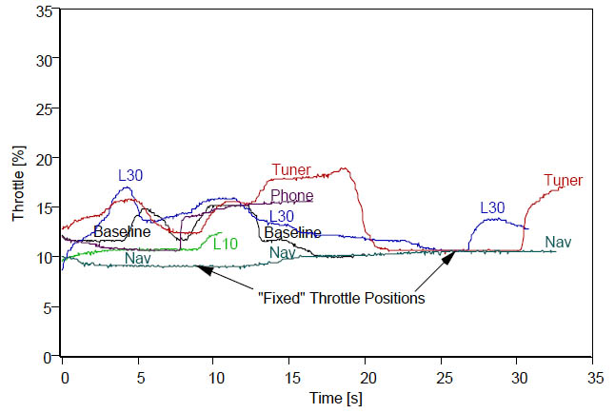
Figure 3.3. Throttle Position (% Open) by Secondary Task
Source: Zylstra, Tsimhoni, Green, and Mayer (2003)

Other Key Studies
Additional studies on the differences between normal and distracted driving and driving performance measures have become available to the public since the completion of Phase 1 of this project. They include efforts to build driver models of normal driving behavior (e.g., Lee and Peng, 2004) based on naturalistic data from the SAVME project (Ervin et al., 2000) and on ICCFOT data (Fancher et al., 1998). Field operational tests, which contain extensive relevant data, are of particular importance to this report. Therefore, a short supplementary literature review follows to fill in the gaps and accommodate some shifts in project direction.

The road departure curve warning (RDCW) FOT (Sayer, Devonshire, and Flannagan, 2005) was a naturalistic driving study, in which data from 36 subjects in instrumented vehicles was collected over 4 weeks. Although the purpose of the test was to examine warning systems, the large data set and extensive video data (especially of in-vehicle activities) provided an excellent source for the analysis of driver distraction. A total of 2,914 4–second clips from about 87,000 miles of driving were coded using the initial UMTRI coding scheme. (See Yee, Green, Nguyen, Schweitzer, and Oberholtzer, 2006 for an overview of all schemes.) Baseline data was collected during the first week of driving when the warning systems were inactive. The systems were active over the 3 subsequent weeks. Data from all 4 weeks was used for that examination.

Statistics for 4 measures of specific interest to this study were examined in that report, throttle (mean and variance), steering wheel angle (variance), speed (mean and variance), and lane position (mean and variance). In an ANOVA of the variance of throttle opening, there were the usual statistically significant effects of age and sex, but the differences due to secondary tasks were not significant (Figure 2.4). In contrast to the literature, where the reported typical SD of throttle position was 3.3 percent, the value found here is about 1 percent (the square root of approximately 1, the value for “none” in Figure 3.4).

Figure 3.4. Throttle Position Variance for Each Secondary Task
(Source: Sayer, Devonshire, and Flannagan, 2005)

In contrast to the throttle position data, there were significant differences in speed variances (dependent on throttle variance) for different secondary tasks (Figure 3.5), but only when the subject was braking. Curiously, adding a secondary task reduced speed variance (braking was more stable). Furthermore, speed variance for when drivers were braking shows the biggest reduction with cell phone use, even though cell phone use is predominantly a conversation task and conversation had no effect. Also related to cell phone use, the variance of throttle was not affected by this task, but the variance of speed was significantly reduced. For multiple tasks, changes in throttle and speed variance were frequently opposite of each other. Although different tasks have different visual, cognitive, auditory, and psychomotor demands, which cause different patterns of interference, the authors have no explanation for these specific results, except to say that road type and age group differences may be confounding these results.

Figure 3.5. Speed Variance by Brake Use for Each Secondary Task
Source: Sayer, Devonshire, and Flannagan (2005)

When distracted, subjects tended to intermittently switch between steering and not steering, similar to distraction-related throttle hold behavior (Zylstra, Tsimhoni, Green, and Mayer, 2003). As shown in Figure 3.6, secondary task performance significantly increased overall variance of steering angle, though the difference between each secondary task and no task was not statistically significant. Again, the values found here for the no secondary task case (0.42=square root 0.18) are quite different from those reported in the literature review (1.44 deg). Variance of steering wheel angle was significantly greater when the brake was in use and, not surprisingly, was significantly affected by road type-road curvature interaction, increasing for curves and remaining constant on expressways (Figure 3.7).
Figure 3.6. Variance of Steering Wheel for Each Secondary Task
Source: Sayer, Devonshire, and Flannagan (2005)

Figure 3.7. Variance of Steering Wheel Angle by Road Type and Road Curvature
Source: Sayer, Devonshire, and Flannagan (2005)

The mean distance from lane center was consistent with the literature. However, standard deviation of lane position (SDLP) was significantly affected by age, with mean values of 0.19, 0.15, and 0.16 for young, middle-aged, and older drivers, respectively. These results are close to those of Green, Cullinane, Zylstra, and Smith (2004), who reported that typical SDLP values were 0.15 to 0.23 m, depending on the type of road.
Position within the lane is largely controlled by steering, and the pattern of results for SDLP should be similar to that for steering variance. Comparing successive columns in Figure 3.7 and Figure 3.8, the trend is alternately increases and decreases according to secondary task. Overall, SDLP was significantly affected by the performance of a secondary task, but there were no statistically-significant pairwise differences between the baseline (no task) and any individual secondary task. In fact, the SDLP was less than the baseline for some secondary tasks, possibly because drivers are aware of the added risk posed by performing a secondary task and elect to perform them in the safest conditions (when few steering wheel corrections are needed). However, that does not mean that secondary task performance does not add to driving risk. Not surprisingly, SDLP was also significantly higher than baseline for driving on curvy roads.
Figure 3.8. Standard Deviation of Lane Position by Secondary Task
Source: Sayer, Devonshire, and Flannagan (2005)

Thus, the RDCW findings show that SD of steering wheel, SD of lane position, SD of throttle, and SD of speed are the statistics most affected by secondary task performance, which is quite different from findings of prior research. A summary of the RDCW findings is given in Table 3.13, which shows the percent change of these four values by secondary task. Positive percent changes indicate degraded performance, and these values are bolded in the table. Correlations were found between the lateral control variables (r=0.77) and between the longitudinal control variables, but only for throttle and speed variance (no braking) (r=0.83). No correlation was found between throttle and speed variance (braking) (r=0.18). In general, the percent changes for lateral control variables were larger than for longitudinal control variables, but there was no consistent pattern across tasks. Note that the direction of change between both lateral and longitudinal control variables was frequently consistent. Although some secondary tasks were associated with degraded performance, some were associated with improved performance. For instance, all but one of the performance statistics for Groom and Eat/Drink showed a negative percent change. So each task has a different effect on driving performance according to its specific visual, cognitive, auditory, and psychomotor demands.

Table 3.13. Percent Change of Statistics for the Four Measures of Interest

Type of Control | Statistic | Task
Type of Control | Statistic | Converse | Groom | Use Phone | Eat/ Drink | Multiple | Other
Lateral | Steering Wheel Variance | 33.3 | 11.1 | 44.4 | 11.1 | 38.9 | 38.9
Lateral | Standard Deviation of Lane Position | 5.9 | -29.4 | 5.9 | -23.5 | 29.4 | -11.8
Longi- tudinal | Throttle Variance | 9.5 | -9.5 | 9.5 | -33.3 | 28.6 | 71.4
Longi- tudinal | Speed Variance (No Braking) | -5.0 | -7.4 | -2.5 | -7.5 | 10.0 | 7.5
Longi- tudinal | Speed Variance (Braking) | 6.7 | -30.0 | -61.7 | -18.3 | -41.7 | -3.3

The literature provides some useful information on how some common driving performance statistics (such as steering wheel angle variance) and uncommon measures (such as the number of throttle holds) differ between normal and distracted driving. However, there is insufficient information for a workload manager to reliably determine the probability of driver distraction for a wide variety of drivers (different ages, genders) in a wide variety of driving situations (different road types, weather, traffic, etc.). As the literature makes clear, additional data on the differences due to road type, road geometry (straight or curved), braking behavior, and possibly driver age is needed before those comparisons can be made. Furthermore, the RDCW results cast doubt upon how secondary tasks (distraction) affect driving performance when tasks are performed in a naturalistic context at a time and place of the driver’s choosing, as opposed to the strictly controlled environment created in Zylstra et al. (2003). This is because drivers may choose to perform secondary tasks in less risky (and therefore less demanding) driving conditions where the task has little or no negative effect on driving performance.

Thus, to identify which driving performance measure-based statistics a workload manager could use to distinguish between normal and distracted driving, this report addresses the following questions:

- What are the values of descriptive statistics (e.g., mean, standard deviation, etc.) for common driving performance measures (steering wheel angle, heading angle, throttle opening, and speed)?
- How do road type and driver age affect those statistics?
- How does distraction (as determined by head position) affect those statistics?
- What distributions fit those statistics?
- For all road types and driver age groups, which single throttle hold definition (sampling interval and size of change threshold (maximum minus minimum)) best distinguishes between normal and distracted driving?
- As a function of road type, driver age group, driver sex, and how a throttle hold is defined, what are the odds of distracted driving?
- For each specific road type and driver age group, which throttle hold definition best distinguishes between normal and distracted driving?
- In addition to throttle holds, which statistics (mean, frequency above or below some extreme value, etc.) for which driving-related measures (lead vehicle range, lane width, outside temperature, etc.) best distinguish between normal and distracted driving?

Method

Database Examined
To distinguish between normal and distracted driving, driving performance data from the advanced collision avoidance system (ACAS) field operational test (FOT), a naturalistic driving study, was examined in detail (Ervin, Sayer, LeBlanc, Bogard, Mefford, Hagan, Bareket, and Winkler, 2005). This experiment, conducted in 2002-2003, assessed the combined effect of adaptive cruise control (ACC) and forward crash warning (FCW) systems on real-world driving performance. Data collection lasted 12 months and involved a fleet of 10 2002 Buick LeSabre passenger cars, each equipped with ACC and FCW systems. Each car was also equipped with 2 monochrome cameras (for the forward scene and the driver’s face) and additional instrumentation that recorded over 400 engineering variables (speed, steering wheel angle, etc.) at 10 Hz. Data was collected starting 5 minutes after the beginning of each trip, so exposure to local roads was underrepresented in the sample. The face video data was recorded once every 5 minutes for 4 seconds at 5 Hz. The forward road scene video data recorded continuously at 1 Hz.

A total of 96 subjects drove the test vehicles. Equal numbers of men and women, in their 20s, 40s, and 60s, participated in the study. Fifteen of the subjects drove for 3 weeks, and 81 drove for 4 weeks. The first week of testing was for baseline, naturalistic data without the ACAS system in operation, which is the data set examined here.

Data in the ACAS database was separated based on road type (9 categories), age group (3 categories), and driver sex (2 categories). The 9 road types were: (0) ramp, (1) interstate, (2) freeway, (3) arterial, (4) minor arterial, (5) collector, (6) local, (7) unpaved, and (8) unknown (Table 3.14). The 3 age groups were: younger (21-30), middle-aged (41-50), and older (61-70) and the 2 driver sex categories were: men and women.

Table 3.14. Road Types in ACAS Data Set

Super-class | Road type | Estimated # clips in full ACAS set | Description
Limited Access | Interstate | 7393 | A road that is not a grade that has limited access, limited crossings, and a U.S. DOT interstate designation
Limited Access | Freeway | 4043 | A road that is not a grade that has limited access and limited crossings but does not have a U.S. DOT interstate designation
Major | Arterial | 1340 | A primary road that allows for high volume, high speed traffic movement with access at grade and few speed changes
Major | Minor Arterial | 4884 | A secondary road with high volume traffic and lower speed traffic than arterials that connects arterials
Minor | Collector | 6221 | A road that distributes traffic between neighborhoods and has moderate volume traffic that generally connects with arterials and limited access roadways
Minor | Local | 2605 | A road used to distribute traffic in and around neighborhoods that has low volume and low speed traffic
 | Unpaved | 201 | A road generally used to distribute traffic to rural destinations that has very low volume traffic and low to moderate speed traffic
 | Ramp | 551 | Roads that are not at grade that serve as connections between limited access roads
 | Unknown | 7495 | A driving area not designated as a public roadway such as a parking lot or public/private facility
 | TOTAL | 34733

For this report, clips from ramps and unpaved roads were excluded from further analysis due to low frequency and, in the case of unpaved roads, difficulty determining lane position and other measures. Clips from unknown roads were also excluded from further analysis since differences due to road type are a key focus in this study. As seen in the table above, the number of clips for each of the 6 remaining road types varied considerably, so they were grouped into 3 road superclasses, combining road types with similar features to create: limited access, and major and minor road superclasses. Limited access roads had the highest overall exposure with 33% of all clips, followed by minor roads with 24%, and major roads with 18%. Clips excluded due to road type (those from unpaved, ramp, and unknown roads) represent about 24% of all clips.

How the Face Clips Were Sampled and Coded
The coding scheme described in Yee, Green, Nguyen, Schweitzer, and Oberholtzer (2006) was used for this analysis to identify (1) driving conditions, (2) where the driver was looking, (3) where the driver’s head was pointed, and (4) what the driver’s hands were doing. Items 2, 3 and 4 were considered to determine when the driver was distracted. Coding was done in 2 passes and each clip was coded by 2 of the 3 analysts, who worked independently and then resolved any coding differences through discussion. In Pass 1, analysts watched each clip to determine whether the subject engaged in a secondary task at any time during the 4-second clip. Pass 2 was a frame-by-frame analysis, where analysts determined the duration of each secondary task and subtask performed and exactly which frame(s) each occurred in.

Pass 1 clips were selected so that the number of clips in each road class, each age group, and both driver sex bins were approximately equal. The authors determined that 3,000 clips from the ACAS FOT video data should be analyzed in order to provide a sample with sufficiently high frequency of secondary tasks and subtasks as well as roughly equally-sized data bins. Note that the selection process introduced a frequency bias into the sample so as to focus on age, sex, and road type differences. The effect of this bias can be approximated and effectively removed by comparing the data in Table 6 with the actual frequency of occurrence from the ACAS FOT data. Problems revealed during later analysis forced analysts to exclude some clips, reducing the final sample size to 2,914 clips (Table 3.15).

Table 3.15. Distribution of Clips in Pass 1 Sample (N=2914 clips) According to SAVE-IT Coding Scheme

Age Group | Driver Sex | Road Type |  |  |  |  |  | TOTAL
Age Group | Driver Sex | Limited Access |  | Major |  | Minor
Age Group | Driver Sex | Inter-state | Free-way | Major Arterial | Minor Arterial | Col-lector | Local
Young | Women | 103 | 101 | 40 | 105 | 106 | 80 | 535 | 1048
Young | Men | 104 | 103 | 48 | 100 | 107 | 51 | 513 | 1048
Middle | Women | 105 | 80 | 56 | 106 | 103 | 80 | 530 | 956
Middle | Men | 100 | 48 | 22 | 103 | 106 | 47 | 426 | 956
Old | Women | 81 | 80 | 15 | 80 | 101 | 57 | 414 | 910
Old | Men | 105 | 95 | 39 | 103 | 102 | 52 | 496 | 910
TOTAL |  | 598 | 507 | 220 | 597 | 625 | 367 | 2914
 |  | 1105 |  | 817 |  | 992

The overall effect of driver sex on distraction (based on head position) was very small compared to the effects of road type and age group. Therefore, clips from men and women were grouped together for this report. After grouping driver sexes together and the 6 road types into superclasses, there were 9 characteristic combinations (3 road superclasses x 3 age groups). Table 3.16 shows the distribution of Pass 1 data as it was grouped and analyzed for this study. The effect of each characteristic and of the interaction between characteristics is explored in further analysis.

Table 3.16. Distribution of Grouped Pass 1 Clips (N=2914 clips)

Age Group | Road Superclass |  |  | Total
Age Group | Limited Access | Major | Minor | Total
Young | 411 | 293 | 344 | 1048
Middle | 333 | 287 | 336 | 956
Old | 361 | 237 | 312 | 910
Total | 1105 | 817 | 992 | 2914

In Pass 2, analysts performed a frame-by-frame analysis on a selection of Pass 1 clips. Each clip contained about 20 frames and with the available resources it was impossible to code each Pass 1 clip (about 58,000 frames). To maximize the sensitivity of tests examining the differences between distracted and normal driving, the difference of primary interest, a subset of Pass 1 clips was selected for Pass 2 coding such that the number of normal and distracted clips (based on secondary task performance) was approximately equal. The final Pass 2 sample included 403 distracted and 416 normal clips, yielding 15,962 frames. (Distracted clips were identified in Pass 1.) Again, this selection process introduced a bias in the frequency of driver distraction for Pass 2 clips, but the relative frequency of individual secondary tasks and subtasks was not affected. During Pass 2, coding analysts recorded the distracting subtask performed (if any) as well as the driver’s head, eye, and hand position. Drowsiness was not coded in Pass 2, since drowsiness is a state and not a secondary task.

For the purposes of this report, distraction (from Pass 2 coding) was based on head position of the subject, not engagement in a secondary task. Secondary tasks affect driver performance to varying degrees, and for some tasks (e.g., chewing gum), the effect may be quite small and difficult or impossible to detect by studying the task’s impact on driving performance measures (Yee, Nguyen, Green, Oberholtzer, and Miller, 2006). When work on this study began, neither the relative demand of different secondary tasks nor the point at which overload occurs was known. Therefore, basing distraction on secondary task performance was thought to be ineffective and possibly misleading. However, it is reasonable to assume that whenever the driver is looking away from the forward scene for a certain length of time he or she is significantly distracted. Accordingly, distraction was determined based on where the driver was looking. Unfortunately, because of lighting, camera positioning, and other factors, it was not always possible to be certain of where the driver was looking, but where the driver’s head was oriented (a correlated measure) could reliably be determined. Therefore, frames were coded “head-distracted” when 4 or more consecutive frames occurred where the driver’s head position was not looking forward at the forward scene. Four frames (0.8 s) were chosen as the threshold for distraction because although distraction can occur for shorter durations, significant distraction that causes detectable changes in driving performance measures is more likely to be at least 0.8 seconds in length. This threshold also prevented coding problems associated with head transitions (Table 3.17).

Table 3.17. Head Position Codes

Code # | Description
0 | Aiming forward at forward scene
2 | Left outside mirror or window
3 | Aiming over left shoulder
4 | Right outside mirror or window
5 | Aiming over right shoulder
6 | Aiming at center mirror
7 | Head down, aiming at instrument panel
8 | Head down, aiming at center stack counsel area
9 | Head down, aiming at lap area
10 | Transition
11 | Other

Some of the clips from the Pass 2 sample were initially removed as road type was labeled unknown. These clips were later reinstated once road type was determined, but this correction occurred after the analysis for this report was complete, so this analysis is based on a slightly smaller sample (14,852 frames). However, the frequency of head-distracted frames was nearly the same for both the original and corrected samples with 7.4% and 7.3%, respectively. In addition, there were no significant road superclass or age group differences between samples (Table 3.18).

Table 3.18. Percentage of Pass 2 Frames from Original and Corrected Sample

Sample | N | Road Superclass |  |  | Age Group
Sample | N | Limited Access | Major | Minor | Young | Middle | Old
Original | 14,852 | 38.1 | 26.7 | 35.4 | 37.3 | 34.2 | 28.7
Corrected | 15,962 | 40.2 | 25.7 | 34.2 | 36.6 | 33.5 | 29.4

RESULTS

1. What are the values of descriptive statistics (e.g., mean, standard deviation, etc.) for common driving performance measures (steering wheel angle, heading angle, throttle opening, and speed)?

Throughout this report, findings related to steering wheel and heading angle (lateral control measures) will be presented together followed by throttle opening and speed (longitudinal control measures). Descriptive statistics for each measure included in this section are: the total sample size (N), range (min and max), mean, standard deviation (SD), and the 25th, 50th, and 75th percentile values (P25, P50, P75) of data. See Appendix A for the observed frequency of each driving performance measure. The sensors used to measure the driving performance variables were accurate to 1 degree for steering wheel angle, a tenth of a degree for heading angle, 1 percent for throttle opening, and a tenth of a meter per second for speed.

Figure 3.9 shows the distribution of all steering wheel angle measurements, and displays a large peak at 0 degrees (median = 0.0, mean = -1.1 degrees). This peak indicates that drivers tended to keep the steering wheel centered. However, the mean is slightly negative, which indicates a slight bias toward the left (negative steering wheel displacement). The histogram is nearly symmetrical and the observed frequency drops sharply as displacement increases so that nearly all data falls between -20 and 20 degrees. For unknown reasons, the standard deviation of steering wheel angle reported here (11.8) is at least double that reported in the Green et al. (2004) literature review.

The distribution of heading angle data is shown in Figure 3.10 and its shape is very similar to the steering wheel angle distribution. There is a large peak at 0 degrees (median = 0.0, mean = 0.10 degrees). The histogram is nearly symmetrical and the observed frequency drops sharply as displacement increases so that nearly all of the data falls between -1.5 and 1.5 degrees.

Despite the negative steering wheel angle mean (-1.1), the mean of heading angle is slightly positive (0.10), so a left steering bias is unlikely. If anything, a slight positive bias was expected since right turns are safer (and preferred by drivers) than left turns, at least for left-hand drive vehicles. The non-zero steering wheel mean is probably due to sensor error (placement or calibration), since the negative mean steering displacement had no affect on heading angle. Note that the standard deviations (and range) for steering wheel angle and heading angle are quite different (11.78 and 0.87, respectively) due to the gain difference between steering wheel and tire wheel angle, which in turn causes the heading to change.

N: 14,852
Min: -176
Max: 171
Mean: -1.1
SD: 11.8
P25: -3
P50: 0
P75: 0

Figure 3.9. Histogram and Descriptive Statistics for Steering Wheel Angle (Deg)

N: 14,852
Min: -8.3
Max: 11.9
Mean: 0.10
SD: 0.87
P25: -0.2
P50: 0.0
P75: 0.3
Figure 3.10. Histogram and Descriptive Statistics for Heading Angle (Deg)

The distribution of overall throttle opening, shown in Figure 3.11, is skewed toward lower values. Most of the data falls between 0 and 20%. Frequency of throttle opening has a slightly bimodal distribution with a maximum at 9% throttle opening and a lesser peak at 3%. There is also a significant drop in frequency between the two maximums (at 6% throttle opening). The mean value is 8.4%, very close to the median value (8%) and the maximum value (9%). The value for standard deviation of throttle found here (5.7) is much larger than the findings of the prior literature review of Green et al. (2004) (3.3%), and that reported by Sayer et al. (2005) (0.5%).

The overall distribution of speed, shown in Figure 3.12, is also bimodal with maximum frequency at 31 m/s and a lesser peak at about 18 m/s. In contrast to throttle opening, speed is not heavily skewed and all the data falls within a fairly small range. The mean speed is 22.4 m/s, very similar to the median value, 21.6 m/s. The standard deviation of speed found here, 8.5, is much larger than 1.1, the value reported in the prior literature review Green, et al. (2004), the prior literature review

Although throttle opening is related to speed, there are many other factors that affect their relationship so the measures are not as highly correlated as steering wheel angle is with heading angle. Change in throttle opening is often corrective and varies according to vehicle speed, which in turn is governed by myriad additional factors, such as vehicle inertia and other lag factors. The bimodal distribution of throttle opening and speed is likely due to differences between road superclasses.
Figure 3.11. Histogram and Descriptive Statistics for Throttle Opening (Percent)
N: 14,852
Min: 0
Max: 47
Mean: 8.4
SD: 5.7
P25: 4
P50: 8
P75: 12

Figure 3.12. Histogram and Descriptive Statistics for Speed (m/s)
N: 14,852
Min: 4.3
Max: 40.0
Mean: 22.40
SD: 8.51
P25: 15.7
P50: 21.6
P75: 30.7

2. How do road type and driver age affect those statistics?
To facilitate examination of the effect of road superclass and age group on statistics of interest, matrices of 9 figures with supporting tables are presented in this section. The ranges shown in the figures have been truncated (-20 to 20 degrees for steering wheel angle and -4 to 4 degrees for heading) to highlight the differences, since the overwhelming majority of data was within those ranges. Furthermore, since the cell sizes were reasonably well balanced, frequency data is presented.

As shown in Figure 3.13, separating steering wheel angle data according to road superclass and age group reveals some significant differences between those groups. Mean steering wheel angle was between -0.5 and 0.5 for all cases except for middle-aged drivers on major and minor roads and older drivers on major roads. These differences are thought to be practically negligible. The standard deviation and range of steering wheel angle was lowest for limited access roads and highest for minor roads, roads that are generally straight, and when curves do appear, they are gradual due to high-speed travel these roads accommodate (requiring small steering wheel displacement). Curves on major and minor roads are more frequent and sharper, so more frequent and larger changes of steering wheel angle are required.

An ANOVA was computed to determine if there were significant differences in the mean and standard deviation for each driving performance measure across road superclass and age groups (Table 3.19). Standard deviation was significantly affected by road superclass for steering wheel angle (p<0.001) and heading angle (p<0.01). Mean is significantly affected by all terms for both throttle opening (p<0.001 for all terms) and speed (p<0.001 for road and road-age interaction, p<0.01 for age).

Table 3.19. Significance of Statistics of Driving Performance Measures

Driving Performance Measure | Mean |  |  | SD
Driving Performance Measure | Road Superclass | Age Group | Rd x Age | Road Superclass | Age Group | Rd x Age
Steering Wheel Angle | NA | NA | NA | *** | - | -
Heading Angle | NA | NA | NA | ** | - | -
Throttle Opening | *** | *** | *** | - | - | -
Speed | *** | ** | *** | - | - | -
* (p<0.05), ** (p<0.01), *** (p<0.001), - (no statistical significance)

The steering wheel distributions by road superclass and age group (Figure 3.13) are very similar to the overall distributions with sharp peaks near 0 degrees and rapid drops in frequency as displacement increases. The distributions are not quite symmetric, especially for major and minor roads, and as with the overall steering wheel distributions, there is a left bias. This is likely due to calibration error because drivers make more right hand than left hand turns because right turns are safer and have tighter radii (when driving on the right side of the road, as in the U.S.) Lane change maneuvers, which are not examined here, also play an important role in distribution of steering wheel angles. The lowest standard deviation found was for young drivers on limited access roads (3.6 degrees) and the highest was for older drivers on minor roads (19.1 degrees), so the standard deviations varied by a factor of 5.3 (19.1/3.6). Sayer et al. (2005), which became available when this analysis was already underway, reports that road type itself does not have an effect but that steering wheel angle variance increases with brake use and road curvature. However, changes in brake use and road curvature are directly linked with changes in road type, so findings of this report are consistent with those results. The standard deviations of steering wheel angle reported here are at least 8.5 times larger than the values reported by Sayer et al. (2005) for all road types.

Steering Wheel Angle
Figure 3.13. Steering Wheel Angle (Degrees) by Road Superclass and Age
(I) Limited Access Road
(a) Age 21-30
(b) Age 41-50
(c) Age 61-70
(II) Major Road
(III) Minor Road

Not surprisingly, heading angle distributions (Figure 3.14) are similar to steering wheel angle distributions (sharp peak at 0 degrees, etc.). As with steering wheel angle, standard deviation and range of heading angle increased from limited access to major to minor roads. The effect of road superclass is consistent with Sayer et al. (2005), who report that SDLP (comparable to heading) increased on curvy roads (most likely minor roads), but unlike in that report, age group showed no significant effect here.

Figure 3.14. Heading Angle (Degrees) by Road Superclass and Age Group
(I) Limited Access Road
(a) Age 21-30
(b) Age 41-50
(c) Age 61-70
(II) Major Road
(III)
Minor
Road

As with the overall throttle opening data, the distributions shown in Figure 3.15 are skewed toward the lower values. The mean and maximum values were largest for limited access roads and slightly larger for minor roads than for major roads. The significant effect of road type, however, is consistent with the results of Sayer et al. (2005). Keep in mind that the relationship between the accelerator pedal position and throttle opening depends on throttle map. In many vehicles, small changes in the position of accelerator from 0 may lead to large changes in throttle opening, which leads to a responsive feeling vehicle.
(a) Age 21-30
(b) Age 41-50
(c) Age 61-70
(I) Limited Access Road
(II) Major Road
(II) Minor Road
Figure 3.15. Throttle Opening (Percent) by Road Superclass and Age Group

As shown in Figure 3.16, the bimodal shape of the distribution of speed apparent in the overall speed distribution almost disappears when data is separated by road superclass. The values reported here are consistent with those reported by Sayer et al. (2005) (6.5% = (square root of .004) x 100).
(a) Age 21-30
(b) Age 41-50
(c) Age 61-70
(I) Limited Access Road
(II) Major Road
(III) Minor Road

Figure 3.16. Speed (m/s) by Road Superclass and Age Group

3. How does distraction (as determined by head position) affect those statistics?

Driver distraction can be characterized in a number of ways and is often determined based on secondary task performance or by the direction of eye gaze. Secondary tasks vary considerably in demand and some may not cause distraction significant enough to affect driving performance measures. However, when a driver is looking away from the road ahead it is likely that the driver is considerably, and possibly detectably, distracted. Due to limitations on reliability of gaze direction from the ACAS FOT video data, head orientation (which is highly correlated with eye gaze) was used to identify distraction for this analysis. That is, a driver was classified as distracted whenever head position was coded as anything other than looking forward at the forward scene for 4 consecutive frames (0.8 s) or more.

The overall rate of distraction was about 7.4% (1,092 “head distracted” / 14,852 total frames). For road superclasses, the most distracted frames occurred on minor roads with 43.4%, followed by limited access with 29.1% and major roads with 27.6%. For age groups, the most distracted frames occurred with middle-aged drivers with 37.9%, followed by older drivers with 31.2% and young drivers with 30.9%. For driver sex, men were more distracted (56% of the frames) than women (44%).

The difference between normal and distracted statistics of the 4 driving performance measures of interest is shown in Table 3.20. For unknown reasons, the mean steering wheel angle (and consequently, heading angle) was smaller for distracted than for normal driving. The standard deviations, however, were notably higher for distracted driving with in increase of 11.7 to 13.2 degrees for steering wheel angle and 0.9 to 1.1 degrees for heading angle. Both Green et al. (2004) and Sayer et al. (2005) report that the SD of steering wheel angle (and in turn, heading angle) increases with distraction, but neither includes information about age-distraction interaction. The statistics for throttle opening and speed, however, were effectively unchanged from normal to distracted driving data according to this data.

Table 3.20. Descriptive Statistics of Overall Data by Distraction

Driving Performance Measure | Min |  | Max |  | Mean |  | SD
Driving Performance Measure | Norm | Dist | Norm | Dist | Norm | Dist | Norm | Dist
Steering Wheel Angle (degrees) | -176 | -148 | 171 | 109 | -1.0 | -2.0 | 11.7 | 13.2
Heading Angle (degrees) | -8.3 | -2.4 | 11.9 | 11.9 | 0.1 | 0.1 | 0.9 | 1.1
Throttle Opening (percent) | 0 | 0 | 47 | 30 | 8.4 | 8.7 | 5.7 | 5.6
Speed  (m/s) | 4.3 | 4.5 | 40.0 | 37.5 | 22.5 | 21.0 | 8.5 | 8.5

The effects of distraction, road superclass, age group, and their interactions were examined using ANOVA for the mean and standard deviation of each driving performance measure. Table 3.21 shows mean and Table 3.22 shows standard deviation. Distraction has a direct effect on 1 statistic of each measure, standard deviation of heading angle and throttle opening and mean of steering wheel angle and speed. However, given these differences are the limit of what the vehicle could measure, these differences are of limited practical significance. There are many interaction effects for means of the 4 measures, but very few for standard deviations.

Table 3.21. Significance of Terms for Mean of Driving Performance Measures

Driving Performance Measure | Road | Age | Dist | Rd x Age | Rd x Dist | Age x Dist
Steering Wheel Angle | - | - | - | *** | - | **
Heading Angle | *** | *** | ** | *** | *** | *
Throttle Opening | *** | *** | * | *** | - | -
Speed | *** | *** | - | *** | *** | -
* (p<0.05), ** (p<0.01), *** (p<0.001), - (no statistical significance)

Table 3.22. Significance of Terms for Standard Deviation of Driving
Performance Measures

Driving Performance Measure | Road | Age | Dist | Rd x Age | Rd x Dist | Age x Dist
Steering Wheel Angle | *** | - | * | - | - | *
Heading Angle | ** | - | - | - | - | -
Throttle Opening | - | - | - | - | - | -
Speed | - | - | ** | - | * | -
* (p<0.05), ** (p<0.01), *** (p<0.001), - (no statistical significance)

The ratio of change in standard deviation for each measure was computed to examine the magnitude of the effect of distraction as follows:

Change Ratio = (SD of distracted – SD of normal) / SD of normal

For example, the change ratio of steering wheel angle for young drivers on limited access roads is: (5.1 – 3.5)/3.5 = 0.46. (See Appendix B for descriptive statistics for each measure by road superclass, age group, and distraction.) These factors were significant for steering wheel angle and for heading angle. The change ratio analysis for throttle opening and speed showed that distraction had no significant effect on the standard deviation of either measure (see Appendix C). This finding is consistent with the results of the ANOVA analysis for both measures.

The standard deviation change ratios for steering wheel angle (Figure 3.17) show that age group is a significant factor in distraction since it increased with distraction for younger drivers (from 20% to 80%) and decreased with distraction for middle-aged and older drivers. Range (max-min) of steering wheel angle decreased with distraction for all road superclass and age group combinations.

Age Group | Road Superclass |  |  | Mean
Age Group | Limited Access | Major | Minor | Mean
Young (21-30) | 0.44 | 0.90 | 0.24 | 0.53
Middle (41-50) | -0.32 | -0.48 | -0.08 | -0.30
Older (61-70) | -0.09 | -0.28 | -0.11 | -0.16

Figure 3.17. SD Change Ratios for Steering Wheel Angle (degrees)

The heading angle change ratios (Figure 3.18) show that trends were not consistent across age groups, but across road superclasses. This is opposite of steering wheel angle change ratio findings, but consistent with the ANOVA. The standard deviation of heading angle decreased with distraction on limited access and major roads and increased with distraction on minor roads.

Heading Angle Change Ratio
Limited Access Major Minor
Road Superclass
Age Group | Road Superclass
Age Group | Limited Access | Major | Minor
Young (21-30) | -0.03 | -0.25 | 0.45
Middle (41-50) | -0.08 | -0.31 | 0.49
Older (61-70) | -0.37 | -0.13 | 0.01
Mean | -0.16 | -0.23 | 0.31

Figure 3.18. SD Change Ratios for Heading Angle (degrees)

4. What distributions fit those statistics?

To use statistics of driving performance measures to determine when a driver is distracted, one needs to know the distributions for normal and distracted driving for each of those measures. Steering wheel angle and heading angle are highly correlated and their distributions are similar in shape, so they should fit the same distribution function, though the distribution parameters may be different. A double exponential function should provide a good fit for both steering wheel and heading angle since distributions were roughly symmetrical with a sharp peak at about 0 degrees and the observed frequency decreased rapidly with displacement (absolute value of the angle). Although the normal and distracted means are quite similar in almost all cases, the standard deviation and range vary considerably by road superclass and age group. The probability density function for a double exponential distribution is as follows:
Where, μ = location parameter (mean)
β = scale parameter (decay),
$\sqrt{2}β$ = standard deviation

$f(x)=\frac{\text{exp}\left(−\left|\frac{x−m}{β}\right|\right)}{2β}$,

The fit for steering wheel angle data was best for limited access roads, followed by major roads and, finally, minor roads (Figure 3.19). The scale parameter, β (as well as standard deviation), is generally larger (slower decay) for distracted than for normal driving, is smallest for limited access roads, and is largest for minor roads. The quality of fit decreases with the standard deviation. See Appendix D for a comparison of distribution and fitted standard deviation for normal and distracted driving.

The fit of heading data was quite good for all distributions, but there was very little difference between the normal and distracted functions (Figure 3.20). The scale parameter, β, of fitted heading angle (as well as SD) is highest for minor roads and lowest for limited access roads. There was very little variation in mean due to road superclass, age group, or distraction. The fit was more accurate than the fit for steering wheel angle, but as before, accuracy decreases as SD increases (see Appendix D).

For both steering wheel angle and heading angle, the effect of road superclass is greater than that of age group or distraction. Based on a correlation analysis, there was a strong correlation between the SD of fitted steering wheel and fitted heading angle (r = 0.83). A correlation analysis on the magnitude of standard deviation change ratios for the fitted statistics found no correlation (r = 0.54), although an increase or decrease in the standard deviation of steering wheel angle caused a similar change in heading angle.

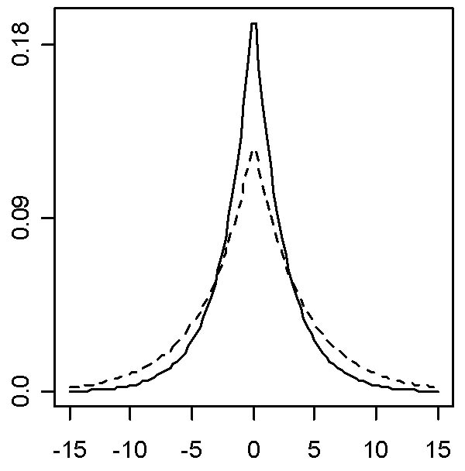
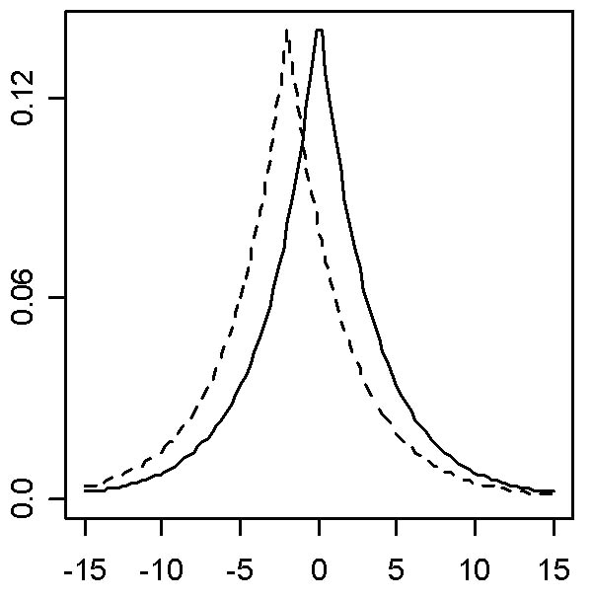
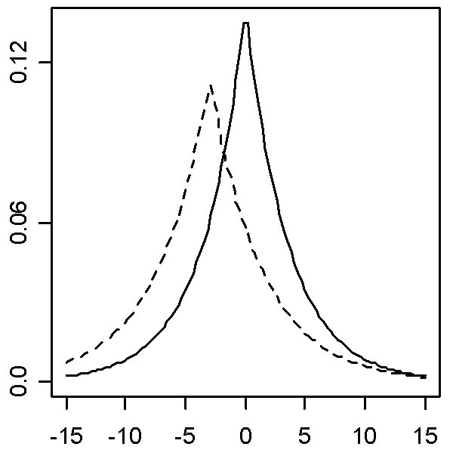
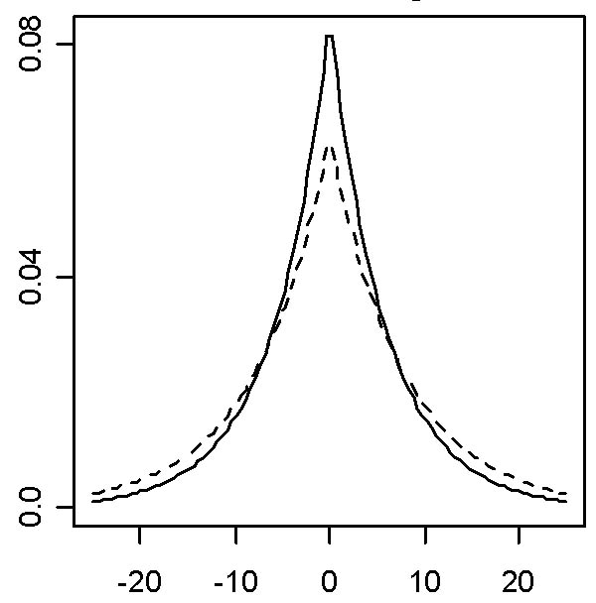
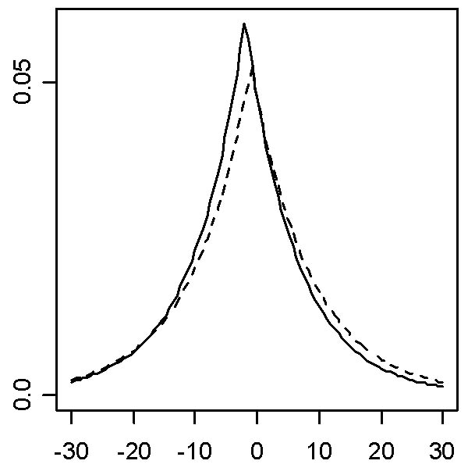
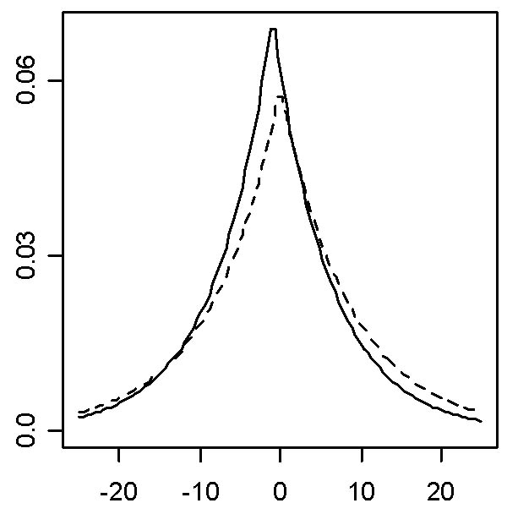
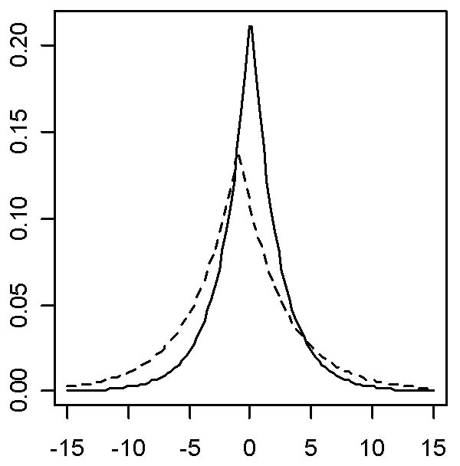
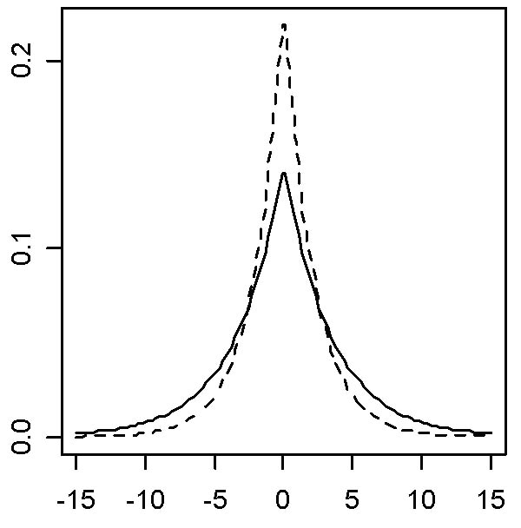
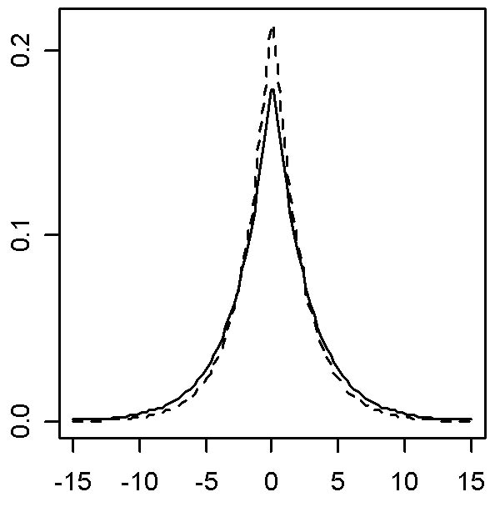
Figure 3.19. Parameters and Fit of Double Exponential Distribution to Steering Wheel Angle by Road Superclass, Age Group, and Distraction
(II) Major Road
(III) Minor Road
(I) Limited Access Road
(b) Age 41-50
(c) Age 61-70
(a) Age 21-30
Normal
Distracted
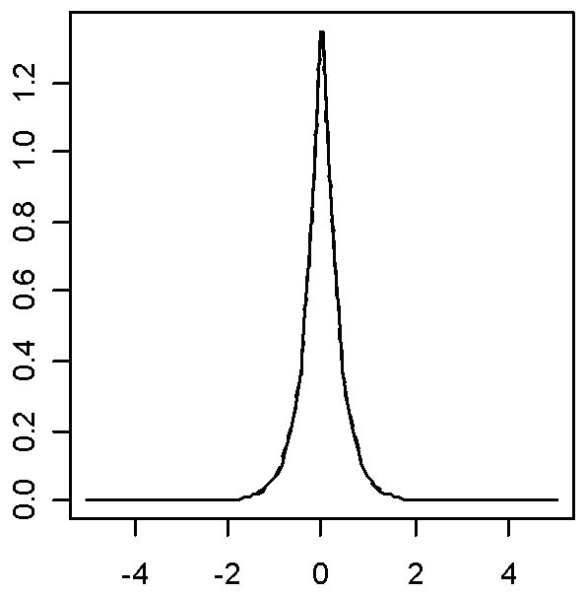
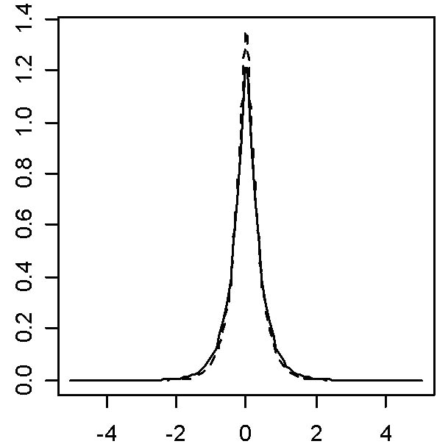
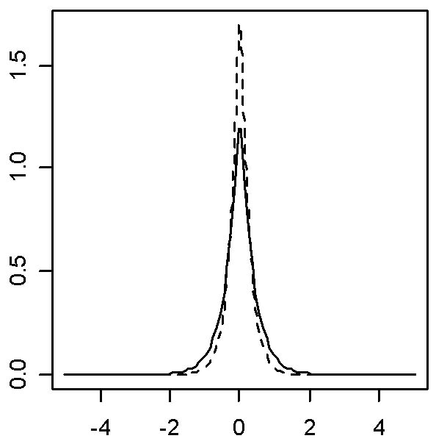
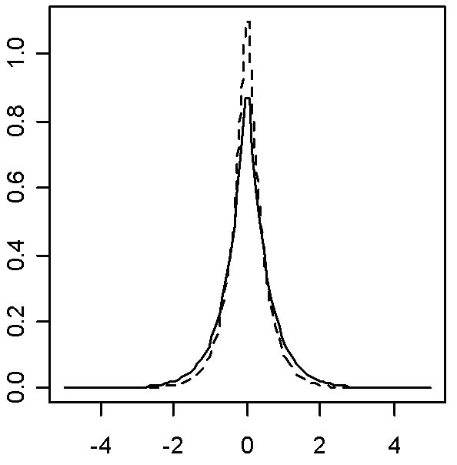
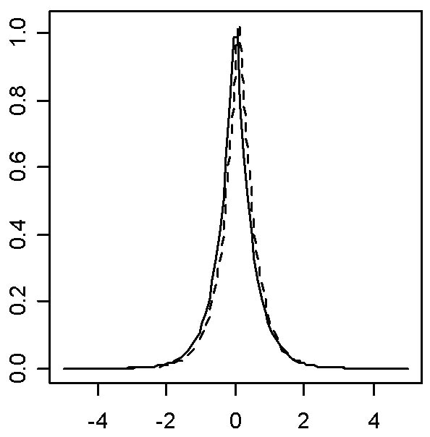
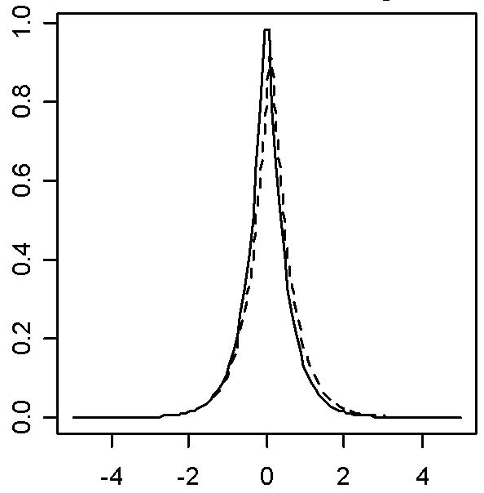
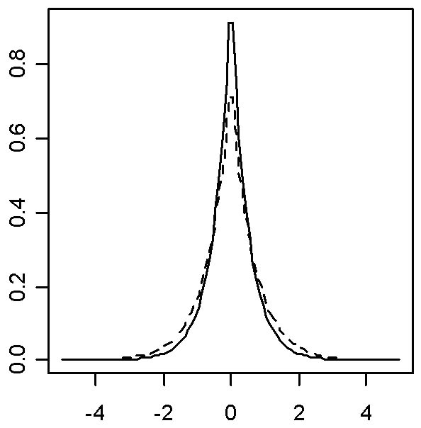
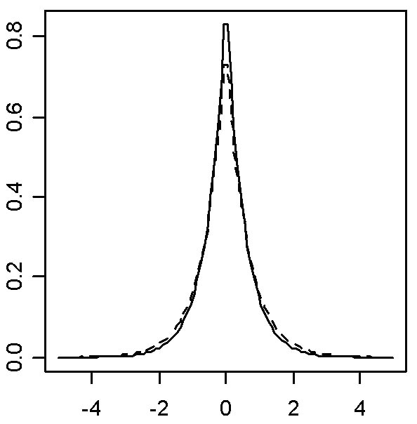
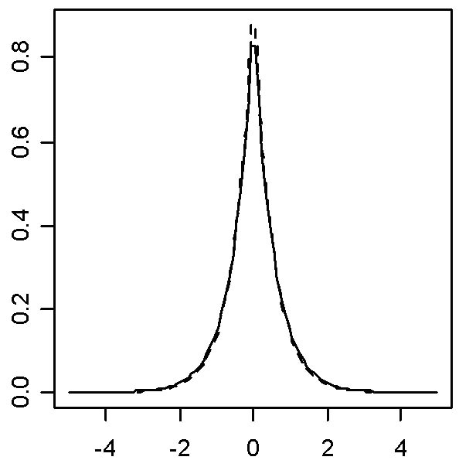
Normal
Distracted
(I) Limited Access Road
(b) Age 41-50
(c) Age 61-70
(a) Age 21-30
(II) Major Road
(III) Minor Road
Figure 3.20. Parameters and Fit of Double Exponential Distribution for Heading Angle by Road Superclass, Age Group, and Distraction

Throttle opening and speed were not as highly correlated with one another as were steering wheel and heading angle. Speed and throttle opening are bounded at the negative end (one cannot driver slower than zero) but have relatively unbounded maxima. Log normal distributions are usually fit in such situations, but for computational ease, a more general gamma distribution was used. As expected, distribution of throttle opening data had only 1 tail, so gamma distribution was appropriate. The distribution of speed, however, had 2 tails and observed data was spread more evenly throughout the range, giving a relatively symmetrical shape. So, although the distribution shape of speed data is not as regular as steering wheel or heading angle data, a double exponential function was used. The probability density function for a gamma distribution is as follows:

$$f(x)=\frac{β^{g}x^{g−1}\text{exp}(−βx)}{G(g)},(x³0,g,β>0)$$
Where, Γ denotes the gamma function
γ = shape parameter
1/β = scale parameter
γ/β = mean
${\sqrt{g}}/β$ = SD
$2/\sqrt{g}$ = skewness
$3+6/g$= kurtosis

The shape parameter (γ) determines the skewness and kurtosis (how peaked/flat) and so can be changed to fit a variety of throttle opening distributions. The scale parameter (1/β) determines the total scaling. Small γ values lead to larger skewness (more asymmetrical shape) and relatively peaky shape, with the peak close to zero. As γ increases, the skewness decreases asymptotically toward a flatter, more symmetrical shape.

The fitted standard deviation is similar for all road superclasses, and the fitted mean is smallest on minor roads and largest on limited access roads (Figure 3.21). Each distracted distribution had a higher fitted mean than its corresponding normal distribution, except for middle-aged drivers on minor roads. The shapes of normal and of distracted fit are fairly easily distinguishable, so distraction seems to have a significant effect on the fitted distribution for throttle opening. Both γ, the shape parameter, and β, the scale parameter, for distracted driving are generally larger than for normal driving. Based on the comparison of the parameters from the fitted and distribution data, the fit of the gamma distribution is better for normal than for distracted data but the fitted means are remarkably close for both distracted and normal data. (See Appendix D for comparison of standard deviation and mean for fitted and distribution data.)

The fitted standard deviation (as well as β) of speed is smallest on limited access roads, and the fitted mean (γ) is largest on limited access roads and smallest on minor roads (Figure 3.22). Based on comparison of the fitted and distributed data statistics, the fit of double exponential distribution is better for normal than distracted data, but the fitted means are fairly close for both distracted and normal data. (See Appendix D.)

For both throttle opening and speed, the effect of road superclass is greater than the effect of age group, but distraction also has a considerable effect. Based on a correlation analysis, the fitted means of throttle opening and speed are highly correlated (r = 0.88), but the SDs are not (r = 0.42). The SD change ratios of these measures were similarly analyzed and no correlation was found (r = 0.53). The change ratio of speed is less than that of throttle opening for almost all cases.

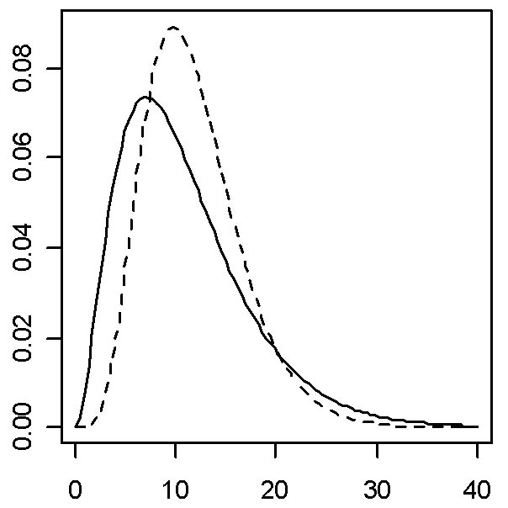
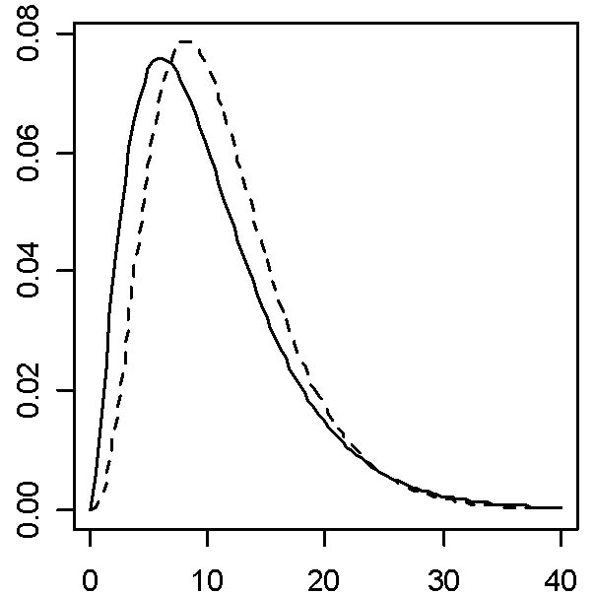
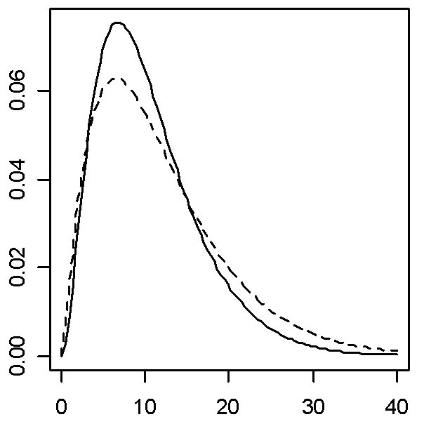
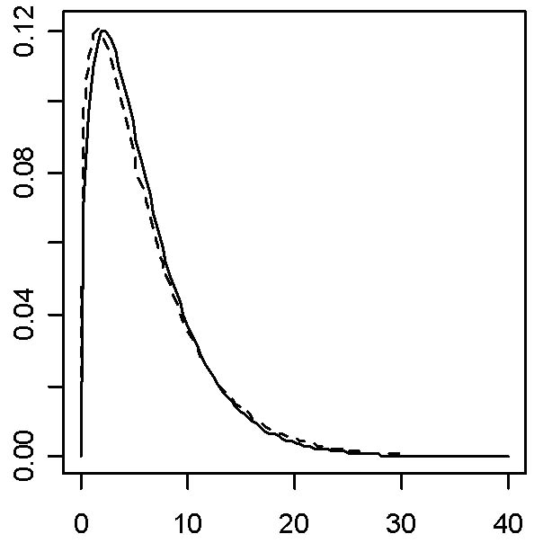
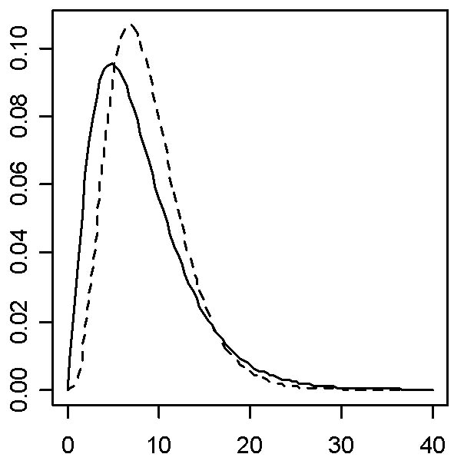
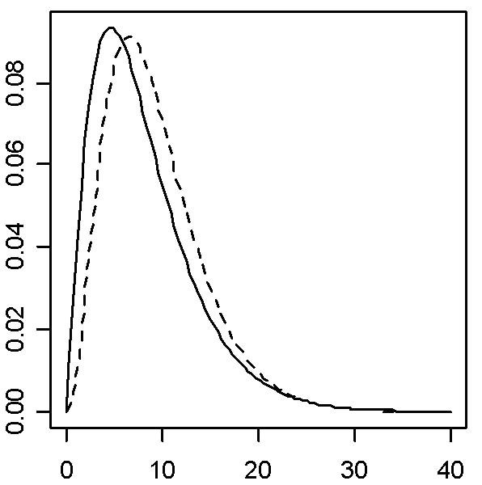
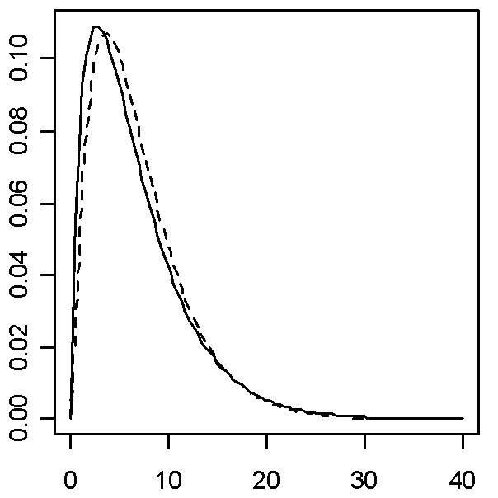
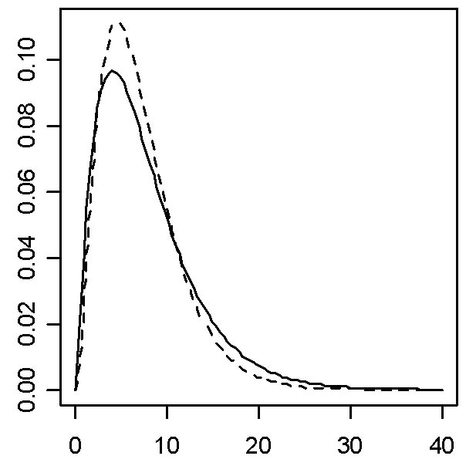
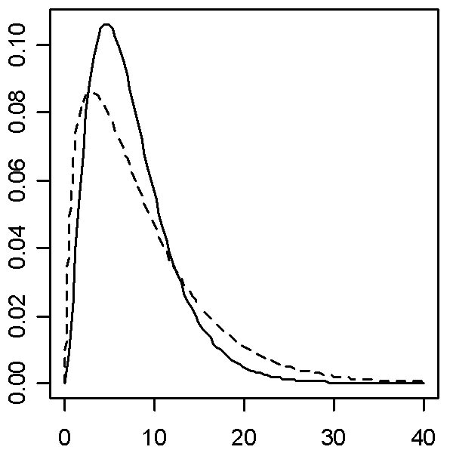
Figure 3.21. Parameters and Fit of Gamma Distributions to Throttle Opening
by Road Superclass, Age Group, and Distraction
Normal
Distracted
(I) Limited Access Road
(b) Age 41-50
(c) Age 61-70
(a) Age 21-30
(II) Major Road
(III) Minor Road

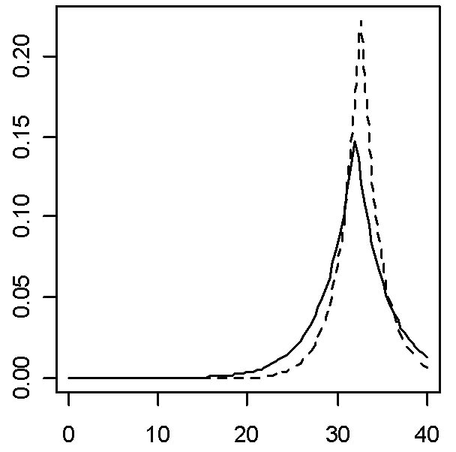
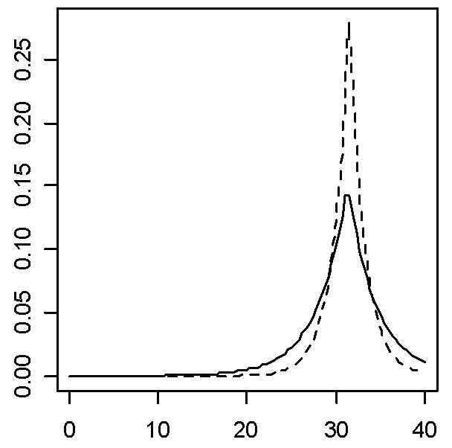
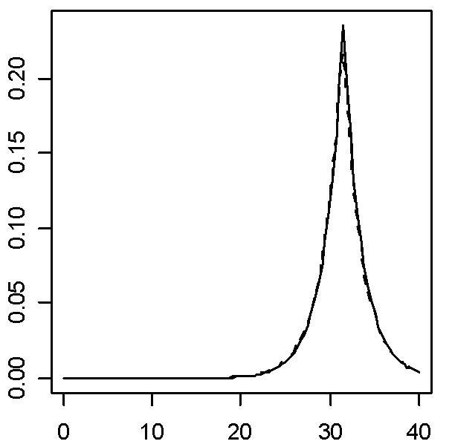
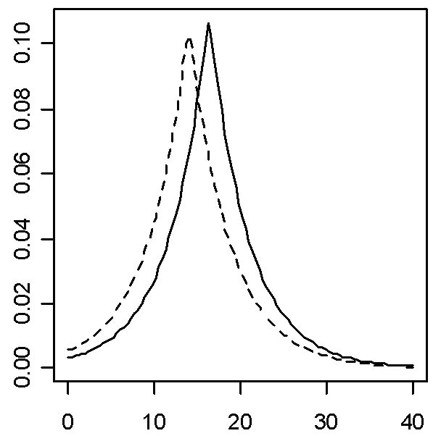
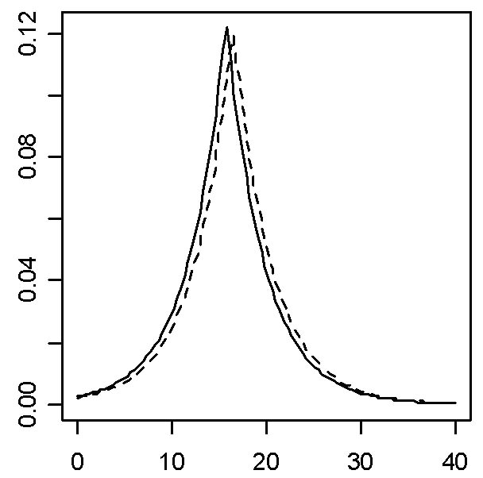
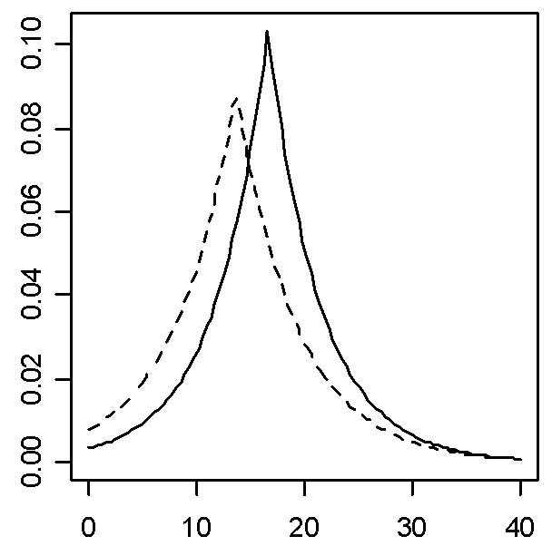
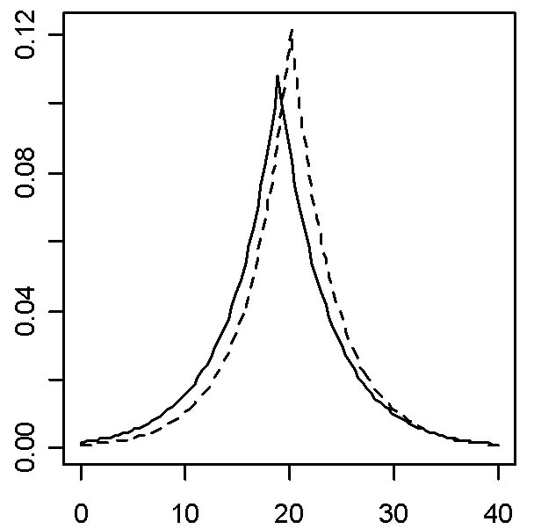
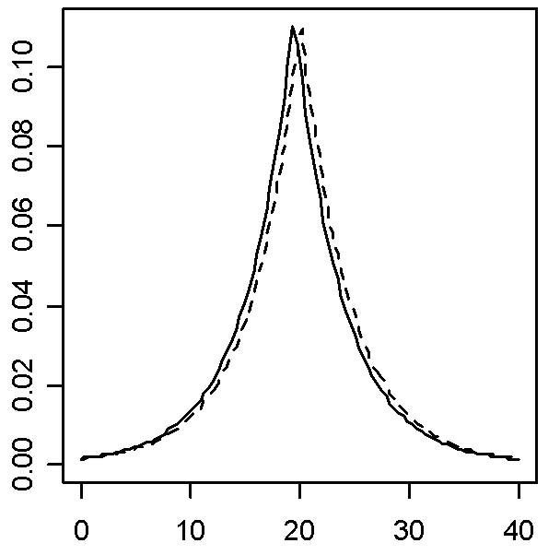
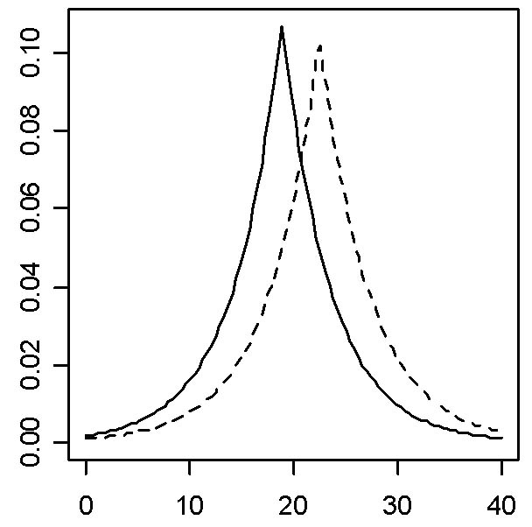
Figure 3.22 Parameters and Fit of Double Exponential Distributions to Speed
by Road Superclass, Age Group, and Distraction
Normal
Distracted
(I) Limited Access Road
(b) Age 41-50
(c) Age 61-70
(a) Age 21-30
(III) Minor Road
(II) Major Road

5. For all road types and driver age groups, which single throttle hold definition (sampling interval and size of change threshold (maximum minus minimum)) best distinguishes between normal and distracted driving?

According to Zylstra et al. (2003), it may be possible to use throttle holds to distinguish between normal and distracted driving. Remember that, in this report, distraction is determined by head position and “head-distracted” is whenever there were 4 or more consecutive frames (0.8 s) where the driver was not looking forward. ACAS FOT provides throttle data divided into 2-second clips with 1% accuracy, thus the throttle opening activity before and after the clip cannot be known. Given these constraints, a throttle hold in this report was defined as a duration of time (time window) in which the maximum minus the minimum throttle opening does not exceed some value (threshold). This part of the report explains how analysts determined which parameter values to use in the subsequent analysis.

To determine possible thresholds, analysts found the maximum minus the minimum throttle opening (threshold) for 811 clips from the ACAS FOT data (Figure 3.23). Note that the distribution is skewed toward lower values (zero change in throttle opening in more than 300 of the 811 clips). The median and mean of this throttle opening distribution are 3 and 4.3, respectively. So thresholds of 1, 2, 3, and 4 were considered.
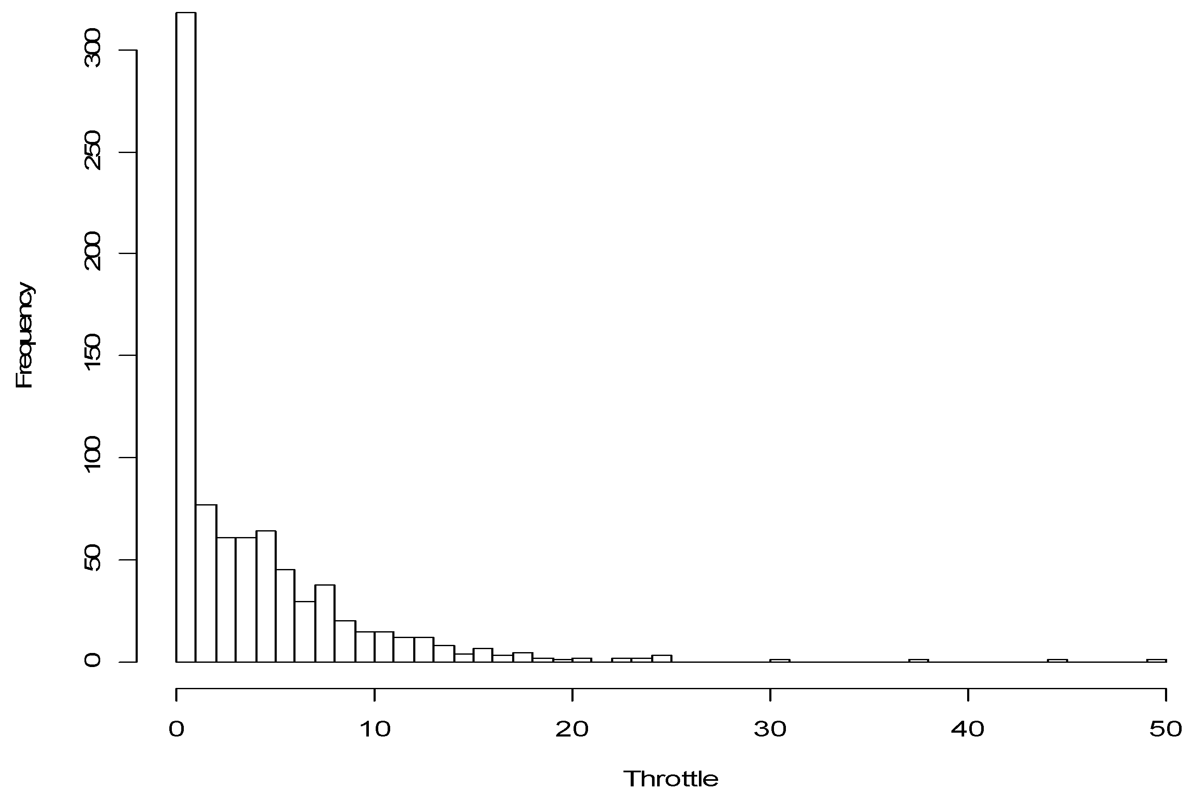
010 20 30 40 50
Maximum - Minimum Throttle Opening (Threshold)
300
250
200
150
100
50
0
N = 811
Min = 0.0
Max = 50.0
Mean = 4.3
P25 = 1.0
P50 = 3.0
P75 = 6.0

Figure 3.23. Histogram of Maximum Minus Minimum Throttle Opening of Each Clip

Each clip was about 4 s long, so the maximum time window is 4 s. Therefore analysts chose time windows of 1, 2, and 4 s for consideration. The hold ratio (holds/nonholds) for normal versus distracted driving was used to compare results for different parameters. Using hold ratios to compare results for each possible threshold showed that the largest difference between hold ratios in normal and distracted driving occurred when threshold = 4. (See Appendix E for thresholds = 1, 2, and 3.) As shown in Figure 3.24, where threshold = 4, the greatest difference between normal and distracted hold ratios, the highest frequency of throttle holds, and the most consistency across road superclass and age groups occurs when time window = 1 s. So the parameter values chosen for continuing analysis were threshold = 4 and time window = 1 s. The difference between the ratios generally decreased with driver age.

(III) Minor Road
(II) Major Road
(I) Limited Access Road
(b) Age 41-50
(c) Age 61-70
(a) Age 21-30
Normal
Distracted
Figure 3.24. Normal and Distracted Hold Ratios for Each Time Window by
Road Superclass and Age Group (Threshold = 4)

It is extremely important to note that, according to the throttle hold definition and parameters used in this report, throttle holds are more common overall in normal driving than in distracted driving. This result is exactly the opposite of the expected outcome as the hypothesis was based on Zylstra et al. (2003), which states that throttle holds are more likely when drivers are distracted. The conflicting results may be because Zylstra et al. proposed a more precise algorithm with much longer time series patterns to identify throttle holds and/or because of the low resolution of ACAS FOT throttle opening data. Since sensors only registered changes on the order of 1% at a time, micro corrections may not have been detected. In addition, the large throttle change immediately after a hold may not be considered if it occurs outside the time window. Further analyses should examine windows around 1 s, where the differences between hold ratios in normal and distracted driving are greatest.

The selected parameters (threshold = 4, time window = 1 s) were used to perform an analysis of odds ratios. The odds ratio is defined as follows:

$$\text{Hold Ratio=}\frac{\text{ holds}}{\text{ nonholds}},\text{ Odds ratio=}\frac{\text{distracted hold ratio}}{\text{normal hold ratio}}$$

The odds ratio represents how well throttle holds could be used to distinguish distracted from normal driving. When odds ratio = 1, hits (correctly identified as distracted) and false alarms (incorrectly identified as distracted) occur with equal frequency. When the odds ratio is greater than 1, hits occur more frequently than false alarms. Since throttle holds, as defined in this report, are more common in normal driving than in distracted driving, the hold ratio is inverted here so that results are positive. Results of the odds ratio analysis (1/odds ratio) are shown in Figure 3.25. The lower the odds ratio, the less effect distracted driving has on the frequency of the throttle holds, and the higher the odds ratio, the more distracted driving reduces the frequency of throttle holds.

Figure 3.25. 1/Odds Ratio by Road Superclass and Age Group
Odds Ratio
Road Superclass

All odds ratios are greater than 1 except for older drivers on major roads so, in general, hits occur more frequently than false alarms. Limited access road had the largest odds ratio for all age groups, so throttle holds can best distinguish between normal and distracted driving on limited access roads. Road superclass had a stronger effect on odds ratio than did age group. But among age groups, older drivers had the lowest odds ratios and middle-aged drivers had the highest.

6. As a function of road type, driver age group, driver sex, and how a throttle hold is defined, what are the odds of distracted driving?
A logistic regression model was fit to the descriptive statistics to assess how effectively throttle holds can be used to distinguish normal and distracted driving for different road superclasses, age groups, and driver sexes. As shown in the previous section, throttle hold parameter values with time window=1 s and threshold=4 provide the largest difference between normal and distracted throttle holds and the most consistent trends for all road superclasses and age groups.

The response variable in the model was distraction, and it was coded as 1 if a driver was distracted and 0 if a driver was not distracted. As before, a driver is considered distracted if there were 4 or more consecutive frames in which the driver’s head position was not looking forward at the forward scene. The predictor variables are all categorical and the first level of each is designated the baseline case. The predictor variable categories and baseline cases are: throttle hold (nonhold is baseline), age group (age 21-30 is baseline), road superclass (limited access is baseline), and driver sex (female is baseline). For example, the driver sex variable has 2 levels: female and male. Female is the baseline case since it is designated by the first level. So if a driver is female the driver variable is set to zero. If a driver is male the driver variable is set to 1, so the estimate for males is the only driver sex parameter that appears in the model.

Parameter estimates in the logistic model have interpretations on the log odds scale. Namely, in the logistic regression model we assume that the log odds scale can be approximated by a linear function of the parameters:

$\text{log}\left(\frac{P(\text{distracted})}{P(\text{nondistracted})}\right)=b+a_{1}x_{1}+a_{2}x_{2}L$.

In the baseline case, all predictor variables (x_{i}) are set to zero, so the estimate is simply b, the intercept estimate. The estimate a_{i} represents how much the log odds scale changes when the estimate’s corresponding categorical data is changed from the baseline condition. A positive value estimate means that distracted driving is more likely with the corresponding categorical variable than in baseline driving; conversely, a negative value means that distraction is less likely. The odds ratio of distraction with a 95% confidence interval for each condition compared to baseline driving can be calculated by:

Baseline Odds Ratio = exp(Estimate)
95% confidence Interval = exp(Est. ± 1. 96 * Std. Err.)

For example, for throttle hold, the odds ratio of distracted driving is exp(-0.300)=0.74 and the confidence interval is: exp(-0.300 ± 1. 96 * 0.112) = (0.594, 0.923). (See Table 3.23.) So the odds of distracted driving with throttle hold are 0.741 times (95% confidence) the odds of distracted driving with nonhold, the baseline condition. The negative estimate for throttle holds indicates that drivers engaged in throttle holds were less likely to be distracted than those engaged in nonholds. This is consistent with findings of parameter selection analysis (Question 5). Percent distraction can be calculated by:

Odds = exp(parameter Est.) * exp(baseline Est.)
% Distraction = (Odds / (1 + Odds))*100

So, the percentage of distracted driving based on throttle holds is computed as:

Odds = (exp(-.300) * exp(-3.339) = 0.0263,
so % Distraction = (0.0263 / (1 + 0.0263)) * 100 = 2.56%.

Table 3.23. Logistic Regression Model for Distraction Adjusting for Throttle Hold, Road Superclass, Age Group, and Driver Sex

Many interaction terms make it difficult to interpret the fit of a logistic regression model to the ACAS FOT data, but there were no interaction terms involving throttle holds. This is because the effect of distraction on throttle holds was consistent for all road superclasses and age groups when throttle hold parameters are time window = 1 s and threshold = 4. Table 3.24 shows the data, the observed and model-based probabilities of distraction, and the model-based residuals. Some observations (9, 21, 33, and 35) were not fit in the model because they correspond to either very small observed probabilities, such as 0, or very large observed probabilities relative to the rest of the data. All outlier observations were from older drivers (age group 61-70) for nonholds, and 3 of the 4 were females. The residuals indicate the goodness-of-fit of the model as residuals with magnitude greater than 2 (⎪residual⎪ > 2) represent potential outliers. The small observed and predicted probabilities show that distracted driving, as defined in this report, is a fairly rare event. The predicted probabilities range from 0.0256 to 0.1528. The table also shows that throttle holds are much more prevalent than nonholds.

Table 3.24. Results of Model Fit: Observed and Predicted Probabilities, Model Residuals, and Observed and Predicted Odds
Abbreviations:Obs.-Observation
Road -Road Superclass (1: Limited Access, 2: Major, 3: Minor)
Age -Age Group (1: 21-40, 2: 41-50, 3: 61-70)
Sex -Driver Sex (1: Female, 2: Male)
Hold -Throttle Hold (1: Nonhold, 2: Throttle Hold)
Dist/Norm - Number of Distracted/Normal Frames
Resid. - Residuals

Observed odds and model-based predicted odds of distraction are shown in the right end of the table. Estimated odds ratios can be calculated by dividing any 2 predicted odds ratios. For example, to compare distraction during throttle hold to that in nonthrottle hold, divide the predicted odds of nonhold by that of hold (the first 2 lines of the table). When a driver was not in a throttle hold, the odds of being distracted were 1.35 times (0.0355/0.0263=1.35) greater than when in a hold. Note that because this model contains no interaction terms involving throttle, comparing observations where the only difference is in throttle hold will lead to the same result. For example, the odds ratio for observations 15 and 16 is 1.35, the same as before (0.1803/0.1336 = 1.35).

Any other odds ratios of interest can be compared similarly. For example, the odds of being distracted for an older male driver on a limited access road who is not in a throttle hold (observation 11) was 3.68 times greater than for a young female driver on limited access roads who is not in a throttle hold (observation 1) (0.1306/0.0355 = 3.68). Note that road superclass and throttle remain constant, so this fairly large effect is due entirely to age group and driver sex differences. As another example, the estimated odds of distracted driving for a middle-aged male driver on a minor road who is not in a throttle hold (observation 31) was 2.23 times greater than for a young female driver on a major road who is not in a throttle hold (observation 13) (1459/0.0654 = 2.23).

As shown in this section, the logistic regression model that can estimate probability of distracted driving based on throttle hold and other driving-related variables was possible after setting a time window and a threshold appropriately. In addition, throttle hold’s rate of contribution to distracted driving is almost independent of the other parameters even though road superclass, age group, and driver sex each have a significant effect.

7. For each specific road type and driver age group, which throttle hold definition best distinguishes between normal and distracted driving?

Keeping the time window and threshold the same for every road superclass and age group combination yields consistent results, but they are opposite to the results of Zylstra et al. (2003). As seen in the window duration and threshold selection, hold ratios also vary by road superclass and age groups. Therefore, it is reasonable that in some cases, a different definition of throttle holds (different parameters) would improve ability to distinguish normal and distracted driving in those situations and determine whether throttle holds are more frequent for normal driving (as shown in this report) or for distracted driving (as reported by Zylstra, et al.).

As in Question 5, odds ratios are used to examine how effectively throttle holds can be used to distinguish normal and distracted driving (Figure 3.26). However, in this case, throttle holds should increase (not decrease) during distracted driving. Thus odds used here are of hold to nonhold, not nonhold to hold. The odds ratio is defined as follows:

$\text{Hold ratio}=\frac{\text{ holds}}{\text{ nonholds}},\text{ Odds ratio=}\frac{\text{distracted hold ratio}}{\text{normal hold ratio}}$,

When the odds ratio is greater than 1 there are more hits than false alarms; that is, the results are consistent with the intermittent control hypothesis proposed in Zylstra et al. (2003). The odds ratio increases as the ratio of holds to nonholds during distracted driving increases and as the ratio of hits to false alarms increases. In short, the best definition of throttle hold corresponds to the highest odds ratio value.

When 0% throttle opening occurs it is impossible to determine whether the driver’s foot was resting on the accelerator, so throttle holds that occur at 0% are excluded in this analysis as they may not accurately reflect distraction. When throttle opening is very small, the driver is likely either driving at very low speed, slowing down, or maintaining speed with vehicle inertia, so throttle holds that occur in this range may also be misleading. Thus, when determining the best throttle-hold parameters for each road superclass and age group combination, only data with throttle openings exceeding a certain value was analyzed. Road superclass has a significant effect on the distribution of throttle opening, so to be considered throttle opening must be greater than 5% on limited access roads, 3% on major roads, and 2% on minor roads. The ranges of throttle openings analyzed for each road superclass were determined by testing several options to see how the range affected the odds ratio.
Figure 3.26. Odds Ratio at Various Thresholds by Road Superclass
and Age Group
(III) Minor Road
(II) Major Road
(I) Limited Access Road
(b) Age 41-50
(c) Age 61-70
(a) Age 21-30
1 sec
2 sec
4 sec
Time Window:
The best definition of throttle hold (based on odds ratio) varies considerably according to road superclass and age group. For example, on limited access roads the larger time windows are more effective than the standard 1 s time window. Smaller thresholds are more effective for young drivers and larger thresholds are best for older drivers, possibly because young drivers make more precise corrections. Overall, throttle hold effectively distinguished between normal and distracted driving on limited access and major roads, as at least one combination of time window and threshold parameters yields odds ratios greater than 1. But for middle-aged and older drivers on minor roads, there is no effective combination. This may be because certain features of minor roads (frequent speed changes, turns, etc.) do not allow throttle holds that are detectable at this resolution. The standard throttle hold definition (time window = 1 s, threshold = 4) is best for only one road superclass-age group combination: middle-aged drivers on major roads.

In general, varying the time window and threshold according to road superclass and age group produces much greater success than using the same parameters for all combinations and, in most cases, the results are consistent with Zylstra et al. (2003). The odds ratios in this section are generally greater than those obtained in Question 5 (Figure ). However, previous results were better for middle-aged drivers on limited access roads and for middle-aged and older drivers on minor roads.

8. In addition to throttle holds, which statistics (e.g., mean, frequency above or below some extreme) for which driving-related measures (e.g., lead vehicle range, lane width, outside temperature, etc.) best distinguish between normal and distracted driving?

In this section, 36 driving variables (Table 3.25) relating to vehicle behavior, traffic condition, road superclass, and road geometry were selected and separated into 112 predictor variables. (See Appendix F for selection logic.) The driving variables were selected to cover the categories of variability thought to be important but at the same time avoid overwhelming the analyst (and the reader) with an incomprehensibly large data set. The predictor variables were individually fit in a logistic regression model to study how they varied by distraction. Variables could be binary, categorical, or continuous. For some continuous variables, such as LaneWidth, each unit change in that measure led to the associated estimate effect on distraction. Other continuous variables were analyzed based on cases, namely whether the value was below the 0.05 quantile (“05” case), between the 0.05 and the 0.95 quantiles (“0595” case), or above the 0.95 quantile (“95” case). Categorical variables, such as AgeGroup, had 3 levels with a baseline (2 and 3 cases). Binary variables, such as TurnSig, were either active or inactive (2 cases).

As before, distraction is the response variable and is coded as 1 in the logistic regression model if a driver was distracted, and as 0 if not distracted. The first level of each predictor variable is regarded as the baseline case. The numbers that append the predictor variable name indicate the case (if categorical) or the quantile range (if continuous) that was categorized as 1. All other values were categorized as 0.
A variable name appended by “05,” such as AZPtoP05 (peak to peak vertical acceleration), means that values less than the 0.05 quantile were categorized as 1, and all other values as 0. Similarly, a variable name appended by “0595,” such as TRANSSPEED0595 (vehicle speed measured by the transmission controller,) means that the values less than the 0.05 quantile or above the 0.95 quantile were categorized as 1, and values in between were categorized as 0. A variable name appended by “2” or “3” means that the second or third case, respectively, is categorized as 1 and all other values are categorized as 0. For example, for AgeGroup, young drivers make up the first or baseline case, and for TurnSig, off is the baseline case and coded as 0 and turn signal on is coded as 1.

Table 3.25. Predictor Variable Names and Descriptions

Descriptive statistics (such as those for steering wheel angle, etc.) show that extreme values, values in the left and right tails, vary according to road superclass. Therefore, a separate logistic regression model was constructed for each road superclass.

Predictor variables were ranked according to deviance for each road superclass. Deviance is a goodness-of-fit statistic similar to the well-known residual sum of squares used in ordinary least squares regression models. The smaller the deviance value, the better the overall fit. A table of the ranking of deviances for each predictor variable in each road superclass can be found in Appendix F. The 6 best predictors for each road superclass were chosen to use in a logistic regression model. However, if a predictor variable was highly correlated with another variable already included in the model, it was excluded from further analysis.

The results of the variable selection models for limited access roads are shown in Table 3.26. The 6 best predictor ranked variables for limited access roads are as follows: TurnSig, AgeGroup, TransSpeed0595, VP2, VPdot, and LaneOffConf. Note that AZPtoP05 was excluded, even though it ranks as the third best predictor (see Appendix F), because it was highly correlated with another predictor variable. The odds of distraction associated with a positive estimate are higher than for baseline driving, whereas with a negative estimate, distracted is more common than baseline driving. The baseline odds ratio is a comparison of the odds of distraction for each parameter to the odds of distraction in baseline driving as is calculated as:

Baseline Odds Ratio= exp(Estimate)

The odds of distraction to normal driving for each condition can be calculated by multiplying the odds of distraction at baseline with the condition’s baseline odds ratio. From those odds, estimated percentage of distraction for each condition can be calculated as odds/(1+odds)*100. The percentage of distraction for baseline driving on limited access roads is 7.6% ((exp(-2.497)/(1+(exp(-2.497))*100 = 7.6%). A large standard error (Std. Error) is an indication of autocorrelation between two or more predictors in the model.

Table 3.26. Logistic Regression Model Fit to Selected Variables for
Limited Access Roads

TurnSig (turn signal) had the smallest deviance and is the parameter most significantly affected by driver distraction. Turn signal use is associated with a 5.186 times increase in odds of distraction, so about 29.9% of drivers with turn signals on were distracted. This may be because situations where turn signals are used (e.g., changing lanes) require that the driver looks away from the forward scene to assess the safety of the maneuver. So although the driver was frequently looking away from the forward scene during turn signal use, there may have been no internal distraction or secondary task being performed.

AgeGroup (age group) also increased the rate of distraction as middle-aged and older drivers were about twice as likely to be distracted as young drivers (baseline). There was no significant difference between odds of distraction for the 2 older age groups.

The remaining parameters each have negative estimates, so the rate of distraction decreases from the baseline level of when they are included. TransSpeed0595 (transmission speed) had a fairly strong effect since when speed was in the lower 0.05 tail or in the upper 0.95 tail of the distribution, drivers were only about 26% (odds ratio = 0.243) as likely to be distracted than with baseline (TransSpeed between 0.05 and 0.95 quantiles) so only 2% of drivers in this speed range would be distracted. This may be because when drivers travel at very low or high speeds, they are usually performing a maneuver or have some other intention so their situation awareness is relatively high and they choose not to perform a secondary task at that time. In other words, drivers may be more likely to be distracted in normal/stable conditions rather than in demanding conditions.

For variable VP2 (velocity of the current in-path vehicle), drivers were about half as likely to be distracted when velocity of the lead vehicle was between 0 and 30 m/s (VP22) than under baseline conditions. However, when velocity of the lead vehicle was greater than 30m/s (VP23), there was no significant effect. This is reasonable, since the speed of the lead vehicle has little effect on the subject vehicle unless the lead vehicle is traveling more slowly than the subject wishes to go.

For VPdot05 (deceleration of current in path vehicle), distraction was almost nonexistent (0.5%) when deceleration of the lead vehicle was in the lower 0.05 tail of the distribution. This is a very strong effect, but the standard error is also large (1.01), so there is some uncertainty in this estimate. As large standard errors may indicate autocorrelation, it is likely that VP2 and VPdot05 are correlated, although VPdot05 is significant at p<0.005.

LaneOffConf (lane offset confidence) is an ordered variable with 3 levels (baseline: none (0), low/medium: 2, high: 3) and the associated distraction rates appear to have a linear trend (7.6% (baseline), 5.3, and 3.3). That is, as LaneOffConf increases, drivers were less likely to be distracted. This implies when lane markings are difficult to see, the driver has to concentrate more on the primary driving task, so distraction is less frequent. Lane offset confidence is not a factor that has been identified in any well-known studies of distraction relating to workload managers.

The results of the variable selection models for major roads are shown in Table 3.27. The 6 best predictor variables for major roads are as follows: Gender, CipvRange, Geometry40, Brake, LaneOffConf, and AxpTop. The rate of distraction for baseline driving on major roads is 4.2%. Note that a number of variables had smaller deviances than some of the variables included but they were highly autocorrelated with other predictors already in the model (such as Geometry40) and were therefore excluded. It is interesting to note, however, that the small forward road geometry variables appear to be associated with distracted driving.

Table 3.27. Logistic Regression Model Fit to Selected Variables for Major Roads

According to the model, Gender is most closely associated with distraction on major roads and the odds of distraction were almost 3 times (odds ratio = 2.689) higher for males than for females (baseline).

For CipvRange (range to closest in path vehicle), the odds of distraction were slightly, but not significantly, decreased when the range was between 0 and 60 m (CipvRange2), but were increased nearly 2.5 times when range was greater than 60 m (CipvRange3). This is reasonable since when the range to the lead vehicle is large, risk is perceived to be lower, so drivers may be more likely to engage in distracting behavior in such situations.

The estimates for Geometry40 and Brake are negative, so the odds of being distracted are around half that of baseline driving (0.589 and 0.385, respectively). This implies that brakes are employed when the driver perceives sufficient risk (e.g., to slow down to avoid hitting the lead vehicle, to perform a maneuver, when approaching an intersection, etc.) so the driver has high situational awareness and thus is less likely to be distracted.

Note that LaneOffConf (lane offset confidence) is an ordered categorical variable and was also selected for the limited access roads model. In that model the coefficients were negative and tended to show a linear trend. However, in the major roads model the estimates are positive, and there is no apparent linear trend. Low/medium lane confidence (LaneOffConf2) has no significant effect, but high confidence does, as the estimated rate of distracted driving is about twice the baseline rate. So, as with limited access roads, drivers are more likely to engage in distraction behavior when lane offset confidence is high.

The final parameter for major roads, AzpTop (peak to peak vertical acceleration from ABS), is a continuous variable with a negative estimate, so a unit increase in this parameter decreases the odds of distraction to about 1/3.

The results of the variable selection models for minor roads are shown in Table 3.28. The 6 best predictor variables for minor roads are as follows: LaneWidth, OutsideTemp0595, TransSpeed, Geometry120, LaneOffSet0595 and VpDot. The rate of distraction for baseline driving on minor roads is 1.3%, the lowest of any road type. As before, some variables with small deviances were highly autocorrelated with other predictors already in the model and were excluded. It is interesting to note that many of the higher numbered road geometry variables are associated with distracted driving on minor roads. This contrasts with major roads in which the lower numbered road geometry variables were significant. Therefore, one might argue that in terms of driver distraction, the lower numbered road geometry variables are characteristic of major roads, while the higher numbered road geometry variables are characteristic of minor roads.

Table 3.28. Logistic Regression Model Fit to Selected Variables for Minor Roads

Note that almost all of the selected parameters are continuous. For each unit increase in LaneWidth (the most closely associated parameter), the estimated odds of distracted driving increases by 2.18 times (1.3 to 2.7%). So when lane width is large, drivers are more likely to engage in distracting behavior.

Outside temperatures in the lower and upper distribution tails decrease the rate of distraction from 1.3% to about 0.4%. This implies that drivers are less likely to engage in distracting behaviors when the temperature is either very hot or very cold.

For TransSpeed, each unit increase in speed (m/s) decreases the odds of distraction to 0.956, its baseline value. However, larger changes are common (e.g., a 10 unit increase) and would have a larger effect on reducing the rate of distraction.

The estimate for Geometry120 is quite small (-0.018), so each degree of change in the variable leads to a small change in odds, though larger changes in geometry have a more significant effect. For a thirty unit decrease in Geometry120, the estimated odds of distracted driving increases to 0.6 times its baseline value (exp(-0.018*30) = 0.6).

For LaneOffSet0595 (lane offset confidence), the rate of distraction increases by about 50% when the value is in the upper or lower tail of the distribution. Thus, not surprisingly, extreme lane positions occur more frequently when the driver is distracted.

For a one unit increase in VpDot (deceleration of current in path vehicle), the estimated odds of distracted driving increase to 1.57 times the baseline value. This means that when the lead vehicle decelerates and the subject vehicle does not (relative deceleration), distraction is more likely, explaining why the subject vehicle does not respond to the lead vehicle’s change in velocity.

CONCLUSIONS

1. What are the values of descriptive statistics (e.g., mean, standard deviation, etc.) for common driving performance measures (steering wheel angle, heading angle, throttle opening and speed)?

Steering wheel angle and heading angle are highly correlated, so the distribution of overall data for each has the same shape and general features. Both are symmetrical and observed frequency drops sharply with displacement. This creates a sharp peak at 0 degrees and most of the data lies within a very small range of the peak. Throttle opening and speed are related to each other, but are not as highly correlated as steering wheel angle and heading angle. Throttle opening data is skewed toward the lower measurements as the vast majority of data is between 0 and 20%, where speed data is spread quite evenly through the range of measurements. Both distributions are somewhat bimodal, probably because road type, not accounted for in overall data, has a strong effect on speed and therefore throttle opening. Descriptive statistics for steering wheel angle, heading angle, throttle opening, and speed are shown in Table 3.29.

Table 3.29. Descriptive Statistics Based on Overall Data for
Driving Performance Measures

Driving Performance Measure | Min | Max | Mean | SD | P25 | P50 | P75
Steering Wheel Angle (deg) | -176 | 171 | -1 | 12 | -3 | 0 | 0
Heading Angle (deg) | -8 | 12 | 0 | 2 | 0 | 0.0 | 0.3
Throttle Opening (%) | 0 | 47 | 8 | 6 | 4 | 8 | 12
Speed (m/s) | 4.3 | 40.0 | 22.4 | 8.5 | 15.7 | 21.6 | 30.7

The negative steering wheel mean (-1 degree) is likely due to sensor error since the resulting heading angle mean (0 degrees) is not negative. The large differences between statistics of steering wheel angle and heading angle data (e.g., standard deviation is 12 and 1 deg, respectively) are due to gain differences.

2. How do road type and driver age affect those statistics?

The distributions of steering wheel and heading angle remain similar to those of the overall data when separated by road type and age group, with sharp peaks at about 0 degrees. Two-way ANOVA testing showed that the only significant factor for both measures was for standard deviation by road superclass. Standard deviations for both measures were smallest on limited access roads and largest on minor roads (consistent with Sayer et al. (2005) findings). Since age group has no significant effect on standard deviation of steering wheel or heading angle, the values for each road superclass were averaged across age groups to illustrate the changes (Table 3.30).

The bimodal shape of the overall throttle opening and speed data nearly disappears when separated by road superclass and age group. Two-way ANOVA testing of mean and standard deviation by road superclass showed that although no terms significantly affected the standard deviations, all terms significantly affected the means, though the effect of road superclass was dominant (consistent with Sayer et al. (2005) findings). Since road superclass has the dominant effect, the mean values for each road superclass were averaged to illustrate the changes (Table 3.30). So for throttle opening, the mean is highest on limited access roads and roughly the same for major and minor roads. For speed, mean is highest on limited access roads and lowest on minor roads (speed is highly correlated with road type).

Table 3.30. Driving Performance Statistics by Road Superclass

Road Superclass | SD |  | Mean
Road Superclass | Steering Wheel Angle  (deg) | Heading Angle  (deg) | Throttle Opening (%) | Speed  (m/s)
Limited Access | 4 | 1 | 11 | 30.7
Major | 7 | 1 | 7 | 19.2
Minor | 18 | 1 | 7 | 15.6

3. How does distraction (as determined by head position) affect those statistics?

Three-way ANOVA was used to determine how mean and SD over various driver performance measures are affected by distraction (as well as road superclass and driver age). Distraction had a direct effect on mean for both heading angle (p<0.01) and throttle opening (p<0.05). There are also many distraction interaction effects for mean. However, distraction had a direct effect on standard deviation (not mean) for both steering wheel angle (p<0.05) and speed (p<0.01).

The ratio of change in standard deviation for each measure was computed to examine the size of the distraction effect (change ratio = {distracted SD – normal SD} / normal SD). Change ratio analysis shows that age group was important to the magnitude of change in SD for steering wheel angle. When young drivers were distracted, the SD of steering wheel was higher than in normal driving (positive change ratio, 0.53). However, when middle-aged and older drivers were distracted, the SD of steering wheel angle was lower than in normal driving (-0.30 and -0.16, respectively). This trend for young drivers is consistent with Green et al. (2004) and Sayer et al. (2005). Change ratio analysis for heading angle showed that road superclass, not age group, was important to the magnitude of change in SD. When subjects were distracted on limited access and major roads, the SD of heading was lower than in normal driving (-0.16 and -0.23, respectively). However, when subjects were distracted on minor roads, the SD of heading angle wash higher than in normal driving (0.31). Consistent with the literature, the SD change ratios for throttle opening and speed showed no significant trends.

What distributions fit those statistics?

To determine when a statistic for a driving performance measure differs from the norm (such as when a driver is distracted), one needs to know the distributions for normal and distracted driving situations. The distribution of steering wheel angle and heading angle have 2 tails and are quite symmetrical, so the double negative exponential distribution is a good fit for these measures. Theoretically, speed and throttle opening are bounded at the negative end but have relatively unbounded maxima. The distribution of throttle opening fits this expectation, so a gamma distribution provided the best fit. The distribution of speed, however, had 2 tails and was relatively symmetrical, so a double exponential function was also fit to speed.

There were only small differences between fitted normal and distracted steering wheel distributions and even smaller differences for heading angle. So, although the model provided a good fit for heading angle data, in most cases, the distracted and normal distributions were too similar to distinguish using the fitted distributions.

For both measures, smaller standard deviations were associated with better fit and road superclass was the dominant effect. Fit was generally best for limited access roads and worst for minor roads. Despite the strong correlation between standard deviation of fitted steering wheel angle and fitted heading angle data (r=0.83), the standard deviation change ratios for the two measures (size of distraction effect) were not found to be correlated (r=0.54).

For throttle opening, the fitted mean was higher for distracted driving and the shapes of normal and of distracted fits are fairly easily distinguishable, so distraction had a significant effect on throttle opening. As before, the fitted mean SD of speed varies considerably by road superclass and the effect of distraction is apparent, but not strong. For both throttle opening and speed, the fit is somewhat better for normal than for distracted fitted data and road superclass was the dominant effect, while distraction also has a considerable effect. The fitted means of throttle opening and speed are highly correlated (r = 0.88) but the standard deviations are not (r = 0.42).

For all road types and driver age groups, which single throttle hold definition (sampling interval and size of change threshold (maximum minus minimum)) best distinguishes between normal and distracted driving?

According to Zylstra et al. (2003), throttle holds increase when a driver is distracted, so it may be possible to use throttle holds to distinguish between normal and distracted driving. Here, a throttle hold was defined as a duration of time (time window) in which the maximum minus the minimum throttle opening does not exceed some value (a threshold). To determine a throttle hold, the time window duration and threshold must be specified. Throttle hold ratio (hold/nonhold) was used to chose the best definition for throttle holds across all road superclass and age group combinations. Threshold = 4, and time window = 1 s provided a considerable and consistent difference between hold ratios for normal and distracted driving. The difference between hold ratios for normal and distracted driving was greatest for limited access roads and for middle-aged drivers.

According to this analysis, based on a fixed throttle hold definition for all road superclass and age group combinations, throttle holds are more frequent for normal driving than for distracted driving (especially for limited access roads). It is very important to note that these results are the opposite of prior research findings (Zylstra et al., 2003). This may be because the findings are truly contrary, or it may be due to the low resolution of throttle opening measurement (integer) in this study, the effect of different test conditions, use of a fixed throttle hold definition, etc.

An odds ratio (distracted hold ratio / normal hold ratio) analysis showed that hold ratios for normal and distracted driving were quite close (odds ratio close to 1). For all but 1 road superclass-age group combination (older drivers on minor roads), throttle holds were slightly more common during normal driving than during distracted driving.

6. As a function of road type, driver age group, driver sex, and how a throttle hold is defined, what are the odds of distracted driving?
A logistic regression model was fit to the data to assess how well normal and distracted driving can be distinguished using throttle holds (threshold = 4, time window = 1 s) with distraction for each road superclass, age group, and driver sex. According to the model, distracted driving makes up 3.4% of baseline driving (no throttle hold, limited access roads, young, female), which is about half of the rate of distraction according to Pass 2 coding of the ACAS FOT video clips (7.4%).

When throttle holds occur, the rate of distracted driving reduces to 2.6%, again contrary to that predicted in Zylstra et al. (2003). The general trend of the rate of distraction by road superclass, age group, and driver sex for fitted data is consistent with those shown in overall data. Compared to baseline conditions, the rate of distraction for fitted data is significantly higher for males (5.5%, 1.6 times baseline), for minor roads (8.3%, 2.4 times baseline) and for middle-aged drivers (9.0 %, 2.4 times baseline). The logistic regression model provided a good estimate of distraction probability since the residual for almost all combinations of terms is less than 2 (residual < 2 is good estimate).

7. For each specific road type and driver age group, which throttle hold definition best distinguishes between normal and distracted driving?
Throttle hold data and hold ratios vary by road superclass and age group, so it is reasonable that varying the throttle hold parameters may improve distinction between hold ratios in normal and distracted driving. Smaller thresholds were more effective for young drivers and larger thresholds were best for older drivers, possibly because young drivers make more precise corrections. For each age group on limited access and major roads and for young drivers on minor roads, there was some combination of parameters that provided an odds ratio > 1. When the odds ratio is greater than 1, throttle holds were identified more frequently during distracted driving than normal driving. This result is the opposite of that found using the fixed throttle hold parameters and is consistent with the findings of Zylstra et al. (2003). So, by using variable throttle hold parameters, the hypothesis that throttle holds occur more often in distracted than normal driving was confirmed.

However, the standard throttle hold parameters (time window = 1, threshold = 4) were optimal in distinguishing distracted from normal driving in only 1 case (middle-aged drivers on major roads). In general, varying the time window and threshold according to road superclass and age group produced greater success than the standard parameters (used in Questions 5 and 6) since the differences between distracted and normal hold ratios were greater.

8. In addition to throttle holds, which statistics (mean, frequency above or below some extreme value, etc.) for which driving-related measures (lead vehicle range, lane width, outside temperature, etc.) best distinguish between normal and distracted driving?
With distraction as the response variable, 112 driving variables were fit to logistic regression models as predictors in order to determine which are most significantly related to distraction. The 6 best predictor variables for each road superclass were then refit to estimate the probability of distraction for each. Most notably, the 6 best predictor variables were quite different for each road superclass, so it would be important for a workload manager to consider road type in order to correctly identify distracted driving. The best predictor variables for limited access roads were related to driver controls and traffic conditions, and for minor roads were related to external features. This is probably because those features vary more than others on the respective road type. The best predictor variables for major roads are a mixture of the 2 groups, probably because major roads have some similar features to both limited access and minor roads.

For limited access roads (7.6% distraction in baseline), the 6 best predictors for distracted driving were:

- Turn signal [(0-baseline) off, (1) on]
- Age group [(0) young, (2) middle, (3) old]
- Speed from transmission –m/s [(0) .05<=x<=.95, (1) x<.05 or x>.95]
- Velocity of current in-path vehicle – Δ m/s [(0) x=0, (2) 0<x<=30, (3) x>30
- Deceleration of current in-path vehicle - percentile [(0) x>=.05, (1) x<.05]
- Lane offset confidence [(0) none, (2) low/medium, (3) high]

For major roads (4.4% distraction in baseline), the 6 best predictors for distracted driving were:

- Gender [(0) female, (1) male]
- Range to closest in-path vehicle [(0) x=0, (2) 0<x<=60, (3) x>60]
- Forward road geometry – 40m [continuous]
- Brake [(0) not active, (1) active]
- Lane offset confidence [(0) none, (2) low/medium, (3) high]
- Peak to peak vertical acceleration from ABS – g [continuous]

For minor roads (1.3% distraction in baseline), the 6 best predictors for distracted driving were:

- Lane width – m [continuous]
- Outside temperature – C [(0-baseline) .05<=x<=.95, (1) x<.05 or x>.95]
- Speed from transmission – m/s [continuous]
- Forward road geometry – 120m [continuous]
- Heading offset from lane center – m [(0) .05<=x<=.95, (1) x<.05 or x>.95]
- Deceleration of current in-path vehicle [continuous]

Considerations for the Future

The differences between normal and distracted driving for a variety of driver attributes in a variety of driving conditions are identified in this report using statistics of driving performance measures, in particular throttle holds, as well a driver descriptors (age and sex) and road characteristics. These results can be utilized to design a workload manager that effectively identifies driver distraction and to determine the workload of experimental conditions, such as those in driving simulator studies. Designing an effective workload manager is important work for the future, but a number of issues remain unresolved. Across the studies in the SAVE-IT project, how consistent are the various algorithms proposed to measure workload? How should those algorithms be modified to consider night driving, something not considered in several studies? What is the relationship between workload measured by these algorithms and the performance of a wide range of secondary tasks?

The findings reported here are based on naturalistic data, which provides the most realistic view of the actual type and frequency of distraction. In future work, the relationship between distraction and throttle holds (and other measures indicative of distraction) could be analyzed in distraction-related crash data. Such an analysis could improve the identification of throttle holds by confirming or altering parameters (time window and threshold) and could determine whether a workload manager using these measures could be used to identify driver distraction and lessen the severity of, or even prevent, distraction-related crashes.

REFERENCES

Boer, E.R., Rakauskas, M.E., Ward, N.J., and Goodrich, M.A. (2005). Steering Entropy Revisited, Proceedings of the Third International Driving Symposium on Human Factors in Driver Assessment, Training and Vehicle Design, Iowa City, IA: University of Iowa, 25-32.
Dingus, T.A., Klauer, S.G., Neale, V.L., Petersen, A., Lee, S.E., Sudweeks, J., Perez, M.A., Hankey, J., Ramsey, D., Gupta, S., Bucher, C., Doerzaph, Z.R., Jermeland, J., and Knipling, R.R. (2006). The 100-car Naturalistic Driving Study, Phase II-Results of the 100-Car Field Experiment, (Technical Report DOT HS 810 593), Washington, D.C.: U.S. Department of Transportation, National Highway Traffic Safety Administration (www-nrd.nhtsa.dot.gov/departments/nrd-13/driver-distraction/PDF/100CarMain.pdf).
Eoh, H., Green, P.A., Schweitzer, J., and Hegedus, E. (2006). Driving Performance Analysis of the ACAS FOT Data and Recommendations for a Driving Workload Manager (Technical Report UMTRI-2006-18), Ann Arbor, MI: University of Michigan Transportation Research Institute.
Ervin, R., MacAdam, C., Walker, J., Bogard, S., Hagan, M., Vayda, A., Anderson, E. (2000). System for Assessment of the Vehicle Motion Environment (SAVME): volume I. (Technical Report UMTRI-2000-21-1), Ann Arbor, MI: University of Michigan Transportation Research Institute.
Ervin, R., Sayer, J., LeBlanc, D., Bogard, S., Mefford, M., Hagan, M., Bareket, Z., and Winkler, C. (2005). Automotive Collision Avoidance System (ACAS) Field Operational Test Methodology and Results, (Technical Report DOT HS 809 901), Washington, D.C.: National Highway Traffic Safety Administration, U.S. Department of Transportation.
Fancher, P., Ervin, R., Sayer, J., Hagan, M., Bogard, S., Bareket, Z., Mefford, M., and Haugen, J. (1998). Intelligent Cruise Control Field Operational Test, (Technical Report DOT HS 808-849), Washington, D.C.: National Highway Traffic Safety Administration, U.S. Department of Transportation.
Green, P. (2004). Driver Distraction, Telematics Design, and Workload Managers: Safety Issues and Solutions. (SAE paper 2004-21-0022), Proceedings of the 2004 International Congress on Transportation Electronics (Convergence 2004, SAE publication P-387), 165-180. Warrendale, PA: Society of Automotive Engineers.
Green, P., Cullinane, B., Zylstra, B., and Smith, D. (2004). Typical Values for Driving Performance with Emphasis on the Standard Deviation of Lane Position: A Summary of the Literature (Technical Report), Ann Arbor, Michigan: University of Michigan Transportation Research Institute.

Green, P.E., Wada, T., Oberholtzer, J., Green, P.A., Schweitzer, J. and Eoh, H. (2007). How Do Distracted and Normal Driving Differ: An Analysis of the ACAS FOT Data (Technical Report UMTRI-2006-35, Ann Arbor, MI: University of Michigan Transportation Research Institute.

Lee, K. and Peng, H. (2004). Identification and Verification of A Longitudinal Human Driving Model for Collision Warning and Avoidance Systems, International Journal of Vehicle Autonomous Systems, 2(½), 3-17.
Nakayama, O., Futami, T., Nakamura, T., and Boer, E.R. (1999). Development of Steering Entropy Method for Evaluating Driver Workload (SAE Paper 1999-01-0892), Proceedings of the International Congress and Exposition, Warrendale, PA: Society of Automotive Engineers.
Oberholtzer, J., Yee, S., Green, P.A., Eoh, H., Nguyen, L., and Schweitzer, J. (2007). Distracting Tasks People Do While Driving: An Analysis of the ACAS FOT Data (Technical Report UMTRI-2006-17), Ann Arbor, MI: University of Michigan Transportation Research Institute.
Sayer, J., Devonshire, J., Flannagan, C. (2005). The Effects of Secondary Tasks on Naturalistic Driving Performance (Technical Report UMTRI-2005-29), Ann Arbor, MI: University of Michigan Transportation Research Institute.
Schweitzer, J. and Green, P.A. (2007). Task Acceptability and Workload of Driving Urban Roads, Highways, and Expressway: Ratings from Video Clips (Technical Report UMTRI-2006-19), Ann Arbor, MI: University of Michigan Transportation Research Institute.
Wang, J.-S., Knipling, R. R., & Goodman, M. J. (1996). The Role of Driver Inattention in Crashes; New Statistics from the 1995 Crashworthiness Data System (pp. 377-39). 40th Annual Proceedings of the Association for the Advancement of Automotive Medicine. Vancouver, British Columbia, Canada: Association for the Advancement of Automotive Medicine.
Wickens, C. D. (1984). Processing Resources in Attention. In Varieties of Attention (pp. 63-101), Parasuraman, R., Davies, R. Eds., Academic Press: London.
Yee, S., Green, P.A., Nguyen, L., Schweitzer, J., and Oberholtzer, J. (2006). Second Generation UMTRI Scheme for Classifying Driver Activities in Distraction Studies and Coding ACAS Video Clips (Technical Report UMTRI-2006-16), Ann Arbor, MI: University of Michigan Transportation Research Institute.
Yee, S., Nguyen, L., Green, P.A., Oberholtzer, J. and Miller, B. (2007). The Visual, Auditory, Cognitive, and Psychomotor Demands of Real In-Vehicle Tasks (Technical Report UMTRI-2006-20), Ann Arbor, MI: University of Michigan Transportation Research Institute.
Zylstra, B., Tsimhoni, O., Green, P.A., and Mayer, K. (2003). Driving Performance for Dialing, Radio Tuning, and Destination Entry while Driving Straight Roads (Technical Report UMTRI-2003-35). Ann Arbor, MI: The University of Michigan Transportation Research Institute.

Appendix A: Observed Frequency Data

Table 3.31. Observed Frequency of Steering Wheel Angle (degrees)

Table 3.32. Observed Frequency of Heading Angle (degrees)

Table 3.33. Observed Frequency of Throttle Opening (percent)

Table 3.34. Observed Frequency of Speed (m/s)

Appendix B: Descriptive statistics by
road superclass, age group and distraction

Table 3.35. Descriptive Statistics for Steering Wheel Angle (degrees)
by Road Superclass, Age Group, and Distraction

Table 3.36. Descriptive Statistics for Heading Angle (degrees)
by Road Superclass,
Age Group, and Distraction

Table 3.37. Descriptive Statistics for Throttle Opening (percent)
by Road Superclass, Age Group, and Distraction

Table 3.38. Descriptive Statistics for Speed (m/s) by Road Superclass,
Age Group, and Distraction

Appendix C: additional results of
Standard Deviation Change Ratio analysis
Limited Access Major Minor
Road Superclass
Throttle Opening Change Ratio

Age Group | Road Superclass
Age Group | Limited Access | Major | Minor
Young (21-30) | -0.27 | 0.18 | -0.20
Middle (41-50) | -0.16 | -0.27 | -0.17
Older (61-70) | 0.20 | 0.03 | 0.28

Figure 3.27. SD Change Ratios for Throttle Opening (percent)

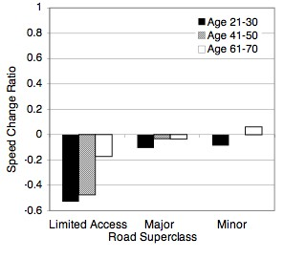
Age Group | Road Superclass
Age Group | Limited Access | Major | Minor
Young (21-30) | -0.53 | -0.10 | -0.08
Middle (41-50) | -0.47 | -0.03 | 0.00
Older (61-70) | -0.17 | -0.03 | 0.06

Figure 3.28. SD Change Ratios for Speed (m/s)

appendix D: comparison of descriptive statistics from distribution and fitted results

Table 3.39. Comparison of Steering Wheel Angle SD from Distribution
and Fitted Results

Table 3.40. Comparison of Heading Angle SD from Distribution and Fitted Results

Table 3.41. Comparison of Throttle Opening SD from Distribution
and Fitted Results

Table 3.42. Comparison of Throttle Opening Mean from
Distribution and Fitted Results

Table 3.43. Comparison of Speed SD from Distribution and Fitted Results

Table 3.44. Comparison of Speed Mean from Distribution and Fitted Results

Appendix E: Ratio of Throttle Holds (Hold/NoNhold) by Road superclass, Age group, and distraction
(I) Limited Access Road
(b) Age 41-50
(c) Age 61-70
(a) Age 21-30
Normal
Distracted
(III) Minor Road
(II) Major Road
Figure 3.29. Normal and Distracted Hold Ratios for Each Time Window by
Road Superclass and Age Group (Threshold = 1)

Figure 3.30. Normal and Distracted Hold Ratios for Each Time Window by
Road Superclass and Age Group (Threshold = 2)
(I) Limited Access Road
(b) Age 41-50
(c) Age 61-70
(a) Age 21-30
Normal
Distracted
(III) Minor Road
(II) Major Road

Figure 3.31. Normal and Distracted Hold Ratios for Each Time Window by
Road Superclass and Age Group (Threshold = 3)
(I) Limited Access Road
(b) Age 41-50
(c) Age 61-70
(a) Age 21-30
Normal
Distracted
(III) Minor Road
(II) Major Road

Figure 3.32. Odds of Hold to Nonhold for Distracted and Normal Driving
(by Road Superclass and Age Group)
Limited Access
Major
Minor

Appendix F: predictor driving variables
Table 3.45. Rationale for Measures Examined

Category | Measurement or Derivative | Comment
Subject Vehicle | Speed | Driving faster should lead to greater workload overall. However, when loaded, drivers slow down. Risk homeostasis theory suggests speed might not have any relationship
Subject Vehicle | Longitudinal acceleration | When the vehicle is braking or accelerating, the workload is greater.
Subject Vehicle | Lateral acceleration | When lateral acceleration is high, the driver is maneuvering (changing lanes, turning, merging) and workload is greater
Subject Vehicle | Lane position (Distance to lane edge) | The closer to the lane edge, the more likely the driver is not attending to the road because they are loaded.
Subject Vehicle | TLC | When the driver does not attend to driving (is distracted), TLC should decrease.
Subject Vehicle | Steering wheel angle | Large angle are associated with turns, lane changes, etc, higher workload situations.
Subject Vehicle | Throttle angle | Greater throttle angle is results in greater speed, so the effects of throttle angle should be the same as speed.
Subject Vehicle | Steering reversals | Large corrections are associated with greater distraction (workload) as they can indicate inattention to the road.
Subject Vehicle | Steering entropy | Several studies have shown that steering entropy is an indicator of workload
Subject | Age | Older drivers are less capable to deal with workload, and rate situations as more difficult relative to young and middle aged drivers.
Subject | Sex | Sometimes there is an age*sex interaction, with young men saying the driving is easy (low workload), but because of relatively poorer health, older men being more challenged (and giving higher workload ratings) than older women.
Other Vehicles | Number (detected by radar) | The greater the number of vehicles ahead, the greater the workload
Other Vehicles | Lead vehicle speed | The greater the speed of a lead vehicle, the greater the workload.
Other Vehicles | Lead vehicle longitudinal acceleration | The greater the change in speed of a lead vehicle, the greater the workload.
Relationship between Subject Vehicle and Other Vehicle(s) | Gap (distance) to lead vehicle | The greater the distance to the lead vehicle, the less the workload
Relationship between Subject Vehicle and Other Vehicle(s) | Range rate (gap rate) | The change in speed of a lead vehicle, especially deceleration, increases workload.
Relationship between Subject Vehicle and Other Vehicle(s) | TTC | Decreasing TTC increases workload.
Road | Number of lanes | Increasing the number of lanes increases the number of vehicles the driver considers, and therefore workload. However, the highest capacity roads (expressways) have been designed to minimize demand (wide lanes, gentle curves, few crossing of other traffic streams), so the opposite relationship could occur.
Road | Class | Same as above
Road | Posted speed | Driving faster than the posted speed may indicate lower workload (less traffic, less demanding geometry, etc.).

Table 3.46. Ranking of Deviance Statistic for Predictor Variables Fit One at a Time in to Logistic Regression Model for Limited Access Roads
Table 3.47. Ranking of Deviance Statistic for Predictor Variables Fit One at a Time in to Logistic Regression Model for Major Roads
Table 3.48. Ranking of Deviance Statistic for Predictor Variables Fit One at a Time in to Logistic Regression Model for Minor Roads

Table 3.49. List of ACAS FOT Data Analysis Factors

Category | Variable | Description | Factors Evaluated
Number of vehicles ahead | Traffic Count | Number of Cars sensed by the vehicle's radar | Mean
Distance to Lead Vehicle | CIPV Range | Headway Distance to Lead Vehicle (125 (max radar range) was written over any 0 (no car sensed) values, because at least 125 m was free of vehicles if the radar returned a 0) | Mean | 1/ (log (mean))
Distance to Lead Vehicle | CIPV Range Rate | Headway Distance Acceleration (If there was to lead vehicle, the value was removed) | Mean
Distance to Lead Vehicle | Headway Time | (Headway / Subject Speed) This value is blank in the data set where there is no car in the radar. | Mean
Distance to Lead Vehicle | Time To Collision | (Lead vehicle speed)-(subject veh speed) / Headway | Mean
Distance to Lead Vehicle | Vp | Speed of vehicle ahead | Mean
Distance to Lead Vehicle | VpDot | Speed change of vehicle ahead | Mean
Road | Lane | Left, Middle, Right (Right is Default) | Value
Road | Curvature | Straight or Curved | Value
Road | LaneWidth | Width of current lane | Mean
Road | Roadclass | Rural, Urban or Expressway | Value
Lateral position | LaneOffset | Distance from Center of Lane (StDev of Lane Position) | StDev
Lateral position | Distance to Lane Edge | Distance to lane edge that the driver is heading towards | Mean | StDev
Lateral position | Steering Reversals | Count of steering wheel reversals over 2 degrees | Count
Lateral position | Lateral Acceleration | Acceleration of Lane Offset | Mean | StDev
Lateral position | Time To Lane Crossing | Distance to Lane Edge / (Lateral Velocity + Lateral Acceleration) | Mean | StDev
Lateral position | Steering Entropy | Erwin Boer's Steering Entropy | Value
Longitudinal Position | Throttle | Mean throttle angle | Mean | StDev
Longitudinal Position | TransSpeed | Vehicle Speed | Mean | StDev
Longitudinal Position | Ax | Vehicle Acceleration | Mean | StDev

