SAVE-IT

SAfety VEhicles using adaptive
Interface Technology
(Task 5)

Final Report: Phase 2
Algorithms to Assess Cognitive Distraction

Prepared by
John Lee
Michelle Reyes
Yulan Liang
Yi-Ching Lee
The University of Iowa
Phone: (319) 384-0810
Email: john-d-lee@uiowa.edu
July 2007

Table of Contents
5.1 Executive summary 6
5.2 Program Overview 10
5.3 Introduction and objectives 10
5.4 Interaction of Cognitive and Visual Distraction 12
5.4.1. Experiment 1: Change detection and safety-relevance 15
5.4.1.1 Method 15
5.4.1.2 Results 18
5.4.1.3 Discussion 20
5.4.2. Experiment 2: Image size and safety relevance 21
5.4.2.1 Method 21
5.4.2.2 Results 22
5.4.2.3 Discussion 24
5.4.3. General discussion 25
5.5 Support Vector Machines to Detect Cognitive Distraction 27
5.5.1. Model Construction 30
5.5.1.1 Data source 30
5.5.1.2 Model characteristics and training 34
5.5.1.3 Model performance measures 37
5.5.2. Results 38
5.5.2.1 Performance of the SVM models 38
5.5.2.2 Comparison with the logistic method 38
5.5.2.3 Effect of model characteristics 40
5.5.3. Discussion 42
5.5.4. Conclusion 45
5.6 Bayesian Networks to Detect Cognitive Distraction 45
5.6.1. Model Construction 47
5.6.1.1 Training of BN models 47
5.6.1.2 Model performance measures 50
5.6.1.3 Mutual information 50
5.6.2. Results 51
5.6.2.1 Comparison of model performance 51
5.6.2.2 Analysis of mutual information 52
5.6.3. Discussion 54
5.6.4. Conclusion 56
5.7 Combining Algorithms to Detect Distraction 56
5.7.1. Data mining techniques to assess cognitive state 59
5.7.2. Development of SVMs and BNs 60
5.7.2.1 Model training 60
5.7.2.2 Model evaluation 61
5.7.3. Model comparison 61
5.7.4. Discussion 64
5.8 References 65

Table of Figures
Figure 5.1. The mean d’ (± SE) as a function of blanking and auditory task 7
Figure 5.2. Testing accuracy and sensitivity for different parameters of input data. 8
Figure 5.3. Comparisons of model type and number of hidden nodes. 9
Figure 5.4. The mean d’ (± SE) as a function of blanking and auditory task in Experiment 1. 18
Figure 5.5. The mean d’ (± SE) as a function of different types of changes and blanking and auditory task in Experiment 1. 19
Figure 5.6. The mean d’ (± SE) as a function of blanking and auditory task in Experiment 2. 22
Figure 5.7. The mean d’ (± SE) as a function of different types of changes and blanking and auditory task in Experiment 2. 23
Figure 5.8. A graphical representation of the support vector machine algorithm. 28
Figure 5.9. Illustration of the algorithm used to identify eye movements. 32
Figure 5.10. Results of the SVM and logistic models. The dashed, dash-dot, and dash-double dot lines indicate chance performance, SVM average, and logistic average, respectively. 38
Figure 5.11. ROC curves for the SVM and logistic models for DRIVE, STAGE, and STEER. 39
Figure 5.12. SVM testing accuracy and sensitivity for the feature combinations. The braces represent the post hoc comparisons between the successive combinations using Tukey-Kramer method. ** indicates p<0.05. 41
Figure 5.13. Testing accuracy and sensitivity for different summarizing parameters of input data. 42
Figure 5.14. The plots of fixation distribution over the background of the driving scenario for IVIS (left) and baseline (right) conditions for participant SF7. The size of each dot represents fixation duration. 43
Figure 5.15. SVM decision variable along the timeline of an IVIS drive and a baseline drive for participant SF7 (for the same data shown in Figure 5.14). 44
Figure 5.16. Examples of a SBN and a DBN, where H is a hypothesis node, S is a hidden node, Es are observation nodes, and t represents time. 46
Figure 5.17. Constrained DBN Structure, where solid arrows represent intra-links and dotted arrows represent inter-links. 50
Figure 5.18. The Comparisons of Model Type, Number of Hidden Nodes and the Interaction. 52
Figure 5.19. The Mutual Information of Seven Categories of Performance Measures. 53
Figure 5.20. Data fusion that transforms raw driving and eye movement data into estimates of cognitive distraction. 59
Figure 5.21. Constrained DBN Structure, where solid arrows represent relationships within the first time step, dotted arrows represent relationships across time steps, and H and E presents the predictive target and performance measures, respectively. 61
Figure 5.22. Comparisons of testing accuracy and sensitivity. 62
Figure 5.23. Comparisons of hit and false alarm rates. 63
Figure 5.24. Comparison of false alarm rate for DBNs, SBNs, and SVMs for window sizes of 5 to 30 seconds. 63

Table of Tables
Table 5.1. The characteristics of fixations, saccades, and smooth pursuits. 33
Table 5.2. The feature combinations used as model input. 34
Table 5.3. Model characteristics and their values. 35
Table 5.4. The Comparisons with Different Characteristics. 49
Table 5.5. The Mutual-Information Distribution of Nine Participants across the Most Predictive Variables (dark shading indicates average normalized mutual information greater than 30%; dark grey indicates between 30% and 10%; grey indicates between10% and 5%; white indicates less than 5%). 54
Table 5.6. Matrix of data fusion strategies and the availability of domain knowledge. 57

Executive summary
The objective of Task 5 (Cognitive Distraction) is to develop an algorithm that uses driver state information to predict decrements in driving performance due to cognitive distraction. Driving performance is operationalized as the reaction time to driving events that require a response by the driver. Specifically, our objectives were to develop an experiment that created a measurable degree of distraction, to evaluate dependent measures associated with this distraction, and to develop an algorithm to predict distraction based on those measures.
In Phase 1, a review of literature related to workload estimation suggested that eye movements and heart rate data might be useful measures of cognitive distraction in that such data could be collected unobtrusively, was technically feasible to include in a production vehicle within the next 10 years, and was reasonably diagnostic. An experiment was conducted to evaluate how IVIS-task (In-Vehicle Information Systems) demands influence driving performance at the control and tactical levels and how this influence correlates with changes in eye gaze patterns. The control level refers to the moment-to-moment operation of vehicles, and the tactical level refers to the choice of maneuvers and immediate goals in getting to a destination. The study also assessed how well these patterns predicted distraction-related decrements in driver performance. The experimental design consisted of twelve combinations of three within-subject independent variables: 1) lead vehicle braking task (control or tactical), 2) multiple resource theory (MRT) dimensions of the IVIS task (verbal or spatial, perceptual or response selection), and 3) response selection complexity (simple or complex, nested within the Response condition). The main dependent measures include driving, eye movement, and electrocardiogram data.
As expected, the tactical braking task had much shorter accelerator release and brake reaction times than the control task. Both accelerator release and brake reaction times degraded during IVIS interactions, but only for tactical braking events. IVIS interactions significantly degraded speed and steering maintenance, reflected by the effect on measures associated with vehicle speed, accelerator position, and steering error and entropy. Three eye movement measures reflected changes in cognitive load: fixation duration decreased, the distance between successive fixations or saccade distance increased, and the proportion of short fixations increased as cognitive load increased. These results indicated that listening to IVIS information was less demanding than responding to questions about it. IVIS interactions degrade a driver’s ability to anticipate emerging conflict situations more than they degrade driver response to a conflict situation (Reyes & Lee, 2004). Hidden Markov Models were used to predict driver distraction from eye data with limited success.
In Phase 2 the underlying mechanisms associated with cognitive distraction were assessed to determine how cognitive distraction might interact with visual distraction to undermine driving performance. Two experiments were conducted using a change blindness paradigm in which the screen of the driving simulator was periodically blanked for one second to simulate a glance away from the roadway. Drivers also performed a complex auditory/vocal task representative of an IVIS destination selection task. Twelve people participated in each of the experiments. Dependent measures included participants’ sensitivity to vehicle changes and confidence in detecting them.
In the first experiment, cognitive load uniformly diminished participants’ sensitivity and confidence, independent of safety-relevance or lack of exogenous cues. Periodic blanking, which simulated glances away from the roadway, undermined change detection to a greater degree than cognitive load; however, cognitive load diminished drivers’ confidence in their ability to detect changes more. Figure 5.1 shows that cognitive load and short glances away from the road are additive in their tendency to increase the likelihood of drivers missing or not recognizing safety-critical events, measured by d’ (the number of standard deviations between the density functions for hits and false alarms). This study demonstrates the need to consider the combined consequences of cognitive load and brief glances away from the road in assessing distraction.
Figure 5.1. The mean d’ (± SE) as a function of blanking and auditory task
To extend the algorithm development of Phase 1, the second experiment examined the effect of cognitive load on driving performance for interactions that varied from one to four minutes. Participants completed four 15-minute drives while performing the IVIS task. There were three IVIS conditions: interacting with the IVIS system, the non-IVIS periods during drives where the IVIS task was present, and a baseline drive with no IVIS interactions. Contrary to our hypothesis, driver response to the lead vehicle braking events was surprisingly uniform across IVIS conditions. IVIS interaction did undermine bicycle detection, and this effect increased with the duration of the task. The detrimental effect of IVIS interactions persisted even after the interaction was completed. Eye movements were systematically influenced by IVIS conditions, although gaze concentration, as measured by the product of the standard deviation of vertical and horizontal fixation locations, responded to IVIS conditions in a manner counter to previous research, with gaze concentration diminishing with cognitive load. The eye movement analysis suggests that two mechanisms might account for the distraction-related performance decrements in this study: a competition for processing resources and an interference between competing goals.
Based on the data from this experiment, both Support Vector Machines (SVMs) and Bayesian Networks (BNs), two data mining techniques, were selected to assess driver cognitive distraction using eye movement and driving performance measures. In the SVM analysis, each subject’s data were used to train and test both SVM and logistic regression models for that subject. Three different model characteristics were investigated: how distraction was defined, which data were input to the model, and how the input data were summarized. SVM models were able to detect driver distraction with an average accuracy of 81.1% and outperformed more traditional logistic regression models. The best-performing SVM model (96.1% accuracy) resulted when distraction was defined using experimental conditions (i.e., IVIS drive or baseline drive), the input data were comprised of eye movement and driving measures, and these data were summarized over a 40-second window with 95% overlap of windows. Figure 5.2 shows the influence of window size and overlay on predictions.

Testing accuracy (percent hits) Sensitivity (d’)
Figure 5.2. Testing accuracy and sensitivity for different parameters of input data.
In the BN analysis, models were trained and tested to investigate the influence of three model characteristics on distraction detection: time-relationship of driver behavior, the inclusion of an intermediate variable (hidden node) that groups model inputs, and summarizing data with different time windows and length of training sequences. Figure 5.3 shows the performance of BNs and the relative benefit of Dynamic BNs (DBN). The results demonstrated that BNs could identify driver distraction for any given driver reliably with an average accuracy of 80.1%. DBNs that considered time-dependencies of driver behavior produced more sensitive models than SBNs. Longer training sequences improved DBN model performance. Blink frequency and fixation measures were particularly indicative of distraction. These results indicate that BNs, especially DBNs, are able to detect driver cognitive distraction by extracting information from complex behavioral data.
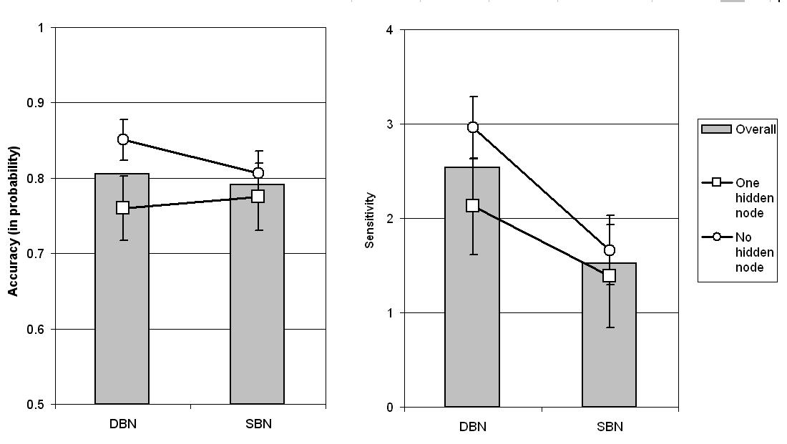
Figure 5.3. Comparisons of model type and number of hidden nodes.
In combination, these experiments indicate that eye movements represent a promising approach to assessing cognitive distraction in real time. Although not perfect, the SVM and BN models provide substantial precision in detecting instances of cognitive distraction, with accuracies of 75-95% depending on the algorithm and input data. The experiments also suggest that cognitive and visual demands are additive. This finding suggests that estimates for degraded driving performance associated with cognitive demand can be added to those associated with visual demand to estimate the combined total. At the same time, these experiments show that cognitive distraction is not a unitary construct and can influence driving tasks differently, as, for example, in the differential effect of cognitive distraction on pedestrian detection and vehicle control seen here. Another important finding is that cognitive distraction can display inertia, affecting driver performance after the task has been completed. This finding supports the need to model task interruptability in predicting IVIS demand (Task 6).

Program Overview
Driver distraction is a major contributing factor to automobile crashes. The National Highway Traffic Safety Administration (NHTSA) has estimated that approximately 25% of crashes are attributed to driver distraction and inattention (Wang, Knipling, & Goodman, 1996). Recent estimates from the 100-Car study suggest that distraction may contribute to more than three quarters of all crashes (Dingus, Klauer, Neale, Petersen, Lee, Sudweeks, Perez, Hankey, Ramsey, Gupta, Bucjer, Doersaph, Jermeland, & Knipling, 2006). The issue of driver distraction may become more critical in the coming years because increasingly elaborate electronic devices (e.g., cell phones, navigation systems, wireless Internet and email devices) are being brought into vehicles that may further compromise safety. In response to this situation, the John A. Volpe National Transportation Systems Center (VNTSC), in support of NHTSA's Office of Vehicle Safety Research, awarded a contract to a diverse team led by Delphi Electronics & Safety including Ford, the University of Michigan Transportation Research Institute (UMTRI) and the University of Iowa. The goal of this program was to develop, demonstrate, and evaluate the potential safety benefits of adaptive interface technologies that manage the information from in-vehicle systems based on real-time monitoring of the roadway and the state of the driver. The contract, known as SAfety VEhicle(s) using adaptive Interface Technology (SAVE-IT), is designed to mitigate distraction with effective countermeasures and enhance the effectiveness of safety warning systems.

The SAVE-IT program serves several important objectives. Perhaps the most important objective is that of demonstrating a viable proof of concept that is capable of reducing distraction-related crashes and enhancing the effectiveness of safety warning systems. Program success is dependent on integrated closed-loop principles that incorporate the state of the driver. This closed-loop vehicle system is achieved by measuring the driver’s state, assessing the situational threat, prioritizing information presentation, providing adaptive countermeasures to minimize distraction, and optimizing collision warning systems.

Introduction and objectives
The objective of Task 5 (Cognitive Distraction) is to develop an algorithm that uses driver state information to predict decrements in driving performance due to cognitive distraction. Driving performance is operationalized as the reaction time to driving events that require a response by the driver. Our specific objectives were to develop an experiment that created a measurable degree of distraction, to evaluate dependent measures associated with this distraction, and to develop an algorithm able to predict distraction based on those measures.
The need to predict cognitive distraction is being driven by the migration of complex technology into cars and trucks. Many drivers are transforming their vehicles into mobile offices, with devices that allow them to use the Internet, send and receive faxes, receive news, and converse on cell phones (Dewar & Olson, 2002). These systems promise benefits of increased comfort, productivity, and mobility. However, they may also distract drivers and undermine driving safety (Goodman, Tijerina, Bents, & Wierwille, 1999; J. D. Lee & Strayer, 2004).
Driving makes intense demands on visual perception (Dewar & Olson, 2002). As a result, operating devices that require glances away from the road result in structural interference, which can have obvious negative effects on driving performance. Increasing the duration of glances away from the road increases the probability of lane departure, such that glances of two seconds lead to 3.6 times more lane departures than glances of one second (Green, 1999). Cognitive interference has less obvious consequences. Operating devices that do not require glances away from the road, such as speech recognition systems, can nevertheless impose a cognitive load that may interfere with driving performance. This cognitive load has the potential to impair drivers’ ability to maintain vehicle control (Rakauskas, Gugerty, & Ward, 2004). Cognitive load can also delay or interrupt cognitive processing of roadway-related information, resulting in longer reaction times (Alm & Nilsson, 1994; 1995; J. D. Lee, Caven, Haake, & Brown, 2001), degraded speed and headway control (Strayer & Drews, 2004), and less effective use of environmental cues to anticipate when to brake (Jamson, Westerman, Hockey, & Carsten, 2004).
The effect of cognitive and structural interference depends on the type of task. Multiple resource theory suggests that two tasks that draw upon the same mode (e.g., information received through the eye only, or through the eye and the ear), code (i.e., analogue/spatial vs. categorical/verbal processes) or stage of processing (e.g., perceptual, cognitive, the selection and execution of response) will interfere with each other more than two tasks that draw upon different resources (Wickens, 1984; 2002). In driving, a concurrent spatial task interferes with drivers’ eye movements to a larger degree than a concurrent verbal task (Recarte & Nunes, 2000). Cognitive interference is greatest for tasks that demand the same resources.
Further, recent extensions of multiple resource theory identified separate visual processing resources: ambient and focal. In driving, ambient vision supports lane keeping and focal vision is critical for event detection (Wickens, 1984; 2002). A meta-analysis of the effect of cell phone use on driving performance showed that hand-held phones that demand focal processing had a relatively small effect on lane keeping, but that hands-free cell phones had a substantial effect on event detection and response (Horrey & Wickens, 2006). However, even tasks that draw upon different resources, such as cell phone conversations (auditory verbal) and driving (visual motor spatial), can compete for central processing resources (Pashler, 1998). Such competition can undermine drivers’ ability to respond to the roadway environment. This issue is addressed with an experiment that examines the interaction of visual and cognitive distraction.
Many studies have investigated cognitive distraction and how it affects eye movement patterns and driving behavior. Recarte and Nunes (Recarte & Nunes) found that increased cognitive load was associated with longer fixations, smaller visual functional-field, and less frequent glances at mirrors and the speedometer. Cognitive distraction undermines driving performance by disrupting the allocation of visual attention to the driving scene and the processing of attended information. For example, cognitive workload impaired the ability of drivers to detect targets across the entire visual scene and caused gaze to be concentrated in the center of the driving scene (Recarte & Nunes, 2003a; Victor, 2005). In addition, cognitive distraction associated with cell phone conversations negatively affected both implicit perceptual memory and explicit recognition memory for items that drivers fixated while driving (Strayer, Drews, & Johnston, 2003b). A meta-analysis of twenty-three studies investigating the effects of cell phone conversation found that cognitive distraction delays driver response to hazards (Horrey & Wickens, 2006). For example, drivers reacted more slowly to brake events (Lamble, Kauranen, Laakso, & Summala, 1999; J. D. Lee, Caven, Haake, & Brown, 2001) and missed more traffic signals (Strayer & Johnston, 2001) when they were performing email, math, or cell phone conversation tasks while driving. Although the negative effects of cognitive distraction on driving have been demonstrated, little research has considered how such effects could be used to detect cognitive distraction in real time.
A promising strategy to address this challenge is to classify driver state in real time and use this classification to adapt in-vehicle technologies to mitigate the effects of distraction (Donmez, Boyle, & Lee, 2003a, 2003b). This strategy is not new. For example, “attentive autos,” which monitor driver attention and emit an alert when the driver looks away from road or when driving demands require a high level of attention, have been studied (Gibbs, 2005). Smith and his colleagues developed a robust system using head rotation and eye blinking to monitor the lack of visual attention due to fatigue while driving (Smith, Shah, & Lobo, 2003).The degree of driver stress (Healey & Picard, 2005) and vigilance (Bergasa, Nuevo, Sotelo, Barea, & Lopez, 2006) was predicted from physiological measures and used to help manage IVIS functions. Also, some studies have used data mining techniques to predict drivers’ intent to change lanes to enhance driver-assistance systems (Mandalia & Salvucci, 2005; McCall, Mipf, Trivedi, & Rao, in press; McCall & Trivedi, 2006).
Obviously, measuring driver state is a core function in such systems. To fulfill this function and avoid intrusive measurement (e.g., measuring galvanic skin response using electrodes), this paper presents an unobtrusive approach that uses eye movements and driving behavior to detect driver cognitive distraction.
The following sections first present two experiments aimed at understanding the mechanisms underlying cognitive distraction and its interaction with visual distraction. Following the experiments, several different algorithms are developed to assess cognitive distraction in real time. The first of these examines the potential of support vector machines, and the second uses Bayesian networks. Finally a comparison between support vector machines and Bayesian networks is presented.

Interaction of Cognitive and Visual Distraction
The behavioral manifestation of cognitive distraction is often the failure to detect events and respond in a timely manner. One possible cause of failure to respond to the environment is that performing a secondary task degrades the encoding and transferring of foveated visual information into short-term memory. Studies have shown that drivers detected (McCarley et al., 2004) and recognized (Strayer, Drews, & Johnston, 2003a) fewer objects when performing a secondary task while driving compared to driving only; however, the number of fixations on the target region were not different for the two conditions. The difficulty in responding to and recognizing previously fixated stimuli in a dual-task condition may relate to the tendency for one stimulus to interfere with the processing of a subsequent stimulus (Shapiro & Luck, 1999), such that drivers’ attention to a non-driving task interferes with the consolidation of information into short-term memory during fixations.
Failure to respond to the environment may also be caused by disruptions in the distribution of visual attention while performing a secondary task. Several researchers have evaluated eye movement patterns to assess how drivers’ inspection behavior changes as a function of cognitive load. Drivers glanced at the mirror and the speedometer less frequently, and their distribution of glances to the road became more concentrated, when performing cognitively demanding tasks while driving (Recarte & Nunes, 2000, 2003b). This reduction of the area scanned by the driver could decrease the probability of detecting traffic events in that attention is not directed toward those events. Non-driving secondary tasks may disrupt drivers’ attention to the roadway, resulting in fewer objects and changes being fixated and attended to.
Visual attention can be guided to objects in the visual field by endogenous control (also called goal-driven, conceptually-driven, or top-down control) and by exogenous control (also called data-driven, stimulus-driven, or bottom-up control). Endogenous control refers to strategic information processing because an observer intentionally directs attention towards relevant stimuli. Exogenous control refers to the direction of attention elicited by characteristics of the visual field and implies automatic or mandatory information processing (Jonides & Irwin, 1981; Posner, 1980; Theeuwes, 1991). Previous studies using a cue-target paradigm have manipulated the predictive validity of a centrally located symbolic cue that pointed to one of several stimulus positions to assess the role of endogenous control. These studies have also assessed the role of exogenous control through a non-predictive abrupt onset (Jonides & Irwin, 1981; Posner, 1980). Results have generally shown that reaction times are shorter when a target appears in a cued, rather than an uncued, location. Jonides (1981) found an interactive effect such that endogenous control in response to a central predictive cue was affected by concurrent memory-load, whereas exogenous control in response to a non-predictive cue was not.
Generalizing to driving, when particular information is relevant to the driver, endogenous control purposely directs attention to particular features in the driving environment. On the other hand, exogenous cues, such as abrupt movements, draw attention to a particular object or location without drivers’ intention. Based on Jonides’ findings, cognitive load would be expected to interfere more with drivers’ attention to safety-relevant objects, which is governed by endogenous control, than with their attention to salient objects, which depends on exogenous control.
The change blindness paradigm offers a promising way to assess the effect of cognitive load on visual attention. When changes occur during a brief occlusion of the scene, as in the flicker paradigm, observers have trouble detecting them even when the changes are large, are presented repeatedly, and are expected to occur (Rensink, O'Regan, & Clark, 1997). Observers do not have trouble detecting changes without the brief occlusion. A common explanation for these findings is that the brief occlusion of the scene disrupts and masks the exogenous cues associated with the abrupt onsets that would normally guide attention to the change (Rensink et al., 1997). Several variations of the change blindness paradigm support this explanation, although visual working memory limits may also contribute to these effects (Luck & Vecera, 2002). When an abrupt onset was added to the pre-change image prior to the disruption of the scene, detection was easier if the changed item was the abrupt onset (Scholl, 2000). Likewise, when high-contrast patterns and changes were both presented in a scene, as in the mudsplash paradigm, observers struggled to detect changes because the high-contrast patterns served as exogenous cues that drew attention away from the location of the change (Rensink et al., 1997). Such results suggest that the brief disruption in the change blindness paradigm interferes with change detection by masking abrupt onsets that normally support exogenous control of visual attention (Jonides & Irwin, 1981; Simons & Rensink, 2005).
Consistent with the characteristics of endogenous control, in the presence of a brief disruption, objects that are more meaningful (Pringle, Irwin, Kramer, & Atchley, 2001), more relevant to traffic safety (Dornhoefer, Unema, & Velichkovsky, 2002), or are of central interest (e.g., objects considered to be important in the scene) (Rensink, 1997) are better detected. Others have observed that change detection was impaired when the advantage for changes of central interest was eliminated by inverting the scenes (Kelley, Chun, & Chua, 2003; Shore & Klein, 2000). These results suggest that the change blindness paradigm undermines exogenous control of attention, but leaves endogenous control relatively unaffected. However, it is also possible that, in the presence of a brief disruption, observers must rely on visual short term memory to determine if there is a change (Hollingworth & Henderson, 2002; Hollingworth, Williams, & Henderson, 2001). Without the brief disruption, memory is less critical in detecting changes because all the information is available to the observer.
In the driving domain, several researchers have used the change blindness flicker paradigm (Rensink et al., 1997) to study how drivers detect roadway events. According to this paradigm, participants view a sequence of unaltered and altered images of a traffic scene from the driver’s perspective, with a brief gray screen between the images (McCarley et al., 2004; Richard et al., 2002). Cognitive load undermined detection of driving-relevant (objects that contained important driving information) and driving-irrelevant (details that were not associated with driving) changes to a similar degree (Richard et al., 2002). In another study, there was a tendency for cognitive load to impair knowledge-driven orienting of attention in older adults, but not in younger drivers (McCarley et al., 2004). In related work, Zheng (2004) developed a dynamic change blindness paradigm in which he asked drivers to detect changes that occurred during brief disruptions in a simulator drive. The results indicated that detection of safety-relevant changes (vehicles that changed location in traffic lanes) was more affected by cognitive load compared to safety-irrelevant ones (changes in vehicle features in traffic lanes). However, safety relevance was confounded with vehicle location and vehicle features, making a definitive interpretation of these data difficult. Generally speaking, cognitive load undermines detection of changes that are relevant to the driving task more than detection of irrelevant changes. These results have partially confirmed Jonides’ (1981) finding that cognitive load was particularly detrimental to the endogenous control of attention.
Previous studies have not, however, addressed the combination of cognitive load with and without visual disruption in a dynamic driving environment. Whether short glances away from the driving scene and cognitive load have an additive or interactive effect on drivers’ ability to detect changes has important practical and theoretical implications.
The objective of the current study is to compare the effects of cognitive load on the endogenous and exogenous guidance of visual attention using a dynamic change blindness paradigm. Changes that occurred during driving scenarios were masked by a one-second gray screen so that the effects of cognitive load on endogenous and exogenous control of attention could be compared. The duration of the visual disruption simulated the time drivers might glance away from the forward view to either check the rearview mirror or interact with an in-vehicle information system (Sodhi, Reimer, & Llamazares, 2002). It was anticipated that cognitive load would diminish endogenous, rather than exogenous, control. Specifically, cognitive load was expected to undermine change detection to a greater degree in the presence of visual disruptions compared to detection performance in the absence of visual disruptions.

Experiment 1: Change detection and safety-relevance
A dynamic change blindness paradigm (Zheng, 2004) was implemented in a driving simulator. A brief visual disruption was designed to remove the transients that normally accompany changes in the visual field, leaving visual attention to be guided by endogenous control. An in-vehicle information system imposed a cognitive loading task that required drivers to listen to auditory messages and respond to questions.

Method
Participants. Twelve native English speakers (5 men and 7 women) participated in the experiment. Participants ranged in age from 22 to 28 years, with an average age of 25 (standard deviation (sd) = 2.2). All drivers were screened for visual acuity, color perception, and depth perception using an Optec Vision Tester. The drivers had at least five years of driving experience, drove at least three times per week, and possessed a valid driver’s license. Participants were paid $15 an hour, with additional compensation (up to $10) based on auditory task performance. The purpose of providing a bonus was to encourage participants to engage in the secondary task.
Apparatus and tasks. A fixed-based, medium-fidelity driving simulator was used to conduct the experiment. The simulator uses a 1992 Mercury Sable vehicle cab that has been modified to include a 50-degree visual field of view, force feedback steering wheel, and a rich audio environment. The fully textured graphics are generated by DriveSafety’s VectionTM software that delivers a 60-Hz frame rate at 1024 x 768 resolution. Data were collected at a rate of 60 Hz.
Each of the four driving scenarios included a straight, four-lane suburban road with a parking lane on each side. Each drive was approximately 6.5 miles long, and participants were asked to maintain a speed of 30 mph. The drive took approximately 13 minutes to complete. Participants were instructed to drive normally, as they would in a real driving environment.
During two of the four drives, the change detection task was administered using a dynamic change blindness paradigm. The projection screen was blanked for one second and replaced with a homogeneous gray screen. Participants were told that the projection screen might blank, and that a change to one of the surrounding vehicles could occur during the blank. In the other two drives, participants were told that the screen would not blank, but that changes would occur during the drive.
Changes occurred when participants reached pre-designated locations. These locations were situated approximately every 200 meters, or every 15 seconds if the driver maintained the recommended speed. Participants were asked to identify the type of change by pressing buttons on the steering wheel. Two response buttons on the left of the steering wheel were used to identify forward and backward vehicle changes in the traffic lane. Two response buttons on the right were used to identify movement changes (forward and backward) and property changes (color and identity) in the parking lane. Buttons were labeled so participants could easily identify which to use.
While driving, participants were also asked to listen and respond to an auditory task (Reyes & Lee, 2004), which presented information about cost (one or two dollar signs), quality (one or two stars), and wait time (short or long) at three different restaurants. The following is an example of an auditory message:
“There are three restaurants located in the area. One restaurant is Louee’s Diner, which has an average entrée price of one dollar sign and a quality rating of one star. There is currently a long wait time at Louee’s Diner. Another restaurant is Pat’s Place, which has an average entrée price of one dollar sign and a quality rating of two stars. There is currently a long wait time at Pat’s Place. The last restaurant is Tee Jay’s Pizza, which has an average entree price of two dollar signs and a quality rating of two stars. There is currently a short wait time at Tee Jay’s Pizza.”
Questions posed at the end of each message required participants to transform the presented information and relate it to categories of restaurants. For example, a question, delivered in an auditory format, was: “Which restaurant could have an average entrée price of $5 and has a quality rating of more than 10 positive recommendations?” Participants learned the definitions of the restaurant categories and were given two sample messages during the practice session. They were required to answer each question verbally with the appropriate restaurant name, and were encouraged to provide their best answer if they were unsure. The voice of the auditory stimuli was a synthetic English-speaking male adult.
Experimental design and independent variables. The experiment was a 2 (blanking: blank, no-blank) x 3 (change: forward, backward, parked-vehicle) x 2 (auditory task: task, no-task) within-subjects design. Each participant drove four experimental drives, two with blanking of the screen (blank) and the other two without (no-blank). The order of the drives was counterbalanced according to a Latin square design. There were three possible changes to the vehicles in front of the participant vehicle, which had different degrees of safety-relevance. The backward changes in the traffic lane were considered to be more safety-relevant and the forward changes in the traffic lane less safety-relevant. The changes to parked-vehicles were considered to be safety-irrelevant. Both lead and parked vehicles were initially located 60 meters ahead of the participant vehicle. The forward change moved the lead vehicle in the right lane (directly ahead of the participant) forward 18 meters. The backward change moved the lead vehicle in the right lane 18 meters closer to the participant vehicle. A parked-vehicle change consisted of either changing the vehicle’s location along the parking lane (backward or forward) by 18 meters, or changing its color or identity. Each type of change was encountered twelve times during a drive, and each change was accompanied by a screen blanking in the blank condition. Twelve no-change catch trials were included to prevent participants from associating changes with the blanking. The same 36 changes occurred at different locations in the no-blank condition.
One drive from each blanking condition contained an auditory task with four unique message sets. Each message was played twice for a total of 150 seconds. Immediately after the repetition of the message, drivers were asked six questions about the restaurants.
Procedure. After participants signed the necessary IRB consent forms, they were introduced to the driving task, the change detection task, and the auditory task. They then drove a ten-minute practice drive to become familiar with the dynamics of the simulator and experience the change-detection task and the message system. For each drive, participants were instructed to always maintain their position in the center of the right lane. Drivers were also instructed to press one of the response buttons when they detected a change.
During each auditory task condition, four sets of pre-recorded auditory messages were played. Participants were asked to answer the questions as quickly as possible while driving and performing the change-detection task. Upon completion of each drive, participants were asked to rate on a 1 to 10 scale (1 = least confident; 10 = most confident) their subjective confidence that they had detected the changes and answered the auditory task questions correctly. The experiment took approximately two hours to complete.
Dependent variables and scoring. The dependent variables included drivers’ sensitivity to changes (d’), subjective confidence ratings, and performance on the auditory task. The confidence ratings were collected using a single item rating in which drivers rated their subjective confidence in their detection performance. A signal-detection approach was used to analyze change-detection performance. A hit was counted if participants detected a change and correctly pressed the corresponding button within 2.5 sec after the onset of the change event. A miss was counted if, within 2.5 seconds, participants either failed to press a button or pressed the incorrect button. A false alarm was defined as pressing a button when there was no change. A correct rejection was defined as not pressing any button when there was no change in the blank conditions. In order to count the number of false alarms and correct rejections in the no-blank conditions, twelve pre-designated locations were time-stamped to correspond to the twelve no-change catch trials in the blank conditions. d’ values were calculated based on the difference between the likelihood of pressing a button correctly when there was a change and the likelihood of pressing a button in the no-change conditions (Macmillan & Creelman, 2005).

Results
The effects of the independent variables on d’ and confidence were analyzed with a repeated measures ANOVA. The statistical model was designed to compare the effects of the auditory task and blanking on change detection. Changes were distinguished according to their safety relevance to drivers, with changes that moved toward the drivers being more safety-relevant, changes that moved away from drivers being less safety-relevant, and changes in the parking lane being safety-irrelevant. Results for the color/identity changes in the parking lane were excluded from the analysis because these changes were not comparable to the forward and backward changes in the traffic and parking lanes. The data were checked to ensure compliance with the normality assumptions (Kolmogorov-Smirnov test for normality, p = .058) and homogeneity of variance (Levene’s test, p value ranged from .052 to .898, except for auditory task on confidence, F(1,142) = 5.48, p = .021). Cohen’s d was also calculated to show the magnitude of the effect of the auditory task and blanking on d’ and confidence. Post-hoc tests were conducted using pair-wise comparisons with Bonferroni adjustments.
Sensitivity to changes. Participants were less sensitive to vehicle changes during the blank condition (F(1,121) = 34.73, p < .0001, d = .88); the auditory task also diminished sensitivity to changes (F(1,121) = 4.23, p = .042, d = .28). The magnitude of the effect of blanking was greater than the effect of the auditory task. The significance of the main effects and non-significance of the interaction effect (F(1,121) = .50, p = .481) suggest that blanking and the auditory task had an additive effect on sensitivity (Figure 5.4).
Figure 5.4. The mean d’ (± SE) as a function of blanking and auditory task in Experiment 1.
Participants were most sensitive to changes when the lead vehicle moved backward (d’ = 1.95) toward the participant and least sensitive to parked-vehicle changes (d’ = 1.11) (F(2,121) = 8.98, p = .0002). The mean sensitivity of forward vehicle changes was 1.61. The backward movement increased the visual angle of the lead vehicle from 0.86 to 1.15 degrees, an increase of 33.7%. In contrast, the forward movement decreased the visual angle to 0.67 degrees, a decrease of 22.1%. To determine whether the superior change detection was influenced by size or safety, a subsequent experiment was conducted (Experiment 2).
The interaction between type of change and blanking failed to reach significance (F(2,121) = 2.60, p = .078), though the means were in the expected direction (Figure 5.5). Parked-vehicle changes were often unnoticed (d’ = .38) when they occurred during blanking. The effect of the auditory task on d’ was similar for different types of changes.
Confidence in detecting changes. Participants were less confident in detecting changes during the blank condition (F(1,121) = 9.10, p = .003, d = .38) and when they were cognitively loaded with an auditory task (F(1,121) = 19.92, p < .0001, d = .58). The magnitude of the effect of the auditory task was greater than that of blanking, which is contrary to the effect sizes for d’ (the black condition: 0.88; auditory condition: 0.28). The interaction between auditory task and blanking was not significant (F(1,121) = 1.46, p = .230).
Confidence was highest with the backward changes (mean = 7.48), followed by the forward changes (mean = 6.51), and finally, the parked-vehicle changes (mean = 5.39) (F(2,121) = 27.61, p < .0001). There were no significant interactions between the type of change and either auditory task or blanking.
The relationship between d’ and confidence was positive in all the experimental conditions. The correlation between d’ and confidence was significant for the task (r(72) = .29, p = .014) and no-task (r(72) = .55, p < .0001) conditions and for the blank (r(72) = .41, p = .0003) and no-blank conditions (r(72) = .35, p = .002).
Figure 5.5. The mean d’ (± SE) as a function of different types of changes and blanking and auditory task in Experiment 1.
Secondary task performance. Performance on the auditory task was not strongly related to participants’ ability to detect changes (r(72) = .05, p = .666). Participants did not systematically neglect the auditory task to improve their detection performance, nor did they neglect the detection task to focus only on the auditory task. However, participants answered slightly fewer questions correctly during the blank condition (mean = 79%) (F(1,59) = 6.42, p = .013) than the no-blank condition (mean = 83%). This finding suggests that drivers considered the auditory task secondary to driving and that there was a slight tendency to neglect it when the change detection demands increased.

Discussion
The introduction of auditory tasks and brief blanking of the driving scene diminished participants’ sensitivity to changes, as well as their confidence in detecting them. The diminished sensitivity to changes is consistent with Zheng’s (2004) findings. Even though the safety-relevant changes were detected more reliably compared to the safety-irrelevant changes, cognitive load uniformly diminished the detection of both types of changes. This finding concurs with that of Richard et al. (2002), who observed that performing a non-driving secondary task impaired drivers’ ability to detect driving relevant and irrelevant changes to a similar degree. The decreased confidence in detecting changes suggests that participants were aware that the cognitive load of the auditory task and the blanking both diminished their performance.
Blanking and the auditory task affected d’ and confidence to different degrees. Blanking had a much stronger effect on drivers’ sensitivity to detecting changes compared to the auditory task; however, the auditory task had a stronger effect on confidence in detecting changes. The stronger effect of blanking on d’ than on confidence suggests that drivers may not be aware of the influence that brief glances can have on performance. They may think that they detected changes efficiently when in fact they did not. The correlations show a positive relationship between d’ and confidence, suggesting that participants were aware of the effect of the experimental conditions on their change-detection performance.
We hypothesized that cognitive load would be particularly detrimental to detecting changes during the blanking condition, when endogenous control guides attention. The non-significant interactions between auditory task and blanking suggest that cognitive load diminishes detection performance to a similar degree whether exogenous cues are available to guide attention or not. This finding indicates that cognitive load and short visual disruptions are additive in their tendency to undermine detection of roadway events. The lack of an interaction may be the result of drivers compensating with methods such as attending less to the auditory task. In fact, participants did answer fewer questions correctly during the blanking condition, in which change detection depended on endogenous control.
Participants were most sensitive to changes when the lead vehicle moved backward. One explanation is that backward movements were more safety-relevant and might have required driver intervention. The safety-relevant movement may have influenced the endogenous control of attention, thereby drawing drivers’ attention toward it. Another explanation is that this change also caused the image size of the lead vehicle to increase, and the retinal expansion may have contributed to a looming cue, making the backward change a salient exogenous cue (D. N. Lee, 1998; Regan & Vincent, 1998). Experiment 2 was designed to further investigate whether the relatively higher d’ for backward changes was due to the endogenous influence of safety relevance or the exogenous cue associated with the increased visual angle.

Experiment 2: Image size and safety relevance
In Experiment 1, participants were most sensitive and confident in detecting backward movements of the lead-vehicle. This backward movement made for a larger, more salient exogenous cue. It also imposed a safety-relevant situation, and so constituted a stronger endogenous cue compared to a forward change in the lead-vehicle position. Experiment 2 was designed to identify the cause of higher d’ for detecting vehicles that moved closer to drivers.

Method
The protocol for Experiment 2 is discussed only to the extent that it differs from the protocol used in Experiment 1.
Participants. Twelve native English speakers (3 men and 9 women) participated in the experiment. Participants ranged in age from 20 to 26 years, with an average age of 22 (sd = 1.7). No participants took part in both experiments.
Apparatus and tasks. Arrangement of the response buttons on the steering wheel was slightly different in Experiment 2: the upper left button corresponded to change-to-left-lane changes, the upper right button corresponded to change-to-right-lane changes, the lower left button corresponded to color/identity changes in the parking lane, and the lower right button corresponded to location changes in the parking lane.
Experimental design and independent variables. The experiment used a 2 (blanking: blank vs. no-blank) x 3 (change: left vs. right vs. parked vehicle) x 2 (auditory task: task vs. no-task) within-subjects design. A left change moved a vehicle that drove ahead of the participant vehicle to the left lane, out of the participants’ lane. A right change moved a vehicle from the left lane to the right lane, directly ahead of the participant vehicle. The right changes are of immediate safety-relevance to drivers since they place the vehicle directly into the lane in which the participant is driving. In contrast, the left changes are less safety-relevant. The left and right changes were further broken into two location categories: near and far. For both left and right changes, six occurred at the near location and six at the far location. The vehicle arrangements and changes were purposely configured to be comparable to those in Experiment 1. The near location corresponded to the end position of a backward change and the far location corresponded to the initial position of a backward change. Parked-vehicle changes were the same as those in Experiment 1. A pace car was placed seven meters ahead of the participant vehicle in the left lane and drove at 30 mph. The participants were asked to maintain their speed relative to the pace car and to keep it in sight throughout the drives.

Results
Results for the color/identity changes in the parking lane were excluded in the analysis. As with the first experiment, the assumptions for normality (Kolmogorov-Smirnov test for normality, p = .061) and homogeneity of variance (Levene’s test, p values ranged from .36 to 1.00, except for the effect of change type on confidence, F(2,141) = 3.67, p = .028) were verified before the analysis of variances were conducted.
Sensitivity to changes. Participants were less sensitive to changes during the blank condition (F(1,121) = 44.25, p < .0001, d = .60) and while performing the auditory task (F(1,121) = 16.05, p = .0001, d = .35). As in Experiment 1, the magnitude of the effect of blanking was greater than that of the auditory task. Similar to Experiment 1, the non-significant auditory x blanking interaction (F(1,121) = 0.18, p = .674) suggests that the effects of blanking and cognitive load are additive (Figure 5.6).
Participants were similarly sensitive to vehicles moving to the left (d’ = 2.79) or the right (d’ = 2.91), but were less sensitive to the changes to parked vehicles (d’ = 1.15) (F(2,121) = 133.32, p < .0001). To identify the cause of higher d’ for detecting vehicles that moved closer to drivers, we performed a separate analysis comparing the main effect of change location on d’. Change location of the moving vehicles affected participants’ sensitivity (F(3,165) = 3.90, p = .010), with greater sensitivity for the close location vehicles (d’=2.46) compared to the far location vehicles (d’=2.25). Post-hoc comparisons showed that vehicle changes to the right were detected no better than vehicle changes to the left at close (t(165) = 1.19, p = 1.000) and far (t(165) = 0.64, p = 1.000) locations. This finding suggests that perhaps image size and location, rather than safety relevance alone, affects sensitivity in detecting changes.
Figure 5.6. The mean d’ (± SE) as a function of blanking and auditory task in Experiment 2.

Figure 5.7. The mean d’ (± SE) as a function of different types of changes and blanking and auditory task in Experiment 2.
The blanking x change type interaction for d’ was significant, F(2,121) = 21.39, p < .0001 (Figure 5.7). Blanking diminished d’ for parked-vehicle changes (t(121) = 9.17, p < .0001), but not for left and right changes. Parked-vehicle changes were often unnoticed (d’ = .36) when they occurred during blanking. The effect of the auditory task on d’ was uniform for different types of changes (Figure 5.7). Neither safety-relevance, changes into or out of the drivers’ lane, nor centrality of the change affected the degree to which cognitive load impaired detection. Given that blanking had a significant effect on detecting parked-vehicle changes, while the auditory task did not, we would expect to have a significant three-way (auditory task x blanking x type of change) interaction. However, our results did not reveal this effect (F(2,121) = 0.38, p = .684).
Confidence in detecting changes. Consistent with change-detection performance, participants were less confident during the blank condition (F(1,121) = 31.53, p < .0001, d = .50) and when there was an auditory task (F(1,121) = 29.95, p < .0001, d = .48). Unlike Experiment 1, where cognitive load had a greater effect on confidence than on change detection performance, here the effect on confidence was similar, even though blanking had a larger effect on change-detection performance.
Participants were similarly confident in detecting the left (mean = 7.68) and right (mean = 7.77) changes and were less confident in detecting the parked-vehicle (mean = 4.64) changes (F(2,121) = 110.71, p < .0001). There were no significant interactions between the type of change and the auditory task or blanking for confidence.
The correlation between d’ and confidence was significant for the task (r(72) = .42, p = .0002) and no-task conditions (r(72) = .36, p = .001) and for the blank (r(72) = .47, p < .0001 and no-blank conditions (r(72) = .33, p = .004). The magnitude of the correlations was comparable between Experiment 2 and Experiment 1.
Secondary task performance. There was little evidence of auditory task-detection trade-off (r(72) = .03, p = .772), suggesting that participants did not neglect the auditory task to improve their detection performance. Contrary to Experiment 1, no differences were observed in secondary task performance between the blank and no-blank conditions (F(1,59) = 1.85, p = .179). It is possible that because the detection task was less demanding with lateral movements, participants could devote more attention to the auditory task. The magnitude of the effect of the auditory task for the two experiments was similar for d’ (.28 vs. .35) and confidence (.60 vs. .50). In contrast, sensitivity in detecting a change in the lead vehicle was substantially lower in Experiment 1 (d’= 1.78) compared to Experiment 2 (d’=2.85). It is most likely that the lack of difference in secondary task performance in Experiment 2 was due to the more demanding detection task in Experiment 1.

Discussion
Consistent with the findings in Experiment 1, the presence of an auditory task diminished participants’ sensitivity to changes and their confidence in detecting them. Cognitive load uniformly decreased the detection of all types of changes. The decreased confidence in detecting changes suggests that participants were aware of their performance degradation when they were cognitively loaded with an auditory task. The tendency for cognitive load and short glances to be additive in affecting drivers’ sensitivity to changes and confidence in detecting them suggests that drivers will be least sensitive to roadway events when structural and cognitive interference occur simultaneously.
Participants were similar in their sensitivity and confidence in detecting right and left changes, even though the vehicle moving from the left to right lane was assumed to be more safety-relevant. Similar to Zheng’s (2004) results, drivers were slightly more sensitive to changes at near locations when compared to far, but much less sensitive to changes in the parking lane. In combination, these results suggest that drivers are sensitive to safety-relevant locations, such as the traffic ahead of them, rather than to safety-relevant events. More thorough manipulations of location and safety relevance are needed to confirm these results.
The significant interaction between blanking and change type for d’ suggests that when searching is guided by endogenous control, changes that are safety-irrelevant are less likely to be noticed. However, the concept of safety-relevance coincides with spatial location in the current study. We did not have safety-relevant events in the parking lane. Therefore our results could also be explained in terms of the location in the visual field such that drivers pay more attention to objects in the traffic lanes and neglect objects on the side of the road. Our results suggest that exogenous cues may be particularly important in guiding drivers’ attention to events that occur away from the center of the road. More research is needed to provide further understanding of whether drivers attend to objects according to their safety-relevance or spatial location.
As in Experiment 1, d’ was positively related to confidence, suggesting that drivers were aware of how the experimental conditions affected their detection performance. The strength of this relationship was similar in the two experiments, even though the lateral movements of the lead vehicle were more easily detected in the second experiment. Drivers seem to be able to adjust their assessment of their performance on the detection task according to its difficulty.

General discussion
Using a dynamic change blindness paradigm, two experiments were designed to investigate the effect of cognitive load on drivers’ ability to detect changes in the driving environment. The dynamic change blindness paradigm creates a condition in which exogenous cues are masked by visual disruptions, resulting in a situation in which visual attention is primarily guided by endogenous control. We hypothesized that cognitive load would diminish drivers’ sensitivity and confidence in detecting changes under these circumstances. The results indicate that cognitive load uniformly diminishes participants’ sensitivity to changes and their confidence in detecting them, independent of safety-relevance or lack of exogenous cues.
Jonides (1981) found that endogenous control was affected by concurrent memory-load, whereas exogenous control was not. In his experiment, the demands of a memory task interfered with endogenous control associated with the central cue, but left the exogenous control associated with the peripheral cue relatively unaffected. Instead of confirming this interactive effect, we found that cognitive load undermined change detection to a similar degree when exogenous cues were masked and when they were not. In addition, cognitive load undermined detection of safety-relevant and irrelevant events similarly. Therefore, our results suggest that cognitive load undermines both endogenous and exogenous control of attention—the safety-relevance or saliency of an object does not guarantee detection if drivers are cognitively loaded.
Both experiments also showed that masking exogenous cues greatly diminishes drivers’ detection of events that occur away from the center of the roadway. Driver training and experience may lead people to monitor the center of the road and to depend on exogenous cues for safety-relevant events that occur on the side of the road. Such expectations enabled drivers to accommodate the lack of exogenous cues in detecting changes in the center of the road, but left them vulnerable to those occurring on the side. Such a process may be an effective adaptation to routine driving situations in which drivers and pedestrians obey the rules of the road, but may fail when the unexpected occurs. Overall, drivers’ ability to detect roadway events is affected by a combination of structural and cognitive interferences, with structural interference being particularly detrimental to events away from the center of the road.
An alternate explanation of these results is that cognitive load diminishes event detection primarily because it degrades information consolidation. Drivers miss detecting objects because these objects (even though previously fixated) are not properly consolidated and transferred into short-term visual memory. This is similar to the attentional blink phenomenon (Shapiro & Luck, 1999), which states that drivers may fail to respond appropriately even if they have looked at objects in the scene because they do not form a durable short-term memory of them. Additional research is needed to understand how drivers scan the environment due to cognitive load. Eye-movement analyses can provide more insight on how cognitive load influences the way in which drivers detect objects in the roadway. One possibility is that the probability of fixating certain objects declines when drivers are cognitively loaded. Another possibility is that the probability of detecting a change given a fixation declines. The first alternative would suggest a failing of visual attention and the second would support a failing of consolidation.
Further, the visual disruptions may not have neatly separated the two mechanisms that guide attention. Unlike many change blindness experiments that present people with unique changes, this experiment included a limited number of changes and locations. In the absence of blanking, the repetition of changes likely led participants to monitor changes according to an attentional set, which suggests that exogenous-guided attention may be influenced by endogenous factors (Folk, Remington, & Johnston, 1992). Furthermore, in situations where exogenous cues were supposedly eliminated by the visual disruptions, the post-blank vehicle that had undergone a backward movement was substantially larger, and the retinal expansion or looming effect (D. N. Lee, 1998; Regan & Vincent, 1995) may have made the vehicle more salient (Franconeri & Simons, 2003). Thus, the looming vehicle may provide an additional exogenous cue that is not eliminated by the visual disruptions. The dynamic change blindness paradigm offers a promising, but imperfect, method for assessing the role of endogenous and exogenous control of attention in driving.
The dynamic change blindness paradigm is a more ecologically valid approach to studying how drivers attend to events in the environment when compared to the static change blindness paradigm. However, its validity is challenged by the artificial technique used to simulate glances away from the road and eliminate exogenous cues associated with roadway changes. In contrast to a natural driving situation, drivers did not choose when they would “glance away” from the road. In reality, drivers might carefully time glances and be particularly attentive to the situation before and after such a glance. The decrement in change detection observed in this study may overestimate the consequence of short glances away from the road. In addition, this study required drivers to engage in a cognitively demanding task, one that many drivers might not attempt. However, the number of drivers who use cell phones and even read newspapers while driving suggests that such tasks are not beyond what many drivers might attempt in the coming years (Glassbrenner, 2005).
Although the artificial nature of some aspects of this study limit its generalization to actual driving situations, the results show that both cognitive and structural distractions can have profound consequences for detecting changes in the driving environment and that drivers may not always be aware of these consequences. Even brief glances away from the road may make drivers vulnerable to neglecting changes, particularly those occurring in the periphery. This could exacerbate drivers’ tendency to neglect safety-critical events that occur to the side of the roadway (Fisher et al., 2002). Drivers’ appreciation for these consequences is imperfect; they may underestimate the consequence of seemingly inconsequential distractions—a brief glance—compared to more obvious distractions. These results suggest that drivers may benefit from feedback regarding how in-vehicle information systems undermine visual attention (Donmez et al., 2003b).

Support Vector Machines to Detect Cognitive Distraction
Providing drivers with feedback regarding their distraction requires that that distraction first be estimated. One promising way to estimate distraction is by monitoring drivers’ eye movements. Three fundamental types of eye movements—fixations, saccades, and smooth pursuit—could reflect allocation of visual attention and consolidation of fixated information. Fixations occur when an observer’s eyes are nearly stationary. The position and duration relate to attention orientation and the amount of information perceived from the fixated location, respectively. Saccades are very fast and straight eye movements that occur when visual attention shifts from one location to another. Smooth pursuits occur when the observer tracks a moving object, such as a passing vehicle; these eye movements serve to stabilize an object on the retina so that visual information can be perceived even when the object is moving relative to the observer. In the context of driving, smooth pursuits function similarly to fixations, since most observed objects in the scene are moving. Nonetheless, pursuits depict a dynamic eye movement while fixations depict a static movement. To reflect this difference, we use two sets of measures to describe these movements in this study.
Some studies have shown links between eye movements, cognitive workload, and distraction (Hayhoe, 2004). The range of saccade distances decreases as tasks become complex, which indicates that saccades may be a valuable index of mental workload (May, Kenned, Williams, Dunlap, & Brannan, 1990). Rantanen and Goldberg (1999) found that visual field shrunk 7.8% during a moderate-workload counting task, and 13.6% during a heavy-workload counting task. Similarly, increased cognitive workload during driving decreased spatial gaze variability, defined by the area covered by one standard deviation of gaze location in both the horizontal and vertical directions (Recarte & Nunes, 2000, 2003b). These links between eye movements and cognitive workload show that eye movement measures are good candidates for predicting cognitive distraction.
Although some studies have related cognitive distraction to eye movements and disruptions in visual attention, little research has considered how eye movement data may be used to detect distraction in real time. Furthermore, most studies (May, Kennedy, Williams, Dunlap, & Brannan, 1990; Recarte & Nunes, 2000, 2003b; Strayer et al., 2003a) consider the relationship between cognitive distraction and eye movement using linear, univariate approaches (e.g., ANOVA). Here, we develop a method of real-time detection of cognitive distraction and degraded driving performance using Support Vector Machines (SVMs), which can capture non-linear relationships and the interaction of multiple measures that other approaches cannot.
Proposed by Vapnik (1995), SVMs are based on a statistical learning technique and can be used for pattern classification and inference of non-linear relationships between variables (Cristianini & Taylor., 2000; Vapnik, 1999). This method has been successfully applied to the detection, verification, and recognition of faces, objects, handwritten characters, speech, speakers, and retrieval of information (Byun & Lee, 2002).
Figure 5.8 shows a simple representation of SVM classification of two classes; the filled and open circles represent instances from each class. These classes could represent, for example, distracted and attentive driver states. The boundary between these classes is shown by the line that encircles the filled circles in the graph on the left and the line that divides the circles on the right. Each of the circles represents an instance of one of the two classes and is defined by a vector of numbers. In the case of driver distraction, these vectors might include numbers describing the driver’s behavior over time, such as the average fixation duration over the previous 20 seconds and the standard deviation of fixation location. Formally, this distraction-related driver state data can be considered as labeled binary-class data ($D={\left\{\left(x_{i},y_{i}\right)\right\}}_{i=1}^{l}$, $x_{i}∈X⊂R^{d}$, $y_{i}∈Y=\left\{−1,+1\right\}$, where x_{i} is a d-dimension real vector and y_{i} is the class label indicating which class the point x_{i} belongs). The number of dimensions, d, corresponds to the number of elements of the vector used to describe the driver’s state (e.g., average fixation duration, standard deviation of fixation location). Using SVMs to identify when a driver is distracted relies on the principle that a vector of numbers can describe the state of the driver and that this vector can be classified as either distracted or attentive.
SVMs identify the state vectors as belonging to one of the two classes by dividing them with a hyperplane, which is a linear boundary in d-dimensional space. The hyperplane is represented by$w⋅x−b=0$, where w is a d-dimension vector that indicates the boundary and b specifies the intercept. For SVM classification, an optimal hyperplane is the one that provides the greatest separation from the closest points from both classes, shown as the line in the graph on the right of Figure 5.8. The greatest separation, also called maximum margin, is the length of the orthogonal line between two hyperplanes, which parallel the optimal hyperplane and touch the closest training data points from each class. The data points that touch these hyperplanes are the support vectors.

Figure 5.8. A graphical representation of the support vector machine algorithm.

The hyperplanes are defined as $w⋅x+b=1$and$w⋅x+b=−1$, and maximum margin is calculated by 2/$\left\|w\right\|$, where is the Euclidean norm. In this way, the training problem can be formulated as
$\begin{aligned}\underset{w,b}{\text{min}} \frac{1}{2}{\left\|w\right\|}^{2} \\ s\text{.}t\text{.} y_{i}(w⋅x_{i}+b)≥1, ∀i\end{aligned}$ (1)
where the constraint means that all the training data are located above or below the hyperplanes and not between the optimal hyperplane and the hyperplanes that touch the data points. The maximum margin presents the minimized upper bound of generalization error.
When the training data can be separated by a linear boundary they are linearly separable. Frequently, data are not linearly separable and several techniques have been developed to address this situation. One technique relies on the concept of a soft margin, which allows for mislabeled data and makes it possible to choose the hyperplane boundary that can split training data as cleanly as possible, recognizing that it is not possible to draw a line that will place all members of a given class on one side of the hyperplane. Such soft margins are implemented by adjusting the formulation in (1)
$\begin{aligned}\underset{ω,b,ε}{\text{min}} \frac{1}{2}{\left\|w\right\|}^{2}+C\sum_{i=1}^{l}{ε_{i}} \\ s\text{.}t\text{.} y_{i}(w⋅x_{i}+b)≥1−ε_{i}, \\ ε_{i}≥0\end{aligned}$ (2)
where $ε_{i}$presents a non-zero penalty of mislabeling data point xi, and C is a predefined parameter used to balance a large margin and large number of mislabeled points.
A second technique to accommodate data that are not linearly separable is to create a non-linear hyperplane using a kernel that transforms the original data to a high-dimensional form using a function$Φ(⋅)$, and then identifies the linear hyperplane in the high-dimensional space. The two graphs in Figure 5.8 show this transformation. The left graph indicates the original data. These data are transformed to another space, the right graph, by$Φ(⋅)$, in which the transformed data can be separated by a linear hyperplane. The linear hyperplane for the transformed data yields a nonlinear boundary (the circle on the left graph) for the original data. The formulized training problem with the kernel trick $x_{i}$ with $Φ(x_{i})$, shown in (3). The dot product of$Φ(⋅)$, $K(x_{i},x_{j})=Φ(x_{i})^{T}Φ(x_{j})$, is called a kernel function and is more convenient to use in solving the training problem than$Φ(⋅)$.
$\begin{aligned}\underset{ω,b,ε}{\text{min}} \frac{1}{2}{\left\|w\right\|}^{2}+C\sum_{i=1}^{l}{ε_{i}} \\ s\text{.}t\text{.} y_{i}(w⋅Φ\left(x_{i}\right)+b)≥1−ε_{i}, \\ ε_{i}≥0\end{aligned}$ (3)
The SVM method is well-suited for measuring the cognitive state of humans for several reasons. First, SVMs can accommodate the relationships between human states and the measurable indicators of the state that are often non-linear. SVMs can generate both linear and nonlinear models and compute the nonlinear models as efficiently as the linear ones. Second, SVMs can extract information from noisy data (Byun & Lee, 2002) and do not require prior knowledge before training. Although the relationship between cognitive distraction and eye movement patterns has no well-defined theoretical basis, we believe that complex relationships do exist between the two and that the SVM method may be able to extract these relationships. Third, the SVM method avoids overfitting by minimizing the upper bound of the generalization error (Amari & Wu, 1999) to produce more robust models than traditional learning methods (e.g., logistic regression) that only minimize training error. Thus, the SVM method is a promising technique for detecting cognitive distraction using eye movement patterns even though the relationship between eye movements and cognitive state does not have a clear theoretical relationship.
To evaluate the proposed method of using SVMs to detect driver distraction and degraded driving performance in real time and to work towards the implementation of such a system, this paper evaluates the detection performance of SVMs, compares SVM performance with that of logistic regression, and discusses the effects of three SVM model characteristics on performance. Testing accuracy and signal detection theory measures of sensitivity and response bias are used to assess the models. Based on the characteristics of SVMs and eye movements, we expect that the SVM method will be able to detect cognitive distraction and degraded driving performance from eye movement and driving measures, and that this method will outperform logistic regression.

Model Construction
To build models, eye and driving data were collected in a simulator experiment, during which ten participants performed three driving tasks and interacted with an in-vehicle information system (IVIS). Raw eye data were transformed into fixation, saccade, and smooth pursuit eye movements, and steering wheel position was transformed into steering error (Nakayama, Futami, Nakamura, & Boer, 1999b). In constructing the models, SVM models were trained for each participant with different values for three characteristics, including different definitions of the model outputs (distraction definition), different combinations of input variables (feature combination), and different summarizing parameters for inputs (window size with overlap between windows). The resulting models generate binary predications of the state of distraction (i.e., distracted or not distracted). Testing accuracy, model sensitivity, and response bias were used to measure and compare model performance.

Data source
Another experiment beyond that described earlier in this report was used as a source of data for the algorithm development. This experiment is described in more detail in the Phase 2 report for Task 6 IVIS Demand.
Participants: Ten drivers (6 male and 4 female), having normal or corrected to normal vision and not wearing glasses, participated in this experiment. They were between the ages of 35 and 55 (mean = 45, s.d. = 6.6), possessed a valid U.S. driver’s license, had at least 19 years of driving experience (mean = 30), and drove at least 5 times a week. They were compensated $15 per hour and could earn a bonus (up to $10) based on their performance of the secondary task.
Driving Task: The experiment took place in a fixed-based, medium-fidelity driving simulator. The driving scenes were displayed on a rear-projection screen with 768 x 1024 resolution; the screen was placed 1.95 meters in front of drivers, producing approximately 50 degrees of visual field. The simulator collected data at 60 Hz. Participants drove along a straight suburban street with two lanes in each direction. The subject vehicle (SV; vehicle driven by the participants) was equipped with a simulated cruise control system that engaged automatically at 45 mi/h and disengaged when drivers pressed the brake pedal. The participants were instructed to follow the vehicle in front of them (the lead vehicle; LV) and to use the cruise control as much as possible. The LV was coupled to the SV by a 1.8-second tailway.
The participants performed three driving tasks during each of six 15-minute drives. The first task was to follow the LV and respond to six LV braking events during each drive. The timing of each braking event was determined by the status of the IVIS task and was initiated by the experimenter. During the events, the LV braked at a rate of 0.2 g until it reached a minimum speed of no more than 20 mi/h and the participant had braked at least once. Following a brief, random delay (0 to 5 seconds), the LV accelerated at a rate of 0.25 g until it reached a speed of 25 mi/h. The LV was then coupled again to the SV with the 1.8-second tailway. The second task was to keep the vehicle from drifting toward the lane boundaries and to drive in the center of the lane as much as possible. The final task was to detect the appearance of a bicyclist on the right side of the road in the driving scene by pressing a button on the steering wheel. The bicyclist appeared about three times per minute and was visible, on average, for about 2.8 seconds.
In-Vehicle Information System (IVIS) Task: During four of the six drives, participants interacted with the IVIS, an auditory stock ticker. The stock ticker was composed of 3-letter stock symbols (e.g., BYS, NUD, VBZ, etc.) each followed by its value (a whole number from 1 to 25). Participants were instructed to keep track of the values of the first two stocks (i.e., the target stocks) presented during each interaction. Each time the drivers heard one of the target stock symbols, they determined whether the value of that stock had increased or decreased since the last time they heard it mentioned, and pressed the corresponding button on the steering wheel. At the end of the interaction with the IVIS, the driver identified the overall trend followed by each of the target stocks from four choices: hill, valley, upward, and downward. Each IVIS drive included four interactions with the stock ticker, whose lengths were 1, 2, 3, and 4 minutes. The order of interactions was counterbalanced for the four IVIS drives using a Latin square, and a one-minute interval separated consecutive interactions.
Eye Movement Measures: Eye movement data were collected at 60 Hz using a Seeing Machines’ FaceLabTM eye tracking system (version 4.1). The eye tracking system uses two small video cameras, posited on the right and left sides of the dashboard, to track head and eye movements. The system calculates, among other measures, horizontal and vertical coordinates for a gaze vector that intersects the simulator screen. The eye tracker was calibrated at the beginning of the experiment and the calibration was checked after each experimental drive. No participant wore glasses or eye makeup during the experiment because the eye tracker has difficulty tracking eyes accurately under these conditions. The tracking error is within 5 degrees of visual angle. The system does not require any head-mounted or chin-rest hardware, and is quite unobtrusive.
The gaze vector-screen intersection coordinates were transformed into a sequence of fixations, saccades, and smooth pursuits. To identify these three eye movements, two characteristics were used: dispersion and velocity (see Table 5.1). Dispersion describes the span (in radians of visual angle) that the gaze vector covers during a movement, and velocity describes the speed (in radians of visual angle per second) and the direction of the gaze vector during a movement.
The continuous data describing eye movement was transformed to identify which of three eye states: fixations, saccades, or smooth pursuit movements. This transformation was achieved by first calculating the posterior probabilities of the three states by multiplying the likelihoods of the values of states for various periods (see Figure 5.9). That is, for one period of data, the likelihood that the particular state occurred could be calculated based on the typical value for the three movements (see Table 5.1). With equal initial prior probabilities, the posterior probabilities for the movements were calculated by multiplying the prior probabilities by the likelihoods. Figure 5.9 shows that the identification procedure calculated the posterior probabilities based on the value of dispersion first, then used these posterior probabilities as the prior probabilities, and calculated final posterior probability based on the value of velocity. The movement with the highest posterior probability that was also greater than 0.3 was identified as the eye movement occurring in that period. The range of characteristic values for each eye movement and the cutoff probability, 0.3, were chosen according to previous research (Jacob, 1995), and adjusted according to the particular characteristics of our data (see the distributions in Figure 5.9). The final result is a series of fixations, pursuit eye movements, and saccade eye movements.
Figure 5.9. Illustration of the algorithm used to identify eye movements.
Table 5.1. The characteristics of fixations, saccades, and smooth pursuits.
Types | Dispersion | Velocity
Fixation | Small (≤ 1°) | Low, random direction
Saccade | Large (> 1°) | 400-600 °/sec, straight
Smooth pursuit | Target decided (> 1°) | 1-30 °/sec, target trajectory

The identification process began with a segment of six frames. Based on the characteristics in Table 5.1, the posterior probabilities of the eye movements were calculated for the segment (see Figure 5.9). If the highest probability was greater than a threshold, the segment was identified as that eye movement. The segment was then increased by one frame, and the process was repeated to check if the eye movement continued in the new frame. If no movement could be identified, the segment was decreased by one frame, and the posterior probabilities were calculated again. If this process resulted in less than three frames in a segment, the eye movement was identified using only the speed characteristic. When speed was high, the movement was labeled as a saccade, when low, it was labeled as a smooth pursuit. After each eye movement was identified, the identification process began again with a new six-frame segment.
Error: Reference source not found shows the ten categories of eye movement measures included in the model development. The fixation and pursuit duration represented the temporal characteristics of eye movements, the horizontal and vertical position of fixations described the spatial distribution of gaze, and their standard deviations (s.d.) represented the variability of gaze. The pursuit distance, direction, and speed captured the characteristics of smooth pursuit, and the percentage of time spent in pursuit movements described the degree to which drivers followed objects continuously rather than discretely sampling the roadway. Saccade measures were excluded because saccade distance was capture by fixation position or by the starting position of pursuit movements. After identifying eye movements, the resulting data were summarized across a window (specifics of this process will be discussed in a later section).
Table 5.2. The feature combinations used as model input.
 | Feature combinations
Eye-movement and driving measures | eye minus spatial data | eye data | eye plus driving
fixation duration | √ | √ | √
mean of horizontal position of fixation |  | √ | √
mean of vertical position of fixation |  | √ | √
s.d. of fixation position | √ | √ | √
pursuit duration | √ | √ | √
pursuit distance | √ | √ | √
pursuit direction | √ | √ | √
pursuit speed | √ | √ | √
percentage of pursuit in time | √ | √ | √
mean of blinking frequency | √ | √ | √
s.d. of steering wheel position |  |  | √
mean of steering error |  |  | √
s.d. of lane position |  |  | √

Driving performance measures: The driving measures consist of s.d. of steering wheel position, mean of steering error, and s.d. of lane position. The driving simulation directly outputted steering wheel position and lane position at 60 Hz. Steering error was calculated at 5 Hz, and is the difference between the actual steering wheel position and predicted steering wheel position. A second-order Taylor expansion is used to calculated the predicted steering wheel position using the earlier steering wheel position and velocity (Nakayama et al., 1999b). The statistical measures were summarized across the same window as the eye movement measures.

Model characteristics and training
Distraction Definitions: Distraction definitions reflect the criteria used to classify the driver as distracted or not distracted. Four different definitions were tested (see Table 5.3). The first two were based on experimental conditions, which described the assumed cognitive states of drivers based on the tasks they were asked to perform. In the experiment, participants drove 4 drives with the IVIS task that included both IVIS and non-IVIS stages and 2 baseline drives without the IVIS task. The DRIVE definition classified the IVIS drives as “distracted” and the baseline drives as “not distracted.” The STAGE definition classified the stages with IVIS interaction as “distracted” and the non-IVIS stages and baseline drives as “not distracted.” Thus, the difference between DRIVE and STAGE lies in the one-minute non-IVIS intervals between IVIS interactions: DRIVE defined these as “distracted,” while STAGE defined these as “not distracted.” Since some cognitive states change gradually and continuously, participants may have remained distracted during the non-IVIS intervals even though the secondary task was not present. Thus, we speculated that DRIVE and STAGE would capture distraction differently.
The other two definitions, STEER (steering error) and RT (acceleration release reaction time), were based on driving performance. RT was defined by the amount of time it took for the subject to release the gas pedal after the lead vehicle started braking. This would be used to attempt a prediction of driver response to breaking events using eye movements and driving performance. STEER was used to explore the association between eye movements and driving steering control. For each participant, the data for STEER and RT were categorized. The upper quartile of each data set was considered “distracted” and the remainder “not-distracted.”
The other two definitions, STEER and RT, were based on driving performance—steering error and acceleration release reaction time. Acceleration release reaction time was defined by the interval from lead vehicle brake to subject releasing the gas pedal. For each participant, we categorized the data that had steering error values or accelerator release reaction times greater than their 75% upper quartile as “distracted” and the remainder as “not-distracted.” The purpose of using STEER as a distraction definition was to explore the association between eye movements and driving steering control. The purpose of RT, on the other hand, was to assess whether eye movements and driving performance could predict driver response to the braking events.
Table 5.3. Model characteristics and their values.
Model characteristics | Values (“distracted” vs. “not distracted” for distraction definition)
Distraction definition | DRIVE | IVIS drives vs. baseline drives
Distraction definition | STAGE | IVIS stage vs. non-IVIS stage and baseline
Distraction definition | STEER | steering error >75% upper quartile vs. ≤75%
Distraction definition | RT | acceleration release reaction time >75% upper quartile vs. ≤75%
Feature combination | Eye - spatial info Eye Eye + driving
Window size | 5, 10, 20, 40 seconds
Overlap | 1% 25% 50% 75% 95%

Feature Combinations: The three different combinations of input variables consisting of eye movement and driving measures were investigated (see Table 5.2.)The inputs were the ten eye movement measures and three driving measures. feature combinations were designed to assess the importance of specific variables for distraction detection. First, we compared "eye minus spatial data" and "eye data." "Eye minus spatial data" excluded horizontal and vertical fixation position from "eye data" because the spatial distribution of fixations may be an important indicator of an eye-scanning pattern and a particularly helpful means of detecting driver distraction. Second, the comparison of "eye data" with "eye plus driving" evaluated how valuable driving measures were in detecting distraction. Since the driving measures included mean steering error, the "eye plus driving" combination was not used to identify distraction defined by steering error.
Summarizing Parameters of Inputs: Two parameters summarized the inputs: window size and overlap between windows. These parameters were used to summarize eye movement and driving performance measures to form “instances,” which were used as the inputs to the SVM models. Window size denotes the period over which eye movement and driving data were summarized. The comparisons of window size serve to identify the appropriate length of data that can be summarized to reduce the noise of the input data. We chose four window sizes: 5, 10, 20, and 40 seconds.
Overlap is the percentage of data in the current window also contained in the previous window, and reflects the redundancy between one instance of input data and another. For the DRIVE, STAGE, and STEER definitions, five overlaps (1%, 25%, 50%, 75%, and 95%) were used for window sizes 5-20 seconds. Only three overlaps (50%, 75%, and 95%) were used for the 40-second window because there were not enough instances to train and test the models when 1% and 5% overlaps were used. For the RT definition, overlaps were not applied because the brake events were discrete. In this case, the models used only the instance occurring immediately before the brake events to predict the RT performance. In a real-time application, window size and overlap interact to affect the computational load on the detection system.
Model Training: First, the data were summarized across the windows to form instances. For each participant, instances with the same window size and overlap were merged, IVIS drives first followed by the baseline drives, and normalized using a z-score. Then, the instance was labeled as either “distracted” or “not distracted” according to the distraction definitions. For each participant, different window-sizes and overlaps produced a different number of instances that were used for training and testing the corresponding models. For the distraction definitions that considered continuous data (i.e., DRIVE, STAGE, and STEER), we randomly picked 200 training instances (100 for each class, taking 1-30 percent of total instances depending on the window-size and overlap) and used the remaining instances for testing. That is, these models were all trained with 200 instances and tested with various numbers of instances. For the RT definition, which considered response to discrete braking events, about 25% of the total instances, evenly divided between the two classes, were used for training. We also used the same training and testing datasets to build logistic regression models. Logistic regression is a binary classifier that uses a generalized linear model based on a logit function ($\text{log}\left(\frac{p}{1−p}\right)$), where p is the probability of a datum belonging to one class. The logit function serves as the dependent variable for the linear regression model. It is used extensively in the medical and social sciences.
We chose the Radial Basis Function (RBF) as the kernel function for the SVM, $K\left(x_{i},x_{j}\right)=e^{−γ{\left|x_{i}−x_{j}\right|}^{2}}$, where $x_{i}$ and $x_{j}$ represent two instances and$γ$is defined before training. The radial basis function is a function whose value depends only on the distance from a central point. The RBF is a commonly used kernel function in SVM applications due to its robustness. It allows for both non-linear and linear mapping by changing the values of $γ$ and C (Hsu, Chang, & Lin, 2006). C governs the soft margin and accommodates imperfect classification of all instances. Using the RBF for SVM models requires only two parameters (C and $γ$) to be defined before training, avoiding numerical difficulties and producing more robust results than other kernels, such as polynomial (Hsu et al., 2006). To obtain the appropriate parameter values, we searched for C and $γ$ in a large range (2⁻⁵ to 2⁵) to find the best model performance. We used the “LIBSVM” Matlab toolbox (Chang & Lin, 2006) to train and test the SVM models. For the logistic regression models, we used the Matlab Statistics Toolbox (i.e., the glmfit and glmval m-functions).
Data from ten participants were used for the DRIVE, STAGE, and STEER definitions, and data from nine participants were used for the RT definition. Some data were excluded because the participants had failed to follow instructions or the eye tracker had malfunctioned. For example, one participant drove too slowly be coupled to the lead vehicle, which produced too few brake events to train models for RT. For most participants, we built 54 models (3 feature combinations x 18 window size-overlap combinations) for each of the DRIVE and STAGE definitions, 36 models (2 feature combinations x 18 window size-overlap combinations) for the STEER definition, and 12 models (3 feature combinations x 4 window sizes) for the RT definition. In all, 1548 SVM models and 1548 logistic models were constructed. These models were tested using instances from the same participants because a preliminary analysis had shown that models fit between participants resulted in highly variable and generally poor prediction accuracy compared to those within participants.

Model performance measures
Model performance was evaluated using three different measures. The first was testing accuracy, which is the ratio of the number of instances correctly identified by the model to the total number of instances in the testing set. The other two measures are associated with signal detection theory: sensitivity (d’), and response bias (β), which were calculated according to (4).
$\begin{aligned}d'=Ζ^{−1}(\text{HIT})−Ζ^{−1}(\text{FA}) \\ β=e^{\left\{\frac{{\left|Ζ^{−1}(\text{FA})\right|}^{2}−{\left|Ζ^{−1}(\text{HIT})\right|}^{2}}{2}\right\}}\end{aligned}$ (4)
where HIT is the hit rate and equal to (true positive /( true positive + false negative)) and also called sensitivity by some researchers. FA is false alarm rate defined as (false positive /( false positive + true negative)) and is equivalent to 1-specificity. $Ζ^{−1}$represents a z-score transformation of the probabilities. d’ represents the ability of the model to detect driver distraction. The larger the value of d’, the more sensitive the model. β signifies the strategy used by the model; models can be either liberal (β<1) or conservative (β>1). The two measures separate the sensitivity and the bias of the model in identifying distraction (Stanislaw & N. Todorov, 1999). These signal detection measures provide a more precise indicator of model performance than simply testing accuracy.

Results

Performance of the SVM models
Averaging across all four distraction definitions, the SVM models detected driver distraction with an 81.1% accuracy (s.d. = 9.05%). The mean sensitivity for all SVM models was 1.54 (s.d. = 1.04), and the mean response bias was 3.91 (s.d. = 35.22). Both accuracy and sensitivity significantly exceeded the chance performance described by 50% accuracy and zero sensitivity (accuracy: t₉=21.66, p<0.0001; sensitivity: t₉=11.71, p<0.0001). Accuracy and sensitivity had a moderately positive relationship with a correlation coefficient of 0.68 (p<0.0001). The dotted lines and bars for the SVM models in Figure 5.10 illustrate these average results.
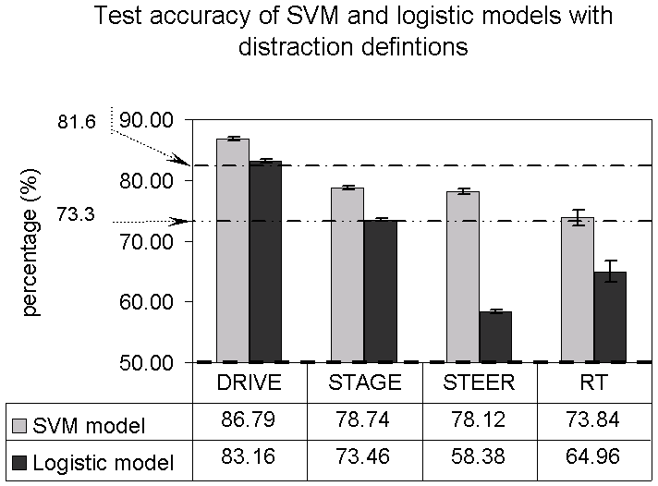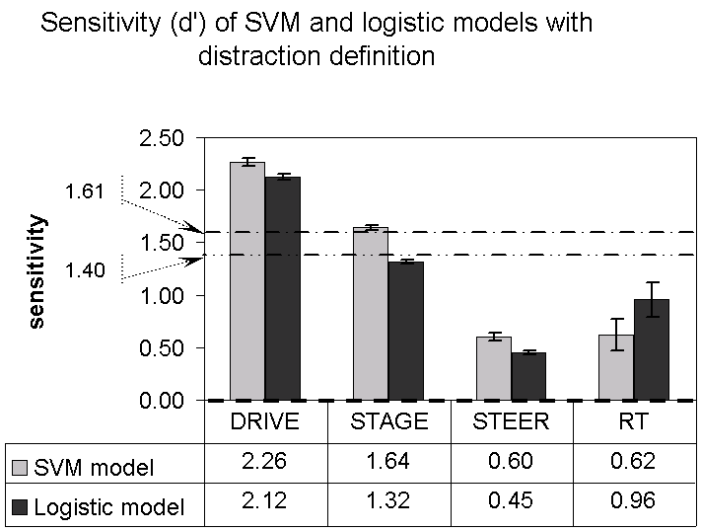
Testing accuracy Sensitivity
Figure 5.10. Results of the SVM and logistic models. The dashed, dash-dot, and dash-double dot lines indicate chance performance, SVM average, and logistic average, respectively.

Comparison with the logistic method
After comparing the SVM method with chance performance, we compared it with the logistic regression method. The paired t-tests showed that the SVM models were more accurate (SVM: 81.1%, logistic: 72.7%, t(9)=11.74, p<0.0001) and more sensitive (SVM: 1.54, logistic: 1.37, t(9)=5.59, p=0.0003) than the logistic models (see Figure 5.10). When we compared response bias, we found that the SVM models have a generally conservative strategy (β=3.91), whereas the logistic models were neutral (β=1.05). However, no significant difference in response bias was found (t(9)=1.63, p=0.137), reflecting a large variance in the bias of the models.
Comparing the performance of the SVM and logistic models for each distraction definition shows that the SVM models outperformed the logistic linear models in testing accuracy for all definitions (DRIVE: t(9)=4.27, p=0.0021; STAGE: t(9)=5.71, p=0.0003; STEER: t(9)=11.47, p<0.0001; RT: t(8)=2.43, p=0.041). The SVM models also had greater sensitivity than the logistic models for DRIVE and STAGE (DRIVE: t(9)=3.02, p=0.0144; STAGE: t(9)=8.84, p<0.0001), and marginally better sensitivity for STEER (t(9)=2.22, p=0.054), but not for RT (t(8)=-1.30, p=0.23). The response bias was similar for both types of models for both DRIVE and STAGE (DRIVE: t(9)=0.81, p=0.440; STAGE: t(9)=1.00, p=0.345; RT: t(8)=1.71, p=0.12). The SVM models were marginally more conservative than the logistic models (t(9)=2.24, p=0.052) for STEER.
None of the distraction definitions showed a significant difference for bias between model types, which was consistent with the overall findings in that the conservative SVMs were not significantly different from the neutral logistic models. Variance of response bias was then examined. Bias was significantly greater for the SVM models than for the logistic models for the first three definitions (DRIVE: F(1,9)=102.20, p<0.0001; STAGE: F(1,9)=2862.28, p<0.0001; STEER: F(1,9)=93201.8, p<0.0001), but not for RT (F(1,8)=0.34, p=0.92). The Receiver Operating Characteristic (ROC) plots in Figure 5.11 clearly show the difference between the two kinds of models for DRIVE, STAGE, and STEER. In both graphs in Figure 5.11, the dash-dot diagonal represents a neutral strategy (β=1). Models using liberal strategies (β<1) are located on the right side of the neutral line, and models using conservative strategies (β>1) are located on the left side.
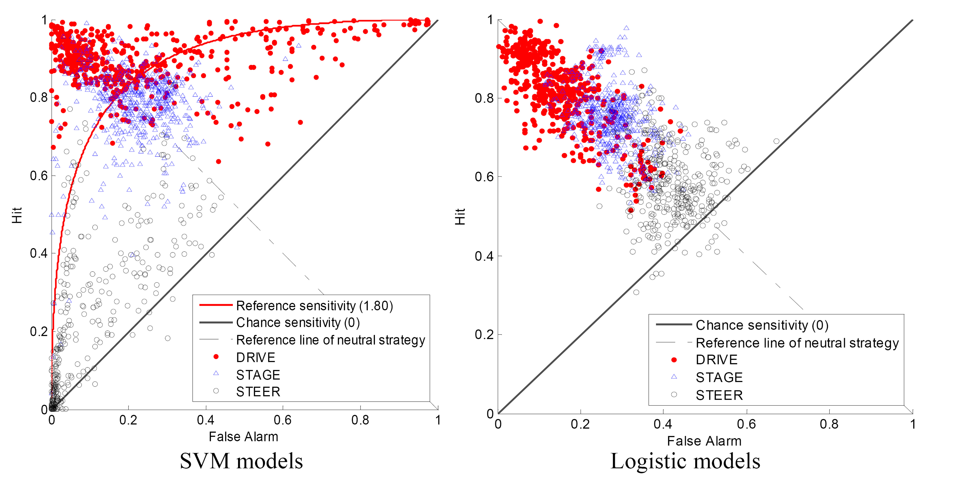
Figure 5.11. ROC curves for the SVM and logistic models for DRIVE, STAGE, and STEER.
The logistic models (the right graph) are located along the diagonal while the SVM models (the left graph) are located across a much wider area and show different characteristics for different definitions. The logistic regression models use a consistent β , while the SVM use a very inconsistent β. That is, misses and false alarms equally contribute to the detection error of logistic models, while SVM models vary the proportion of misses and false alarms according to the proportion of “distracted” and “non-distracted” situations. The SVM models using DRIVE and STAGE tended to use neutral or slightly conservative strategies (almost equal miss and false alarm rates), and STEER used substantially conservative strategies (higher miss rate than false alarm rate). These comparisons show that the SVM models take a more flexible approach to classification than the logistic regress models.

Effect of model characteristics
The results shown above are evidence that the SVM method is a powerful technique for identifying driver distraction. Next, we studied the effects of the distraction definitions, feature combinations, window sizes, and overlaps on model performance in order to offer realistic suggestions as to how to implement real-time distraction detection systems using SVMs. We used the mixed linear model with subject as a repeated measure, and performed post hoc comparisons using the Tukey-Kramer method with SAS 9.0.
Distraction Definition: Accuracy and sensitivity (d’) were significantly affected by the different distraction definitions (accuracy: F(3,26)=254.32, p< 0.0001; sensitivity: F(3,26)=570.17, p<0.0001). The models for DRIVE had the highest accuracy and sensitivity, and the models for STEER and RT had the lowest accuracy or sensitivity (see the left graphs in Figure 5.12). The differences in model sensitivity (d’) are also captured in Figure 5.12. Most points for STAGE and STEER are below the reference curve for sensitivity equal to 1.80, whereas most points for DRIVE are above the reference curve. Despite rather large differences in mean bias (DRIVE: 1.9; STAGE: 3.6; STEER: 8.33), the definitions did not differ significantly due to the large variance in bias discussed earlier.
Comparing the two definitions based on the experimental conditions, the models for DRIVE were more accurate and more sensitive than the models for STAGE (accuracy: t(26)=21.84, p<0.0001; sensitivity: t(26)=17.05, p<0.0001). This suggests that distraction defined by IVIS and baseline drives is more discernible than distraction defined by drivers’ interaction with IVIS system. One interpretation of this result is that drivers’ eye movements are affected by cognitive distraction even after the task has ended, so that their eye movement patterns during the one-minute non-IVIS intervals between IVIS interactions maintained the same or similar patterns as during the interactions.
Comparing the driving-performance-based definitions, distraction defined by steering error (STEER) was predicted more accurately than that defined by RT (t(26)=5.99, p=0.0002). The results show eye movements could reflect the change of steering performance caused by a secondary cognitive task and predict the response time to the braking of the LV, but not with a high degree of sensitivity.
Feature Combinations: Feature combinations had a significant effect on testing accuracy (F(2,18)=25.84, p<0.0001) and sensitivity (F(2,18)=44.68, p< 0.0001) but not on response bias (F(2,18)=2.48, p=0.1117). Testing accuracy and sensitivity increased with the number of input variables (see Figure 5.12). Specifically, the spatial information of eye movements and driving measures both increase model sensitivity (t(18)=2.97, p=0.0212, and t(18)=6.67, p<0.0001, respectively). Adding the driving measures to the eye data increased sensitivity more (0.41) than did adding the spatial information to the other eye movements (0.17).
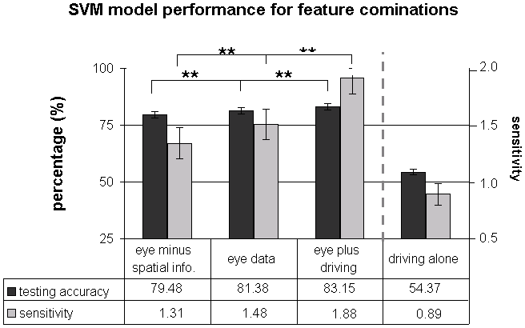
Figure 5.12. SVM testing accuracy and sensitivity for the feature combinations. The braces represent the post hoc comparisons between the successive combinations using Tukey-Kramer method. ** indicates p<0.05.
Because the driving measures improved model performance so dramatically, we built additional models using only driving measures as inputs. “Driving alone” achieved accuracy of only 54.4%, sensitivity of 0.89, and bias of 1.87 (see Figure 5.12). The large differences in accuracy and sensitivity from “eye plus driving” and “eye data” to “driving alone” suggest that eye movement features played a more important role in detection than the driving measures.
Summarizing Parameters of the Input Data: Window size affected testing accuracy (F(3,27)=33.35, p< 0.0001) and sensitivity (F(3,27)=44.68, p< 0.0001) but not response bias (F(3,27)=2.48, p=0.1117). The models’ accuracy and sensitivity increased with window size. Similarly, overlap increased testing accuracy (F(4,36)=19.01, p< 0.0001) and sensitivity (F(4,36)=72.47, p< 0.0001) but not on response bias (F(4,36)=0.79, p=0.5421). Increasing the redundancy of input data between adjacent windows improves model performance. More importantly, window size and overlap interacted to affect testing accuracy (F(17,153)=35.36, p< 0.0002) and sensitivity (F(17,153)=51.01, p< 0.0001) as Figure 5.12 clearly shows, but not response bias (F(17,153)=1.30, p= 0.1966).
Testing accuracy Sensitivity
Figure 5.13. Testing accuracy and sensitivity for different summarizing parameters of input data.
We then studied the effects of summarizing parameters for the distraction definition with the best performance, DRIVE. Window size and overlap show the same trend as in Figure 5.13. The best model, using 40-second window size with 95% overlap, produced 96.08% accuracy, sensitivity of 3.84, and response bias of 4.25.

Discussion
Support Vector Machines, a data mining method, offers a promising approach to detecting driver distraction from eye movements and driving performance in real time. The results show that the SVM models clearly outperformed the logistic regression models. The comparisons for the model characteristics show that, on average, the DRIVE definition, “eye plus driving” feature combination, and 40-second window size with 95% overlap, led to the best model performance.
The results indicate that the cognitive task affected the pattern of eye movements. Figure 5.14 shows these differences for an IVIS and a baseline drive. When drivers interacted with the IVIS, they had fewer and shorter fixations on the right side of the road where the bicyclists appeared. These data suggest that when drivers engaged in the secondary task, they paid less attention to the bicyclist detection task. Diminished performance in detecting objects and a decrease in gaze variability has also been reported in two previous studies (Recarte & Nunes, 2000, 2003b). This consistency shows that the differences found in Figure 5.14 are part of what the SVM models captured in distinguishing distracted from non-distracted drivers.
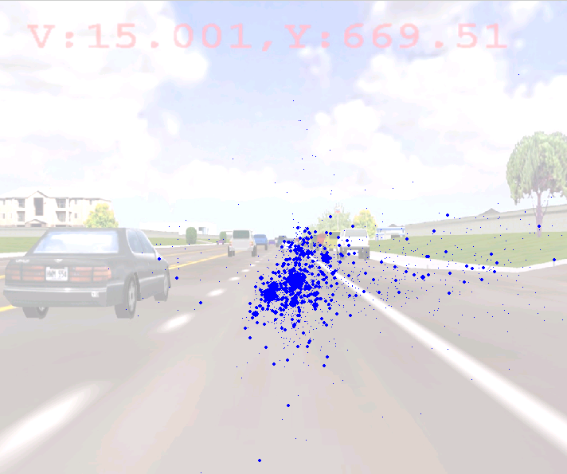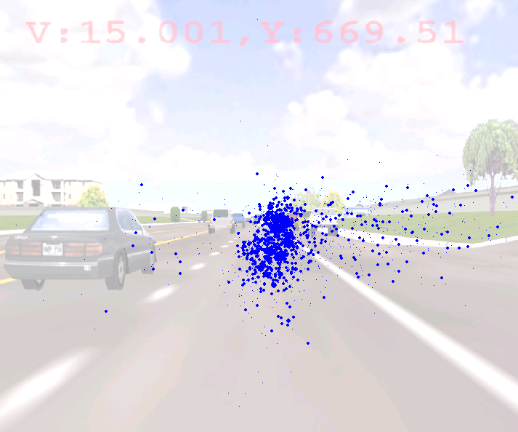
IVIS drive baseline drive
Figure 5.14. The plots of fixation distribution over the background of the driving scenario for IVIS (left) and baseline (right) conditions for participant SF7. The size of each dot represents fixation duration.
One limitation of this experiment is that the bicyclist detection task likely caused drivers to scan the driving environment in a manner differently than they would in normal driving. The discrepancy between the experimental data and reality suggests a need for caution in generalizing the results. If drivers considered the pedestrian-detection task something they could shed as the IVIS demands increased, the corresponding shift in eye movements might make distraction easy to detect, but such a shift might not generalize to actual driving situations. Because this experiment used a pedestrian-detection task, it may have overestimated algorithm performance in that the relatively explicit need to scan the right side of the road does not exist in many driving situations. However, monitoring for pedestrians and bicyclists is a realistic driving task and one that might be neglected in actual driving situations. As a consequence, the driving scenario in this experiment reasonably simulated normal driving. Future research needs to assess the degree to which the driving situation influences algorithm performance.
In addition to the binary states of drivers, the SVM models also generated a decision variable for each testing instance. When the decision variable was positive, SVM models outputted a binary state 1; when negative, the models outputted 0. This decision variable can indicate the distance from the instance to the classification boundary and can be interpreted as the model’s confidence in the binary output. Figure 5.15 shows how the decision variable changed for the “eye plus driving” feature combination, and the 40-second window with 75% overlap. The decision variable remains positive in the IVIS drive and drops below zero in the baseline drive. This figure shows that the decision variables of the SVM models follow the expected trend corresponding to the IVIS task. Also evident in Figure 5.15 is a delay that may be attributed to either the inertia of driver attention, the aggregation of the data over a large window, or some combination of the two. The degree to which this delay reflects characteristics of the algorithm or reflects the driver’s state merits further investigation. Clearly, delay is an issue that must be addressed before SVMs are implemented in a real-time system, which will be discussed later in this section.
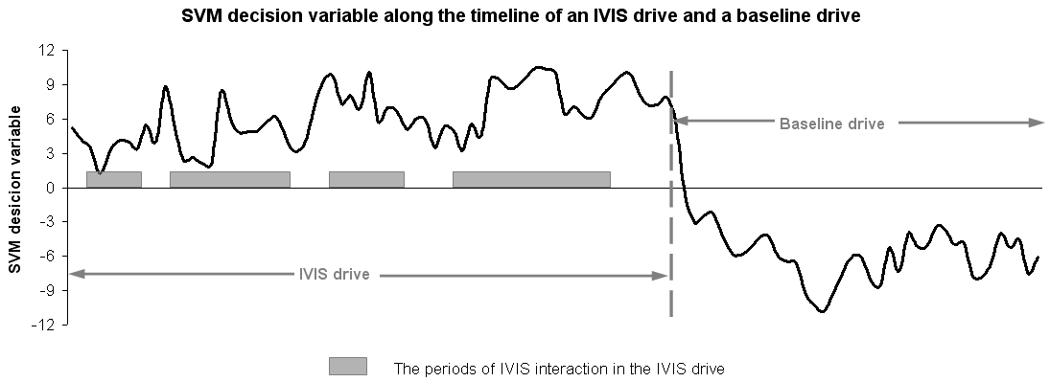
Figure 5.15. SVM decision variable along the timeline of an IVIS drive and a baseline drive for participant SF7 (for the same data shown in Figure 5.14).
Several factors might explain the superior performance of the SVM algorithm relative to that of the logistic regression. First, the SVM models used the RBF kernel function that can fit both linear and nonlinear relationships, whereas the logistic models can only fit linear models. Second, the training of SVMs minimizes the upper bound of the generalization error (Amari & Wu, 1999), whereas the logistic method only minimizes training error. This makes the SVM more robust by rendering overfitting less likely than with logistic regression. Third, the SVM method can adjust response bias to increase performance by changing parameter values (i.e., C and γ). The logistic method looks only to minimize errors (i.e., false alarms and misses), a strategy that largely depends on the ratio of instances from the two classes in the training dataset. In this study, because the training sets were randomly selected and consisted of equal numbers of instances for the two classes (“distracted” and “not distracted”), minimizing the total number of errors led to approximately equal occurrences of false alarms and misses, which in turn resulted in neutral strategies (see right graph in Figure 5.11). Because the proportion of time a driver is “distracted” or “not-distracted” on the road is unknown and will vary, it is impossible to select training data that are representatively proportioned between the two classes and between false alarms and misses. With the same training sets, the SVM models produced different strategies when changing the values of C and γ (see left graph in Figure 5.11).
The spatial and temporal patterns of eye movements have complex connections with cognition, and only indirectly reflect driver distraction. These connections have already been demonstrated with measures aggregated over experimental condition (May, Kennedy et al., 1990; Rantanen & Goldberg, 1999; Recarte & Nunes, 2000, 2003b). Our study further supports eye movements as a real-time indicator of driver distraction. Cognitive distraction can degrade driving performance, and including measures of driving performance boosted SVM accuracy and sensitivity compared to using eye data alone. However, using only driver performance resulted in insensitive models with low accuracy. Similar to our results, others have found that gaze-related features led to much better prediction accuracy compared to driving performance measures alone (Hayhoe, 2004).
There are some additional, practical limitations to implementing distraction detection systems. The first is how to obtain consistent and reliable sensor data. Eye trackers may lose tracking accuracy when vehicles are traveling on rough roads or when lighting conditions are variable. More robust eye tracking techniques are needed to make these detection systems a reality. Steering data can be obtained directly from the angle of the steering wheel, however, and some have developed robust measures of lane position in real driving environments [14]. Second, delay of detection needs to be assessed to evaluate whether it is appropriate for the application. The delay in real-world systems can come from three sources. One is sensor delay. For example, the eye tracker used in this research took approximately 2.6 s to translate the camera image to numerical data. The second source is the data-reduction and computational time of SVM models. It took about one second to reduce data and compute 15-s-long data in this study. These two kinds of delays can be reduced with the advance of sensor and computer technology and the improvement of the data reduction algorithms. The third source derives from summarizing data across windows. Larger windows cause a longer delay. The consequence of these lags will depend on the particular distraction mitigation strategy they support. Developing a systematic approach to balance the cost of time lags with the precision of distraction estimates for particular mitigation strategies represents an important research issue.

Conclusion
SVMs provide a viable means of detecting cognitive distraction in real-time and outperformed the more traditional approach of logistic regression. Comparing the performance of SVM using eye movements to a case without eye movements clearly demonstrates the importance of eye movements as an input to a distraction detection algorithm. Including both eye and driving measures as inputs to a distraction detection algorithm is recommended. These data were collected in a driving simulator with relatively homogenous traffic and roadside objects. On-road data in a more diverse set of conditions is needed to assess the generality of the results.

Bayesian Networks to Detect Cognitive Distraction
Although Support Vector Machines are a promising approach to detecting driver distraction, other data mining approaches may provide a complementary—or even potentially more effective—means of detecting distraction. One such approach is a Bayesian Network. A Bayesian Network represents conditional relationships between a network of random variables. In Figure 5.16, the nodes present random variables which are identified by concepts or measures in the area of interest. The nodes can present hypotheses, observation evidence, or hidden states. Hypothesis nodes, like H, H^{t-1}, and H^{t} in Figure 5.16 represent decision variables and the beliefs (expressed as probabilities) of each possible value. For the models used in this study, the binary hypothesis node was driver distraction (distracted or not distracted). Evidence nodes, like E1, E2, E1^{t-1}, and E1^{t}, represent observed measures used to infer the state of decision variables. Summarized eye movement and driving measures, such as mean fixation duration or mean lane position, are the evidence nodes for this application. Hidden nodes, like S, S^{t-1}, and S^{t}, are abstract concepts that cannot be directly measured, but may be important for belief inference, because they can group related evidence. Therefore, hidden nodes can help make models more meaningful and form a hierarchical network structure. Possible intermediate abstract concepts represented by hidden nodes could be overall eye scanning pattern or an overall level of driving performance. These classes of nodes are exclusive to each other. For example, Hidden Markov Models (HMMs), a simple BN, have hidden hypothesis nodes.
The arrows represent conditional relationships between the nodes in a BN. For example, in Figure 5.16, the arrow from S to E2 on the left graph means that by giving the value of S, we can know the probability of E2 being a certain value. By knowing S, the value of E2 is independent on any other node.
Static Bayesian Network | Dynamic Bayesian Network
Figure 5.16. Examples of a SBN and a DBN, where H is a hypothesis node, S is a hidden node, Es are observation nodes, and t represents time.
BNs are either Static (SBNs) or Dynamic (DBNs). SBNs, shown on the left in Figure 5.16, consider evidence and beliefs at a single point in time and cannot describe probabilistic relationships across time. DBNs, shown on the right in Figure 5.16, can model time-series events as a Markov process. DBNs connect two SBNs that are identical in structure from two successive time steps. That is, the state of a node at time t is conditionally dependent on all nodes in both the previous (t-1) and current (t) time steps.
Many studies have used BNs to describe human behavior (Guhe et al., 2005b; Ji, Zhu, & Lan, 2004a; Kumagai & Akamatsu, 2006a; Li & Ji, 2005a). BNs have several advantages that make them well suited for this application. First, human behavior is usually complicated, dynamic, and stochastic. BNs are capable of representing these complex relationships. The hierarchical structure of BNs can systematically present information from different sources and at different levels of abstraction (Li & Ji, 2005a), and can also capture probabilistic relationships. BNs have a much more diverse and flexible representation than some formalized mathematical approaches. Second, a BN is not only a computational model but also a form of knowledge representation. The training of BNs can identify the meaningful relationships that underlie model predictions. Studying mutual information between evidence and hypothesis nodes reveals the most influential evidence underlying model predictions (Guhe et al., 2005a). Unlike other data mining approaches, such as support vector machines, BNs reveal the relationships that generate the model predictions. Third, BNs can handle situations with missing data (Li & Ji, 2005a). The certainty of the hypothesis will change according to BNs’ reasoning, which incorporates new data using a probabilistic dependence network when new evidence is added. Because of these advantages, BNs are applicable to human-behavior modeling and have been used to detect affective state (Li & Ji, 2005a), fatigue (Ji et al., 2004a), lane change intent during driving (Kumagai & Akamatsu, 2006a), and pilot workload (Guhe et al., 2005a). Despite these advantages, creating a correct and stable BN model requires extensive computational capability and a large amount of training data.
Although BNs have been used in many studies of human behavior, no research has applied this technique to real-time detection of driver distraction. This study presents a BN approach to identifying driver cognitive distraction non-intrusively and in real-time, using eye movement and driving performance data from a driving simulator experiment. The objectives of this study were to learn what features of BN models most influence the detection of driver distraction and to explore the new insight into cognitive distraction that BN models produce.

Model Construction
The same data used to train and test the SVMs were used to train and test the BNs.

Training of BN models
Following the results from a previous study (Liang, Reyes, & Lee, 2007), IVIS drives and baseline drives were used to define driver cognitive state as distracted and not distracted, respectively. The BN models used this information to define the hypothesis node. The evidence used by the BN models, hereafter called instances, were discretized values of eye movement and driver behavior data summarized over a windows of 5, 10, 15, or 30 seconds. The raw eye data were transformed into fixation, saccade, and smooth pursuit eye movements. From this basic eye movement behavior, the following summary eye movement measures were calculated: mean and standard deviation (SD) of fixation duration, horizontal and vertical fixation location coordinates, pursuit duration, pursuit distance, pursuit direction and pursuit speed, percentage of the time spend on performing pursuit movements, and mean blink frequency. Summarized driving performance data included standard deviation of steering wheel position, mean steering error (Nakayama, Futami, Nakamura, & Boer, 1999a), and standard deviation of lane position. Finally, all 19 of the summarized measures were discretized, using cutoff points for each measure that maximized the information gain for the state of cognitive distraction. The splits for the measures used the cutoff points that were the most representative of the two cognitive states (Tan, 2005).
Several BN models were trained and tested for each of nine participants. One participant’s data was omitted because he failed to perform the driving tasks as instructed. Following the typical data mining practice (Tan, 2005), two-thirds of the instances (equivalent to approximately one hour of driving) were chosen at random to form the training set, and the remainder (about 30 minutes of driving) formed the testing set. The training of BN models included structure learning and parameter estimation. Structure learning identifies the possible connections between nodes within a BN, and parameter estimation identifies the conditional probabilities for these connections. These two kinds of learning were processed in one learning run.
The BN models were trained using a Matlab toolbox (Murphy) and an accompanying structure learning package (LeRay, 2005). The hypothesis node represented driver state of cognitive distraction, which was defined by the experimental conditions (IVIS drives – distracted; baseline drives – not distracted). The evidence nodes included the 19 discrete measures of eye movements and driving performance. The hidden node, which is not a hypothesis node in this study, represents an abstraction and aggregation of the evidence, such as overall eye scanning pattern or a general level of driving performance.
Model performance was compared for three factors (see Table 5.4): BN model type, presence of a hidden node, and summarizing parameters for training instances. The first factor, model type, compared SBN and DBN models to assess how time dependencies affect model performance. Driving involves a series of actions taken by drivers to control vehicles, and these actions are sequentially related because changes in driver performance and cognitive state are continuous and gradual. Taking time-dependent relationships into account may help capture the overall pattern of driver performance, and so the DBN models may detect driver distraction more precisely than the SBN models.
The second factor considered whether including a hidden node improved model performance compared to a model without a hidden node. Because hidden nodes can group evidence in a meaningful way, they may be less sensitive to noisy data for inferring hypothesis nodes. Hidden nodes can also simplify inference by requiring less evidence at each step of the inference. Luo and colleagues (Luo, Wu, & Hwang) proposed a hierarchical DBN with five hidden nodes to successfully identify human motion from a video sequence. In this study, some possible intermediate concepts, such as eye movement pattern or driving performance, may aggregate observed measures and provide a more stable indicator of driver cognitive distraction than the observed measures themselves. Although hidden nodes may improve model performance and provide meaningful interpretation, they also increase computational complexity and uncertainty in training.
The last factor was the summarization of the parameters used to create the instances for training and testing. Specifically, the various window sizes over which data were summarized were compared. The aim was to find the summarization of data that balances noise reduction and the washout of the distraction signal associated with a longer window. For DBNs, window size also defined the time steps. That is, evidence at time step t was the summarized measures across a window ending at time t; evidence at time step t+1 was summarized across the next window, which started at t and ended at t + window size. Liang et al. (Liang et al.) found that longer windows improved model performance. Since the total quantity of training data was fixed (approximately one hour of driving), the number of training instances decreased with increasing window size. Thus, the performance of models with longer window sizes might deteriorate because they were trained with fewer instances. More importantly, large windows could impose a delay in detecting distraction. A second summarization parameter, sequence length, was considered for DBNs. A sequence contained multiple, consecutive training instances. It was thought that longer sequences might provide more comprehensive and stable time-dependent relationships between driver distraction and performance, and could be expected to train better-performing models. The sequence lengths were 30, 60, and 120 seconds.
Table 5.4. The Comparisons with Different Characteristics.
FACTORS | LEVELS
BN Types | SBNs | DBNs
Number of Hidden Node | 0, 1 | 0, 1
Summarization Parameters | Window Size | Sequence Length | Window Size
Summarization Parameters | 5, 10,15, 30 s | 30 s | 5, 15 s
Summarization Parameters | 5, 10,15, 30 s | 60 s | 5, 10, 15 s
Summarization Parameters | 5, 10,15, 30 s | 120 s | 5, 10, 15, 30 s

The structures of the BNs were constrained so that the training procedure was computationally feasible and the trained models could be reasonably explained. When SBNs had a hidden node, the hypothesis node (distracted/not distracted) was connected to the hidden node, and the hidden node to the evidence nodes. This meant that there were conditional relationships between the hypothesis and hidden nodes, and between the hidden and evidence nodes, like the arrows between nodes in Figure 5.16. There were no direct connections between the hypothesis and evidence nodes. When SBNs had no hidden nodes, the hypothesis node was connected with the evidence nodes directly. For DBN models (see Figure 5.17), the links within a time step, called intra-links, were present only in the first time step. After the first step, nodes were linked only with those in the previous time step. These links between time steps were called inter-links. The inter-links connected the hypothesis node at a previous time step to the hidden node at the present time step; the hidden node at a previous time step was connected to the evidence nodes at the present time step when the DBN models had a hidden node (see Figure 5.17). When DBN models had no hidden node, the hypothesis node at the previous time step was connected to the evidence nodes at the present time step. For DBNs, two structures, an intra-structure and an inter-structure, were trained, while only one structure was trained for the SBNs.

Figure 5.17. Constrained DBN Structure, where solid arrows represent intra-links and dotted arrows represent inter-links.
In total, 234 BN models were trained. Each participant had 26 BN models: 8 SBN models (2 levels of hidden nodes crossed with 4 levels of window size) and 18 DBN models (2 levels of hidden nodes crossed with 9 combinations of summarization parameters). The trained models included estimates of the beliefs of distracted/not distracted situations for the testing cases. The resulting networks were assessed with experimental conditions (IVIS drives/baseline drives) to evaluate their ability to identify distraction.

Model performance measures
Model performance was evaluated with the same measures used for SVM in the previous section.

Mutual information
Normalized mutual information was also used to assess the strength of dependencies between performance measures and cognitive distraction. Mutual information, I(X;Y), describes the information shared by two random variables, X and Y (Guhe et al., 2005a). That is, it measures how much uncertainty of Y is reduced by knowing X. The higher the level of mutual information, the closer the connection between the two variables. Based on the trained model, the normalized mutual information of each driver behavior measure and cognitive distraction can be calculated according to (3)
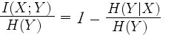……………………………………………...………..(3)
where X represents a performance measure, Y represents cognitive distraction, H(Y) is the entropy of cognitive distraction, and H(Y|X) is the entropy of cognitive distraction given the particular performance measure. The entropy measures the uncertainty of a variable. This normalized mutual information describes the degree to which uncertainty in identifying distraction is reduced by knowing the measure. The higher this value, the more indicative the measure is of driver distraction.
To compare the mutual information of performance measures, we grouped the model inputs according to their correlation, because correlated measures may have a similar association with the level of driver cognitive distraction. A factor analysis with varimax rotation, which transforms the factors so that they are orthogonal to each other, was conducted on 19 discrete performance measures. The results showed that 52.3% of the variation in the 19 measures could be accounted for by six common factors. These six factors included fixation duration (consisting of mean and SD of fixation duration and percentage of smooth pursuit), fixation horizontal distribution (mean and SD of fixation horizontal coordinates), fixation vertical distribution (mean and SD of fixation vertical coordinates), pursuit duration (mean and SD of pursuit duration and distance, and percentage of smooth pursuit), pursuit speed (mean and SD of pursuit speed), and driving performance (SD of steering wheel position, mean of steering error, and SD of lane position). An additional category containing only blink frequency was added because the six factors explained little of the variance of blink frequency. Average normalized mutual information was calculated and compared for the groups of fixation duration, fixation horizontal distribution, fixation vertical distribution, pursuit duration, pursuit speed, driving performance, and blink frequency.

Results
The analyses were conducted in two parts. The first part evaluated the overall BN model performance, and then examined the effects of the three model characteristics by comparing testing accuracy and two SDT measures. T-tests and the mixed linear model with subject as a repeated measure were used for these analyses. Post-hoc comparisons were performed using the Tukey-Kramer adjustment for multiple comparisons. The second part of the analyses examined the relationships between model structure and performance and mutual information. The mutual information of six common factors was also compared intuitively to identify the strength of the relationships between performance measures and driver cognitive distraction.

Comparison of model performance
Mean accuracy of BN models was 80.1% (SD = 10.0%); sensitivity, 2.22 (SD = 1.17); and response bias, -0.52 (SD = 2.95). Accuracy and sensitivity were both far better than the chance performance described by 50% accuracy and zero sensitivity (accuracy: t(8) = 9.05, p < 0.0001; sensitivity: t(8) = 5.71, p = 0.0004). Overall, the BN models favored “distraction,” leading to a relative high false alarm rate (0.37) and high hit rate (0.87). That is, the models correctly detected distraction 87% of the time when distraction was present, but also incorrectly detected distraction 37% of the time when distraction was not present.
For the first factor, model type, which compared SBNs and DBNs, we found that, on average, DBN models were more sensitive than SBN models (F(1,8) = 21.2, p = 0.0017), but there were no significant differences in accuracy (see Figure 5.18) and response bias. This result shows that considering time-dependent relationships increases the ability to detect distraction. The presence of a hidden node had a significant influence on all three performance measures (accuracy: F(1,8) = 30.33, p = 0.0006; sensitivity: F(1,8) = 9.86, p = 0.014; response bias: F(1,8) = 15.02, p = 0.0047). The models without a hidden node recognized distracted situations more accurately, and with greater sensitivity, and tended to err in identifying distraction when it was not present, compared to those with one hidden node.
There was a marginally significant interaction between model type and the presence of a hidden node for accuracy (F(1,8) = 5.12, p = 0.052) but not for sensitivity or response bias (sensitivity: F(1,8) = 3.01, p = 0.12; response bias: F(1,8) = 0.58, p = 0.47). As seen in Figure 5.18, the decrease in accuracy when a hidden node was present was greater for the DBNs than for the SBNs. When the models had no hidden node, the accuracy of DBNs was significantly greater than that of SBNs (t(8) = 2.4, p = 0.043), but DBN models did not show a significant advantage in accuracy compared to SBN models (t(8) = -0.83, p = 0.43) when there was a hidden node.
Figure 5.18. The Comparisons of Model Type, Number of Hidden Nodes and the Interaction.
The summarization parameter, window size, had no significant effect on the performance of the SBNs, as measured by accuracy, sensitivity, and response bias. Similar results were obtained for DBNs, with no significant effects of window size for the three model performance measures. Longer training sequences produced more sensitive models (F(2,16) = 12.26, p = 0.0006), but accuracy and bias were not affected. No interaction between window size and sequence length was found. The most accurate predictions of distraction occurred with DBNs and a 120-second training sequence.

Analysis of mutual information
In addition to the analyses on model performance, mutual information between evidence nodes (performance measures) and hypothesis node (driver distraction) was calculated and compared for the SBN and DBN models without a hidden node. Mutual information showed a correlation with model performance. The total mutual information carried in a model had a moderately positive relationship with its accuracy (r = 0.48, p<0.0001) and sensitivity (r = 0.51, p<0.0001). As window size increased, the number of links in a model decreased (SBNs: F(3,24) = 135.0, p<0.0001; DBNs: F(3,24) = 470.3, p<0.0001) and the average mutual information per link, as calculated by total mutual information in a model divided by the number of links, increased (SBNs: F(3,24) = 20.7, p<0.0001; DBNs: F(3,24) = 66.8, p<0.0001). These results suggest that the larger windows more clearly identify critical performance indicators of driver distraction.
Figure 5.19 shows the averaged normalized mutual information of all seven categories of measures for the trained SBN, and DBN intra- and inter-structures. Blink frequency played the most important role in identifying driver cognitive distraction, as shown by the high level of normalized mutual information. When mutual information was averaged across SBN, DBN intra-, and DBN inter-structures, knowing blink frequency reduced 37% of uncertainty in the detection. Fixation measures, especially fixation duration and vertical distribution, also helped to distinguish driver states because the average normalized mutual information of fixation duration and vertical distribution were 10% and 12%, respectively. However, pursuit eye movement and driving measures had only a weak connection with cognitive distraction, as reflected in their normalized mutual information of less than 2%. The SBN, and DBN intra- and inter-structures had similar patterns of mutual information distribution across these seven categories.
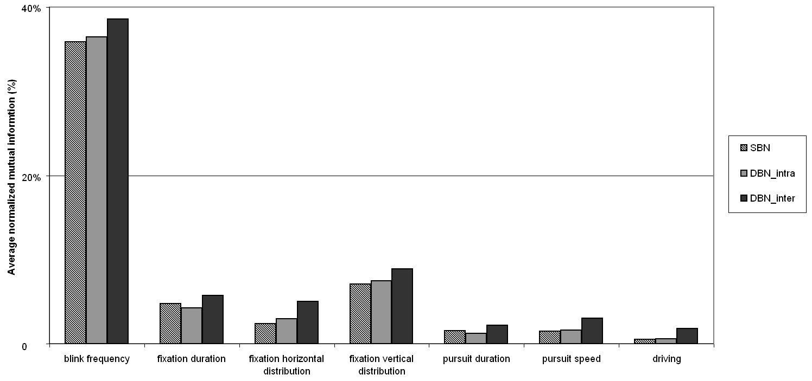
Figure 5.19. The Mutual Information of Seven Categories of Performance Measures.
Mutual information also revealed individual differences. Table 5.5 shows the mutual information distributions for the four measures with the highest mutual information values. Although the average mutual information for blink frequency is 37% across all participants, this value is less than 10% for three participants. The other groups of performance measures also show inconsistent mutual information across participants, suggesting the need to estimate separate BN structures and parameters for each individual.
Table 5.5. The Mutual-Information Distribution of Nine Participants across the Most Predictive Variables (dark shading indicates average normalized mutual information greater than 30%; dark grey indicates between 30% and 10%; grey indicates between10% and 5%; white indicates less than 5%).
Participant | 1 | 2 | 3 | 4 | 5 | 6 | 7 | 8 | 9
Blink frequency
Fixation duration
Fixation horizontal distribution
Fixation vertical distribution

Discussion
The performance of BN models confirmed that they are a useful and promising technique for identifying driver cognitive distraction. Drivers behaved differently when they were cognitively loaded and BNs were able to detect these differences. Eye movement and driving performance measures, especially those having high mutual information with distraction, were useful in predicting drivers’ cognitive state. The best predictors of distraction were DBNs using 120-second training sequences. These models produced an accuracy of 86.4%, with a sensitivity of 3.90. DBNs produced more sensitive models, suggesting that time-dependent data contains information that indicates distraction.
The presence of a hidden node, particularly for the DBN, diminished model performance. This was surprising in that a hidden node represents a free parameter that should enable the model to fit the data more precisely. One interpretation of this result is that including an intermediate state in the model does not accurately describe the mechanisms underlying cognitive distraction. The model structure without a hidden node is a more accurate representation of the relationship between driver performance and cognitive state. Another possibility is that, because hidden nodes introduce more uncertainty in the model learning process, using equal amounts of training data for the models both with and without hidden nodes may have caused the hidden node models to be less accurate. This second possibility would also explain why accuracy decreased from no hidden node to one hidden node more for the DBNs than for the SBNs; the learning process was more complex for DBNs. To determine which explanation is correct, another study with is needed to ensure that training can produce accurate parameter estimates.
Window size did not affect model performance for either the SBNs or DBNs, which means that evidence summarized across different periods of time did not present the distraction signal differently, and that the definition of time step did not affect model performance of DBNs. These results conflict with those from Liang et al. (Liang et al.), where larger windows improved the ability of SVM to detect cognitive distraction. The conflicting results may reflect important differences between the two methods. As with the hidden node comparison, the models that use longer window sizes were trained with fewer instances because the length of total data was fixed, meaning that large windows produced fewer training instances. The effect of sequential length of training examples conforms to this explanation, with sequential length of training examples improving DBNs model performance. Longer sequences supply more repeated cases from which DBNs can extract the stable relationship between performance and cognitive distraction.
The analysis of mutual information showed that blink frequency had the strongest relationship with cognitive distraction. Another study used blink measures to study driver vigilance (Bergasa et al., 2006), and found that when drivers were alert, they blinked less frequently. We found a similar pattern of behavior; during baseline drives, drivers blinked at 0.31Hz, but when they interacted with the secondary task, they blinked at 0.49 Hz (F(2,18) = 361.4, p<0.0001). Such an increase in involuntary eye movements may disrupt the consolidation of visual information (Strayer et al., 2003b). The time-dependent changes in fixation horizontal distribution, pursuit speed, and driving measures are all more predictive of distraction than when such changes are considered as static measures, because their mutual information in DBN inter-structure (5%, 3%, and 2%, respectively) was higher than that in SBN structure (2%, 1%, and 0.5%, respectively). The mutual information analysis also shows that individual differences render unrealistic a uniform model structure that fits all people.
Interestingly, larger window sizes decreased the number of links and increased the mutual information per link in the trained models. This suggests that larger window sizes make important dependent relationships between performance measures and distraction more prominent, but do not necessarily improve model performance. One possible reason is that training instances decrease as window size increases.
Although this BN approach aims at real-time detection, there remains an unavoidable lag from when the driver’s cognitive state changes until the model recognizes the change. As with the SVM algorithm, the lag results largely from three sources: sensor delay, model computational delay, and the delay caused by summarizing the measures across a window. Sensor delay is the time required for data acquisition and reduction, and model computational delay is the computational time of BN models. The magnitudes of the first two kinds of delay are on the order of seconds. The third source reflects the need to summarize the measures across a window, which is expected to be approximately half of window size. That is, a 5-second window produces about a 2.5-second delay, and 30-second windows produce about 15-second delays. As a consequence, increasing window size also increases model lag. The cost of the lag needs to be balanced against the prediction accuracy needed to support the specific distribution mitigation strategy. For the BNs in this study, the greater number of training instances seemed to balance the less precise state estimates associated with small time windows. Further analysis of larger datasets with more training instances are needed to assess this possibility and the tradeoff between prediction accuracy and prediction lag.
Although using BN to identify driver distraction represents a promising approach, implementation in production vehicles will depend on the development of sensors. For example, economical eye tracking devices that are robust to road surface, lighting conditions, eye color, and eye glasses are only now becoming a reality. The outcomes of this study suggest that as eye tracking and other driver-state sensors become more available, real-time measurement of driver distraction may be feasible. BN models that identify driver distraction provide critical input to distraction mitigation strategies that might include warning a distracted driver to attend to the road, diminishing the threshold of collision warnings, or recording instances of distraction for later review (Donmez et al., 2003a).

Conclusion
BNs provide a viable means of detecting cognitive distraction in real-time. Compared with SBNs, DBNs produce more sensitive detection models, suggesting that considering time-dependent relationships is useful in estimating the cognitive state of drivers. To train DBN models, longer training sequences are needed in order to produce sensitive models. Among the performance measures used in this study, blink frequency, fixation duration and fixation horizontal and vertical distribution played more important roles in identifying distraction than did smooth pursuit and driving performance measures. These data were limited, as they were collected in a driving simulator with relatively homogenous traffic and roadway scenarios. On-road data in a more diverse set of conditions are needed to assess the generality of the results.

Combining Algorithms to Detect Distraction
Although the previous sections considered SVMs and BNs as separate alternatives for detecting distraction, it may be useful to consider how they complement each other and how they might be combined to detect distraction. Detecting cognitive distraction is a complex procedure, which requires a robust data fusion system. Unlike visual and manual distraction, the challenge of detecting cognitive distraction is to integrate multiple data streams, including eye movements and driving performance, in a logical manner to infer the driver’s cognitive state. One way to address this challenge is by using data fusion. Data fusion systems can align data sets, correlate relative variables, and combine the data to make detection or classification decisions (Waltz, 1998). One benefit of using a data fusion perspective to detect cognitive distraction is that data fusion can occur at different levels of abstraction. For instance, sensor data are aggregated to measure driver performance at the most concrete level. These performance measures can then be used to characterize driver behavior at higher levels of abstraction, such as at the level of maneuver. This hierarchical structure can be used to logically organize the data and inferences, and to reduce parameter space in the detection procedure. The fusion systems also can continuously refine the estimates made at each level across time, which enables a real-time estimation of cognitive distraction.
There are two general approaches to implementing a data fusion system: top-down and bottom-up. The top-down approach identifies the targets based on known characteristics, such as shape and kinematic behavior. In the detection of cognitive distraction, the top-down approach uses the behavioral responses of drivers under high levels of cognitive load, reflecting existing theories of human cognition such as Multiple Resource Theory (Wickens, 2002) and ACT-R (Salvucci & Macuga, 2002). The limitation of the top-down approach is that it makes it impossible to implement data fusion without a complete understanding of the underlying process—something that is lacking in the area of driver distraction.
The bottom-up approach overcomes this limitation, and uses data mining methods to extract the characteristics of the targets from the data directly. Data mining includes a broad range of approaches able to search large volumes of data for unknown patterns, using techniques such as decision trees, evolutionary algorithms, support vector machines, and Bayesian networks. These methods are associated with multiple disciplines (e.g., statistics, information retrieval, machine learning, and pattern recognition) and have been successfully applied in business and health care domains (Baldi & Brunak, 2001; Tan, 2005). In the driving domain, decision tree, Support Vector Machines (SVMs), and Dynamic Bayesian Networks (DBNs) have successfully captured the differences in behavior between people driving normally and when distracted, and produced promising results in terms of detecting cognitive distraction (Liang, Reyes, & Lee, In press-a, In press-b; Zhang, Owechko, & Zhang., 2004).
The strategies for constructing data fusion systems include using the top-down approach alone, the bottom-up approach alone, or a mixed approach, which combines both top-down and bottom-up strategies. The choice of strategies depends on the availability of domain knowledge, as shown in Table 5.6. When the targets are very well understood, a data fusion system can be constructed using the top-down approach only. Currently, most data fusion systems use this strategy. Nevertheless, the lack of domain knowledge imposes an important constraint on this top-down-alone strategy in some domains, such as the detection of cognitive distraction. The bottom-up-alone and mixed strategies overcome the limitation. Oliver and Horvitz (2005) have demonstrated the effectiveness of these two strategies. They successfully used Hidden Markov Models (HMMs) and DBNs to construct a layered data fusion system able to recognize office activities by learning from sound and video data.
Table 5.6. Matrix of data fusion strategies and the availability of domain knowledge.
 |  | Data fusion strategies
 |  | Top-down approach | Mixed approach | Bottom-up approach
Domain knowledge | All available | √ | √ | √
Domain knowledge | Partially available |  | √ | √
Domain knowledge | Not available |  |  | √

Detecting cognitive distraction requires a bottom-up data mining strategy because the effects of cognitive demand on driving are not clearly understood. Although some theories of human cognition can help explain driver behavior, most theories only aim to describe, rather than predict, human performance, and thus cannot be used to detect cognitive distraction. Some theories, like ACT-R, represent promising approaches that are beginning to make predictions regarding distraction and driver behavior. On the other hand, various data mining methods have been used to detect cognitive distraction. Zhang et al. (2004) used a decision tree to estimate driver cognitive workload from glances and driving performance. In two other studies, Support Vector Machines (SVMs) and Bayesian Networks (BNs), successfully identified the presence of cognitive distraction from eye movements and driving performance (Liang et al., 2007, In press-a, In press-b; Zhang et al., 2004). Thus, strategies using bottom-up and mixed approaches are suitable data fusion strategies for detecting cognitive distraction.
The procedure for detecting cognitive distraction can be formulated in two sequential stages—feature refinement and state refinement—as shown in Figure 5.20. Feature refinement uses the top-down approach and transforms sensor data (such as eye and driving performance raw data) into performance measures based on an understanding of what measures may be most sensitive to distraction. The sensor data are collected at a high frequency (e.g., 60 Hz) and include eye tracking systems and measures of vehicle speed and driver steering inputs. Feature refinement transforms raw data into eye movements described as fixations, saccades, and smooth pursuits according to the speed and dispersion characteristics of these movements. Various eye movement measures (such as fixation duration and saccade distance) are then calculated to describe drivers’ scanning activity. Indicators of cognitive distraction, such as the standard deviation of gaze, are used as inputs for the next stage. State refinement then fuses these measures to infer a driver’s cognitive state. In this stage, data mining methods are applied to train detection models from the data.
Figure 5.20. Data fusion that transforms raw driving and eye movement data into estimates of cognitive distraction.

Data mining techniques to assess cognitive state
Different data mining methods produce different models. Function-based and probabilistic-based models represent two of the most promising classes of models for assessing cognitive state. Typical function-based models include SVMs, linear regression, and polynomial fitting, while typical probabilistic-based models include decision trees, naïve Bayesian classifiers, and BNs. Each of these classes has advantages in detecting cognitive distraction in real time. Most function-based models have mature techniques for training and testing, as well as fewer computational difficulties compared to probability-based models. On the other hand, probability-based models explicitly represent the relationships between drivers’ cognitive state and performance, which helps summarize knowledge from resultant models. SVMs and BNs are the representatives of function-based and probability-based models, respectively.
Like SVMs, BNs can model complex, non-linear relationships. However, BNs aim to identify relationships between variables, and to use these relationships to generate model prediction. BNs can explicitly present the relationships learned from data. As a consequence, studying trained BNs helps identify cause-effect links between variables, and the hierarchical structure of a BN provides a systematic representation of these relationships. BNs are applicable to human-behavior modeling and have been used to detect affective state (Li & Ji, 2005b), fatigue (Ji, Zhu, & Lan, 2004b), lane change intent during driving (Kumagai & Akamatsu, 2006b), pilot workload (Guhe et al., 2005b), and driver cognitive distraction (Liang et al., In press-a). One disadvantage of BNs is that they become computationally inefficient when models have a large number of variables (i.e., 20). Another disadvantage is that training techniques for BN are less robust than those available for SVMs.

Development of SVMs and BNs
Although both SVMs and BNs have been successfully applied to the task of detecting cognitive distraction, it is not clear which method is more effective or how they might differ from each other in carrying out this task. Here, we compare the effectiveness of the SVM, SBN and DBN methods in detecting driver cognitive distraction from eye movements and driving performance. Nineteen performance measures were used to detect cognitive distraction. The training data were randomly selected from experimental data collected in a simulated driving environment. Testing used accuracy and two signal-detection-theory measures. DBNs, which consider time-dependent relationships, were expected to have the best performance. Of the two methods that only consider the relationship at single time point, it was expected that SVMs would perform better than SBNs because SVMs have fewer computational difficulties in terms of training and testing. The data for these comparisons were the same as those used to develop the SVMs and BNs discussed in previous sections.

Model training
For each participant, three kinds of models were trained with the randomly-selected data and the best model settings obtained from the previous studies (Liang et al., 2007, In press-a, In press-b). Testing accuracy and the signal detection theory measures of sensitivity and response bias were used to assess the models.
The best parameter settings for each kind of model were selected. IVIS drives and baseline drives were used to define each driver’s cognitive state as “distracted” or “not distracted.” These became the prediction targets. The 19 performance measures—including 16 eye movement measures and 3 driving performance measures that were summarized across a window (5, 10, 15, or 30 seconds long)—were used as predictive evidence. SVM models used a continuous form of the measures, while BN models used a discrete form.
As in the previous description of SVMs, the Radial Basis Function (RBF),$K\left(x_{i},x_{j}\right)=e^{−γ{\left|x_{i}−x_{j}\right|}^{2}}$, was chosen as the kernel function, where $x_{i}$and $x_{j}$ represent two data points and γ is a pre-defined positive parameter. The RBF is a very robust kernel function. Using the RBF, it is possible to implement both non-linear and linear mapping by manipulating the values of γ and the penalty parameter C, a pre-defined positive parameter used in the training calculation (Hsu et al., 2006). In training, we searched for C and γ in the exponentially growing sequences ranging from 2⁻⁵ to 2⁵, using 10-fold-cross-validation to obtain good parameter settings (Chang & Lin, 2006). “LIBSVM” Matlab toolbox (Chang & Lin, 2006) was used to train and test the SVM models.
BN training included structure learning, which identified conditional dependencies between variables, and parameter estimation, which determined the strength of these dependencies. With 19 measures, the structures of the BNs were constrained so that the training procedure was computationally feasible. For SBNs, the direction of the arrows with the target node—“distraction” or “not distraction”—was from the target node to performance nodes. The performance nodes could connect with one another. For DBN models (see Figure 5.21), the arrows within a time step were present only in the first time step and constrained as SBNs. After the first step, the arrows were only from the nodes in the previous time step to the current one. The BN models were trained using a Matlab toolbox (Murphy, 2004) and an accompanying structure learning package (LeRay, 2005).
Figure 5.21. Constrained DBN Structure, where solid arrows represent relationships within the first time step, dotted arrows represent relationships across time steps, and H and E presents the predictive target and performance measures, respectively.
Three types of models were trained with randomly selected data for each participant. The training data took about 2/3 of the total data. The other 1/3 was used as testing data. The training data for SVM and SBN models were time-independent instances, and the training data for DBN models were 120-second sequences. In total, there were 108 models trained, 36 models (9 participants x 4 window size) each of DBNs, SBNs, and SVMs.

Model evaluation
Model performance was evaluated using the same measures used for the SVM and BN models in the previous sections.

Model comparison
We conducted a 3x4 (model types: DBN, SBN, and SVM by window size: 5, 10, 15, and 30 seconds) factorial analysis on three model-performance measures using a mixed linear model with participants as a repeated measure. We then performed post hoc comparisons using the Tukey-Kramer method with SAS 9.0.
DBN, SBN and SVM models differed in terms of accuracy and sensitivity (testing accuracy: F(2,16) =6.6, p=0.008; sensitivity: F(2,16) =32.5, p<0.0001. As shown on the left in Figure 5.22, DBNs and SVMs were more accurate than SBNs (DBNs: t(16) =3.4, p=0.003; SVMs: t(16) =2.77, p=0.01. The DBN and SVM models had similar accuracy, t(16) =0.66, p=0.5. On the right side of the figure, the DBN models are shown to be significantly more sensitive than the SVM and SBN models, SBN: t(16)=7.7, p<0.0001; SVM: t(16) =6.1, p<0.0001. The SVM and SBN models had similar sensitivity, t(16)=1.6, p=0.13. These comparisons indicate that DBNs can predict driver distraction more precisely than SBNs and SVMs. Although the SVM and SBN models showed similar sensitivity, the SVM models had an advantage in terms of testing accuracy, perhaps due to their robust learning technique.
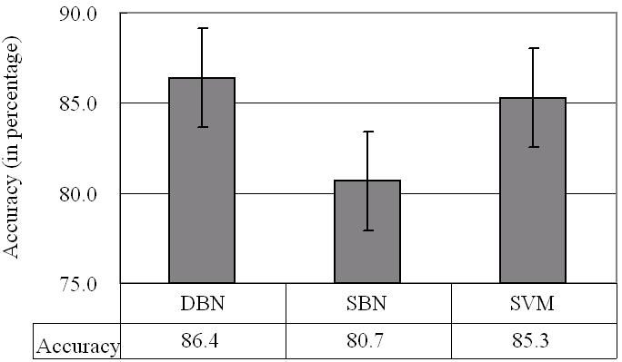 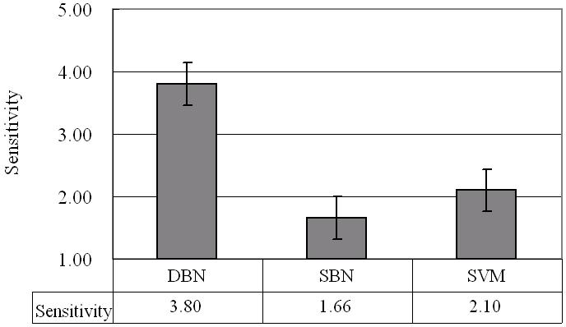 Testing accuracy Sensitivity
Figure 5.22. Comparisons of testing accuracy and sensitivity.
The decision bias was marginally different for the three models, F(2,16=2.8, p=0.09). The DBN models were more liberal than the SBN and SVM models (DBN: -1.85; SBN: -0.47; SVM: -0.55) with marginal significance, SBN: t(16) =2.1, p=0.051; SVM: t(16) =2.0, p=0.06). The SBN and SVM models had similar response biases, t(16) =0.1, p=0.9, which were not different from the neutral model that is characterized by zero, SBN: t(16)=1.1, p=0.3; DBN: t(16) =1.3, p=0.2. These results help explain the discrepancy in the comparisons of the DBNs’ and SVMs’ testing accuracy and sensitivity. Although less sensitive than the DBN models, the SVM models achieved accuracy similar to the DBN models by using a more neutral strategy. Nevertheless, to explain how SBN and SVM models resulted in different accuracy levels given their similar sensitivity and response bias, the analyses of hit and false alarm rates were needed.
Figure 5.23 shows show that DBNs had higher hit rates—and SVMs had marginally higher hit rates—compared to SBNs, F(2,16)=4.8, p=0.02; DBN: t(16) =3.1, p=0.008; SVM: t(16)=2.0, p=0.06. False alarm rates for the three types of models were similar, F(2,16)=1.1, p=0.4. This indicates that the DBN and SVM models reached higher accuracy than the SBN models by generating a greater hit rate.
The effect of window size interacts with model type to affect the false alarm rate, F(3, 24)=3.0, p=0.052; interaction: F(6, 46)=2.0, p=0.08. Figure 5.24 disaggregates the false alarm data in Figure 5.23 to show how false alarms were affected by window size. False alarms increased with window size from 5 to 15 seconds, and then decreased at 30 seconds, particularly for the DBN (see solid line in Figure 5.24). All the models followed this trend, but the magnitude of the change was much more dramatic for the DBN than for the SBN and SVM models. No main effect or interaction was found for testing accuracy, sensitivity, response bias, or hit rate. 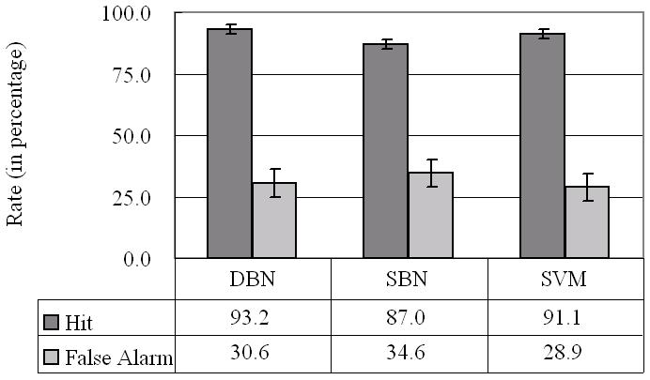
Figure 5.23. Comparisons of hit and false alarm rates.

Figure 5.24. Comparison of false alarm rate for DBNs, SBNs, and SVMs for window sizes of 5 to 30 seconds.
In summary, DBNs produced more sensitive models than SBNs and SVMs. The DBN and SVM models were more accurate and had higher hit rates than the SBN models. However, the effects of response bias on the three types of models were only marginally significant. Window size and its interaction with model type did not affect testing accuracy, sensitivity, response bias, or hit rate, but marginally affected false alarm rate.

Discussion
Compared to SBN and SVM models, the DBNs, which model time-dependent relationships between drivers’ behavior and cognitive state, produced the most accurate and sensitive models. This indicates that changes in drivers’ eye movements and driving performance over time are important predictors of cognitive distraction. At the same time, the SVM models detected driver cognitive distraction more accurately than the SBN models. This suggests that the SVM learning technique has advantages over the BN technique. The cross-validation learning process seems to have resulted in better parameters for the SVMs. We used a 10-fold cross-validation to search for the best C and γ values in the range of 2⁻⁵ to 2⁵. One possible result of selecting good parameters may be evident in the marginally increased hit rates and relatively lower false alarm rates of the SVM models, although the difference in false alarm rate was not significant. In addition, SVMs have fewer computational difficulties than BNs. It took less than one minute for SVMs to train a model, but approximately a half hour for SBNs, and even longer for DBNs using an equal number of training data.
Real-world distraction detection systems will need to both accurately detect driver cognitive distraction and minimize the number of false alarms to promote acceptance of the system. An interesting finding of this paper is that window size had a marginal effect on false alarm rate, but did not affect the other four measures. This effect was particularly salient for DBNs. It means that either a small (5 s) or large (30s) window size used to summarize drivers’ performance measures will decrease false alarms without affecting overall model performance. However, as shown in Figure 5.24, the false alarm rates are still relatively high. Reducing false alarm rate is an important issue that future studies need to address.
Based on these comparisons, a hybrid learning algorithm that combines the time-dependent relationship and SVM learning technique could result in even better-performing models for detecting driver cognitive distraction from eye movements and driving performance. Possible ways to integrate SVMs and DBNs include bagging and paralleling. Bagging describes using multiple models to make predictions on one target. It involves first training multiple (an odd-number of) SVM and DBN models with different training datasets to form a set of models. Then, each model makes a prediction for the same datum (or case). The final prediction of cognitive state for this datum (“distracted” or “not distracted”) depends on the vote of all models in the set. This method can reduce the variance of prediction and avoid overfitting.
Paralleling involves connecting two models sequentially. For example, if some aggregated descriptions of drivers’ behavior, such as eye scanning patterns, are demonstrated to be essential for identifying cognitive distraction, we can first use SVMs to build models to identify the eye scanning patterns from eye movement measures, and then use DBN models to infer cognitive states from the patterns identified. One such an approach combined a Bayesian Clustering by Dynamics and SVM model to forecast electricity demand (Fan, Mao, Zhang, & Chen, 2006).
Models developed using data mining methods can be reciprocal with the top-down theories. For example, the relationship identified from BNs may help uncover evidence to support a current theory or to create a new one regarding the cognitive processes that underlie cognitive distraction. Such theories related to human cognition can, in turn, provide top-down constraints that can be integrated into bottom-up models, such as the initial structure and structural constraints of BN models. Data mining and cognitive theories can directly cooperate to identify cognitive distraction. For instance, data mining methods can be used to summarize driver performance into an aggregated characteristic of driving behavior, such as seriously-impaired driving behavior or diminishment of the visual scanning field. A model based on a cognitive theory can then take the characteristic as an input to identify a driver’s cognitive state. Thus, a combination of top-down and bottom-up models may provide more comprehensive prediction of cognitive distraction than either alone.
We have discussed how to detect visual and cognitive distraction as if they occur in isolation. In the real driving environment, cognitive distraction often occurs together with visual and manual distraction. To obtain comprehensive evaluation of driver distraction, the detection needs to cover all kinds of distractions. Two models—one that detects visual and one cognitive distraction—need to work together in future IVIS. To simplify detection, the procedure can begin by checking the level of visual and manual distraction, because such distraction is much easier to detect than cognitive distraction. If visual distraction is detected, it may not then be necessary to check cognitive distraction.

References

